▶ ▶ ▶
▶ ▶ ▶
▶ ▶ ▶
▶ ▶ ▶
▶ ▶ ▶ ▶ ▶ ▶ ▶ ▶

Warburton

▶ ▶ ▶ ▶ ▶ ▶ ▶ ▶ ▶

Place Plan

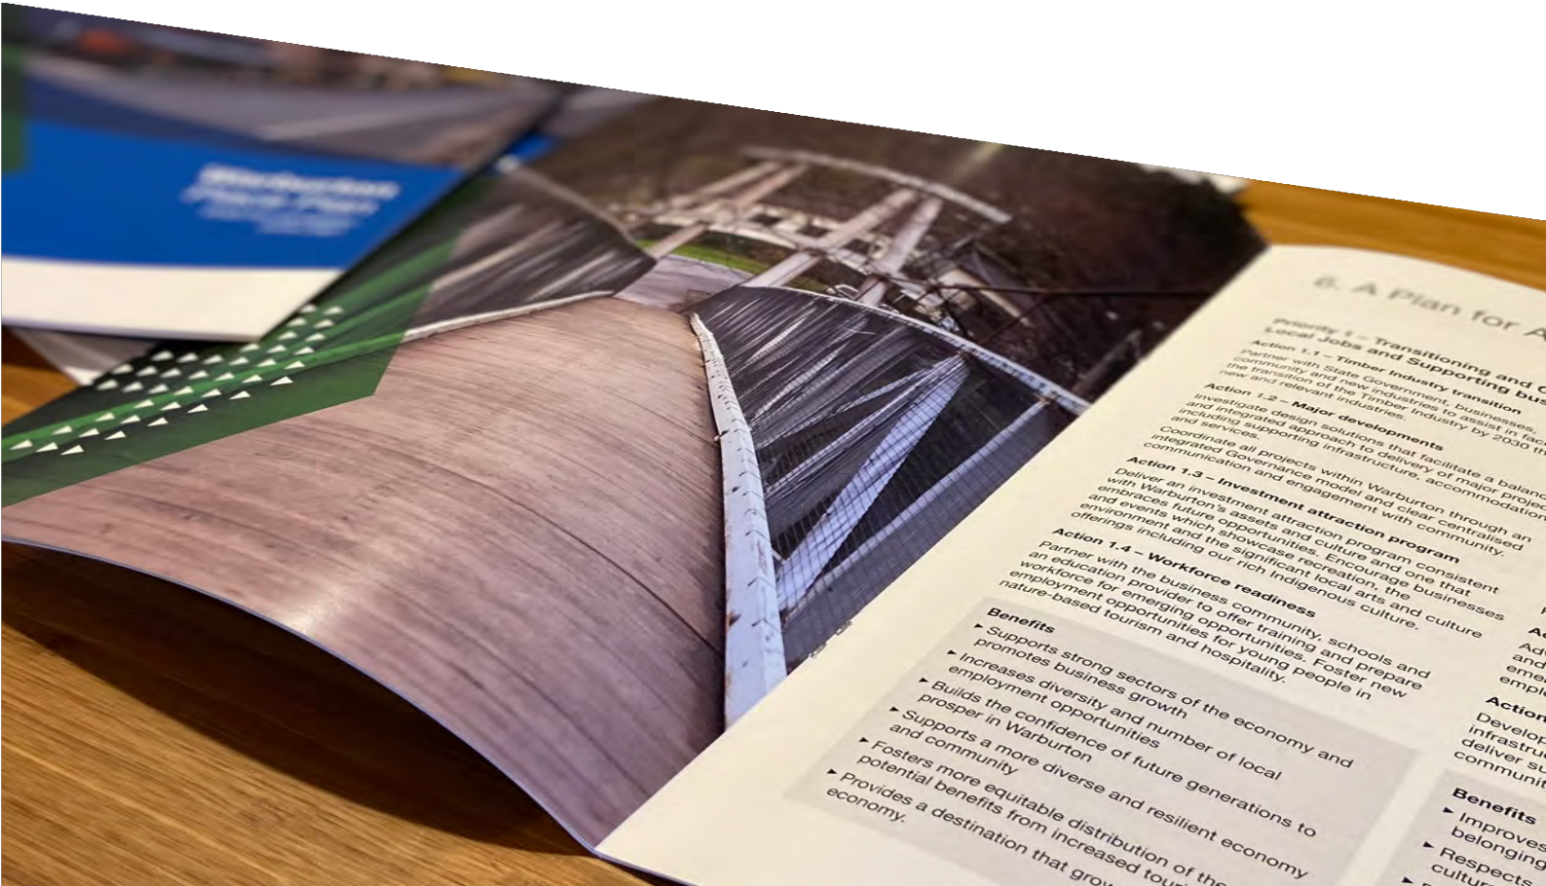
▶ ▶ ▶ ▶ ▶ ▶ ▶ ▶
▶ ▶ ▶
▶ ▶ ▶
▶ ▶ ▶
▶ ▶ ▶

Consultation and Engagement Report
November 2021

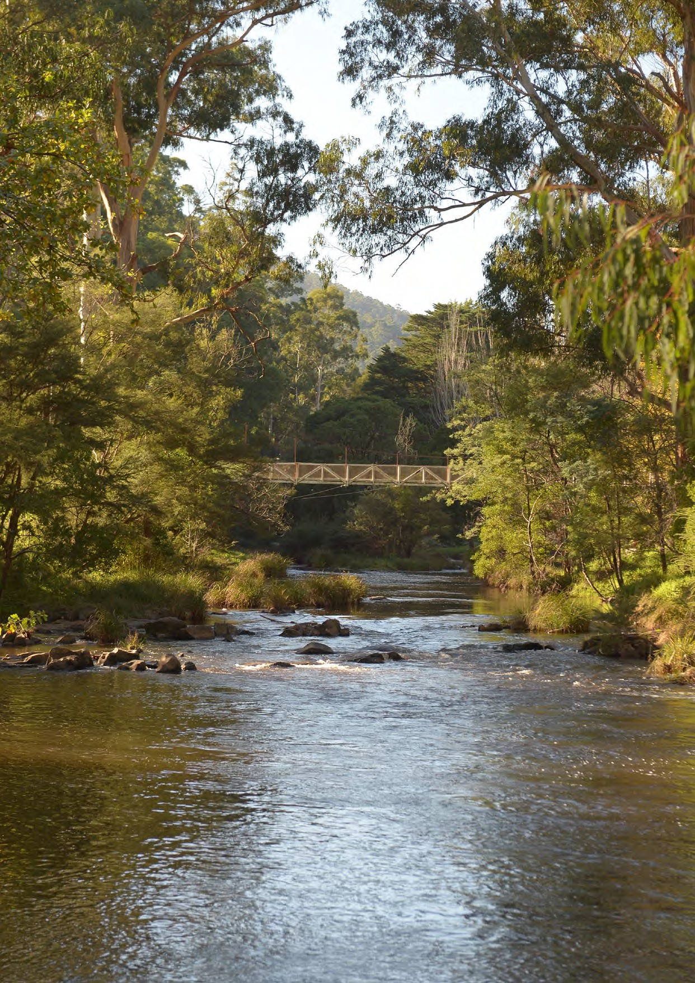
2 / Warburton Place Plan Consultation and Engagement Report

Acknowledgement of Country
We respectfully acknowledge the Traditional Owners, the Wurundjeri People as the custodians of this land.
We also pay respect to all Aboriginal community elders, past and present, who have resided in the area and have been an integral part of the history of this region.

Published by Yarra Ranges Council 2021.
This document is available on our website. To request a copy, email or phone our Customer Service Centre using the details below:
yarraranges.vic.gov.au mail@yarraranges.vic gov.au Phone: 1300 368 333

Who we spoke to

Warburton has a highly engaged and proud community who actively participated in a broad suite of consultation and engagement for the Warburton Place Plan

2 Consultation and Engagement periods for the place plan were undertaken (December 2018-May 2019 and July 2021-August 2021)

An Engagement and Directions Paper was completed and published (October 2019)

A letter was mailed out to over 3,750 households in the Warburton and the surrounding area to inform the community of the exhibition process and provide details of how to view the draft plan and provide feedback

2 forums with key stakeholders, including business and community groups

Drop In Sessions were organised to be held each week in the Mechanic’s Hall in the Warburton Arts Centre with over 40 people meeting with Council staff who were on hand to provide information and
collect feedback

12 people attended a webinar that was conducted on the evening of the 18th August. The webinar allowed members of the community that could not attend a Drop In Session an additional format to gain information on the draft Warburton Place Plan

2,354 page views of the Shaping Yarra Ranges Warburton Place Plan page from 1,469 unique visitors

Council’s July group email to Warburton community groups included information on the exhibition and these was followed up with an update feature in the August group email
@

77 contributors through the Shaping Yarra Ranges Warburton Place Plan web page

“I like that Warburton is finally being taken seriously by Yarra Ranges Council”

Businesses in the Warburton Main Street were approached to put up posters in their shopfronts to advertise the exhibition period and many traders did so

Hard copies of the Draft Warburton Place Plan were made available at Warburton Waterwheel Visitor Information Centre and Yarra Junction Community Link

The draft Warburton Place Plan was exhibited for 8 weeks

Visitors came from: Social Media Channels (37%); Direct to Shaping Yarra Ranges (26%); Yarra Ranges Website (17%); Search Engines
(13%); and Other Sources (7%)

Warburton Place Plan Consultation and Engagement Report / 3

What we heard

Community feedback was generally supportive of the Place Plan. With many of the submissions recognising the key issues and directions for
Warburton and also providing direct commentary in response to the proposed opportunities and plan for action.

The Draft Warburton Place Plan undertook a wide ranging and thorough consultation and engagement process through avenues such as: a mailout; key stakeholder forums; drop in sessions; a webinar; Shaping Yarra Ranges webpage; and email.
Of submissions received 9% were comments simply stating support for the Place Plan without providing any additional comment or feedback. Another 57% provided comments that were supportive or validating of the Place Plan and were directly related to items and recommendations which have already been addressed by the Actions in the Place Plan or will be explored in detail through each Action. A small number of submissions focused on consultation methodology
which was considered to have been addressed through the various formats and opportunities offered throughout the consultation period. A further 4% made suggestions
This Consultation and Engagement report provides a high-level summary of the most prominent feedback provided in response to the priority areas and actions proposed within the Place Plan. The feedback received has been used to inform some adjustments to the Warburton Place Plan, which will be put forward for
Council adoption. Once the Place Plan has been adopted by Council an Urban Design Framework will be developed to translate these principles into actual designs and projects prepared for delivery. In addition, progress on actions and projects will be reported annually. With performance and monitoring made publicly available on- line.

Did we hit the mark?

that had not been captured and the Place Plan has been updated to accommodate these.
There were a handful of general comments (around 19%) which were typically not related to the content of the Place Plan, but rather general commentary on Council or other concerns. These are noted however did not make any suggestions to improve the Place Plan. A further set of comments (around 11%) were beyond the scope of the Place Plan, which largely related to the Warburton Mountain Bike Destination project which has held its own engagement over several years and is currently governed by stringent statutory requirements. It will be subjected to its own expert evidence, analysis and review however the Place Plan ensures any impacts are planned for.
The passion and pride for Warburton was clearly evident in the submissions received and was displayed by many
SORT OF

47%

26%

27%
YES

NO

at key stakeholder forums, and drop in sessions. Almost all of the submitted feedback received was from within the Yarra Ranges with the vast majority from Warburton.
needs of the broader community.”
“You really need to ensure you are not displacing our local community to suit the

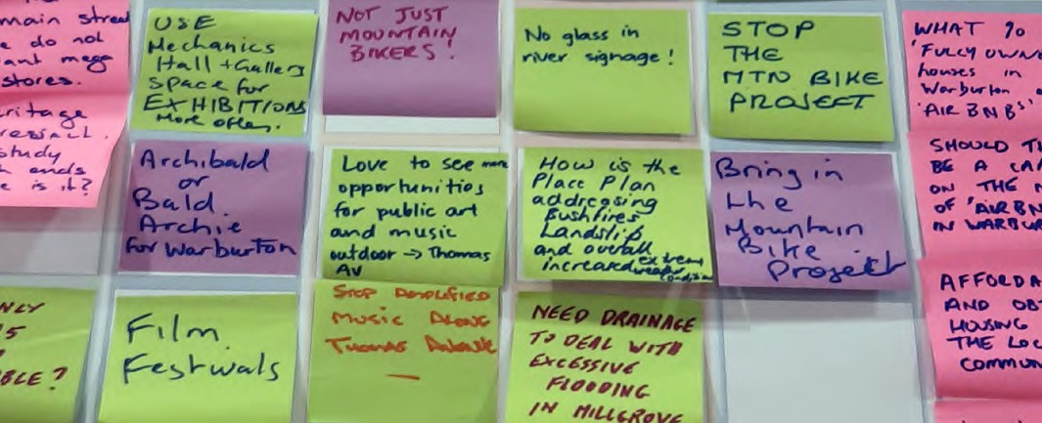

“I love the detailed thoughts of the planning and the fact the locals from Warburton and surrounding areas have been looked after and taken into consideration. Looking forward to the next 5 years”

Where were submissions from?

“Please place more emphasis on protecting the environment and
implementing the Place Plan in a sustainable manner.”

OTHER* HEALESVILLE OLINDA
REEFTON

MILLGROVE

EAST WARBURTON

11%
3%
3%
4%

4%

8%

9%

58%

YARRA JUNCTION WARBURTON

“It does a really great job of combining the wishes of the majority of concerns that the community has expressed for a thoroughly exciting future”

* Includes submissions from Don Valley, Keysborough, Launching Place, Lilydale, McMahons Creek, Ringwood, Wandin North, and Yarra Glen

Most used words/phrases
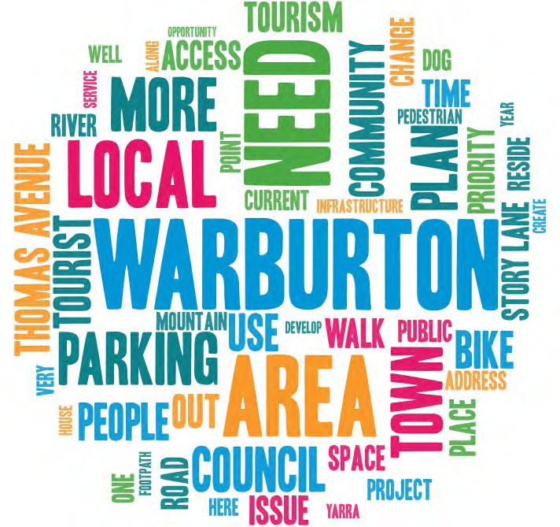

Priority 1 - Transitioning and Growing Local Jobs and Supporting businesses

Warburton’s people will have increased opportunities to prosper as the town grows with a more diverse and robust economy.

TIMBER INDUSTRY
TRANSITION

MAJOR DEVELOPMENTS

22%

33%

31%

14%
WORKFORCE READINESS

“Infrastructure needs to be sorted out for the locals before tourism”

INVESTMENT ATTRACTION PROGRAM

“I like that there is a
vision bringing economic opportunities and vibrancy to Warburton”

Workforce readiness
* Most supported Actions as ranked in the Warburton Place Plan survey

FEEDBACK
Action 1.1  Timber Industry transition | Questions were raised on the need for Action 1.1. Feedback received was either completely supportive of the action item or alternatively, suggested that the action item was completely unnecessary, as the timber industry was more relevant to other towns and not Warburton.
Comments in support of the Action item were closely linked to the benefits to the natural
environment.
 | Comments raised concerns that other Action items were more important and relevant to Warburton at this time.
 | Suggestions encouraged any timber industry transition program to be used to create new timber heritage trails and other investment/attraction opportunities to honour Warburton’s logging past.
Action 1.2 Major developments | Very strong support was provided for this Action with much of the feedback supportive of the opportunities this Action presented for Warburton.
 | Concerns that Major Developments also included accommodation, and infrastructure, resonated in many of the submissions. Many of the responses saw major developments as responding directly to tourism, with infrastructure delivering more for the local community.
 | Requests for this Action to be split into individual actions that separated infrastructure from major developments were mentioned.
 | Addressing local issues including: drainage; sewerage; roads; car parking; and toilets were also suggested as key elements.
Action 1.3 Investment attraction program | Recognition of the need to focus on tourism, whilst retaining the character of the town was seen as a priority. Requests were received to maintain any tourism within sustainable limits.
 | The Warburton Mountain Bike Destination had a broad range of views expressed with much of the feedback split as either for or against the project.
 | Suggestions were also provided regarding the increased use of many of Warburton’s heritage buildings to maximise investment attraction opportunities.
Action 1.4 | There was strong support for the focus on helping all businesses and community members benefit  from the tourism, with workforce training considered a priority.
 | Suggestions to partner with the business community, schools, other education providers, and support services to offer integrated learning, training and employment pathway opportunities.
 | Requests were made that there was limited commentary within the Place Plan about aged, youth, disability, and vulnerable communities, with Warburton currently lacking community spaces, and training areas for community members to gain employment skills locally.

Priority 2 - People, Culture and Community Wellbeing

A diverse, connected, supported and active Warburton with increased housing choice and access.

“There is a very strong craft community here
which used to be celebrated in the Warburton Winter-Fest. There is very little outlet for local crafts people. We need support to revive cultural festivals for the town and region”

INDIGENOUS CULTURAL HERITAGE

20%

14%
EVENTS

ADVOCACY

HOUSING
16%

27%
23%

MOBILE PHONE AND INTERNET

Encourage all businesses and public spaces backing onto Thomas Avenue to celebrate, educate and enliven the area, showcasing the land and the Yarra River”

* Most supported Actions as ranked in the Warburton Place Plan survey

FEEDBACK
Action 2.1 Indigenous Cultural Heritage | Indigenous Cultural Heritage was well supported with feedback encouraging more indigenous engagement and culture in Warburton.
 | Comments suggested that Indigenous Cultural Heritage needs to be built into any tourism strategy.
Action 2.2 Advocacy | Comments displayed an enormous passion for the local Warburton area with much of the feedback promoting Warburton’s character and beauty.
 | Requests were made to advocate for many of Warburton’s empty buildings to be reactivated such as the local hospital as a priority, to support increased activity within Warburton in the future.
Action 2.3 Housing | Very strong support was provided for this Action. Comments all recognised the value of the Action with the feedback concerning the management of the growing short term accommodation issues within Warburton.
 | Requests for Council to take some control of the short term accommodation issues ensuring that future development is appropriate and sustainable.
 | Requests for Council to also recognise the value of tourism, and encourage residential development in adjoining towns, so that residents have options outside Warburton.
 | Requests for Council to also engage with owners of vacant buildings within Warburton to to transform properties into affordable social housing opportunities.
Action 2.4 Mobile phone and internet | Very strong support was provided for this Action. Local internet services were repeatedly mentioned  as poor with improved internet seen as beneficial to local residents and business owners alike.
 | Links to emergency information were also commented on with the capacity to call for emergency services in times of power outage seen as critical.
Action 2.5 Events Strategy | An events strategy was commented on to showcase the region in support of the local community. Feedback was provided around ensuring diversity of attractions.
 | Suggestions for the revival of cultural festivals for the town and region, in addition to existing sporting events.

Priority 3 - Character, Place and Inclusion

Integrated and highly accessible services and spaces that support good health, access to the natural environment, social care and connectedness.

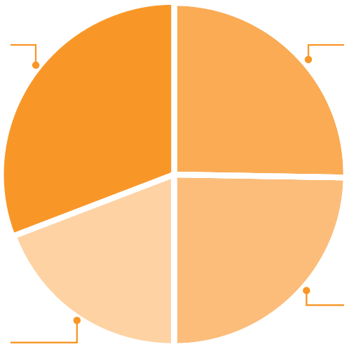
URBAN DESIGN FRAMEWORK

UNIVERSAL DESIGN

31%

19%

25%

25%

YARRA RIVER

HERITAGE

“What is needed is for the window front of the Arts Centre to be returned to a small Main Street window front gallery again as it used to be and was originally intended to be.”

“It is a struggle here, without footpaths across most of the town, to take a stroll or a dog-walk around the residential areas of Warburton”

* Most supported Actions as ranked in the Warburton Place Plan survey
Yarra River

FEEDBACK
Action 3.1  Urban Design Framework | This Action was very well supported with much of the commentary confirming the critical need and  desire for an Urban Design Framework for Warburton.
Many of the detailed suggestions provided within the consultation and engagement period are particularly relevant to future design considerations, and concepts that will be explored in the Urban Design Framework. Suggestions included:
- design and function of Story Lane;
- buildings fronting Thomas Avenue;
- spaces for public art and music;
- more community spaces; and
- enhanced heritage buildings
 | Feedback was very supportive of having a design framework that would illustrate these ideas for Warburton in the future to create a tangible picture for the area that people could see and engage with.
Action 3.2 Universal Design | Comments for this Action were focused on improving safe access around the residential streets and the river walk for diverse groups within Warburton.
 | Requests for all ageing and unsafe infrastructure to be improved with much of the feedback concerning traffic hazards and the lack of sealed footpaths needed to provide safe access to and from the residential and commercial areas of Warburton.
Action 3.3 Heritage | Comments requested that the Place Plan recognise the need to focus on tourism, whilst retaining the character, and heritage of the town. Support was provided to retain the character of the streetscape in the main street and avoid the introduction of any large format retail premises.
 | There were numerous comments regarding the retention, preservation, and improvement of many of the heritage buildings and sites within Warburton. The feedback showed a strong desire to encapsulate the history of Warburton and the surrounding region.
Action 3.4 | The Yarra was seen as very important, and was a strongly supported Action.
 | Comments supported links to the Yarra River, and the Indigenous Cultural Heritage within the broader Upper Yarra region, not just the Warburton township.
 | A number of comments supported reorientating the businesses towards Thomas Avenue and opening up to the Yarra River.

Priority 4 - Environment and Sustainability

A strong connection with nature and confidence that it has been protected. Warburton town centre retains its beautiful spaces and streets leading to a greater sense of community, safety, and pride.

“A clear commitment needs to be made to ensure that we have access to emergency information and the capacity to call for
emergency services in times of power outage”

RESILIENT RENEWABLE
ENERGY

25%

27%

EMERGENCY SAFETY PLAN

ECOLOGICALLY SUSTAINABLE DEVELOPMENT
(ESD)
19%

14%
15%

ENVIRONMENTAL EDUCATION
ns

“There needs to be locatio to accommodate increased numbers of visitors - should there bea fire. Traffic will be an issue on days of increase
fire risk - don’t encourage too many people”

WASTE MANAGEMENT

* Most supported Actions as ranked in the Warburton Place Plan survey
Emergency Safety Plan

FEEDBACK
Action 4.1 Resilient renewable  energy | This Action item was strongly supported. Feedback was very supportive of alternative energy sources and commented on the value that reliable energy would provide Warburton. With suggestions including:  - batteries/generators to keep business going on those many occasions when power supply is cut; and locally sourced solar supply
 | Feedback also commented on the synergies and needs that renewable energy could provide in an emergency where people need to access power during mains power outages.
Action 4.2 Ecologically Sustainable  Development (ESD) | Comments were supportive of ESD suggesting that the environment should be prioritised. Feedback also supported this Action in light of the recent Intergovernmental Panel on Climate Change (IPCC) report on climate change.
Action 4.3 Waste management | Waste management was focused on litter and refuse left by tourists and visitors to Warburton. Requests were made for a program to discourage litter and protect the local environment.
 | Requests were also provided concerning town sewerage.
Action 4.4 Environmental education | Suggestions indicated a desire for more emphasis on protecting the natural environment. Comments were received regarding a lack of planning for habitat protection or identification of native species at risk.
 | There was comment on the lack of mention of the ever growing feral deer population that is destroying the environment.
Action 4.5 | There was very strong support for this Action. The vast majority of feedback received indicated the critical nature of this Action and many comments wanted the Action to be prioritised even more.
 | Comments were also received suggesting that a sensible safety plan is needed that links with other Actions for example, mobile phone and internet coverage, which is essential in emergencies. As well as managing the towns population on high risk days to limit the risk for visitors and locals alike in emergency situations.
 | Requests were provided that suggested that this Action needs to be more broadly applied than fire risk. Feedback indicated that other environmental hazards and risks need to also be considered.

Priority 5 - Parking, Traffic and Transport
solutions

An easier and safer town to get around with quality roads and public transport infrastructure.

PARKING SOLUTIONS

CYCLING AND PEDESTRIANS

34%

18%

17%

31%
WAYFINDING SIGNAGE

INNOVATION

“Parking needs to be addressed, as it is impossible for locals to use
Warburton during peak tourist times”

“Most locals drive everywhere, creating more traffic congestion and parking problems because there is nowhere safe to walk in our own town. Slipping over in mud or tripping over tree roots while avoiding falling off huge embankments and cliff faces is never fun for anyone”

* Most supported Actions as ranked in the Warburton Place Plan survey

FEEDBACK
Action 5.1 Parking solutions | Parking was identified by a number of comments as a major problem with strong support for  prioritising this Action.
 | Requests for better planning for events, and well prepared, and signed parking options was seen as vital.
 | Existing public spaces were commented on with requests that any new parking areas should avoid these spaces as they are public assets that provide spaces to support the social integrity and fabric of Warburton.
 | Parking was strongly supported as an Action, but solutions such as shuttle buses were questioned if they would create more headaches for neighbouring towns where vehicles would need to be parked impacting locals in these towns.
Requests to focus on improving traffic and parking during peak tourist periods was part of much of
the feedback.
Action 5.2 Cycling and Pedestrians | Requests for more footpaths for shared use of both cyclists and pedestrians were received. With commentary also linking to a need for signage and line markings to indicate the correct use of these shared areas.
 | Safety was supported within this Action with lighting suggested, amongst other things, to enhance connection and safety.
Action 5.3 Innovation | This Action was strongly supported and highly contentious. Feedback requested more emphasis  on solutions to traffic congestion and saw public transport as only a small part of this.
The majority of feedback focused on traffic flow in and out of Warburton, with concerns
surrounding access, safety, and movement all raised in received submissions.
Action 5.4 Wayfinding signage | Comments regarding signage were primarily focused on encouraging correct use of roads and access points. Much of the feedback requested signage to solve existing problems with traffic movement and parking.

Next Steps

As a 20 year plan, the actions signal strategic intent for Warburton and surrounds. These key next steps will ensure the Place Plan progresses towards the delivery of real projects and community outcomes.

Warburton Place Plan Adopted by Council
The Warburton Place Plan will be considered for adoption by Council on 23 November 2021, and aligned to delivery of key strategies and Actions included in Council’s annual Corporate Action Plan.

Urban Design Framework and Potential Projects (including Quick Wins)
An Urban Design Framework to be developed to translate the principles into actual designs and projects prepared for delivery. Solutions that can be readily delivered will
be designed and costed in order to seek funding for construction.

Warburton Place Plan Action Plan, Reporting, and Review
The Actions will be integrated into Council’s annual business and project planning with specific actions allocated to departments and teams for delivery. Progress on actions and projects will be reported annually. The Warburton Place Plan will be reviewed and evaluated over time to ensure it is current, relevant and adapted to any changes that have arisen. Performance and monitoring will be publicly available through Council’s on-line channels.

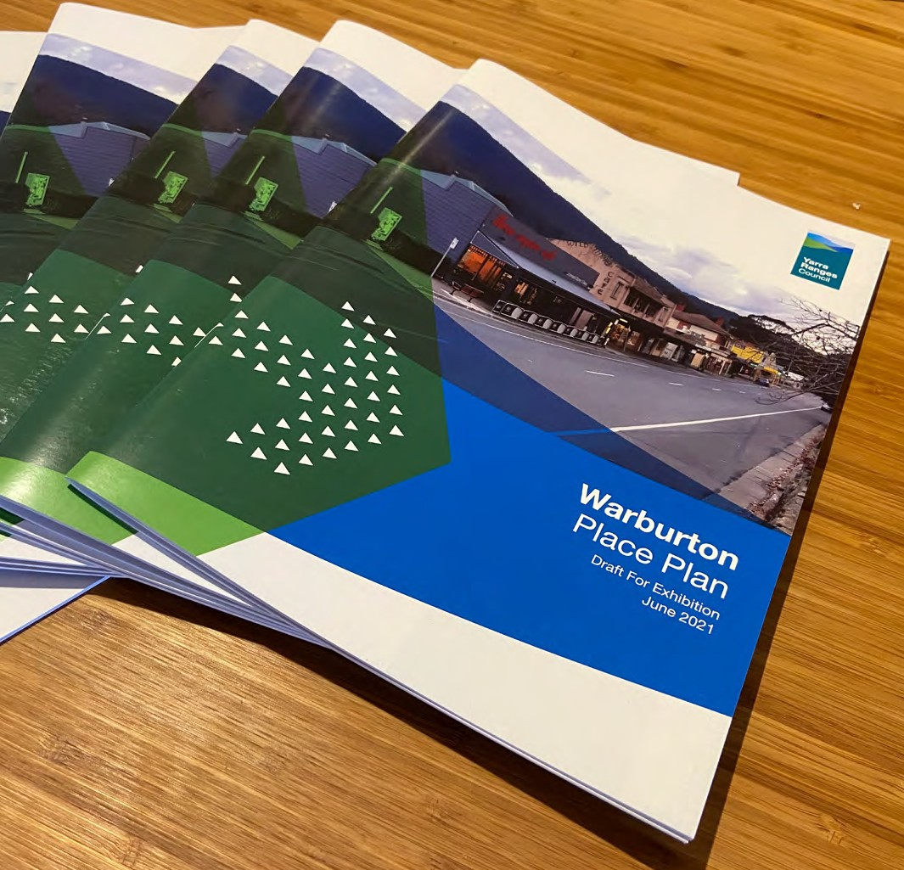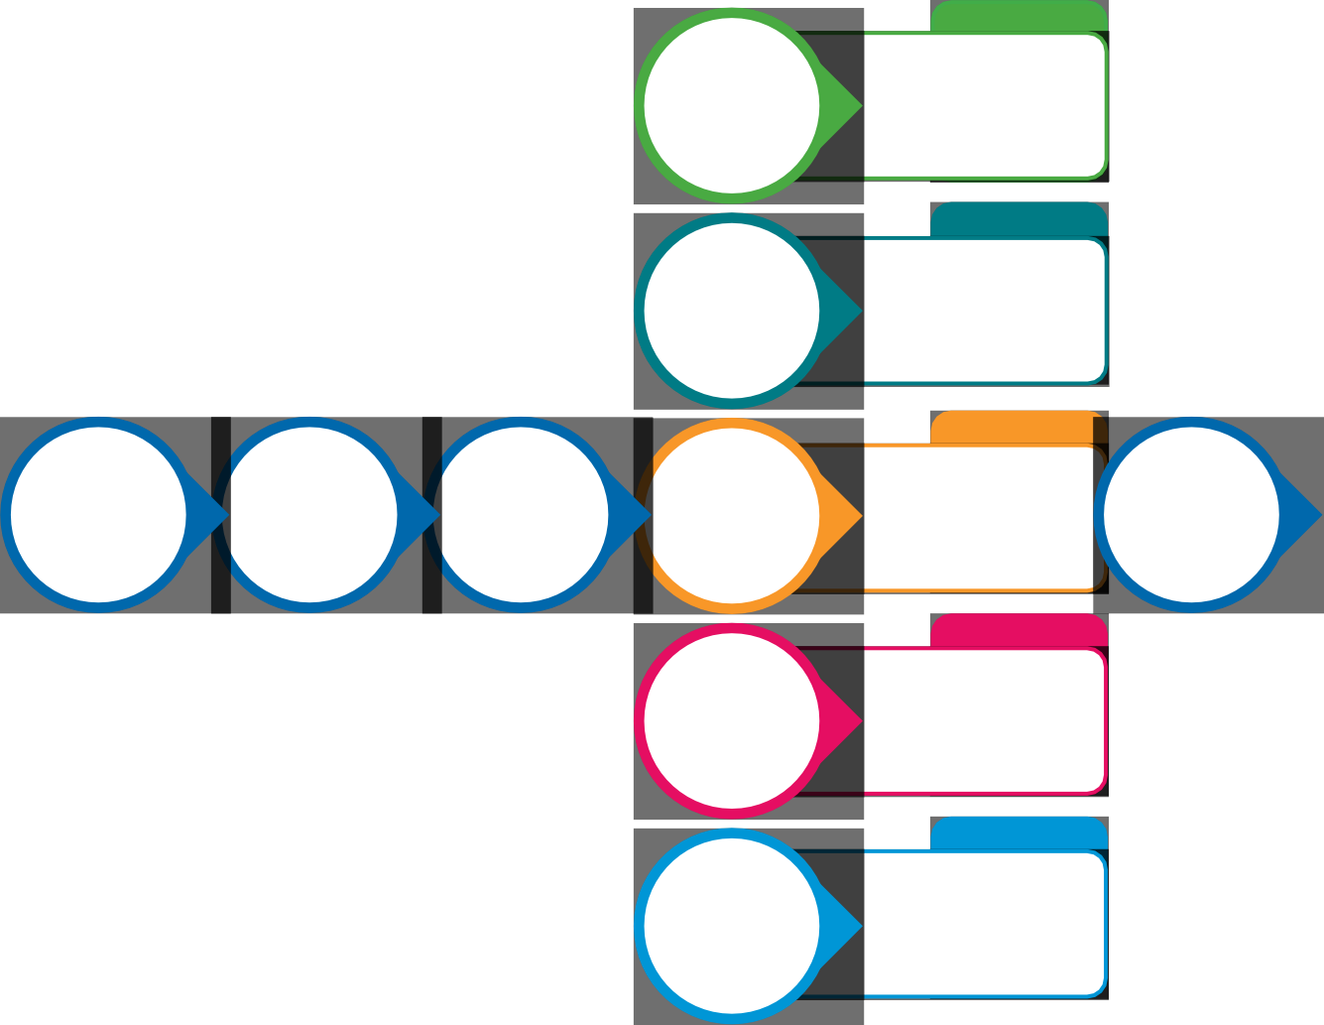
Potential Projects
Transitioning and Growing Local Jobs and Supporting Businesses
➔Integrated Governance Model
➔Investment Attraction Program
Potential Projects
People, Culture and Community Wellbeing
➔Affordable Housing Strategy
➔Events Strategy
➔Planning Scheme Controls

Potential Projects
Consultation and Engagement Report
Finalise Warburton Place Plan
Warburton Place Plan Adopted by Council
Character, Place and Inclusion
➔Urban Design Framework
➔Update Design Development Overlay (DDO)
➔Heritage Controls
Warburton Place Plan Reviewed Annually
Potential Projects
Environment and Sustainability
➔Emergency Safety Plan
➔Waste Management Strategy
Potential Projects
Parking, Traffic and Transport Solutions
➔Parking and Traffic
Strategy
➔Smart Cities Strategy
➔Wayfinding Strategy

▶ ▶ ▶
▶ ▶ ▶
▶ ▶ ▶
▶ ▶ ▶
▶ ▶ ▶ ▶ ▶ ▶ ▶ ▶
▶ ▶ ▶ ▶ ▶ ▶ ▶ ▶
▶ ▶ ▶ ▶ ▶ ▶ ▶ ▶
▶ ▶ ▶
▶ ▶ ▶
▶ ▶ ▶
▶ ▶ ▶

