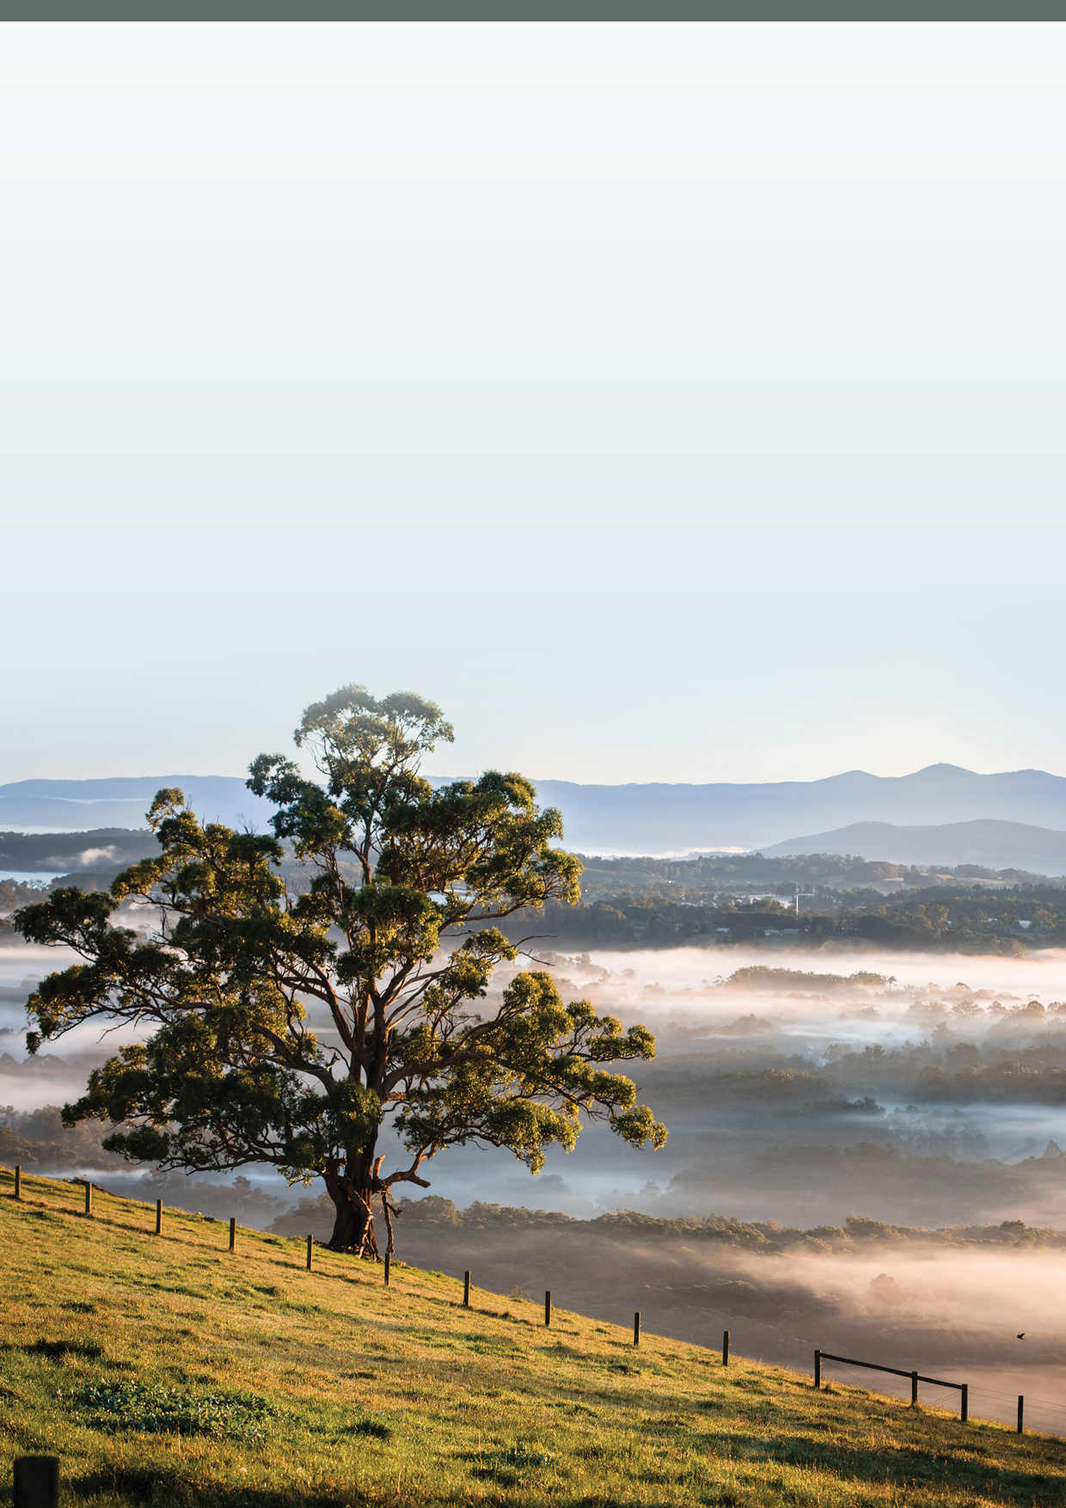

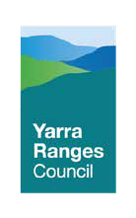
COUNCIL PLAN 2021-2025

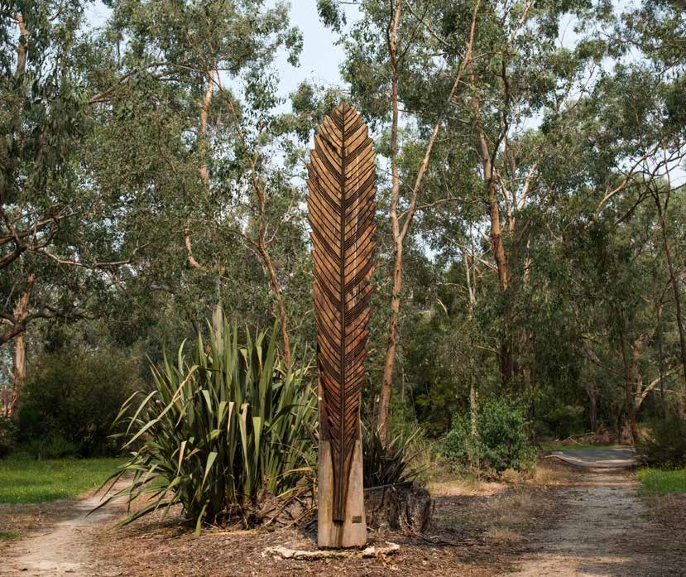Acknowledgement of Country
We respectfully acknowledge the Traditional Owners, The Wurundjeri People as the Custodians of this land. We also pay respect to all Aboriginal community Elders, past and present, who have resided in the area and have been an integral part of the history of this region.

Value of History
We acknowledge that history shapes our identities, engages us as citizens, creates inclusive communities, is part of our economic well-being, teaches us to think critically and creatively, inspires leaders and is the foundation of our future generations.

2 Yarra Ranges Council Pan 2021-25

Table of Contents
What is a Council Plan? | 4
How the plan was developed? | 5
Message from the Mayor and Councillors | 6
Message from the CEO | 7
Your Councillors | 8
Yarra Ranges Community Values Statement | 12
Yarra Ranges Community Vision 2036 | 14
Our Challenges | 16
About Yarra Ranges | 18-19
Our Executive Team | 22
Our Organisation | 24
Strategy and Planning | 26
Community | 27
Our Planning | 28
Our Approach | 30
What we want to achieve | 32
Our Strategic Direction | 33
Major initiatives for 2021-25 | 34
Connected and Healthy Communities | 36-41
Quality Infrastructure and Liveable Places | 42-47
Protected and Enhanced Natural Environment | 48-51
Vibrant Economy, Agriculture and Tourism | 52-55
High Performing Organisation | 56-61
Council Action Plan | 63
Copies and Further Information | 63
 |  | 3

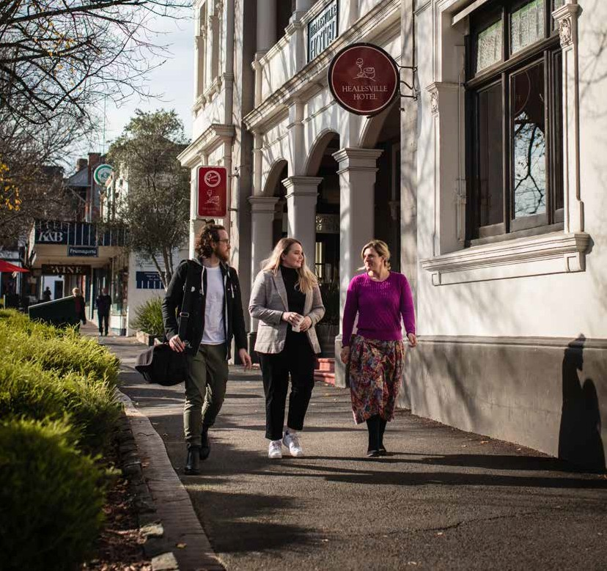

What is a Council Plan?
The Council Plan is Council’s key planning document for the four year electoral term. It describes the things that Council stands for, our objectives, the high priority activities we will complete and how these activities are going to be resourced.
Importantly, it also explains how our performance will be
measured and reported back to the community through the Annual Report and other performance reports.

4 Yarra Ranges Council Pan 2021-25

How the Plan was developed
The development of the Council Plan occurs collaboratively, between community, councillors and officers. Importantly, it is developed based on a review of the current environment, the major issues facing the Yarra Ranges and the current and emerging needs of our community captured through comprehensive community engagement processes. Fifty Community Panel members representing the Yarra Ranges community and the wider community contributed their ideas and priorities to develop this plan and their Community Vision. Their recommendation are incorporated, balanced against Council’s financial position to then determine the content of the Council Plan and the actions for the next four years.

Input

Community Consultation Community Value Community Vision
Local Community Plans

Service delivery, Strategy and Policy Commitments

Long Term Financial Plan

State and Federal Government Policy
Output
Business Plan
Service Improvements
Annual Budget Capital
Expenditure Program
Mid-Year Progess Report
Annual Report

Council Plan
2021-2025
The Plan
How We Report

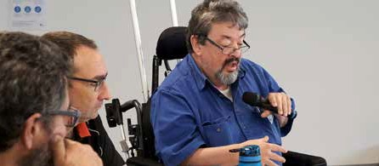
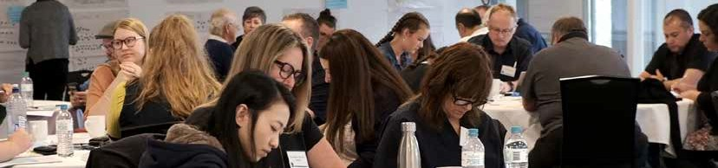
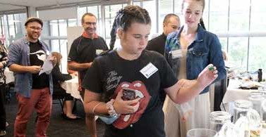

Corporate Action Plan
5

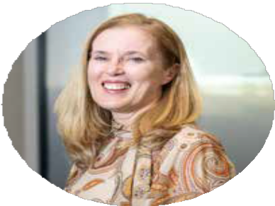
Message from the Mayor and Councillors

What a year… a global pandemic and constant adjustment to deal with the challenges of COVID-19 with the deep levels of stress this created for many; the profound impact of halts on trading for our local businesses; and, more recently, the devastating storms that hit our
community on June 9th. And the year ahead is clearly throwing similar challenges at us. Helping individual and business resilience is very much front of mind.
The recovery from these storms is only just beginning and of course our recovery from the pandemic is still ahead of us as we work to find ways to make it easier for our community members to get vaccinated and stay well. We’ve been working in many ways to support our communities adjust to the changes and challenges of the last 12 months and will continue to invest your money to do this in the years ahead.
This Council Plan sets our focus, our major initiatives and our goals for supporting and delivering for the communities of Yarra Ranges for the next four years. A key area of focus will be to support and enable our local economy and businesses to survive and bounce back. Other specific areas of focus include:
- Improving mental health outcomes for the community, strengthen social connections and advocate for equitable and accessible mental health services throughout Yarra Ranges.
- Becoming a world-class trails and eco-tourism destination which includes the delivery of projects like the Warburton Mountain Bike Destination, the Yarra Valley Trail and RidgeWalk.
- Sourcing renewable energy generated by Council and extending benefits to the community through advocacy and securing funding to deliver our Solar Farm project.
- Continuing our focus on our townships and suburbs being great places to live and work through integrated place planning for our priority activity centres and town centres.
- Building community resilience by working together on effective emergency planning and preparedness, with a focus on bushfire and including the development of a firestick program.
- Improving Aboriginal health and wellbeing by supporting Oonah Health and Community Services Aboriginal Corporation to establish an integrated Aboriginal health facility.
- Implementing the myriad of important legislative changes well and in ways that make Yarra
Ranges Council more inclusive and high performing with a noteworthy focus on Gender Equality Act 2020 and the Local Government Act.
- Preparing and implementing a Biodiversity Plan that will provide renewed environmental focus for Council, the community and our partners.

6 Yarra Ranges Council Pan 2021-25

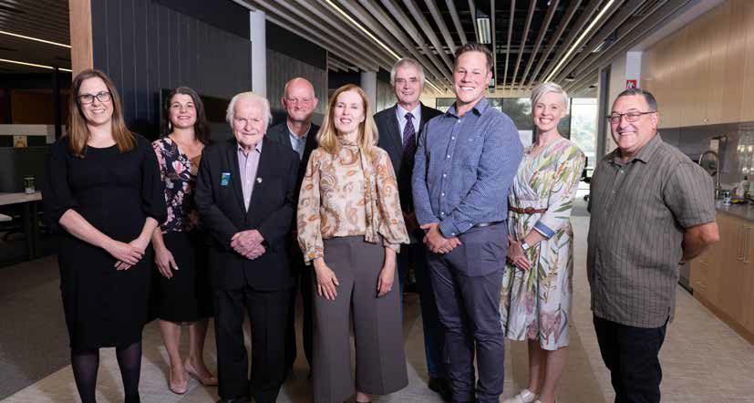
7

The vision for this and all the other work we do in delivering 120+ services, is to create and support connected and healthy communities; quality infrastructure and liveable places; a protected and enhanced natural environment; a vibrant economy, agriculture and tourism industry and; a high performing organisation. Even with all the curve balls thrown to us in the last year and the need to deliver services very differently or do completely new things, we never lose sight of our role in doing the things most important to you all and doing them well.
For all of us around the Council table – even if it has been a virtual one – we bring the voices of the communities from across Yarra Ranges to this Council Plan, the insights from each of our wards and a strong commitment to continuing to improve the quality of life for all in our community. This Council Plan is our commitment to you and speaks to the priorities that you have identified in so many ways and the that are most important to delivery or achieve. And of course, the conversation and consultation doesn’t stop here and we will be asking for your feedback on strategies, projects and just everyday, to tell us what we could do differently or better or even what we are doing well.
The next four years will be critical for our community as we recover, rebuild and reconnect in communities and towns and as a municipality. This is at the heart of this Council Plan and every decision we make. We know everyone’s journey has been different, that priorities are different and ever changing and that our role in making the right decisions at the right time has never been more important. This Council Plan is our promise to you on what is most important and how we will continue to do the work for you that matters the most.
Stay safe and well.

Councillor Fiona McAllister
Mayor Yarra Ranges Council 2021

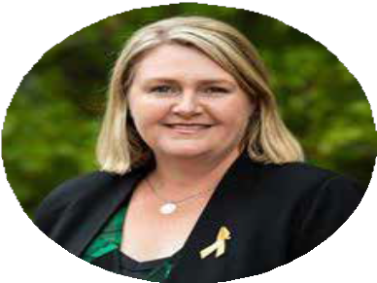
Message from
Our CEO

Welcome to the Council Plan 2021-25.
After the last year and a half, it can be hard to think about the future – let alone plan for it. The impact of the pandemic and the recent storms across the region have been colossal on our community members, and both will be big factors in Council’s ongoing planning and service delivery for years to come.
This four-year Council Plan sets out what our goals are over coming years – what we want to do and why, and what the benefits will be for those who live and work in this beautiful part of the world.
In the next four years, we have a number of things we’d like to achieve, across a number of categories, including:
Connected and Healthy Communities
We want to make sure communities are safe, resilient, healthy, inclusive and socially well-
connected. Quality services should be accessible to everyone. We’ll be implementing priority actions from strategies, like our upcoming Health and Wellbeing Plan and our Healthy and Active Ageing Plan, to ensure that our spaces are age-friendly and help promote good health. We’ll update our Aquatics Strategy to plan the provision of our aquatic facilities and we’ll advocate for better public transport connections.
Quality Infrastructure and Liveable Places
We want to make sure our facilities and infrastructure meet the current and future needs of the community. Places should be well-planned hubs of activity that foster wellbeing, creativity and innovation. We’ll look at how we plan social infrastructure, welcoming community assets and space, responding to the needs of the community and ensuring they’re well-maintained for future generations. As one example, we’ll work to revitalise Lilydale through several major projects and initiatives and review our housing strategy to make sure our communities are well-designed and provide choice and vibrant neighbourhood character.
Protected and Enhanced Natural Environment
We want to leave a healthier environment for future generations.
To do this, we’ll implement actions in our Liveable Climate Plan, rolling out more renewable energy in our facilities, improve amenity and access in our parks and reserves and pursue innovative waste processing technology to make our bin collections as sustainable as possible. We’re going to support environmental volunteer groups and prepare and implement a Biodiversity Plan to ensure that plants, animals and ecologies in Yarra Ranges are supported and retained.
Vibrant Economy, Agriculture and Tourism
We want to make sure our tourism, agriculture, health and other industries are leading, dynamic and thriving, with strong investment and attraction to underpin sustainable economic growth.
We’ll review our Economic Development Strategy and Investment Attraction Plan, to help create more local jobs and drive local investment. We’ll work with our partners in Yarra Ranges Tourism to support sustainable eco-tourism and develop a cultural and creative brand for the region.

8 Yarra Ranges Council Pan 2021-25

We’re going to deliver improvements to our recreational trails and continue development of new trails, to not only support good health and social needs in our community, but drive more tourism and economic benefit to the region.
High Performing Organisation
We want to be an innovative, responsive organisation that listens and delivers quality, value-for- money services to our community. We will continue to strive for excellence in all corners of our organisation, set new aspirations and reinvigorate our ways of working to ensure we achieve the best outcomes for our community.
We will continue to embed the principles of diversity and inclusion in our workforce, roll out more meaningful and inclusive community engagement to build community trust and participation and streamline our processes for the benefit of community members and staff alike.
We will increase the community’s access to our information and performance, strengthen our advocacy to other levels of Government about important community issues and always adapt and refine our services to best meet the needs of the community, while supporting our workforce at every step.
For a more detailed list refer to the 2021-25 Council Action Plan at yarraranges.vic.gov.au.
Gender equity
Creating a gender equitable and inclusive Yarra Ranges is essential to ensuring that our resources, power and opportunities are equitably distributed and all community members and employees have fair and equal opportunities.
Under the Gender Equality Act 2020 all Council’s are now required to take positive action towards achieving gender equality. At Yarra Ranges Council this will support us to build on the last five years of positive action – we welcome this Act and look forward to ensuring our workplace is both gender equitable and inclusive.
In this Council Plan, you’ll find more detail about how we hope to work towards and achieve these goals. As with any important undertaking, we can’t do this alone. We’ll be working with community, environment and sporting groups, other levels of government and our community members on many of these projects. There will be many opportunities for collaboration, engagement and for our residents to influence programs, projects and services.
In the meantime, you can stay up to date on our activities and our community engagements at shaping.yarraranges.vic.gov.au
Finally, ensuring our organisation remains financially sustainable will be one of our greatest challenges in the years ahead. As the geographically largest metropolitan council with 55 townships spread over 2500km2, it remains a challenge to balance the needs and desires of diverse urban and regional communities with prudent financial management. As we look to recover and rebuild from the pandemic as well as the June 2021 severe storms, finding new and better ways to ensure the services we provide and the assets we know our community value so greatly, is more critical than ever. And to do this, we need to work alongside our community, and focus on strengthening our partnerships with service agencies and other levels of government.
And where we can we need to create new partnerships that enhance outcomes.
I encourage you to read through this plan and think about how you’d like to get involved in coming years. We’ll need your thoughts, ideas and feedback along the way, and all the while as an organisation, we will continue to work hard on delivering for our community.

Tammi Rose,
CEO of Yarra Ranges

9

Your Councillors

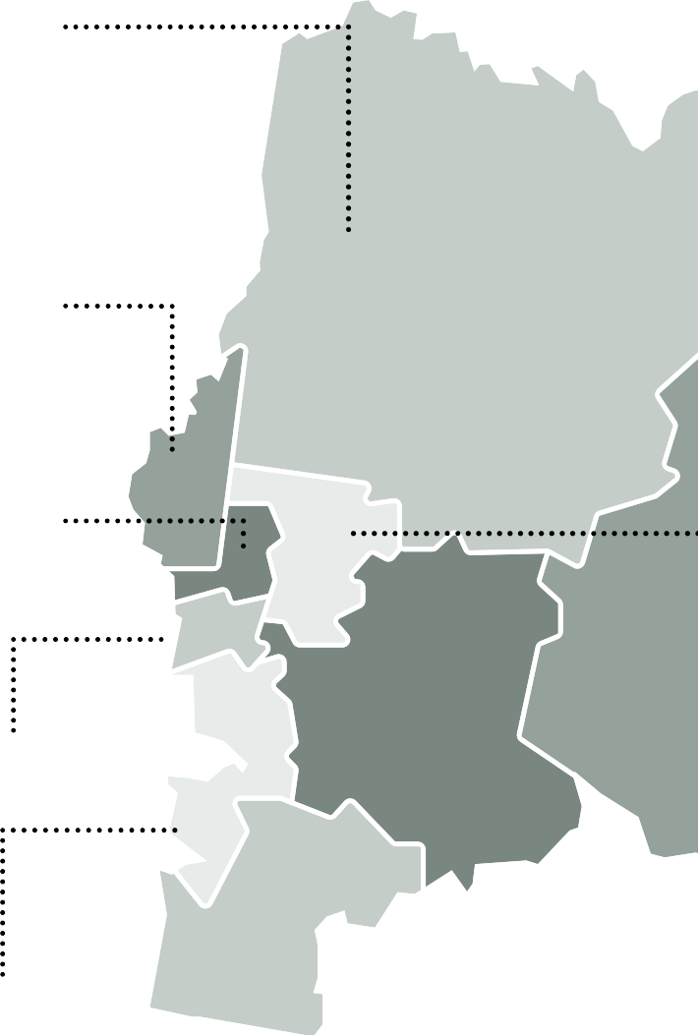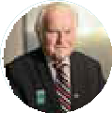Ryrie Ward Mayor Cr. Fiona McAllister
Ryrie Ward Councillor
0408 349 640
CrFionaMcAllister@yarraranges.vic.gov.au

Chirnside Ward Councillor Richard Higgins
Chirnside Ward Councillor
0429 151 489
CrRichardHiggins@yarraranges.vic.gov.au

Melba Ward Councillor Sophie Todorov
Melba Ward Councillor
0438 166 090
CrSophieTodorov@yarraranges.vic.gov.au

Walling Ward Councillor Len Cox OAM
Walling Ward Councillor
03 9761 9356
CrLenCox@yarraranges.vic.gov.au

Streeton Ward Councillor Cathrine Burnett-Wake
Streeton Ward Councillor
0437 967 826
CrCathrineBurnett-Ward@yarraranges.vic.gov.au

Lyster Ward Councillor Johanna Skelton
Lyster Ward Councillor
0437 938 075
CrJohannaSkelton@yarraranges.vic.gov.au

10 Yarra Ranges Council Pan 2021-25

Yarra Ranges Council has nine councillors elected by residents to govern the
municipality. The municipality is divided into nine wards and one councillor is elected to represent each ward. The Mayor of Yarra Ranges is chosen each year in November by the councillors for a twelve-month term.

O’Shannassy Ward Councillor Jim Child
O’Shannassy Ward Councillor
0408 079 227
CrJimChild@yarraranges.vic.gov.au
Billanook Ward
Councillor Tim Heenan
Billanook Ward Councillor 03 9736 2956
CrTimHeenan@yarraranges.vic.gov.au

Chandler Ward
Deputy Mayor Cr. David Eastham
Chandler Ward Councillor 0437 962 053
CrDavidEastham@yarraranges.vic.gov.au
11

Yarra Ranges Community Values Statement

12

This Community Values Statement was drawn from the responses received from more than 1,700 Yarra Ranges community members who shared their values with us in 2016.
Their combined responses have created the first Yarra Ranges Community Values Statement.

We value our families, friends and neighbours, our close knit communities and the support we freely give to each other in our towns. We value the way we help each other in times of need and how we work together to make our communities safe and friendly places to settle into and raise our families.

We value fresh air, clean rivers and streams, valley views and mountain vistas. We value the diverse and unique natural environment we live in, the many native plants and animals that inhabit it and the opportunities we have to ‘go bush’ in our backyard. We value our active spaces and our healthy lifestyle and how it sustains us in both mind and body.

We value our close connection to place. We value the spiritual connection the traditional custodians of our land have to place in Yarra Ranges, and our role in respecting these places, learning about them and preserving them for future generations.

We value our vibrant culture and our opportunities for creative expression. We value being able to paint, draw, dance and sing; and we value being able to share and celebrate our creativity with each other through festivals, markets, performances and other events.

We value our “best of both worlds” location where we can access nearby services while living in a peaceful and natural environment. We value the support available to people of all abilities and life circumstances, and that no one ever need feel isolated or unable to be part of our diverse and inclusive community.

We value our many wonderful attractions, and that we live somewhere special that others come to visit. We value our highly productive communities, our internationally recognised high quality produce and the opportunities we have to buy local and
support our local businesses.

Yarra Ranges Council recognises the Community Values Statement and will ensure that these values remain at the forefront of all council decision making and inform council planning for the future.

13

Yarra Ranges Community Vision 2036

Whether you live here or visit, you will see how much we care for Country, how inclusive and connected our communities are, and how balanced growth makes this the best place in the world.

The vision statement has been developed by Council to describe Council’s aspirations for the future of the municipality - how we would like Council to be in 2036. It was based on the ideas of more than 1,000 members of our community, captured in late 2016. This vision was checked with our Community Panel and the broader community again in 2021. The revised Community Vision 2036 now reflects the community’s future aspirations for the municipality.

In 2036 Yarra Ranges is a wonderful place to live, and a world-class destination for visitors and investors
who make a significant contribution to prosperity within the region.
Our community members are proud of where they live. Their values are respected, they feel connected and they place health and wellbeing as a priority.
The municipality’s natural beauty, stunning landscapes and reputation for exceptional local produce is enhanced, and have a significant influence on decisions made regarding sustainable growth and development in the region. A focus on responsible eco-tourism projects, access to digital services,
networks and infrastructure and balanced economic development has enhanced the region’s reputation and improved quality of life for all. The look and feel of our commercial and industrial areas, and
their environmental characteristics, has improved. Our roads, paths and other infrastructure are well maintained. Our townships are designed to improve liveability and support health and wellbeing through improved footpaths, trails, lighting and infrastructure.
Advocacy for innovative and state of the art transport solutions has improved access to important community services, new and upgraded facilities, infrastructure and jobs.
‘Gateways’ into Yarra Ranges and other areas throughout the municipality now strengthen the identity of the First Nations people, their culture, stories, history and progress towards reconciliation. This connection strengthens our collective identity, our culture and heritage and creates a sense of belonging for our diverse community.
Educational facilities build the skills of our people and develop our leaders to strengthen communities and support local employment. Our community members are passionate about where they live. They contribute their time, volunteering to support people in need, and their voice, providing feedback to Council about issues that impact them.
Through a local planning approach, the strength of local communities and their sense of place is enhanced, recognising they are diverse and have different needs to support their health, safety and wellbeing, while also embracing the commonalities they share in calling Yarra Ranges home.
Yarra Ranges is known to prioritise sustainability and the protection of biodiversity and habitat. Regenerative farming practices are used to protect precious agricultural land that nourishes our community with access to healthy, locally grown food. The community has taken steps to actively mitigate against Climate Change and be prepared for natural disasters including bushfire planning.
Services are accessible, gender equitable and inclusive catering to all ages, genders and abilities. Our community is healthy and active, with easy access to recreational facilities and cultural activities that are available for everyone. Disadvantaged residents are well supported through partnerships between government, business and community organisations.
At the heart of our vision is an authentic desire for Council to engage and listen to all members of our community, including our young people, and respond to their needs and aspirations. We are visible, transparent, accountable and communicate clearly and honestly.
Council resources are managed responsibly, and principles of fairness and consistency are applied to avoid unnecessary burdens for rate payers. Through expertise, insight, technology and creativity, Council is a leader in striving for excellence and delivering best practice services for the community. We inspire people to create a better future.

15

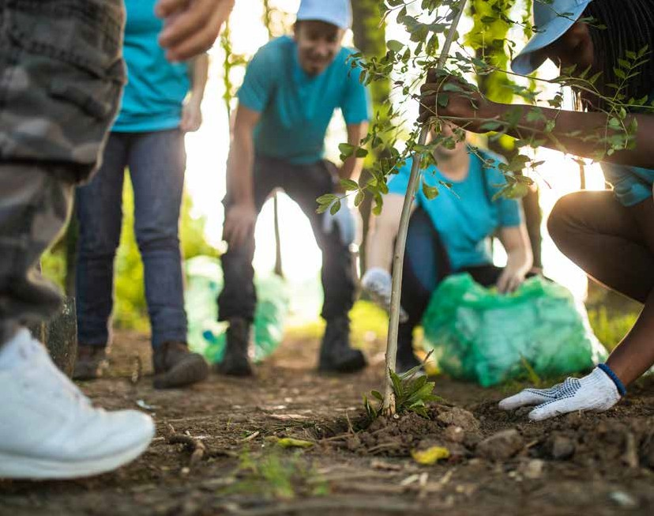Our
challenges

There are a number of complex issues facing Council which have informed the development of this Council Plan. These have been identified by the community, staff and Councillors and present an ongoing challenge. Some of the key issues are:

Community
- the social and psychological impact of isolation due to COVID-19 restrictions
- addressing the disadvantage, stigma, stereotyping, prejudice and violence experienced on the basis of gender, age, ability, cultural identity, religion or sexual orientation
- economic hardship on businesses and residents impacted by the pandemic and severe storms
- the different needs, expectations and identities of our suburbs and rural communities
- appropriately planning for future growth that considers the impact of increased infill development across the municipality
- the high levels of socio-economic disadvantage experienced in pockets across the municipality, creating greater need for Council services, support and advocacy efforts
- the aging population placing increasing pressures on a number of our services

16 Yarra Ranges Council Pan 2021-25

Service delivery
- the impact of the COVID-19 pandemic to change and adapt to emerging community needs
- the large geographic size of Yarra Ranges means it is more costly to deliver services, and there are greater distances for residents to access services
- ensuring our ageing population continues to receive high standards of care as the changes to the service delivery and funding model for aged care is implemented
- ensuring that the networks of roads, footpaths, bridges and drainage are maintained and renewed into the future and the particular challenges associated with the
geographic spread and topography of the area
- Reforms introduced by State Government to improve services in areas of Age Care and Waste
- service funding formulas used by State Government which disadvantage Yarra Ranges due to the assignment of an urban funding classification which fails to recognise the costs associated with delivering services to our rural communities

Environmental
- protecting and improving our unique and precious natural environment and providing environmental leadership by reducing emissions
- the increased frequency and severity of extreme weather events such as storms, floods, drought and fire and the need for additional emergency management prevention and preparedness
- securing adequate water supplies to ensure the economic stability for the agricultural industry
- adapting to the challenges posed by a changing climate and changing energy markets

Financial
- the reduced options to raise revenue due the introduction of rate capping by the State Government at the same time as continuing to ensure services needed by the community are accessible
- the need for significant investment in our ageing infrastructure to meet the expectations of the community with many buildings built 40 to 50 years ago
- the effects of the shifting of costs for the delivery of key services by the Federal and State Government onto local government

Engagement
- technology is driving community expectation to improve the ways we communicate, provide information, deliver services and report back to the community (online, anytime, anywhere).

17

About
Yarra Ranges

Next 10 yesrs populations growth expectancy rate:

10,972

Population aged 65 is expected to increase by:

2.7%

Residents

161,325
Aboriginal and Torres Starit Islander Peoples populations:

1,624
Yarra Ranges has the largest concentration of Aborginal and Torres Strait Islander people in
the Eastern Region

Land Area

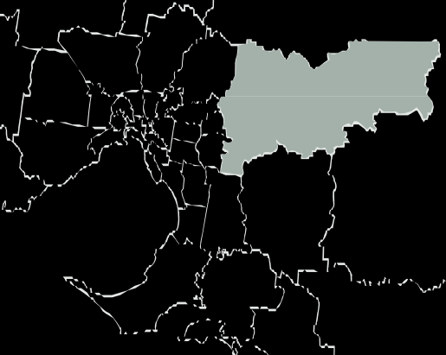
2,500 km2
Suburbs, townships and small communities.

55

12th
Largest local government area in Melbourne in terms of population, size and geographic area.

No. of Female:
LGBTIQ+: 4.2%
Heterosexual,

Speak English at Home:

88%

75,720
not LGBTIQ+:

No. of Male:
73,819
93.3%

Speak an Aboriginal and Torres Starit Islander lanuage ay home:

2.2%

Speak a language other than English at home:

7.2%
Born Overseas:

16.3%

18

60-79 years

19%
80+ 4%

25%
0-19 years

Home owners with or without mortage.

65%

40-59 years

27%
Median Age:
40

20-39 years

33%

Renters in the Yarra Ranges
33%

Number of businesses:

13,679
Total persons employed:

86,487
Method of Travel to Work:
Driving: 56,105
Public Transport: 4,779
Walking: 1,070
Others: 12, 077

Agriculture
5TH Largest Industry

Gross revenue:

$788.4m
Regional exports:

$513m
Total persons employed:

2000

Largest Industry

Retail Trade
Local Jobs:

47,166
Job Seeker and Youth allowance recipients:
Yarra Ranges

5,982
Greater Melbourne

13,679

19

Healthy Eating

Yarra Ranges community members eperienced food insecurity over 4% higher than in VIC overall.
Yarra Ranges community members consume less take- away meals and snacks (more than once a week) by 5% lower than VIC overall.
Yarra Ranges community members consume 5% more sugar-sweetened drinks daily than VIC overall.

Mental Health

Yarra Ranges has 1% less- high/very high levels of psychological distress than VIC overall.
Yarra Ranges community members have sought help for a mental health-related problem in the last 12 months 7% more than VIC overall.
Yarra Ranges community has 11% more residents who have ever been diagnosed with anxiety or depression.

Physical Activity

Sedentary or insufficient physical activity.

YR: 40% | VIC: 46%

Met physical activity guidelines.

YR: 58% | VIC: 51%

20 Yarra Ranges Council Pan 2021-25

Violence Against Women & Gender Inequity

Increase in number of family violence incidents.

YR: 12% | VIC: 7%
Increase of rate of family violence incidents

YR: 5% | VIC: 11%

Percent of people who feel safe when walking at night:

Female: 43.3%
Male: 79.9%

All of the data seen above has been sourced from the following sites and articles:
Australian Bureau of Staistics: Yarra Ranges Census | Id community, atlas.id.com.au. Demographic resources about the Yarra Ranges | Victorian Womens health atlas, victorianwomenshealthatlas.net.au | Victorian Agency of health Information, Findings from the Victorian population health survey 2017. www.bettersafercare.vic.gov.au | YarraRanges website and reports: Environmental Strategy 2015-2025 Yarra Ranges Council | Annual Report 2019-2020 | Yarra Ranges health and wellbeing profile, 2017 | Yarra Ranges 2012 -2022 economic development strategy

Disclaimer
The following pages about “Key facts about Yarra Ranges” is published for educational purposes only as well as to give general information and a general understanding about Yarra Ranges. The infographic data that has been put together a resourced from legitimate and reputable sites/ articles from dates ranging between 2015-2021. While care has been taken to ensure the content in appropriate for your particular purposes.
In addition, the publication is a snapshot in time based on historic information which is liable to change. The Yarra Ranges Council accepts no responsibility and disclaims all liability for error, loss or other consequence which may arise from you relying on information contained in this report.
21

The Yarra Ranges contain some of the most environmentally important areas in Victoria. These precious areas include the Mountain Ash forests of the Dandenong Ranges and Central Victorian Highlands.
Remnant native vegetation is home to iconic species such as the Powerful Owl, the Helmeted Honey-eater and Leadbeater’s Possum.

188,000
Hectares of native vegetation.

Yarra Ranges is recognised as a special place for its natural beauty and diverse habitats.
The mountainous landscape and the Yarra RiverValley contains significant areas of remnant native vegetation providing an important habitat for wildlife.

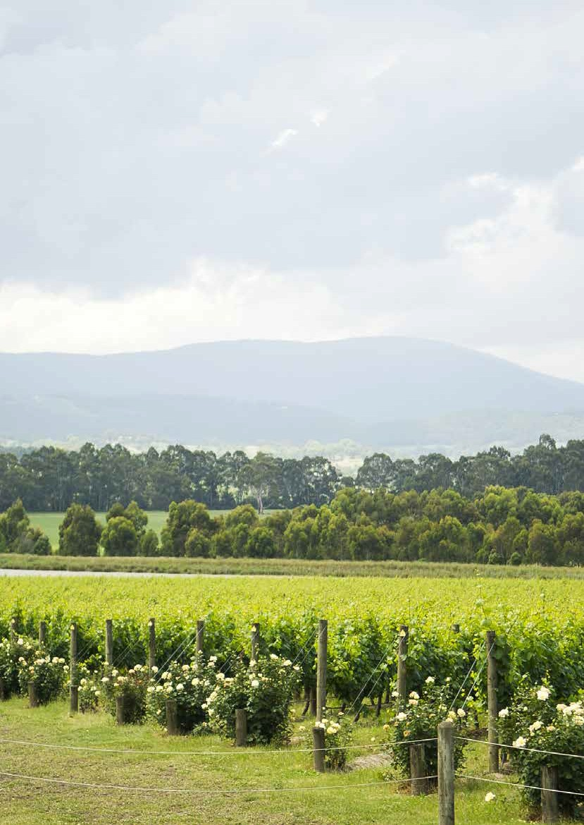

Our
Executive Team

22

Yarra Ranges Council is led by the Chief Executive Officer, who operates under the delegation of the elected Council and is responsible for the overall management and performance of all council operations, services and infrastructure delivery. The Chief Executive Officer, along with a group of directors, forms Council’s Executive Team.

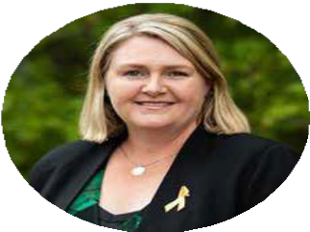
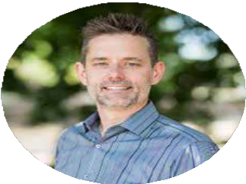

Tammi Rose
Chief Executive Officer

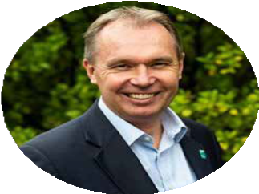
Mark Varmalis
Director of Environment and Infrastructure
Andrew Hilson
Director of Corporate Services

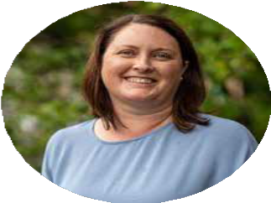
Kath McClusky
Director of Planning, Design and Development
23

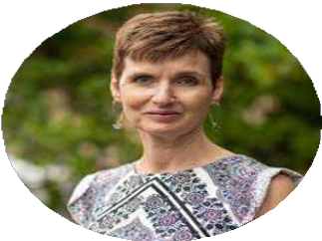

Jane Price
Director of Communities
Jane Sinnamon
Director of Recovery

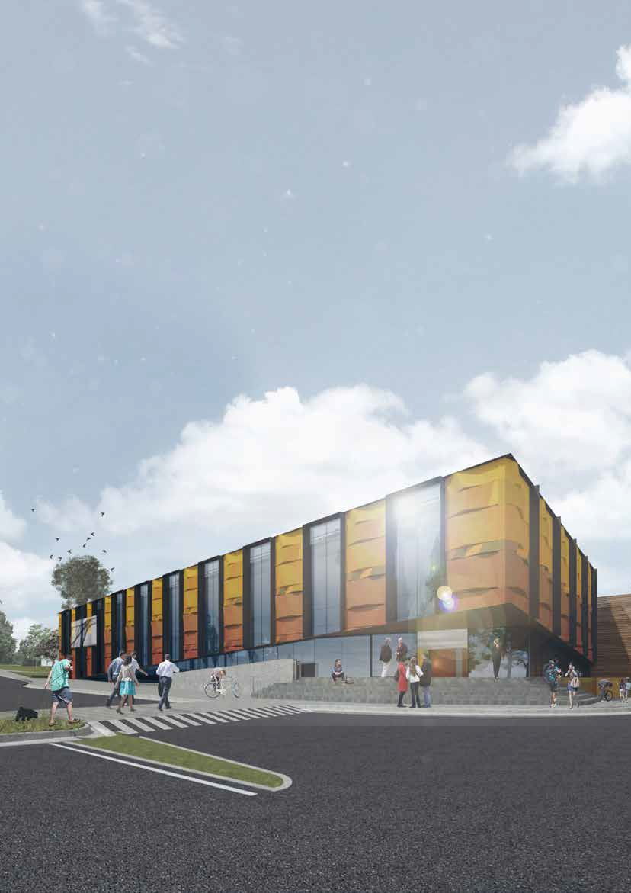

Our
Organisation

24

Our Vision
Whether you live here or visit, you will see how much we value our natural beauty, how connected our communities are, and how balanced growth makes this the best place in the world.

Our Commitment
We’ll be truthful, represent the community’s needs, be positive and responsive and always strive to do better.

Our Organisational Structure
Our organisational structure is designed to most effectively deliver quality services to our community. It supports our focus on innovation and responsiveness through continuous improvement and enables us to effectively deliver on this Council Plan.

CEO

Strategy & Transformation

Environment and Infrastructure

Infrastructure Service

Recreation, Projects & Parks
Assets & Capital Programming

Sustainable Environment & Facilities
Planning, Design & Development

Planning & Building

Design & Place

Economic Development & Investment

Strategic Projects
Corporate Service

Customer & Communications

People & Culture Financial Services Information Services

Communities

Community Well-being

Community Support

Creative Communities

Recovery

Built and Natural Environment

Community and Business recovery

Recovery Support

25

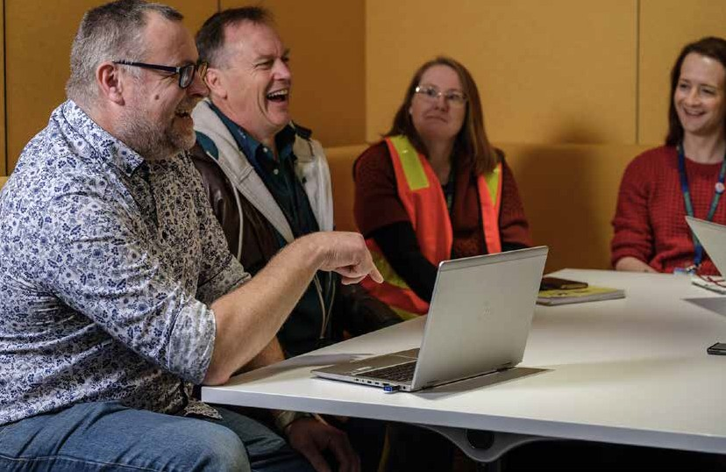Strategy and Planning

Yarra Ranges Council is proud of its integrated planning framework. A recent review of the framework ensures Council’s plans, strategies and resources are more closely aligned and increase the connection between what the community values, their
priorities and Council’s planning processes.

Strategic Framework

Community
Council’s Planning
Council’s Approach

Community
Vision 2036

Community
Values Statement
Council Planning

High Performing Organisation
Economy, Agriculture & Tourism
Quality Liveable Places
Enhanced Natural Environment
Healthy Connected Communities
(Municipal Strategic Statement)
Revenue and Rating Plan
Financial Plan
Budget
Business Excellence
Corporate Values
Strategies

Business Plan

Individual Performance & Development Plans

26 Yarra Ranges Council Pan 2021-25

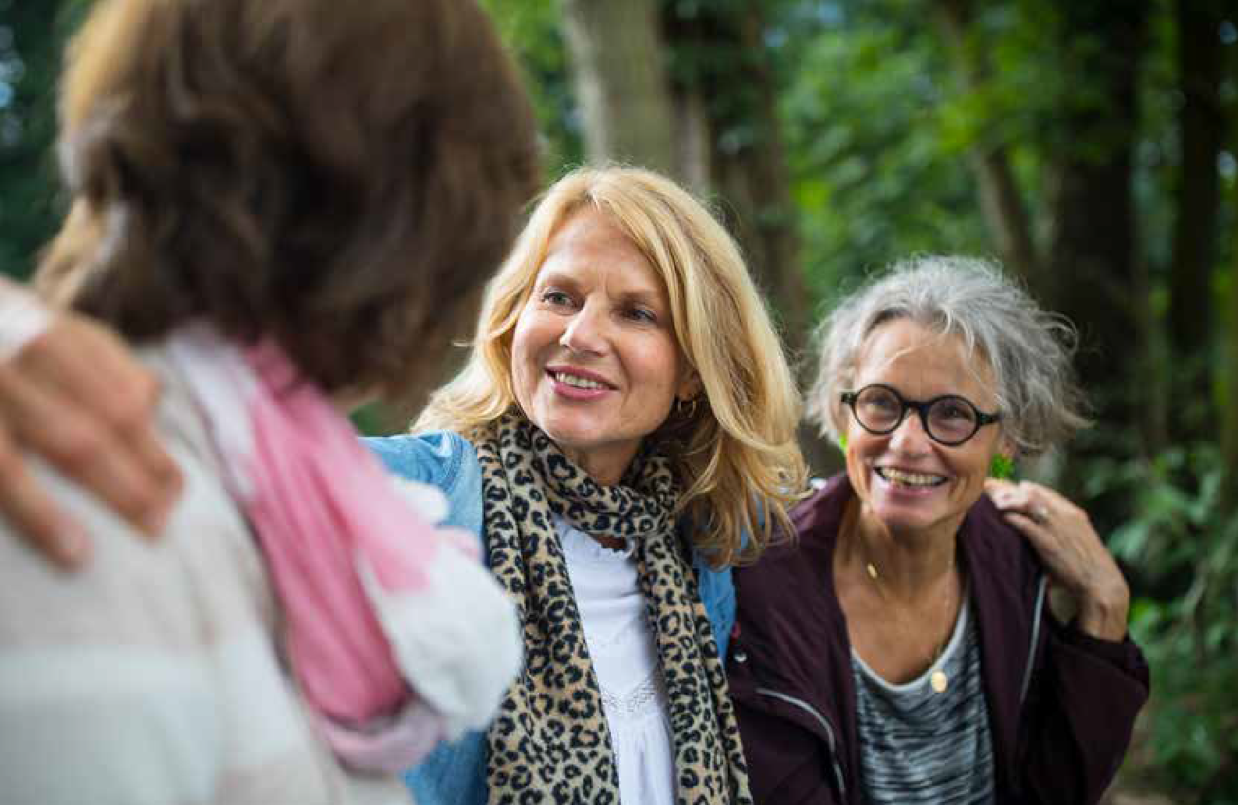Community Vision 2036

Community
The vision describes the community’s aspirations for the future of the municipality in 2036. The vision represents the values, needs, aspirations and guides the priorities for Yarra Ranges.

My Community – Yarra Ranges Values Statement
27
Council has asked the Yarra Ranges community members what is important to them now and what they value. This information was used to develop ‘My
Community – Yarra Ranges Values Statement’. This statement was an important input to developing the new vision for the municipality and all of the content in this Council Plan. It will also guide future planning and Council’s advocacy efforts on
behalf of the community.
Council is also continuing on a program of local area planning which involves supporting local communities to develop visions and plans for their townships or local communities. These plans are becoming an important information source into Council’s planning processes and this Council Plan.

Our Planning

Council Plan and Council Action Plan
The Council Plan describes Council’s vision for the future of the municipality. It describes the things that Council stands for, our objectives, the main activities we will complete and how these activities are going to be resourced. Importantly, it also explains how our performance will be measured and reported through Council’s Annual Report and other performance reports.
The Council Plan is developed every four years and reviewed annually. The review occurs in conjunction with the development of the budget and internal business plans. This ensures strong alignment between the organisation’s strategic direction and the activities listed in the Council Action Plan to be carried out within individual departments. The list of actions contained in the Council Action Plan are reviewed annually. The document can be found on yarraranges.vic.gov.au

28 Yarra Ranges Council Pan 2021-25

Strategies and plans
Council has a number of strategies which guide our delivery to achieve Council’s vision and five strategic objectives. Council also has a number of policies and management plans that focus on a particular topic and describe Council’s position and actions to address these issues.

Department business plans
Business plans are developed annually by each department or business unit in the organisation. They describe and assess the services delivered, key projects and performance measures and align with the delivery of objectives, strategies and activities of the Council Plan.
Business plans are developed by managers in conjunction with staff in their teams alongside the preparation of department budgets. This ensures that the business planning process gains the value of the experiences, priorities and aspirations of the whole team and activities are able to be adequately funded.

Financial Plan
The Financial Plan is a key part of Council’s strategic planning process and outlines our commitment to providing responsible financial management. It considers:
- Council’s current financial position
- key issues and risk areas
- strategies to address the issues faced
- the projected ten year financial position based on various assumptions.
The Financial Plan is reviewed annually alongside the Council Plan and Budget to ensure the aspirations in the Council Plan can be adequately funded.

Rating and Revenue Strategy
The Rating and Revenue Strategy establishes the revenue raising framework to determine the most appropriate and affordable revenue and rating approach for Council which, in conjunction with other income sources, will adequately finance the services and initiatives to deliver on the strategic objectives in its council plan. The Rating and Revenue Plan is prepared alongside the review of the Council Plan each year.

Budget
Council prepares a four year budget each financial year. The budget includes information about the rates and charges to be levied, the capital works program to be completed and financial statements which describe Council’s income and expenditure for the year.
The budget is prepared alongside the review of the Council Plan with specific project and service delivery requirements balanced against available resources.

29

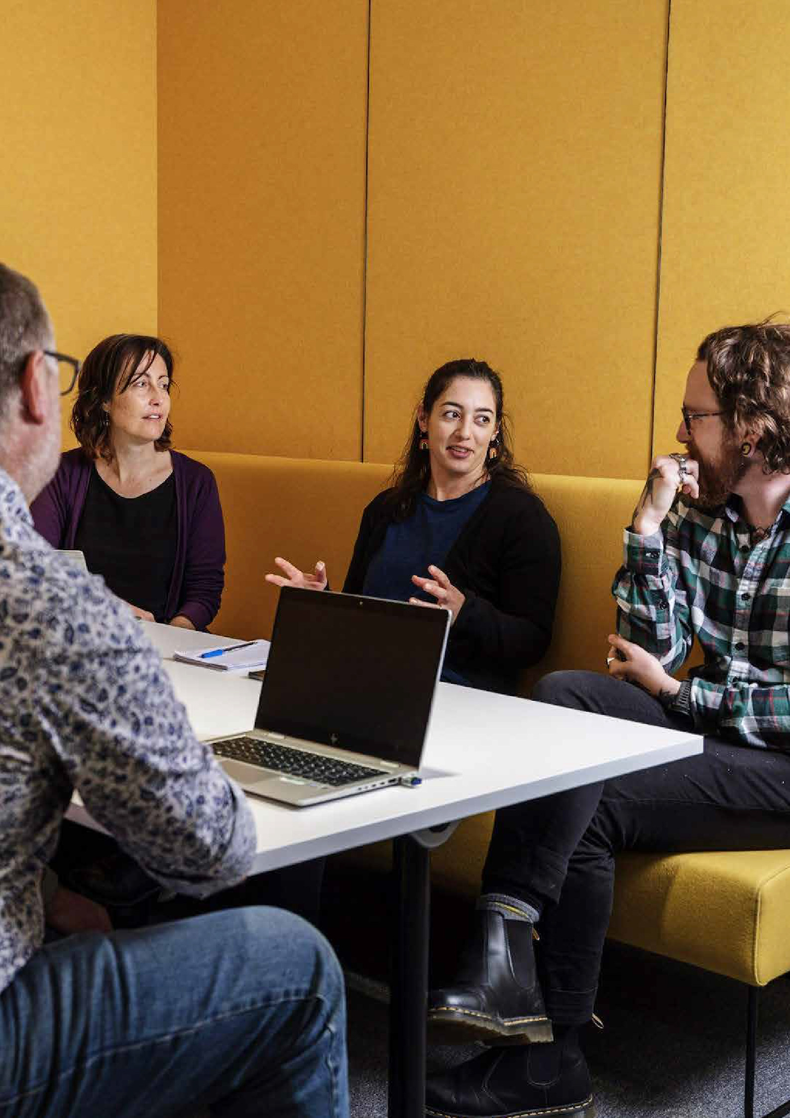Our
Approach

30

Business Excellence
The internationally recognised Business Excellence Framework assists Council to achieve high levels of performance and deliver value to our customers. The framework is based on universal principles of organisational improvement. The principles are incorporated through seven categories which are used to assess and improve our organisation. The categories are:
- Leadership
- Strategy and Planning
- Information and Knowledge
- People
- Customers and other Stakeholders
- Process Management, Improvement and Innovation
- Results and Sustainable Performance.

Values
The organisation’s values guide our behaviour and underpin everything we do. Our values help us achieve the organisation’s vision and mission and improve the quality of the services we offer to our community.

Trust Empowerment Innovation

Gender Equity and Intersectionality
The organisation is committed to working toward a Yarra Ranges where women, men and gender diverse people have equitable access to resources, power and opportunities. This commitment is supported by our obligations under the Gender Equality Act 2020.
Employees have a responsibility to promote gender equality through their attitudes, behaviours and day-to-day work, including by completing Gender Impact Assessments
on all strategies, policies, programs and services with a direct and significant impact on the public.

31

What We Want to Achieve
Council has identified five strategic objectives to describe what we are working towards – how we want Yarra Ranges to be in the future. These objectives, and the activities we will complete over the coming four years, have been developed in response to our community’s priorities and the big issues facing Yarra Ranges. All activities completed by the organisation contribute to one or more of these objectives. A list of these activities can be found in the Council Action Plan 2021-25.

Connected and Healthy Communities Communities are safe, resilient, healthy, inclusive and socially well connected. Quality services are accessible to everyone.

Quality Infrastructure and Liveable Places
Quality facilities and infrastructure meets current and future needs. Places are well planned and are hubs of activity that foster wellbeing, creativity and innovation.

Protected & Enhanced Natural Environment
A healthier environment for future generations.

Vibrant Economy, Agriculture and Tourism
Our tourism, agriculture, health, manufacturing and other industries are leading and dynamic. Strong investment and attraction underpins sustainable economic growth and job creation.

High Performing Organisation
An innovative, responsive organisation that listens and delivers quality, value for money services to our community.

32 Yarra Ranges Council Pan 2021-25

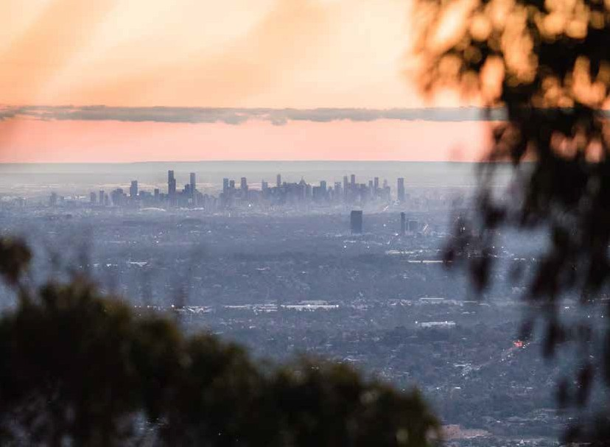Our Strategic Direction

The following pages outline the:
- Major Initiatives – critical priority projects for the next four years
- Five strategic objectives – the goals for the organisation
- Community Values - what the community told us they value
- Vision 2036 - what we want the future to look like
- Strategies –details the direction and what we will do to achieve the objectives
- Performance measures – how we will measure our progress against the key strategies

This section also contains other supporting strategies, policies and management plans and a list of the services council provides to the community.
Council will report on its progress against strategies and associated measures online at yarraranges.vic.gov.au. We will also report back to the community on our progress throughout the year via social media, eNewsletters and Yarra Ranges Local. An extensive report of our progress will be included in the Annual Report.

33

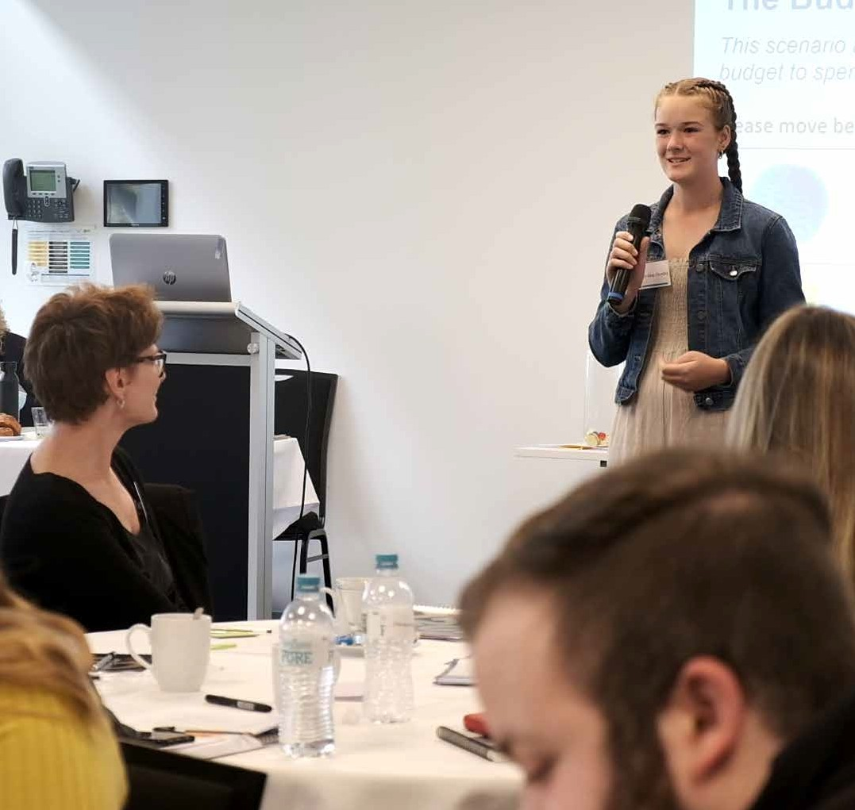Major
initiatives for 2021-25

The voices of the community have played a critical role in identifying and determining the priorities for the coming four years through the Council Plan Community Panel and broader community engagement. The Council Action Plan outlines in detail the full list of activities we will complete to work towards achieving our goals during the 2021-25 period. These actions are reviewed annually and can be found online at yarraranges.vic. gov.au

The most important initiatives and projects that Council will prioritise over the next four years include:

34 Yarra Ranges Council Pan 2021-25

1
2

Improve Aboriginal health and wellbeing by providing a range of supports to Oonah Health and Community Services Aboriginal Corporation to establish the Healesville Belonging Place, an integrated Aboriginal health facility.
Become a world class trails and eco-tourism destination through project development, delivery, advocacy and partnerships, including the delivery of the Rivers and Ridges projects.

3

Ensure the plants, animals and ecologies of Yarra Ranges that our community value so much are supported and retained alongside us in healthy landscapes, by preparing and implementing a Biodiversity Plan that provides renewed focus for Council, the community, and partners.

Reduce our ecological footprint through our commitment to source renewable energy generated by Council and extend benefits to community through advocating and securing funding to deliver on initiatives including Council’s Solar Farm project.
4

5
6

Improve mental health outcomes for the community, strengthen social connections, and advocate for equitable and accessible mental health services across the municipality.
Undertake and deliver integrated place planning for priority activity centres and town centres to achieve coordinated community outcomes across Yarra Ranges, in accordance with the Living Places Framework.

7

Build community resilience by working together to achieve greater emergency planning and preparedness with a focus on
traditional cultural burning practices.
This will include the development
a firestick program across public,
private land and local training hubs.

35

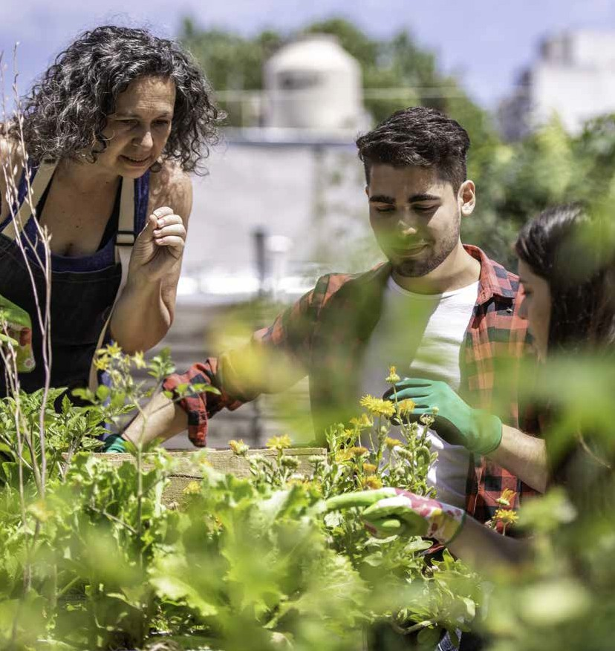

Connected and Healthy Communities

36

Communities are safe, resilient, healthy, inclusive and socially well connected. Quality services are accessible to everyone.

What the community values
The community values families, friends and neighbours, close knit communities and the support freely given to each other in towns. Community members value the way they help each other in times of need and how they work together to make our communities safe and friendly places to settle into, raise our families, care for and engage with our older residents.
They value our active spaces and healthy lifestyle and how it sustains them in both mind and body. They value their vibrant culture and their opportunities for creative expression. They value that no one ever needs to feel isolated or unable to be part of the diverse and inclusive community. They value the rich history that our older residents bring to community and what they offer to family life.

Our Vision for 2036
In 2036 Yarra Ranges is a wonderful place to live, and a world-class destination for visitors and investors who make a significant contribution to prosperity within the region.
Our community is proud of where they live. Their values are respected, they feel connected and they place health and wellbeing as a priority.
Educational facilities build the skills of our people and develop our leaders to strengthen communities and support local employment. Our community is passionate about where they live. They contribute their time, volunteering to support people in need, and their voice, providing feedback to Council about issues that impact them.
Through a local planning approach, the strength of local communities and their sense of place is enhanced, recognising they are diverse and have different needs to support their health, safety and wellbeing, while also embracing the commonalities they share in calling Yarra Ranges home.
Services are accessible, gender equitable and inclusive catering for all ages, genders and abilities. Our community is healthy and active, with easy access to recreational facilities and cultural activities that are available for everyone. Disadvantaged residents are well supported through partnerships between government, business and community organisations.

Connected and Healthy Communities 37

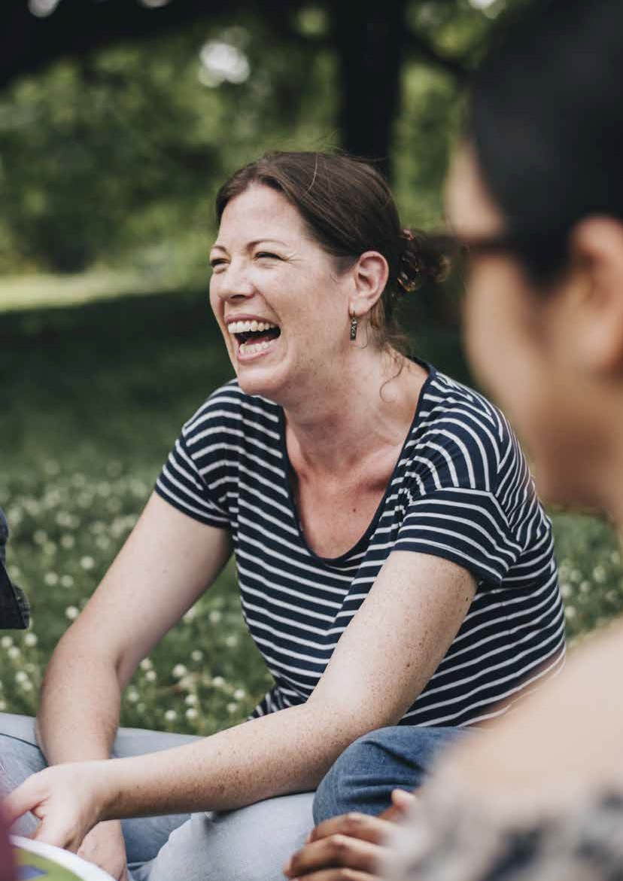

How we plan to achieve our objectives

38

Health and Wellbeing Plan - sets strategic direction for how Council works to support optimal health and wellbeing for its community. Council’s vision for health and wellbeing is that: Yarra Ranges has connected and healthy communities that are resilient, fair and inclusive. Our places are liveable and sustainable.
The new priorities of the Plan are: respond to public health impacts of emergencies, tackle climate change and its impact on health, increase healthy eating, increase active living, improve mental wellbeing and social connection, prevent violence against women and children and reduce harmful alcohol and drug use.

Measures of success Target by 2025

Healthy Eating - the annual rate of growth in the prevalence of diabetes in Yarra Ranges is reduced
Baseline data 2020 is 4.6%, desired rate of increase is maximum 10% per year, target is less than 5.1% for 2022
Maximum 10% increase per year

Physical Activity – there is an increase in the 5% increase from 2017 data
level of adults undertaking sufficient physical
activity prevalence of adults by 2023

Baseline data 58.4% 2017, target is to maintain 58.4% for 2020 and increase to
61.3% by 2023 data release No increase Prevention of Violence Against Women – the
rate of police callouts for family violence does not continue to increase

Baseline 1,084 per 100,000 in March 2021, target is rate of no more than 1,084 per 100,000 in subsequent years

Drug and Alcohol Harm - ambulance call outs for drug and alcohol

Baseline number is 382 in 2019/20 financial
year, target is less than 458 call outs for 2022
Mental Health – the rate of overnight admitted mental health-related population rates of separations does not grow by more than 5% per year
Baseline is 104.9 separations per 10,000
residents in 2018-19, target is 110 per 10,000 or less than 2019-20
20% or less

5% or less growth rate

Connected and Healthy Communities 39

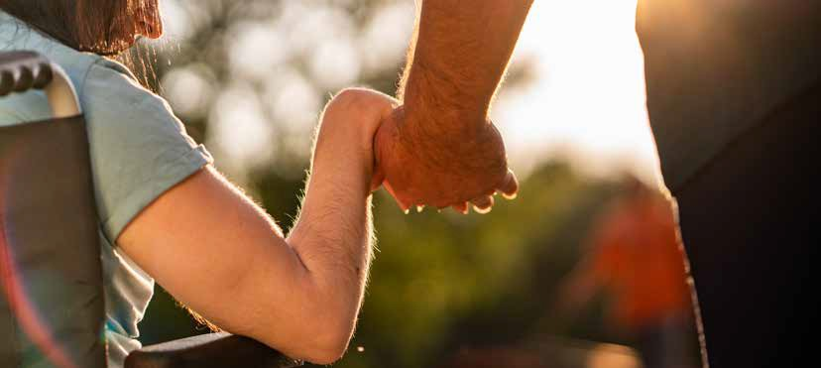Child and Youth Strategy
Aims to support and plan for the future of children, young people and their families. It ensures universal services are accessible and advocacy continues to address critical service gaps while delivering targeted support to those in the greatest need.

Creative Communities Strategy
Plan for creative places in the region that are reflective of distinct local cultural identity and diversity. It aims to shape Yarra Ranges as a place where arts, culture and heritage are part of our daily lives and integrated into the way we live.

Reconciliation Framework for Action
Aims to improve Indigenous health and wellbeing through increased participation in society and community life. Acknowledges and respects Indigenous culture and improves access to Council Services.

Community Safety Strategy
Aims to improve safety in Yarra Ranges through advocacy, leadership and collaborative partnerships and work with communities to build resilience. It aims to develop protection and prevention programs and establish the organisation’s readiness to activate, respond and assist in recovery.

Equity, Access and Inclusion Strategy
Outlines the way Council will work to create more accessible and inclusive communities that encourage participation by people with a disability in all spheres of life. It also encourages greater community and business participation in providing inclusive services and facilities.

40 Yarra Ranges Council Pan 2021-25

Some of the projects we will deliver
Services we provide
Supporting strategies, policies and management plans
- Implement Council’s Healthy and Active Age Plan
- Implement the Pandemic Recovery and Resilience Framework
For a complete list of projects and initiatives please refer to the Council Action Plan.

- Social planning and policy development
- Primary health planning and coordination
- Disability, inclusion and access services
- Food, health and environment inspections and protection
- Library services in partnership with Eastern Regional Library Corporation
- Maternal and child health and immunisation services
- Early years development planning
- Early childhood education and care (Pre-school, Child Care)
- Activities and programs that improve early childhood development
- Youth activities and programs
- Youth development programs
- School crossing supervision
- Animal management
- Community and cultural festivals and events grants program
- Cultural facilities including Yarra Ranges Museum
- Services and programs to increase participation in arts and culture
- Pandemic and storm recovery
- Community safety
- Fire prevention and emergency management
- Volunteer coordination
- Positive ageing services including respite, domestic assistance, transport and social support groups
- Indigenous programs
- Community engagement and development programs
- Recreation programs.
- Recreation and Open Space Strategy
- Housing Strategy
- Guiding Principles on Housing and Homelessness
- Municipal Strategic Statement
- Municipal Emergency Management Plan
- Community Engagement Policy
- Electronic Gaming Machine Gambling Policy
- Reconciliation Policy
- Festivals and Events Policy
- Community Volunteer Participation Policy.

Connected and Healthy Communities 41

Quality Infrastructure and Liveable Places

42

Quality facilities and infrastructure meets current and future needs. Places are well planned hubs of activity that foster wellbeing, creativity and innovation.

What the community values
The community values close connection to place. They value the spiritual connection, especially the traditional custodians of the land and place in Yarra Ranges, and the role in respecting these places, learning about them and preserving them for future generations. They value our “best of both worlds” location where they can access nearby services while living in a peaceful and natural environment.

Our Vision for 2036
In 2036 Yarra Ranges is a wonderful place to live, and also a world-class destination for visitors and investors who make a significant contribution to prosperity within the region.
Our community members are proud of where they live. Their values are respected, they feel connected and they place health and wellbeing as a priority.
‘Gateways’ into Yarra Ranges and other areas throughout the municipality now strengthen the identity of the First Nations people, their culture, stories, history and progress towards reconciliation. This connection strengthens our collective identity, our culture and heritage and creates a sense of belonging for our diverse community.
Advocacy for innovative and state of the art transport solutions has improved access to important community services, new and upgraded facilities, infrastructure and jobs.
The look and feel of our commercial and industrial areas, and their environmental characteristics, has improved. Our roads, paths and other infrastructure are well maintained. Our townships are designed to improve liveability and support health and wellbeing through improved footpaths, trails, lighting and infrastructure.

Quality Infrastructure and Liveable Places 43

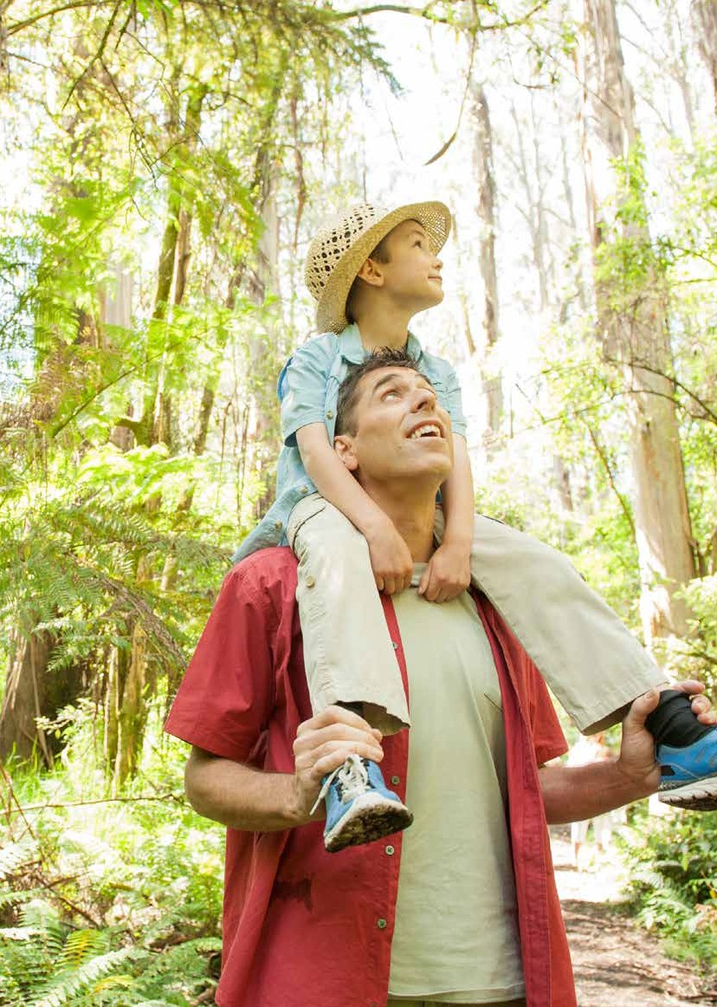

How we plan to achieve our objectives

4444

‘Connect’ - Integrated Transport Strategy - guides transport planning and decision-making over the next two decades to address the most pressing challenges and the big moves required to make getting around in Yarra Ranges more convenient, safer and more sustainable. This will include improved public transport, with better connections between modes (such as cycling, walking and public transport), better footpaths, more walkable neighbourhoods and cycling networks separated from roads to achieve a safer, healthier, more connected, sustainable and more inclusive Yarra Ranges.

Source: ABS Census data, baseline 2016 census
≥ 4% reduction
% of Car usage to travel to work (baseline 89%)
Target by 2025
Measures of success

% of Train/ Bus use to travel to work (baseline 7%)
% of walk to work (baseline 2%)
% of using a bicycle to travel to work (baseline 0.1%) Source: ABS Census data, baseline 2016 census
% of Car usage for non-work trips under 3km (baseline
75%) ≥ 6% reduction
Source: ABS Census data, baseline 2016 census
≥ 1.8% increase
≥ 0.8% increase
≥ 1.7% increase

% of Train/ Bus use for non-work trips under 3km (baseline 0.5%)
% of walk for non-work trips under 3km (baseline 24%)
% of using a bicycle for non-work trips under 3km (baseline 0.5%)
Source: ABS Census data, baseline 2016 census Number of trips by Car (baseline 87%)
Number of trips by Public Transport (baseline 3%) Number of trips by Walking (baseline 9%) Number of trips by Bike (baseline 0.6%)

Source: Victorian Integrated Survey of Travel and Activity Baseline data Journeys recorded in YRC 2018

≥ 0.6% increase

≥ 1.6% increase

≥ 3.7% increase

Reduce biennially in all measures

Quality Infrastructure and Liveable Places 45

Asset Management Strategy - Asset Management Strategy - guides improvement in Council’s asset management practices to ensure long-term management of its infrastructure assets is sustainable for current and future generations of the community.

Measures of success Target by 2025

Asset Management maturity rating score

Baseline 2021 maturity score = 900
Source: National Asset Management Assessment Framework measures asset management performance across 11 core areas of asset management competencies.
1,000 maturity level score

Municipal Planning Statement
Sets the strategic planning, land use and development objectives for Yarra Ranges and the strategies for achieving them. It is used as the basis for the use of zones and other land use controls within the planning scheme.

Recreation and Open Space Strategy
Plans for an active and healthy Yarra Ranges future providing quality and diverse sport and recreation facilities, parks and community spaces, activating our community spaces, supporting local sport and recreation clubs while protecting the environment and developing effective community and organisational partnerships. Sub strategies include: Skate/BMX strategy, Playground Development Strategy and the Yarra Ranges Tennis Plan.

Aquatics Facilities Strategy
Determines future needs, actions and priorities for aquatic facilities across the municipality.

Housing Strategy
Guides Council’s long-term planning to manage the future housing growth to best meet the needs of the community. It will ensure new housing is well designed, provides for housing choice and improves neighbourhood character outcomes in residential areas.

46 Yarra Ranges Council Pan 2021-25

Some of the projects we will deliver
- Activating, develop or construct community facilities
- Seal gravel roads in township across the municipality
- Complete the Lilydale Structure Plan
- Amend the Planning Scheme to align to the outcomes of the Housing Strategy
- Plan, facilitate and develop projects including Lilydale Revitalisation project, Kinley re-development and Level Crossing Removal
For a complete list of projects and initiatives please refer to the Council Action Plan

Services we provide
Supporting strategies, policies and
management plans

  - Maintenance and renewal of buildings
  - Management of facilities
  - Road, footpath and bike path construction and maintenance
  - Drainage works
  - Major Council building projects
  - Urban design including township and streetscape improvements
- Maintenance and redevelopment of sportsfields,
playgrounds and reserves
- Aquatics facilities
- Public transport advocacy
- Strategic land use policy development
- Planning permits, approvals and advice
- Affordable housing advocacy.
- Capital Expenditure Program
- Yarra Ranges Planning Scheme
- Community Hubs Policy
- Road Management Plan
- Vision 2020 By Design – Built Environment Framework
- Green Wedge Management Plan
- Township Structure Plans
- Place Plans
- Liveable Climate Plan
- Special Rates and Charges Policy
- BMX and Skate Park Strategy.

Quality Infrastructure and Liveable Places 47

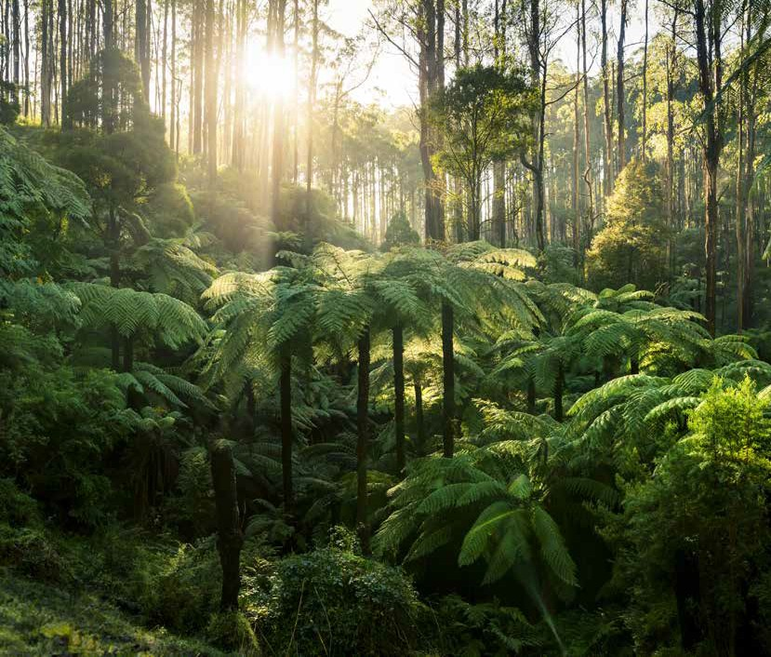

Protected and Enhanced
Natural
Environment

48

A healthier environment for future generations..

What the community values
The community values fresh air, clean rivers and streams, valley views and mountain vistas. They value the diverse and unique natural environment they live in, the many native plants and animals that inhabit it and the opportunities they have to ‘go bush’ in their backyard. They value our close connection to place. They value the spiritual connection the traditional custodians of the land have to place in Yarra Ranges, and the role in respecting these places, learning about them and preserving them for future generations.

Our Vision for 2036
The municipality’s natural beauty, stunning landscapes and reputation for exceptional local produce is enhanced, and have a significant influence on decisions made regarding sustainable growth and development in the region. A focus on responsible eco-tourism projects, access to digital services, networks and infrastructure and balanced economic development has enhanced the region’s reputation and improved quality of life for all.
Yarra Ranges places a high importance on sustainability and the protection of biodiversity and habitat. Regenerative farming practices are used to protect precious agricultural land that nourishes our community with access to healthy, locally grown food. The community has taken steps to actively mitigate against Climate Change and be prepared for natural disasters including bushfires planning.

Protected and Enhanced Natural Environment 49

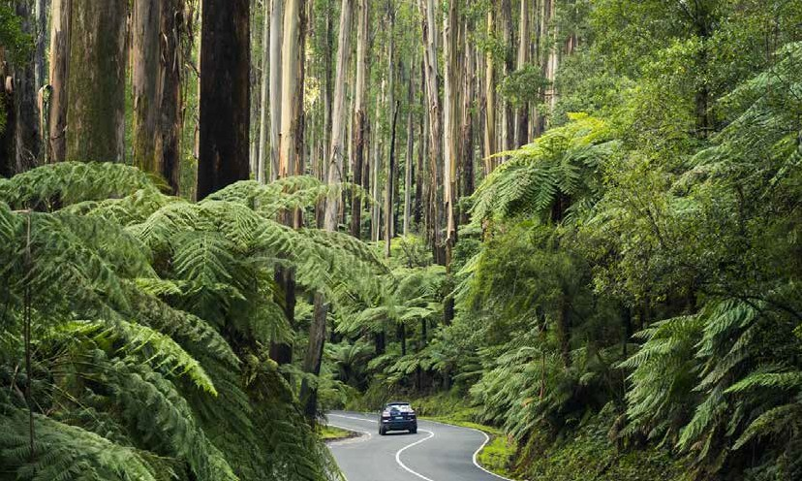How we plan to achieve our objectives

Environmental Strategy - improves the health and biodiversity of our natural environment through environmental best practice, supporting the future of agriculture and horticulture and reducing of resource and energy consumption to represent the best interests of our environment.

Measures of success | Target by 2025
Potable water use for irrigation, roads maintenance and
aquatics by 2025. | 25% reduction
Baseline data:
2018-19 – 190,635 & 2019-20 - 138,249

Customer satisfaction rating for environmental education targeted programs,

80% satisfaction score annually

Plants planted per annum to contribute to native
fauna habitat, increased property floristic diversity and 200,000 or greater agricultural productivity such as shade, shelter, windbreaks
on private property

Kilometres of roadside with bushfire fuel levels reduced 40km or greater
Increase habitat restoration through change in the
proportion of reserves from medium to high conservation 2% or greater annually status.

50 Yarra Ranges Council Pan 2021-25

Liveable Climate Plan - aims for Council be more efficient in using renewable energy, building resilient buildings, having a zero emission fleet, taking sustainable lifecycle approach to asset management and incorporate climate thinking in strategies, policies, programs and services
as we help the organisation and the community adapt to a changing climate. The plan aims to empower the community to be liveable and connected and focus on deliberate climate responsible services and programs including Living Landscapes, Food Security, Sustainable transport, thriving economy and adapting together as one community in the shift to a low carbon future..

Measures of success Target by 2025

Reduction of 60% of corporate greenhouse gas emissions on 2005 levels by December 2025, with a view to net zero by 2040.
2020 corporate emissions are estimated at 12,000 tCO2e

6,400 tCO2e or lower

Some of the projects we will deliver
- Implement actions of the Urban Tree Canopy Strategy
- Prepare and implement a Biodiversity Plan
- Develop a Municipal Waste Plan
For a complete list of projects and initiatives please refer to the Council Action Plan.

Services we provide
Supporting strategies, policies and
management plans

- Environmental education programs including a focus on schools
- Weed reduction and re-planting programs
- Biodiversity conservation
- Support for friends and Landcare groups
- Waste management services
- Community support to reduce impact and prepare for climate change.

- Green Wedge Management Plan
- Flora and Fauna Management Plan
- Waste Management Plan
- Recreation and Open Space Strategy
- Weed Management Strategy
- Integrated Transport Strategy.

Protected and Enhanced Natural Environment 51

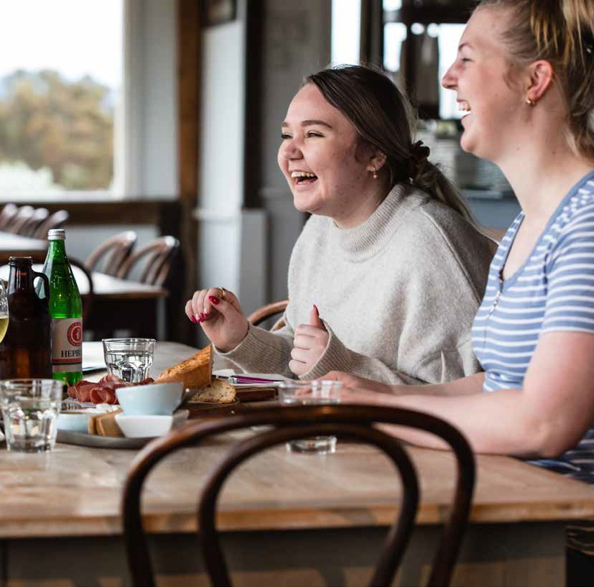

Vibrant Economy, Agriculture and Tourism
52

Our tourism, agriculture, health, manufacturing and other industries are leading and dynamic. Strong investment and attraction underpins sustainable economic growth and job creation.

What the community values
The community values the many wonderful attractions, as they live somewhere special that others come to visit and enjoy. They value our highly productive communities, our internationally recognised high quality produce and the opportunities to buy local and support local businesses.

Our Vision for 2036
In 2036 Yarra Ranges is a wonderful place to live, and a world-class destination for visitors and investors who make a significant contribution to prosperity within the region.
The municipality’s natural beauty, stunning landscapes and reputation for exceptional local produce is enhanced, and have a significant influence on decisions made regarding sustainable growth and development
in the region. A focus on responsible eco-tourism projects, access to digital services, networks and infrastructure and balanced economic development has enhanced the region’s reputation and improved quality of life for all. The look and feel of our commercial and industrial areas, and their environmental characteristics, has improved.
Educational facilities build the skills of our people and develop our leaders to strengthen communities and support local employment. Community
members are passionate about where they live.
‘Gateways’ into Yarra Ranges and other areas throughout the municipality now strengthen the identity of the First Nations people, their culture,
stories, history and progress towards reconciliation. This connection strengthens our collective identity, our culture and heritage and creates a sense of belonging for our diverse community.

Vibrant Economy, Agriculture and Tourism 53

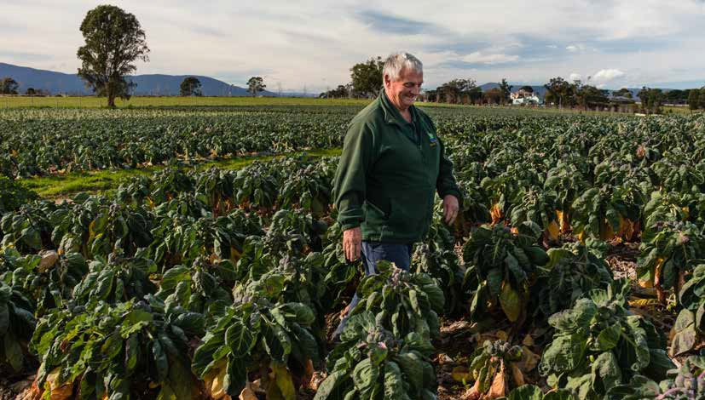How we plan to achieve our objectives

Economic Development Strategy - aims to improve the economic health and vitality of our communities through sustainable business practices and local job creation, increase accessibility to economic opportunities through improved transport, encourage investment, training and skill generation to attract new businesses to the region. The strategy will guide to Yarra Ranges to be i-ready and supports a low carbon economy and improves place based and investment outcomes in Yarra Ranges.

Increase annually
Growth in resident spend locally Baseline data: $1,188 million (May 2021)
Target by 2025
Measures of success

Growth in overall visitors spend locally Baseline data: $671m (May 2021)

Increase annually

Plants planted per annum to contribute to native
fauna habitat, increased property floristic diversity and 200,000 or greater agricultural productivity such as shade, shelter, windbreaks
on private property

Growth of international visitors in the Yarra Ranges and Dandenong Region
Baseline data: 14,000 - (December 2020)
Gross Regional Product - Increase the net wealth generated by the local economy influenced through employment, productivity and industry types in the area Baseline data: $6.7billion in 2021

Increase annually

3% or greater

54 Yarra Ranges Council Pan 2021-25

Some of the projects we will deliver
- Develop and deliver a network of recreational trails across the municipality
- Deliver initiatives in the Bayswater Business Precinct Transformation Strategy
- Develop a cultural and creative brand for the Yarra Ranges to attract and retain creative professionals, creative businesses and cultural tourism spend.
- Review our Economic Development Strategy and Investment Attraction Plan, to help create more local jobs and drive local investment.
For a complete list of projects and initiatives please refer to the Council Action Plan.

Services we provide
Supporting strategies, policies and
management plans

  - Dedicated Business Concierge – Priority Investment
Process and Small Business Office
  - Strategic Connections and Business Networks
  - Access to training programs and sustainable business practices
  - Facilitate tourism development and regional marketing
  - Agribusiness support and development
  - Jobs Portal – connecting local employers and jobseekers.

- Green Wedge Management Plan
- Reconciliation Framework for Action
- Child and Youth Strategy
- Liveable Climate Plan.

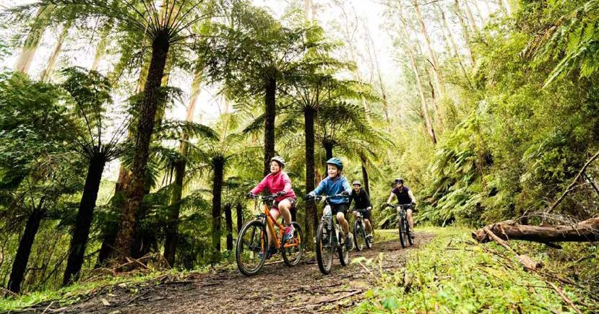
55

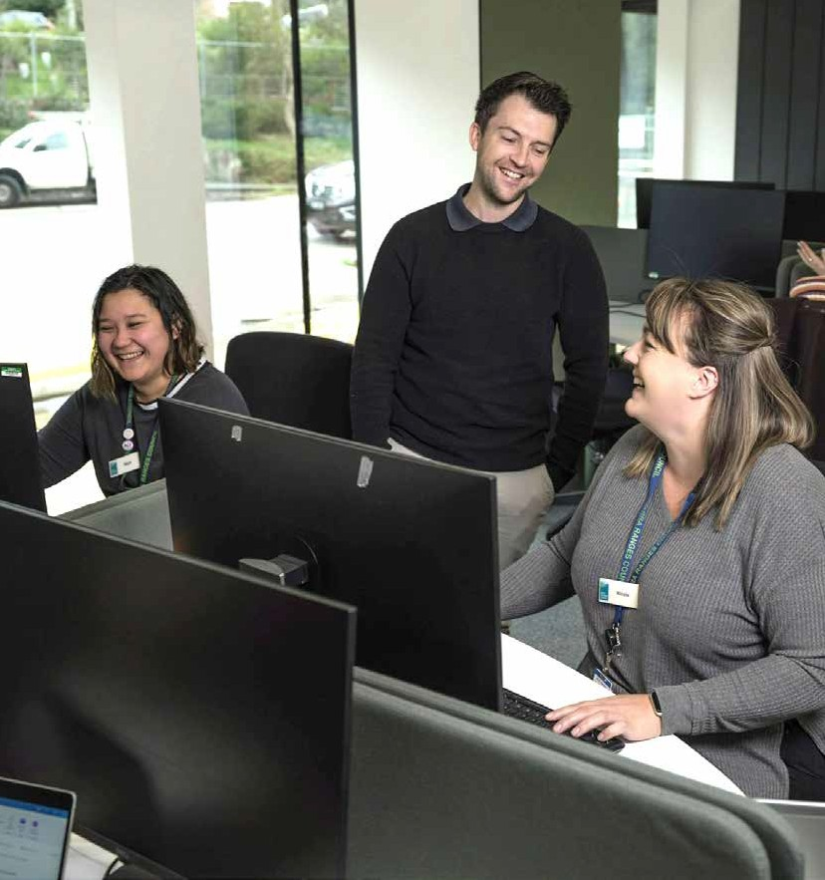

High Performing Organisation

56

An innovative, responsive organisation that listens and delivers quality, value for money services to our community.

Our commitment to the Community Values Statement
Council recognises the Values Statement as the collective voice of the Yarra Ranges community. Council will ensure that these values remain at the forefront of all its decision making and that it informs Council’s planning and advocacy for the future.

Our Vision for 2036
At the heart of our vision is an authentic desire for Council to engage and listen to all members of our community, including our young people, and respond to their needs and aspirations. We are visible, transparent, accountable and communicate clearly and honestly.
Council resources are managed responsibly, and principles of fairness and consistency are applied to avoid unnecessary burdens for rate payers.
Through expertise, insight, technology and creativity, Council is a leader in delivering best practice services for the community. We inspire people to create a better future

High Performing Organisation 57

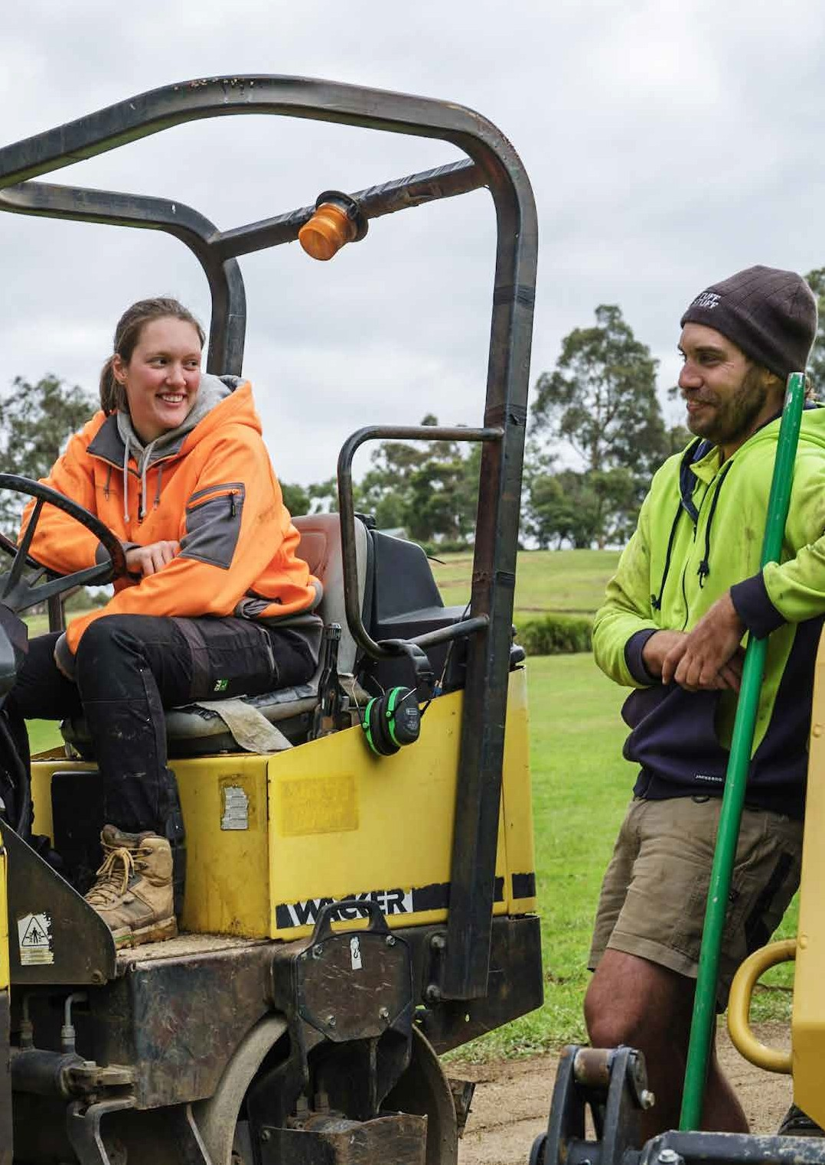

How we plan to achieve our objectives

5588

‘YR Ignite’ - High Performing Organisation Strategy - aims to build a dynamic and flexible organisation that supports thriving communities. It supports the organisation to do things differently, with a focus on the way we operate. With a focussed on the way we operate. How to improve listening to our community and our people; recognising the value of working collectively and collaboratively. This strategy will help build our strategic capability and our operational systems to improve our decision making, our services and ultimately the health, diversity and strength of our community. This will be achieved
through establishing structures, systems, technologies, processes and the right resources needed to deliver our objectives in the Council Plan.

% increase in Council’s Maturity Model Assessment in:
Target by 2025
Measures of success
  - Building a great culture
  - Leadership that achieves outcomes
  - Focus on community and customer
  - Individual’s performance and accountability via their performance development plans
  - Information Technology systems and data management maturity
Source: Yarra Ranges Maturity Model Assessment

Increase annually

Number of lost time injuries incidents 11 or fewer
Customer satisfaction with Yarra Ranges Council Source: Yarra Ranges Customer Satisfaction Score
Increase annually

Increase in gender equity and diversity inclusion amongst YRC staff
Source: Yarra Ranges Employee Alignment and Engagement Survey

Increase annually

High Performing Organisation 59

People and Culture Strategy
Builds organisational and leadership capacity through a leadership framework to ensure the right people are in the right roles at the right time and using modern systems that are integrated, flexible and support business partnering.

Communication and Engagement Strategy
Plans and develops proactive and strategic communication activities to build capacity, harness social media platforms and electronic messaging and the promotion of the Yarra Ranges brand.

Information and Communication Technology Strategy
Aims to modernise technology to move towards ‘any device, any time, anywhere’, mobilising users and improving processes.

Health and Safety Strategy
Supports the strong committed leaders, systems and programs to ensure a safe work environment for staff who are healthy, informed and engaged in safe work practices.

Customer Experience Strategy
Reviews, improves and evaluates how we deliver customer service to all of our community through our people, systems, processes and technology.

60 Yarra Ranges Council Pan 2021-25

Some of the projects we will deliver
- Streamline internal Council processes and improve systems to deliver more efficient services
through the Equip Program.
- Increase the community’s visibility, understanding of and access to Council’s information and performance.
- Build community capacity to be active in achieving community outcomes.
For a complete list of projects and initiatives please refer to the Council Action Plan.

Services we provide
Supporting strategies, policies and
management plans

- Communications, advocacy and media relations
- Community engagement
- Dedicated community contact centre
- Front line customer service through our five community
link centres
- Financial management and reporting
- Procurement, contracts and tendering
- Corporate planning and performance
- Information technology and records management
- Rating and valuation services
- Council governance and meeting procedures
- Occupational health and safety
- Human resources, employee relations and organisational development
- Risk management, insurance and assurance.

- Financial Plan
- Councillor Expenditure and Donation Policy
- Election Period Policy
- Legislative Compliance Policy
- Social Media Policy
- Community Engagement Policy.

High Performing Organisation 61

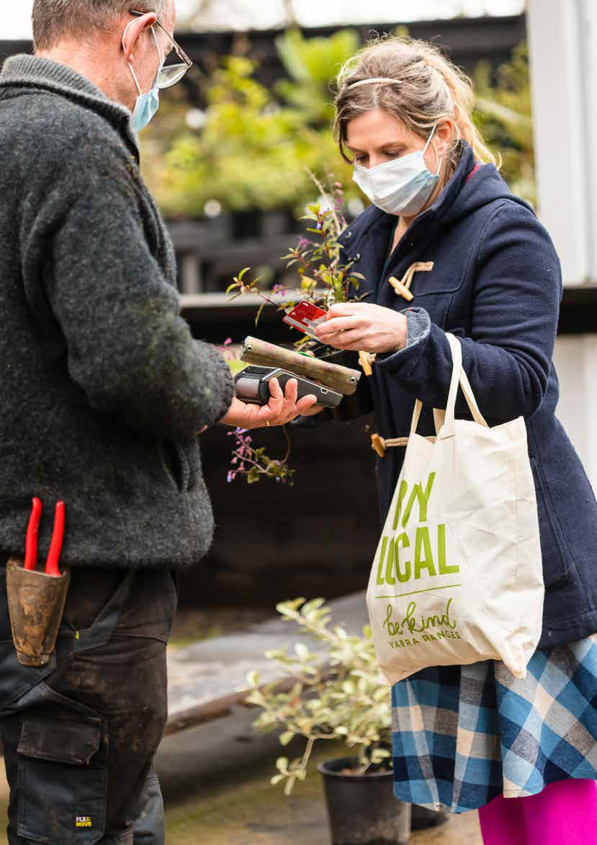

6622

Council Action Plan
The Council Action Plan contains the activities that Council will do over the next four years to deliver on the Council Plan. These activities include the key priority projects that the Council has identified as the most important and a list of activities and projects that will deliver on the five strategic objectives and the long term vision for the municipality. The Corporate Action Plan is an attachment to the four year Council Plan and is reviewed annually to ensure what we do is still relevant to providing high quality services that meet the needs of the community.

Copies and further Information
Copies of the Corporate Action Plan are available as hard copies or online.
All strategic documents to support the delivery of the strategic objectives are available in hard copy and in electronic format on Council’s website at: www.yarraranges.vic.gov.au or by contacting 1300 368 333.

63

64

Contact Information

Community Links Lilydale
15 Anderson Street

Healesville
110 River Street

Monbulk
21 Main Road

Yarra Junction
2442-2444 Warburton Highway

Upwey
40 Main Street

National Relay Service
133 677 - for callers who have a hearing, speech or communication impairment and for Text Telephone or modem callers

1300 555 727 - for callers using Speech to Speech relay

9658 9461-TTY

Translation and Interpreting Service 131 450 Translating and Interpreting Services (TIS) National. An interpreting service is available if required.

Chinese Simplified (Mandarin)
如需要，可拨打全国翻译服务处 (TIS) 的电话131 450 提供口译服务。
Chinese Traditional (Cantonese)
如需要，可撥打全國翻譯服務處 (TIS) 的電話131 450 提供傳譯服務
Chin Hakha
Holhlet na herh ah cun Translating and Interpreting Services (TIS) kha 131450 ah chawnh in hlohleh rian tuawn nak kha hman khawh a si

Dutch
Indien nodig kunt u onze tolken- en vertaaldienst Translating and Interpreting Services (TIS) bellen op 131 450 om
met een tolk te spreken

Italian
Un servizio di interpretariato è disponibile, se richiesto, contattando i Servizi di
traduzione e interpretariato nazionali (TIS)al numero 131 450

65

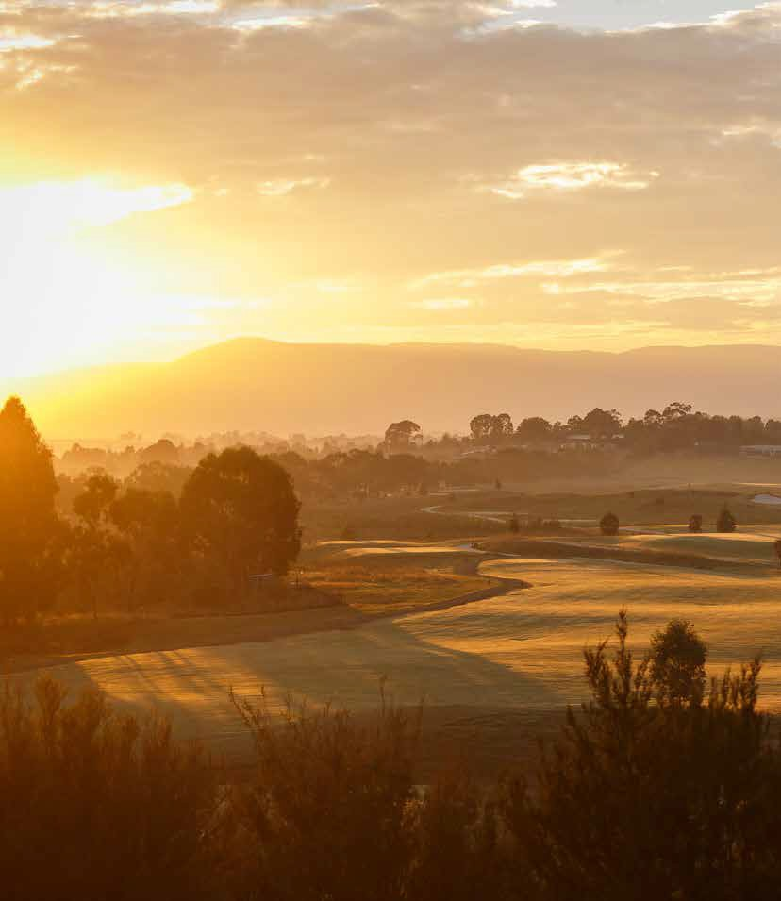

Yarra Ranges Council PO Box 105
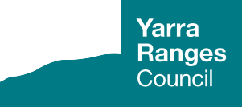Lilydale VIC 3140

1300 368 333 | mail@yarraranges.vic.gov.au yarraranges.vic.gov.au

