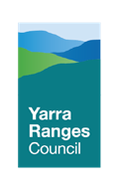
COVID-19 PANDEMIC
RECOVERY FRAMEWORK

Contents
Executive Summary 2
Recovery Framework 2
Purpose 3
Background 3
Vulnerable members of the community 3
National principles for disaster recovery 4
Council’s Values and Commitments 4
Council’s Role in Recovery 5
Recovery Objectives and Outcomes 5
Economic Recovery Outcomes 6
Objective 1 6
Objective 2 6
Objective 3 7
Social Recovery Outcomes 8
Objective 1 8
Objective 2 8
Objective 3 9
Recovery Governance 10
Pandemic Recovery Governance Structure 10
Recovery Implementation 10
COVID Recovery Fund 11
Monitoring Evaluation and Reporting 11
Communications 12
References 12
Appendices 13

MARCH 2021

Executive Summary
The Yarra Ranges COVID-19 Pandemic Recovery Framework (the Framework) is intended to shape Council’s approach for short, medium and long term activities to support the economic, social and health impacts of the COVID-19 pandemic.
The complexity of recovery in the context of a Pandemic is exacerbated by the protracted nature of the public health emergency, the continuing threat of outbreaks and community infection, the restrictions on how people live and work and the significant role of all levels of government.
As such, the likely impacts and needs will change over time and a cautious and considered approach is required to ensure Council’s efforts to support communities is best targeted with greatest effect.
Yarra Ranges Council’s approach to COVID-19 recovery has been, and will remain staged, using best practice recovery principles underpinned by Council’s vision and 2021-24 Council Plan (under development).
This staged approach, supported by ongoing collection and analysis of up to date, gender disaggregated data, will help Council to understand and respond to the known and emerging impacts of COVID-19; the activities that will best address the changing needs of our communities and contribute to long term resilience building. It is also possible that if any future outbreak led to a further prolonged lockdown which impacted Yarra Ranges then there could be a return to an earlier stage.
At the time of finalising this document the Yarra Ranges is in Stage 2.

Stage 1 March 2020 to October 2020

Stage 2 November 2020 to November 2021

Stage 3 From November 2021

Recovery Framework

3-6 Months
Short Term Recovery
Ongoing relief support
Impact data analysis
Recovery Planning
Community Connection
6-12 Months
Medium Term Recovery
Coordinate recovery
Community Led Activities
Resilience Focus
Proactive Advocacy
1-4 years
Long Term Recovery
Resilience Outcomes emerging
Community Strengths
Evaluation measures monitored

Purpose
The purpose of this Framework is to:
- Define recovery outcomes that support the development of short, medium and longer term recovery activities; and to
- Provide a process for the effective evaluation of these activities to understand their contribution towards intended outcomes.

Background
This document was initially developed as the Yarra Ranges ‘Early Recovery Framework’ in May 2020. It is based on a first round of impact and needs assessment information which was collected from residents, organisations, businesses and official data sources such as the ABS.
When Victoria experienced a second wave, resulting in significant stage 3 and stage 4 lockdowns, a second round of data was collected. This information was brought together in the Yarra Ranges COVID-19 Detailed Report (November 2020) and subsequent Yarra Ranges COVID-19 Impact Report Executive Summary Update (November 2020), and provided Council with an updated insight in to broad and localised impacts. Further refinement of the early Framework and the high-level recovery outcomes within it was then undertaken and is presented in this document.
Throughout the course of recovery planning, Council has remained committed to:
- The need for ongoing community impact and needs assessment – mapping of vulnerabilities and identification of those most impacted over time, through consistent collection of gender disaggregated data, will continue to help validate our recovery timeframe over which it is reasonable to expect the desired outcome ‘targets’ to be reached or achieved.
- An outcomes driven approach – which has focussed recovery programs around common notions of success and the types of activities that will help achieve it; as well as providing a clear and consistent understanding of what recovery programs should achieve and how these achievements are best evaluated for target communities
- Incorporating realistic recovery timeframes - for some recovery outcomes it is not possible to observe a significant change within a short period of time. Indicators and standards for change need to be mindful of what is “realistic” change and can be observed at different times.

Vulnerable members of the community
This framework will recognise and identify groups in the community that are vulnerable or are experiencing vulnerability and who are most impacted by the pandemic. This includes people with disability, people experiencing domestic violence and homelessness.

Further information is needed to better understand the way in which the pandemic is affecting those most impacted. Council recognises that women, men and gender non- binary people are impacted in different ways and the need to understand the way in which COVID-19’s gendered impacts are influenced by other important factors such as Aboriginality, age, disability, ethnicity, gender identity, race, religion and sexual orientation.

National principles for disaster recovery
Yarra Ranges Council supports and adopts the National Principles for Disaster Recovery, which are underpinned by Council’s own vision. These include the following principles:
Understand the context. Successful recovery is based on an understanding of the community context, with each community having its own history, values and dynamics.
Recognise complexity. Successful recovery responds to the complex and dynamic nature of both emergencies and the community.
Use community-led approaches. Successful recovery is community-centred, responsive and flexible, engaging with community and supporting them to move forward.
Coordinate all activities. Successful recovery requires a planned, coordinated and adaptive approach, between community and partner agencies, based on continuing assessment of impacts and needs.
Communicate effectively. Successful recovery is built on effective communication between the affected community and other partners.
Acknowledge and build capacity. Successful recovery recognises, supports and builds on individual, community and organisational capacity and resilience.
Recognising vulnerable groups. Successful recovery recognises emerging vulnerable groups including young people, the older workforce, newly homeless and women experiencing family violence.

Council’s Values and Commitments
Council has a number of values and commitments that will underpin recovery outcomes and subsequent activities. This includes our commitment to reconciliation, gender equality, preventing child abuse and inclusion and the following legislative obligations:
- Gender Equality Act 2020 - It is a legislative requirement under the Gender Equality Act 2020 that Council assesses the needs of persons of different genders when developing or reviewing a policy, program or service which has a direct impact on the public.
- Victorian Equal Opportunity Act 1995
- Victorian Disability Act 2006
- Age Discrimination Act 2004 (federal)
- Victorian Child Wellbeing and Safety Act 2005
- Victorian Child Youth and Family Act 2005
Council’s approach to recovery will be inclusive and resilience focused. Council will take account of gender; recognising that successful recovery recognises and responds to the gendered impacts of disasters. It will also take account of the needs of people who are vulnerable or experiencing vulnerability, as well as hard to reach groups in the approach to recovery. This includes its approach to ongoing impact assessment, decision-making, activity design, implementation of initiatives, communication, and evaluation to maximise participation and potential, and to increase economic, social and community resilience. (Checklists have been provided in this document to assist - refer to Appendices)

Council’s Role in Recovery
Under Victorian emergency management arrangements Council is responsible for co- ordination of recovery at the municipal level. As the level of government closest to community, Council is well placed to connect and work with affected communities.
As part of recovery planning for the COVID-19 pandemic, Yarra Ranges Council will support community recovery activity through:
- Advocacy
- Providing Council services ( recognising Council’s essential service provision to prioritise, enable and support community recovery)
- Promoting the work of our partners and others
- Enabling and supporting our community partners
- Facilitating connection between community and community services
Yarra Ranges Council will consider the needs of the most affected or impacted sectors of our community throughout the recovery phase of COVID-19.

Recovery Objectives and Outcomes
Below are the intended areas of outcome focussed recovery for COVID-19 under the Economic and Social (including Health) recovery environments. These outcomes are informed by the Australian Institute of Disaster Resilience (AIDR), Recovery Monitoring and Evaluation Framework. They are a guide to be monitored and adapted by the Yarra Ranges COVID-19 Recovery Committee as required.
Council recognises the diverse mix of individuals and household types that make up the Yarra Ranges community. This includes women, men and gender non-binary people, and single and co-parenting families.

Economic Recovery Outcomes

Objective 1
Members of the Yarra Ranges community can meet their material and service needs and participate in the economy.
Supporting Data:
- The number of JobSeeker or Youth Allowance recipients decreased in the Yarra Ranges in January 2021 (6.5 per cent) compared with December 2020 (7.3 per cent). However, it is anticipated that there is likely to be a spike in JobSeeker recipients following removal of JobKeeper payments at the end of March 2021.
- 35.9 per cent of businesses in the Yarra Ranges have active JobKeeper applications as at November 2020. This ranks Yarra Ranges 10 out of 79 local government areas in Victoria, suggesting that a relatively high proportion of businesses may experience financial difficulties once JobKeeper support ends at the end of March 2021.
Key Outcomes
- Impacted members of the community and businesses have access to an adequate
- range of goods and services.
- Impacted community members have sufficient financial security to allow them to take advantage of economic opportunities.
- Community members have access to banking and financial support services.
- Vulnerable groups are prioritised in terms of their ability to participate in the economic system (e.g. employment prospects, accessing credit) and not further disadvantaged.

Objective 2
Businesses, organisations and industries in the local economy can operate and trade in line with broader economic trends.
Supporting Data
- Travel restrictions and other social lockdown measures are forecast to decrease the Yarra Ranges Gross Regional Product (GRP) by -11.4% by the end of March 2021 (compared to a -8.3% contraction for Victoria Gross State Product).
- Businesses in the Yarra Ranges have some job shortages due to increase demands and deficiencies in specific skills/qualifications. For example, aged care and personal care are experiencing a shortage of qualified staff. Many older workers who have lost their jobs do not have computer literacy putting them at risk of not finding work.
- Some Yarra Ranges businesses have reported telecommunication issues (slow data speeds and poor connectivity) as well as being unable to source supply chains that have been lost due to overseas suppliers being shut down.
Key Outcomes
- Consumer and business confidence levels support business operations (both within and outside of the community).
- Business models are appropriately adaptive to market conditions and fluctuations.
- Impacted businesses and organisations have information they need to operate safely and continue to recover from the pandemic.
- Businesses have the capacity and capability to continue operation.
- Businesses and not for profits can access or attract appropriately skilled workers
- Business and not for profits have access to critical banking and financial services.
- Community service organisations and business can continue to provide regular services to vulnerable community members.
- Vulnerable businesses have secure and stable access to supply chains and networks (including markets, physical infrastructure and assets, and telco networks).

Objective 3
The economy is sufficiently flexible and adaptable to shocks.
Supporting Data
- For September 2020, the number of jobs based in Yarra Ranges dropped by 7.6%, with 3,178 jobs lost. Most businesses surveyed (95%) had been impacted by the pandemic, and this impact was significant for more than half of businesses engaged.
- A lack of diversity in business types may make some areas more vulnerable to the pandemic. Townships with a high reliance on tourism and hospitality (e.g. Healesville, Warburton, Belgrave) have reported a disproportionate impact as a result of the pandemic.
Key Outcomes
- Economic activity is appropriately diverse.
- Yarra Ranges labour force have transferable skills.
- Models of innovation and entrepreneurship exist.

Social Recovery Outcomes

Objective 1
Community members have access and can meet health, wellbeing and safety needs (including mental health) arising from the pandemic
Supporting Data
- Within the month of June 2020, the number of active mental health patients in Yarra Ranges increased by 90%, from 5,096 to 9,683.
- EDVOS statistics indicate that prior to the pandemic, 30% of their clients engaged with EDVOS for the first time. This figure doubled to 60% during stage 3&4 restrictions. EDVOS also reported that between March and June 2020, referrals and consultations from universal services increased by 20%.
Key outcomes
- Community health levels are appropriate for the community profile.
- Existing health clients receive continuity of their care e.g. health services continue.
- Community members have the knowledge, skills and resources for dealing with health, wellbeing and safety issues related to the pandemic experience.
- Vulnerable community members can access appropriate services and support to deal with health, wellbeing and safety needs.
- Community members can continue to access family violence support services
- Vulnerable community members receive priority support to address excessive stress and hardship arising from the pandemic.
- Mental health is supported through social connection and sense of belonging is high

Objective 2
Impacted households, families, and individuals can act autonomously to contribute to their own recovery outcomes.
Supporting data
- Telecommunications – Yarra Ranges Council received 1,627 internet speed tests between September and November from residents and businesses. This information was gathered in response to ongoing commentary from the community about the poor internet service they have experienced during the pandemic. Given the increased need by the community and businesses for reliable and fast internet during the pandemic, this data will provide the evidence base to support Yarra Ranges positioning for an advocacy program.
- Recent data for Yarra Ranges shows a 30% increase in mental health video conference consultations and an 18% increase in mental health telephone consultations, for the twelve months to June compared to the twelve months to May. The general demand for telehealth services rose by 51% for video consultations and 282% for telephone consultations between March and May 2020. These figures illustrate a shift in demand from face to face consultations to on-line and telephone consultations.
- Service providers were concerned about difficulties with online delivery, including lack of engagement with Zoom classes; and difficulty in providing telehealth services to people with complex needs.
Key outcomes
- Impacted households, families, and individuals have the information needed to make decisions.
- Impacted households, families, and individuals are enabled to affect their own recovery through appropriate supports and income sources.
- Impacted households, families, and individuals have access to digital tools and platforms.

Objective 3
Community members feel sufficiently safe and secure following the pandemic to engage in social activities and interactions with other members of the community.
Supporting data
- Council snapshot data collected in August 2020 identified youth homelessness as a prominent theme. The youth development team had received direct contact regarding six local young (aged 16 to 23) people in need of emergency support in one week which is very unusual.
- Providers of homelessness services in the Yarra Ranges have indicated that generally there has been less required of them during pandemic with many of the homeless being housed. The State Government provided funding to house around 2,000 homeless people across Melbourne during the pandemic. However, there are concerns from the homeless sector that some people will be forced back onto the streets when the program is due to end in April 2021.
- There is a significant concern among local service providers surrounding on-going funding and resource issues, e.g. lack of resources to develop grant applications, increase in demand, loss of volunteers, loss of income to pay recurring costs and general funding needs.
- Service usage reduces during lockdown - flow on to escalation of issues and deferred referrals for children / young people experiencing mental health and disabilities.
Key outcomes
- Risks for community transmission of COVID-19 minimized.
- Community members can manage their own safety.
- Community members are confident in returning to daily community activity.

Recovery Governance
To support the identified recovery outcomes and ensure their success, an emphasis on effective recovery coordination within Council and the broader municipality is a high priority. With 55 townships and settlements across Yarra Ranges impacted by the COVID-19 public health event, effective co-ordination of recovery will aim to reduce duplication of effort and community fatigue.
Yarra Ranges will co-ordinate recovery through the Yarra Ranges COVID-19 Pandemic Recovery Committee, chaired by the Pandemic Recovery Manager. The Recovery Committee will be supported by the Pandemic Management Team and reports to Council’s Executive Leadership Team (see figure 2). Updates will be provided to Council, members of the Yarra Ranges Municipal Emergency Planning Committee (MEMPC), Yarra Ranges Municipal Relief and Recovery Sub Committee and emergency partners at the regional and state level. Reporting arrangements may evolve as medium to long term COVID-19 recovery activities emerge.
The governance structure below, recognises Council’s organisational recovery focus and provides the opportunity to connect and identify Council service delivery priorities that can effectively support community recovery outcomes. This connection will allow for Council service areas to prioritise recovery activities across the medium to long term recovery stages.

Pandemic Recovery Governance Structure
Executive Leadership Team
- Pandemic Management Team: Public health, Communications, Monitoring, Evaluation, Research, Administrative Support
- Organisational Recovery Structure
- COVID-19 Pandemic Recovery Committee
- Social Recovery Sub Committee – Project Working Groups
- Economic Recovery Sub Committee – Project Working Groups
- Recovery communications Campaign Team

Recovery Implementation
Given the scale of impact the COVID pandemic has had on the Yarra Ranges community, it is essential that all recovery activities initiated and supported by Council are understood, providing us with opportunities to collaborate and coordinate for the most effective implementation.
The following diagram outlines how Council intends to operate internally to support the range of Recovery activities occurring within Yarra Ranges and across Council as many departments will need to adapt services to ensure Council is meeting community needs during this time

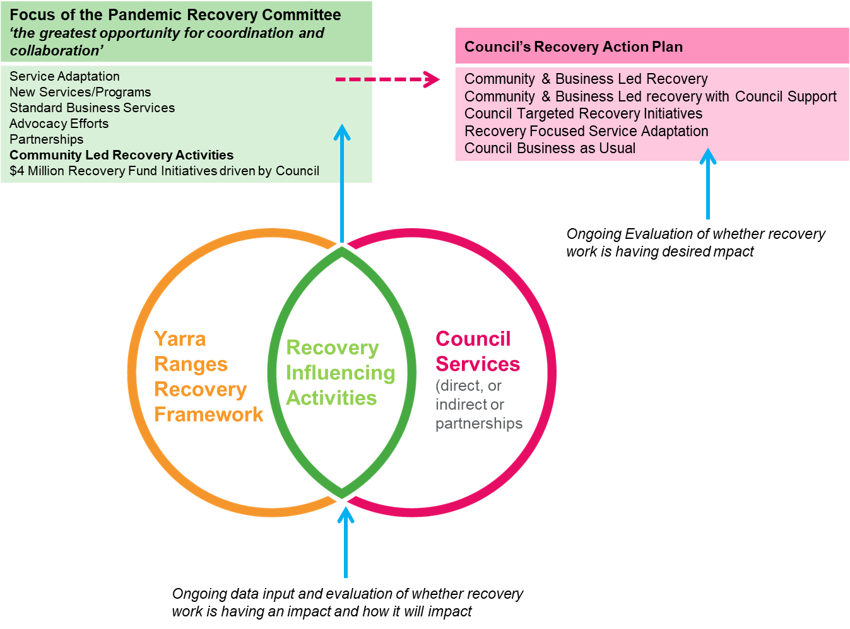

COVID Recovery Fund
The 20-21 Council Budget has provided for a $4 Million Recovery Fund to support community recovery. The COVID-19 Recovery Fund Process provides officers with guidance on their roles and responsibilities in managing the funding of community recovery initiatives and establishes clear expectations in the key areas of the process for funds approval and reporting.

Monitoring Evaluation and Reporting
A program logic approach will be used to help monitor the ongoing impacts of recovery activity. This will include development of key performance indicators that guide evaluation activities. This approach will enable Council to monitor the effectiveness of COVID- 19 recovery programs and modify them accordingly.
Working groups will report to each sub-committee with consolidated reports provided to the Pandemic Recovery Committee on a regular basis. Council will receive a report on a monthly basis.
Reporting will capture new and emerging information relating to the impacts of the pandemic, as well as the impact of Council programs and actions taken in relation to COVID recovery in Yarra Ranges over the short, medium and longer term. .This will enable action and service adaptation over the next four years.

Communications
Council will develop and implement a Recovery Communications Plan to keep our communities, partners, Councillors and staff informed about what is being done, why it is being done, when it is being done and what the intended outcome is.
Council's Communication Plan will build on best practice principles of effective communication in recovery by:
- establishing a two-way dialogue where possible and seeking input and feedback during the recovery program;
- ensuring information is accessible to diverse audiences by using a range of media and using existed and trusted channels;
- where appropriate, ensuring communication is coordinated and consistent with relevant organisations;
- repeating key messages in order to maximise the reach to community members whose receptiveness to information will vary; and
- providing relevant, timely and targeted information that supports capacity building and empowers the community and individuals to influence their own recovery.

References
- COVID-19 Impact Report Executive Summary Update Dec 2020
- Yarra Ranges Municipal Relief and Recovery Plan, 2020
- AIDR, Recovery Monitoring and Evaluation Framework, 2018

Appendices

Checklist to ensure diversity, gender and safety is reflected in Council’s approach to community recovery

The following checklist will be used to guide the Yarra Ranges Council Pandemic Recovery Committee in ensuring recovery planning (including impact assessment), activity design and evaluation processes consider the needs of vulnerable, newly vulnerable and harder to reach members of the Yarra Ranges community.

General
- Have you investigated the demographics and characteristics of the communities affected by disaster to inform recovery planning and activity design?
- Have you identified and included, where practical, community leaders and members who are representative of Aboriginal communities, age groups, people with a disability, ethnic groups, gender identities, race, religions, sexual orientations?
- Do you have strategies for including and supporting people with carer responsibilities so they can fully participate in consultation and activities?
- Have you identified strategies to ensure that messaging reaches those most in need?
- Is the COVID communications to community accessible to people from a CALD background or in plain English?

Gender
- Have you identified ways to involve a representative group of women, men and gender non-binary people in all aspects of emergency management?
- Have you consulted with community leaders that are representative of women, men and gender non-binary identities?
- Have you considered the social, cultural and economic restrictions on women that prevent them from effectively engaging with disaster decision-making?
- Have you developed means to always collect gender disaggregated data, particularly in the context of observing who turns up to public meetings, workshops, events and who is accessing recovery support systems and services?
- Do you offer gender-identification options of woman/man/gender non-binary (meaning intersex/unspecified/undetermined) in written forms (including evaluation forms) and ask self-identification questions in verbal interviews (ie. how would you describe your gender?)
- Have you collected, or do you have access to, gender-disaggregated data for analysis, reporting, activity design and evaluation?
- How have the specific needs of men, women and gender non-binary people been considered in activity design?
- Have you identified people in your organisation with gender expertise to advise where necessary on design and review of activities?
- Have you reviewed (and updated) communications and resources, and checked for references to gender stereotypes or assumptions about capability based on gender?
- Have you provided gender and family violence response training and education to employees and volunteers working in design and implementation of emergency recovery actions?
Safety and Wellbeing of Children and Young People
- Are the voices of children and young people included in engagement, planning and evaluation processes?
- Are governance and staff members responsible for recovery aware of Council's Child Safety and Wellbeing Policy and trained in Child safety?
- Are key Recovery/ frontline staff able to identify if a child is at risk or showing signs of abuse or neglect and know where and how to report?
- Do all front-line staff have adequate screening including current WWCC?
- Are all planned activities and events planned to acknowledge the specific needs of the following children/ young people?
    - the cultural safety of Aboriginal Children
    - the cultural safety of children from culturally and/or linguistically diverse backgrounds
    - the safety of children with a disability.

*Checklist questions are based on questions outlined in the Gender and Emergency Management Action Checklist, designed by members of the Gender & Disaster Pod, an initiative of WHGNE, WHIN & MUDRI

