# PRIORITY 1: RESPONDING TO PUBLIC HEALTH EMERGENCIES – THE PANDEMIC AS A CASE STUDY

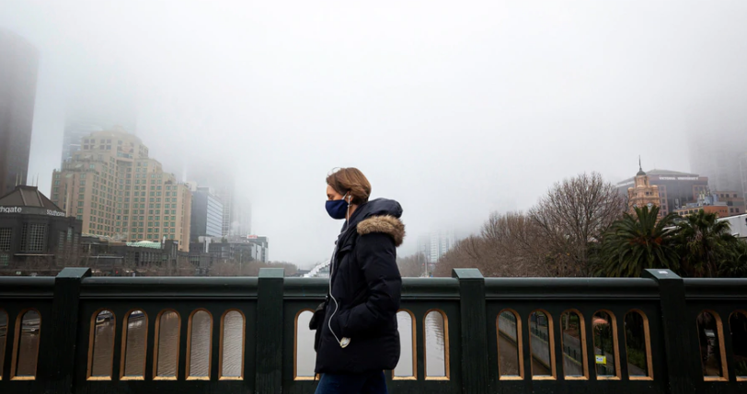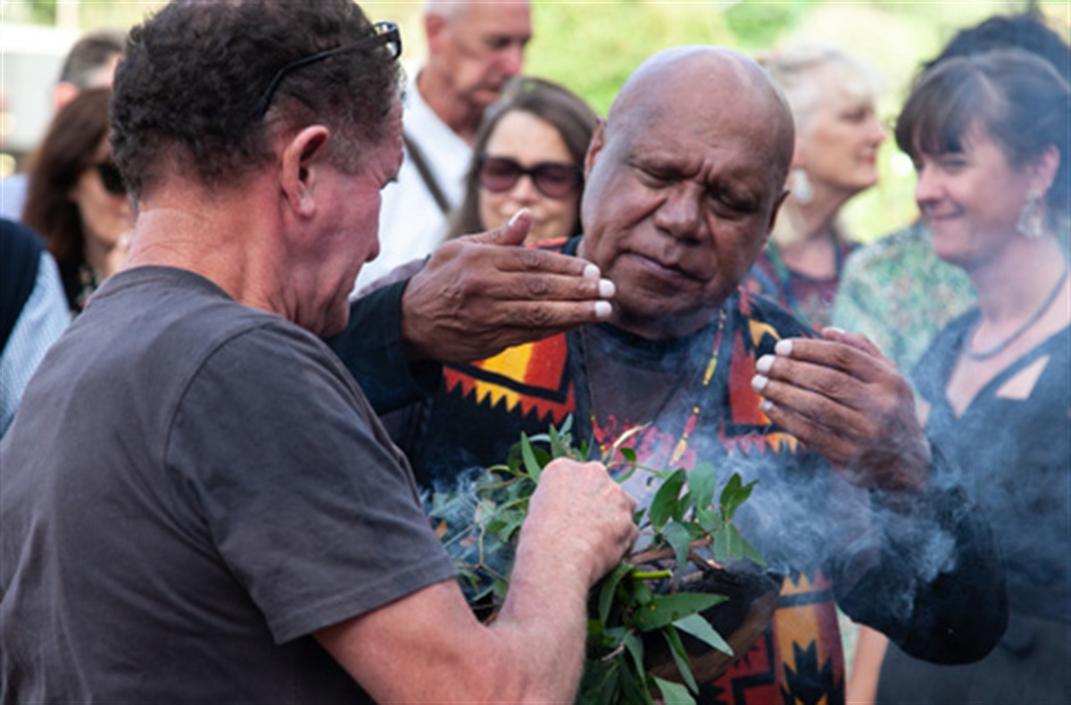

#### Why are we increasing our focus on public health emergencies?

2020 has seen first severe bushfires, and then the emergence of a global pandemic which saw Victorians spend many months of the year in lockdown. The COVID-19 pandemic has had a range of impacts on physical and mental health, lifestyle behaviours, and access to health services. Some of these will prove to be short-term, but some may lead to long-term changes in behaviour or have long-term health impacts. Those who were in bushfire-affected areas were more affected by the impacts of lockdown. Issues such as the health impacts of public health emergencies such as the pandemic and climate change, healthy lifestyles and mental health are inextricably linked, and central to Council’s work on supporting community health and wellbeing.

#### The health and wellbeing impacts of COVID-19

The main immediate impacts included:

* Increased mental health issues – including increased emergency department presentations for self-harm, especially amongst young people; increased hospital admissions for mental illness; a massive increase in calls to mental health crisis support lines and website access, particularly in Victoria; increased use of mental health services; and increased mental health prescriptions.
* Reduced hospital use for chronic diseases, including respiratory illness, diabetes, heart attack and stroke. There was a large decrease in cancer screening and cancer reporting, and reduced ambulance call-outs for heart attack and stroke. These conditions are major causes of death, so if not identified earlier these conditions could lead to a higher level of preventable deaths.
* Changes in service access, including reductions in elective surgery and increased use of telehealth. Nearly one third of Medicare-subsidised mental health related services, delivered between March and September 2020, were delivered via telehealth.
* The main immediate effects included increased mental health issues as shown by growth in calls to crisis lines and use of mental health services.
* Increased use of prescription medications for mental health and respiratory conditions.
* Increased accidents in the home and increased injuries to children on bikes; but reduced motor vehicle accidents.
* The main social and mental health impacts include low levels of life satisfaction, lack of connection to other people, difficulties staying connected with friends or family, and strained relationships within households.
* Lifestyle impacts include reduced exercise amongst many respondents, much higher daily consumption of sugary drinks and much lower vegetable consumption. The data on whether alcohol consumption has increased considerably is mixed.
* 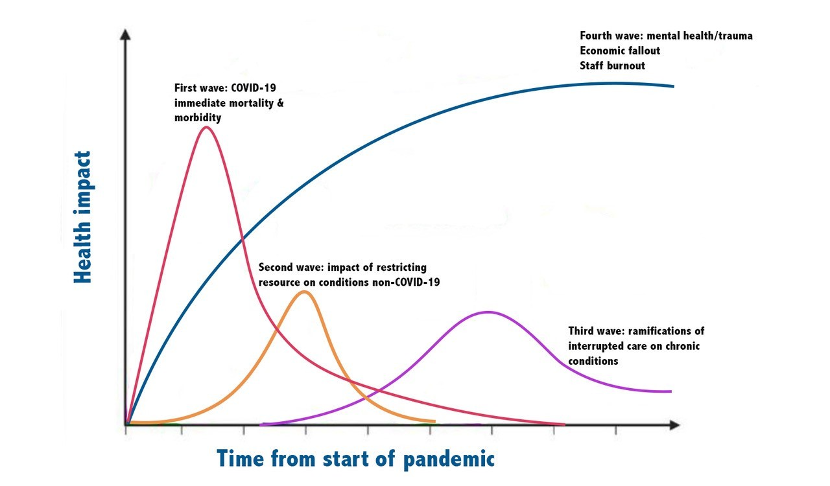There were a range of financial impacts, including general financial hardship and needing to ask for financial help; much higher food insecurity and reliance on cheap unhealthy foods; concern about future employment and housing security; and inability to pay housing costs and bills on time.

Respondents from Interface areas on the edge of metropolitan Melbourne were more likely to find it hard or very hard to stay connected to friends and family than those from across Victoria. They were much less likely to be exercising most days of the week, compared to residents of inner metropolitan Melbourne. They had a significantly higher level of reliance on low-cost unhealthy food due to financial issues, a higher level of other food security impacts, and the lowest level of vegetable consumption of any region.

#### Who was most affected?

Women, young people and indigenous Australians were particularly affected by the health and wellbeing impacts of lockdown. Victorian women lost jobs at nearly 5 times the rate of men in July 2020, and currently have an employment rate nearly 50% higher than men’s.

Young people aged 18-24 suffered worse impacts in terms of mental health, employment and financial impacts, food security, and social connection. Indigenous residents also impacted more, with much higher levels of psychological distress, financial hardship, alcohol harm and food insecurity. Gender inequity increased across Victoria in terms of gender roles, with women being the ones spending the most time helping children (72% of women).

#### Local impacts

In September 2020, Council conducted a survey of nearly 170 Yarra Ranges residents about the impacts of the pandemic and the resultant lockdown. It found that social isolation and mental health were by far the main areas of impact. The key issues for those surveyed were social isolation (nearly 70%) of respondents; and mental health of respondents (nearly 50%), their families (44%) and their children (35%). Relationship strain was also an issue for nearly 20% of respondents. Twenty-six percent of respondents had contacted mental health services for assistance.

Other health and wellbeing concerns included:

* Lifestyle issues including reduced physical activity and healthy eating, and increased alcohol consumption.
* Remote learning, and concerns about the ongoing educational impacts on children who had fallen behind, particularly those with disabilities or special needs.
* Job loss and reduced hours. Twenty-eight percent of individual survey respondents had applied for JobKeeper or JobSeeker, and 16% had sought financial assistance.
* Parenting and caring responsibilities, and being available for children.

The pandemic has seen a rise in mental health patients living in Yarra Ranges. Between the twelve months to May 2020 and the twelve months to June 2020, the number of active mental health patients in Yarra Ranges increased by 90%, to nearly 10,000 people.

#### What can Council do?

Council is developing a COVID Recovery Framework, which will outline its planned responses to the pandemic, along with further work on measuring the local impacts.

Unlike other health priority areas, there is limited information on evidence-based responses to the impacts of a global pandemic and lockdown.

For recovery from both the pandemic, and for other potential public health emergencies (e.g. bushfires), supporting mental health and community resilience are key spheres of activity.

Research done so far on minimising harmful outcomes has found that increasing mental health service capacity, increasing community connectedness (including via working in a workplace, sports and social gatherings), employment and youth education programs, and increasing income and employment levels, are key focus areas to aid recovery. Council has a role in responding to various factors forecast to contribute to the pandemic’s health and wellbeing impacts, including:

* Supporting community connection in as many ways as possible, e.g. through community clubs and sport.
* Focusing on economic development, particularly to mitigate job losses, and to support work, education and re-training for young people.
* Advocating for increased access to essential service, supports and infrastructure - particularly mental health services, affordable housing, income support and emergency relief.

As social connection is one of the key determinants of mental health, Council policies and programs designed to promote a sense of belonging, increase awareness and acceptance of diversity, prevent violence, and build community resilience, can all support mental wellbeing.

Council is also involved in a range of work to support healthy eating and being physically active, areas which have been negatively impacted during lockdown.

#### Sources:

* <https://www.theage.com.au/national/victoria/calls-for-female-focused-budget-as-women-face-financial-gender-disaster-20200815-p55m0e.html>
* <https://www.abc.net.au/news/health/2020-08-01/cancer-costs-covid-19/12508230>
* <https://www.theage.com.au/politics/federal/the-year-in-health-covid-19-sees-surgery-backlogs-cancer-screenings-dip-and-crisis-calls-soar-20201216-p56nvu.html>
* <https://insightplus.mja.com.au/2020/30/suicide-deaths-forecast-for-13-7-increase/?utm_source=InSight%2B&utm_campaign=34f6153416-EMAIL_CAMPAIGN_2020_07_31_05_27&utm_medium=email&utm_term=0_7346f35e23-34f6153416-43048133>
* Victorian Health Promotion Foundation (2020). VicHealth Coronavirus Victorian Wellbeing Impact Study, Report for survey #1: How the first coronavirus lockdown impacted the health and wellbeing of Victorians. Retrieved from <https://doi.org/10.37309/2020.PO909>
* The Age (2020). *More cash to boost Victorian mental health services as lockdown takes toll.* Retrieved from <https://www.theage.com.au/politics/federal/more-cash-to-boost-victorian-mental-health-services-as-lockdown-takes-toll-20200816-p55m93.html>
* <https://www.theage.com.au/national/victoria/victoria-records-394-new-covid-19-case-17-deaths-20200809-p55jz4.html>
* The Conversation (2020). *Victorian emergency departments during COVID-19: overall presentations down but assault, DIY injuries up* <https://theconversation.com/victorian-emergency-departments-during-covid-19-overall-presentations-down-but-assault-diy-injuries-up-144071>

## <https://www.aihw.gov.au/suicide-self-harm-monitoring/data/covid-19>

## <https://www.aihw.gov.au/getmedia/b31ddb3e-712e-4c04-bab3-24846046951e/COVID-2.pdf.aspx>

## <https://www.aihw.gov.au/news-media/media-releases/2020/december/how-covid-19-changed-the-way-australians-used-heal>

* <https://www.aihw.gov.au/reports-data/australias-health-performance/looking-back-on-health-in-2020>
* Yarra Ranges Council (2020). Data analysis of results from *Be Kind survey of individuals in Yarra Ranges, September 2020*
* Department of Health and Human Services (2019). Improving mental wellbeing. Retrieved from: <https://www2.health.vic.gov.au/about/health-strategies/public-health-wellbeing-plan/mental-health>

# PRIORITY 2: TACKLING CLIMATE CHANGE AND ITS IMPACTS ON HEALTH

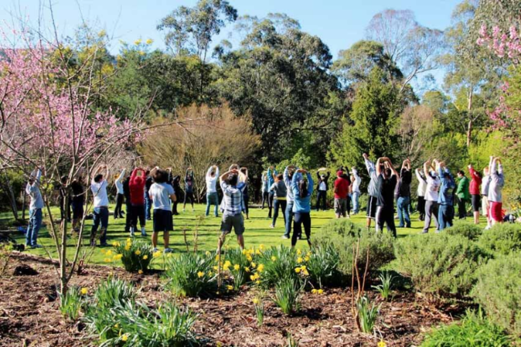

Local government is identified in the Climate Change Act 2017 as a decision maker which must consider climate change when preparing a municipal public health and wellbeing plan. Tackling climate change and its impact on health is one of four priorities identified as a focus area for action in the Victorian Public Health and Wellbeing Plan 2019-2023; and is an indicator for the Plan’s desired outcome that “Victorians belong to resilient and liveable communities”. Under the Public Health and Wellbeing Act 2008, councils are required to have regard to the state plan when preparing their public health and wellbeing plans.

#### Why are we increasing our focus on climate change?

Climate change has been identified by the World Health Organisation as the leading threat to public health in the 21st century. Victoria’s climate has become hotter and drier over the past few decades. Over the next thirty years, climate is forecast to lead to increased average temperatures, increased high-heat days, increased high fire danger days, increased sea levels, reduced snow and more intense rainfall. The effects of these changes will include increased intensity and numbers of extreme weather events such as heatwaves, bushfires, drought and floods; accompanied by indirect effects on water quality, food safety, air quality, changes in land use, and changes in the ecology and biodiversity.

#### How does climate change affect population health?

Climate change has a range of potential direct and indirect health impacts. The direct health impacts are predicted to include deaths, injuries and ill-health due to respiratory diseases, cardiovascular diseases, infectious diseases, mental health issues, allergies, injuries, poisoning, dehydration and malnutrition. There will also be a range of indirect impacts, such population displacement, increased food insecurity and socio-economic impacts. Food security has already become a growing health issue during the 2020 lockdown, alongside mental health.

Action to mitigate climate change is essential to reducing these impacts. Yarra Ranges Council’s work on climate change mitigation is capture in its Liveable Climate Action Plan. However, local government also needs to focus on supporting community adaptation, as a certain amount of climate change is now inevitable due to the current and future impact of past human activity (e.g. population growth, increased emissions).

Council has the opportunity to use activities in the areas of mitigation and adaptation to also achieve health co-benefits (see diagram below). Actions in this areas both reduce negative impacts on our environment, and promote physical health and wellbeing.

#### Climate change and the determinants of health

Climate change is expected to both impact the major determinants of health, including socio-economic status, education, housing, transport, food security, social capital and social connections. People will also suffer from different levels of impact depending on many of these factors (e.g. income, housing security) and also individual factors such as age, gender and indigenous status.

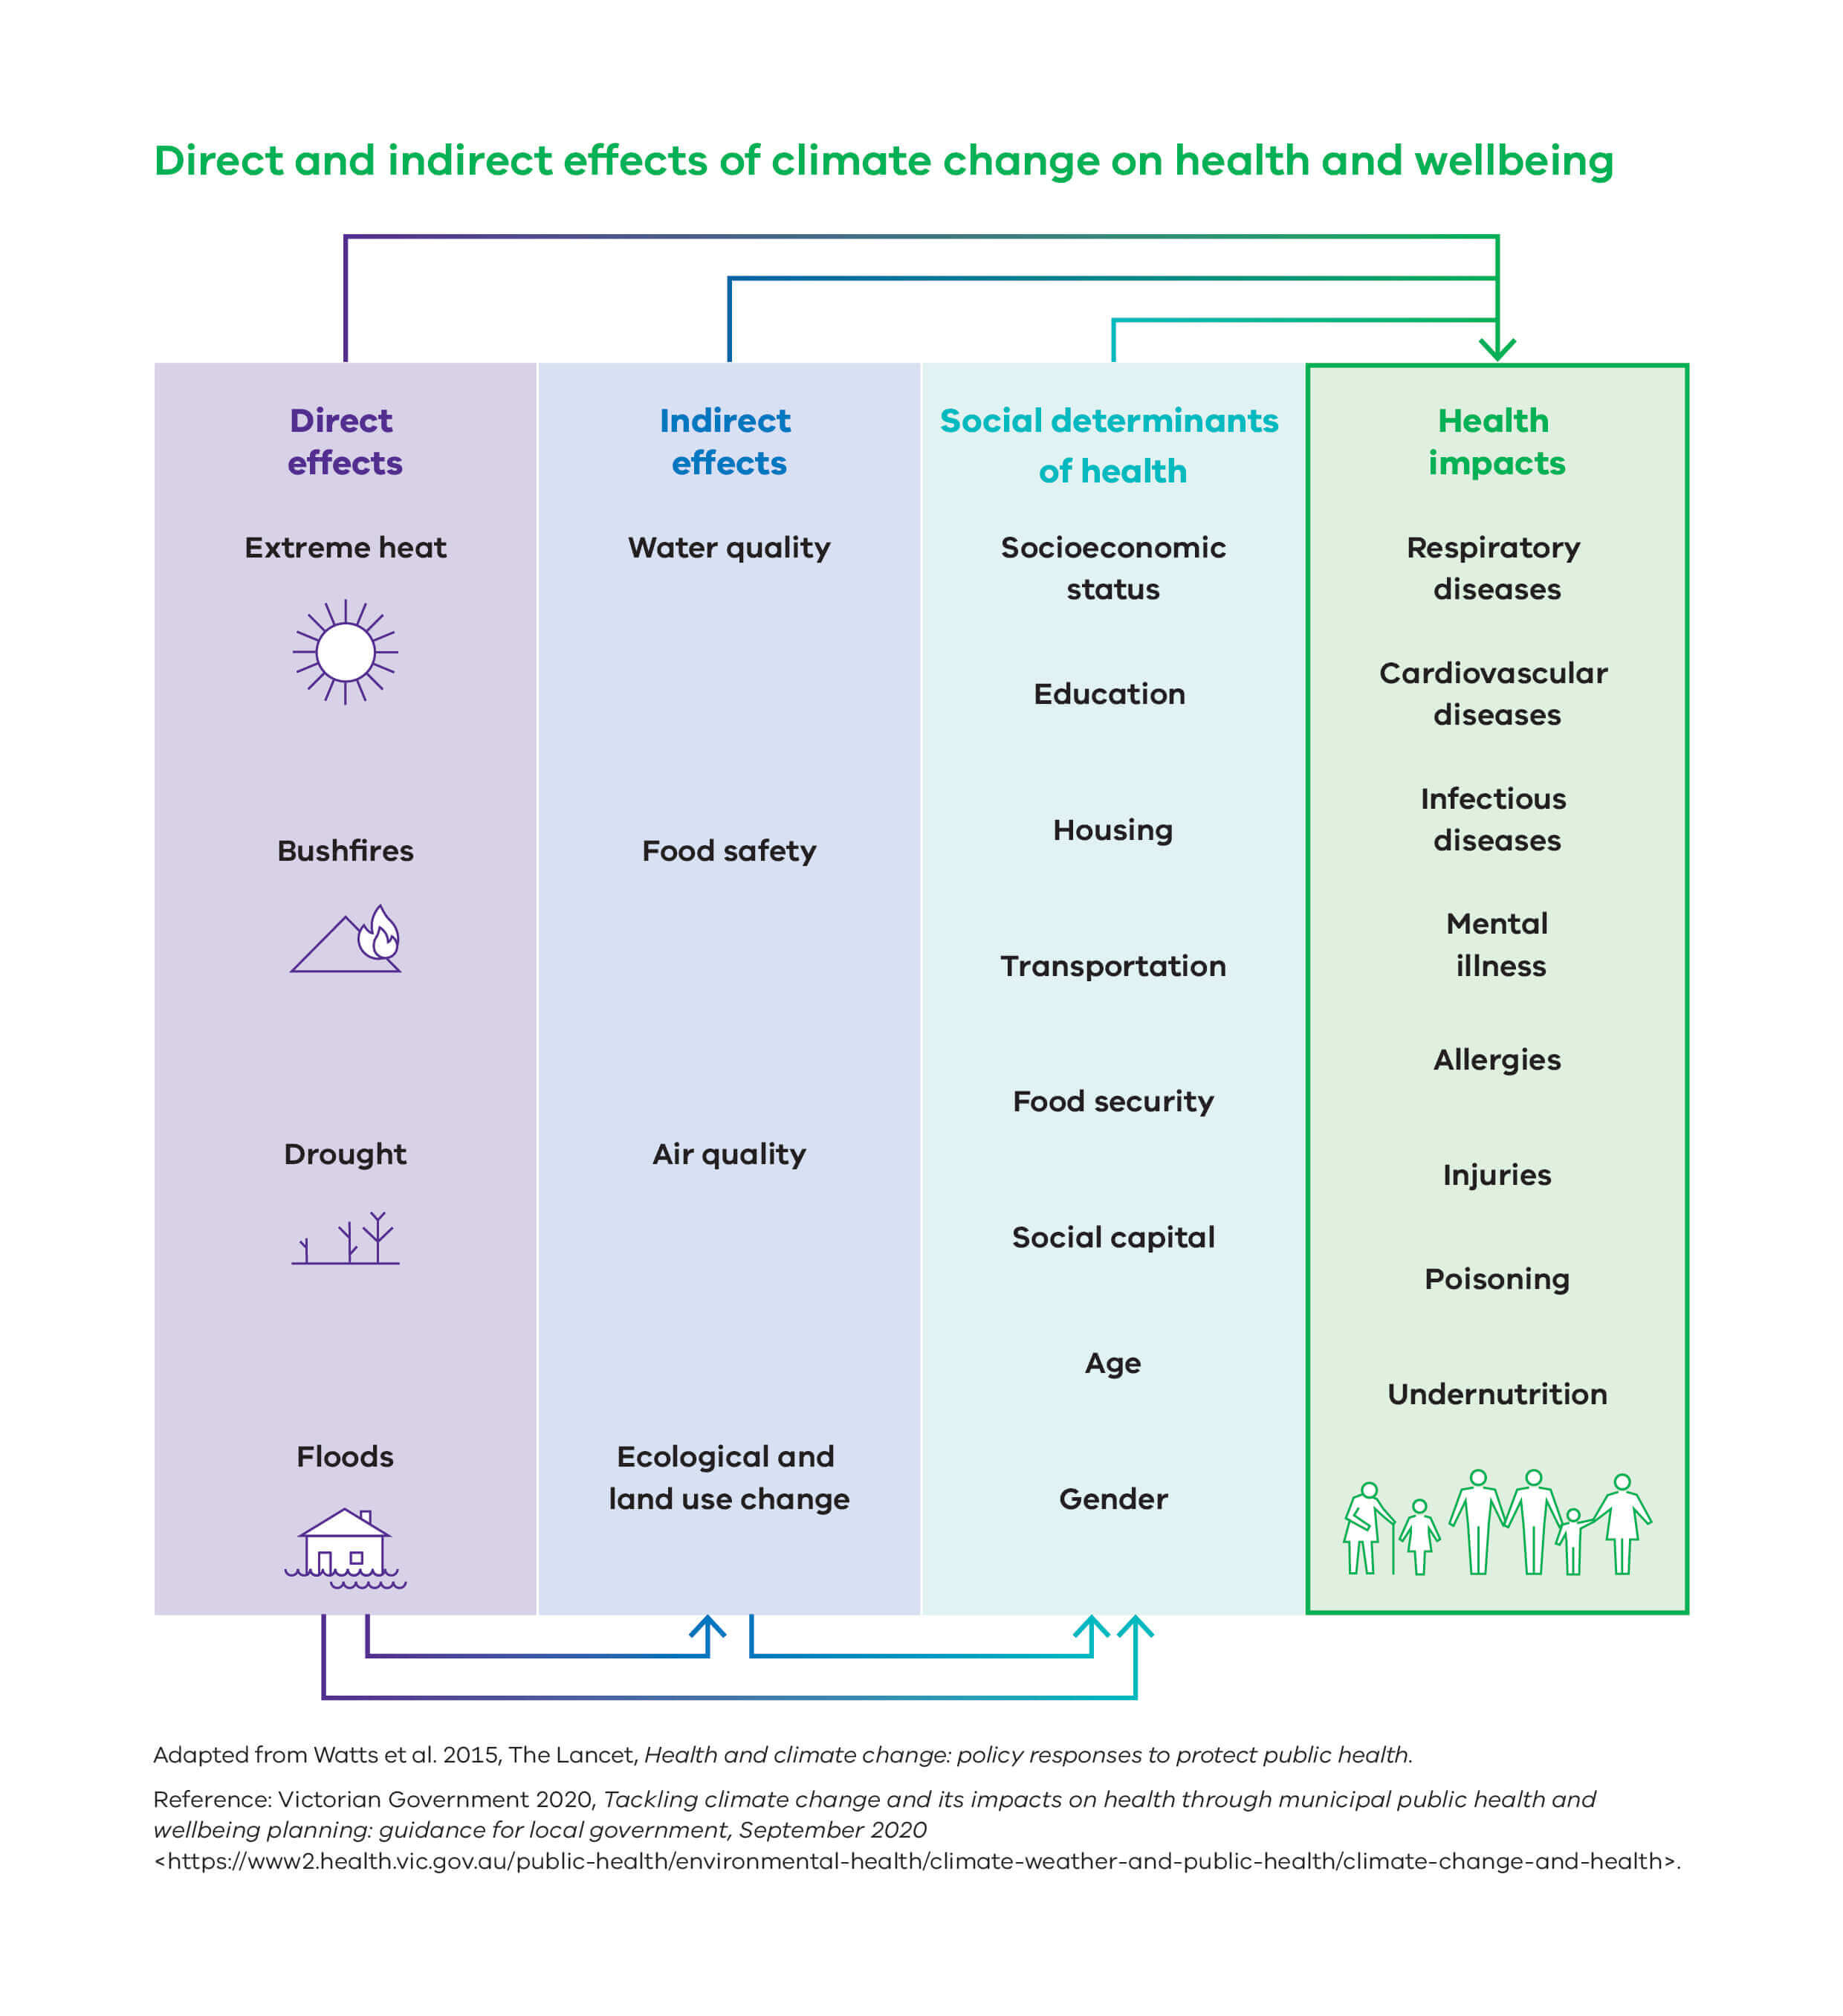

#### What can we do?

Implementation guidance has been released to accompany the Victorian Public Health and Wellbeing Plan.[1] This identifies evidence-based strategies which can be used by local governments to increase active living, and the types of actions which can be used to support these strategies.

Climate change mitigation is critical to preventing the most significant public health impacts of climate change, and there are many initiatives that can be implemented by local government to both mitigate the impacts of climate change and improve health.[2]

##### Health co-benefits

Measures put in place to mitigate and adapt to climate change will not only help to reduce the direct and indirecthealth impacts of climate change, but will also have health “co-benefits” in terms of improving health risk factors. E.g. using active transport to reduce emissions involves increased physical activity; consuming food which involves less packaging and processing, will support healthier eating patterns, and reduced obesity and high blood pressure.

#### What have we done?

Yarra Ranges Council has already taken a number of the actions identified as necessary to incorporating climate change into health planning. Council has

Put climate change and its impact on the community on the agenda for Council and the community - through declaring a Climate Emergency; developing a wide-ranging Liveable Climate Action Plan, following on from community and internal consultation about climate issues; and recognising its legislative and moral imperative to tackle climate change and its impact on health.

* Identified climate change as a key health and wellbeing priority for Yarra Ranges.
* Included information on current and potential impacts of climate change on community health and wellbeing, within the health and wellbeing profile which informs the health plan.
* Begun to work with key stakeholders to identify how Council and the community can work together to support a healthy sustainable food system, a priority linked to both health and climate change, and with clear health co-benefits.

The consultation and community engagement process for the health and wellbeing plan will work to identify community, stakeholder and Council perceptions relating to the impacts of climate change on community health and wellbeing. The development of the health and wellbeing plan will include strategies and actions to assist mitigation of and community adaptation to the impacts of climate change, as these specifically relate to health impacts; broader mitigation and adaptation efforts are captured in Council’s Liveable Climate Action Plan. This will include considering how climate change links in with other priorities, such as healthy eating.

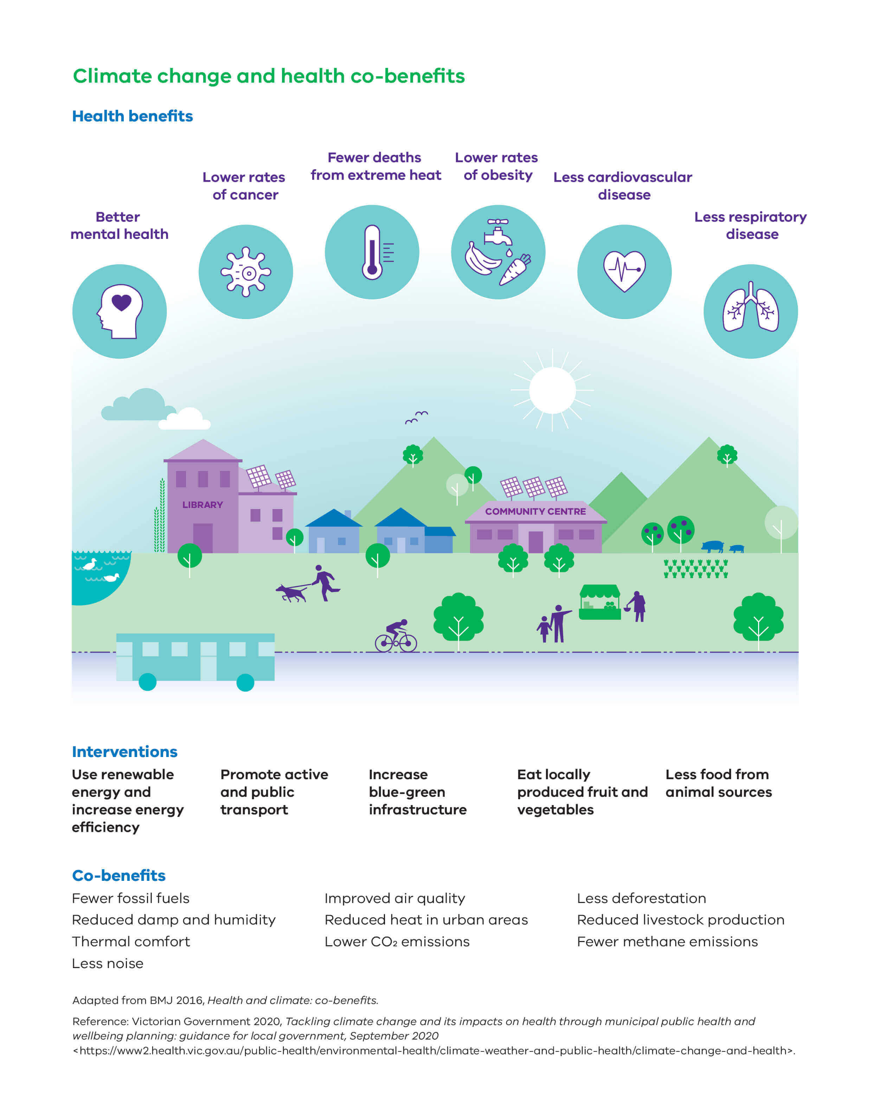



# PRIORITY 3: INCREASING HEALTHY EATING

Increasing healthy eatingis one of four priorities identified as a focus in the Victorian Public Health and Wellbeing Plan 2019-2023.

#### Why are we continuing to focus on healthy eating?

Healthy eating is central to good health and wellbeing. What we eat and the food environment have changed substantially over the past three decades. Many Victorians do not consume enough of the foods and drinks required to keep them healthy, such as fruits, vegetables and wholegrains and consume too many discretionary and processed foods and drinks, often high in energy, saturated fat, added sugar, salt or alcohol. 58% of Australian’s food spending is on unhealthy foods and drinks.

This shift has coincided with an increase in obesity, contributed to chronic diseases such as cardiovascular disease, type 2 diabetes and some cancers. 68% of Victorian adults are overweight or obese – an estimated 3.3 million Victorians. Vulnerable populations are more at risk of unhealthy eating patterns, particularly those living in disadvantaged areas, and Indigenous residents.[3]

#### Healthy eating during the COVID-19 pandemic

The Australian Bureau of Statistics COVID-19 survey found one in five Australians experienced problems maintaining a healthy lifestyle due to COVID-19. They consumed more unhealthy snacks and more alcohol. In Victoria, during lockdown:

* Sugary drink consumption more than tripled, with nearly one-third of respondents living in the metro/rural interface having sugary drinks every day.
* Food insecurity nearly doubled during lockdown – 7% of respondents ran out of food and could not afford to buy more.
* Indigenous residents had much higher levels of food insecurity.
* Interface areas had the lowest vegetable consumption - only 4% of respondents were eating enough, compared to 8% across Victoria –the worst of any region.[4]They were also more likely to rely on low-cost unhealthy food due to financial issues, at 29% compared to 23% for Victoria. Seven percent of Interface respondents in Interface areas went without meals, 9% used food relief agencies, 17% worried about having enough money to buy food, and 11% skipped meals to feed their households.

Young people aged 18-24 had much higher food insecurity, being more likely to eat a restricted range of low-cost food, go without meals, use food relief agencies, worry about having enough money to buy food, skip meals to feed their households, and run out of food and be unable to buy more.

* Young people aged 25-34 were more likely to: eat takeaway food regularly, eat a restricted range of low cost food, go without meals, use food relief agencies, worry about having enough money to buy food, skip meals to feed their households, drink sugary drinks daily, and run out of food and be unable to buy more.

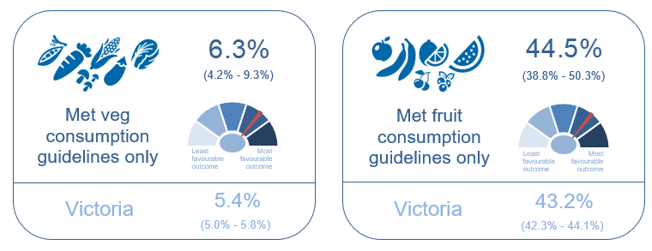Yarra Ranges Council surveyed nearly 170 Yarra Ranges residents during lockdown. Healthy eating was one of the main concerns for individuals, and nearly 20% of parents and carers of children and teenagers had contacted food relief services during lockdown.

#### Healthy eating and food security in Yarra Ranges

Both healthy eating and food security were significant issues even before the pandemic. In 2017, 68% of adults in Yarra Ranges were obese or overweight, compared to 70% for Victoria. Ten percent had been affected by food insecurity in the past 12 months.

* 15% of Yarra Ranges residents consumed sugar sweetened drinks daily, compared to 10% across Victoria. Yarra Ranges had the fourth-highest level across the 31 metropolitan local government areas. This was an increase from 11% in 2014.
* Only 4% of residents ate enough fruit and vegetables (the same as the average). 6% met the vegetable consumption guidelines, and most residents ate less than half the recommended level of vegetables per day. A higher 45% met the fruit consumption guidelines.
* Often takeaway and other processed foods are being consumed in place of fresh fruit and vegetables - 16% of residents were consuming take-away meals or snacks multiple times each week

More detailed food security data from the 2014 VPHS indicates that 16% of adults in Yarra Ranges were worried about food insecurity with hunger, the highest in the Eastern Metropolitan Region (the EMR average was 9% and the Victorian average was 12.5%).  11% of parents relied on low-cost food to avert food insecurity with hunger, the second-highest level in the EMR (compared to 7.4% for the EMR and 13% for Victoria).  The barriers to accessing healthy food included:

* Some foods are too expensive (22%, above the 17% EMR average, and the highest level in the EMR).
* Inadequate and unreliable public transport (5%, compared to 3.7% for the EMR – Knox was highest within the EMR, at 8.4%.
* Limited variety (7.5, similar to EMR average of 7.4%).
* Can’t get the right quality (8.5%, compared to 12% across the EMR and significantly below average).

While Yarra Ranges seems to have access to high quality food, the cost of healthy food and public transport access remain an issue for a substantial proportion of the community.[5]

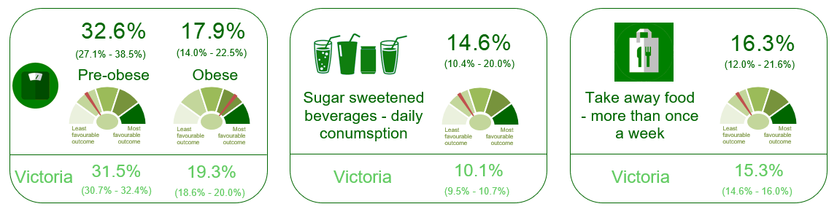

# PRIORITY 4: INCREASING ACTIVE LIVING



Increasing active living is one of four priorities identified as a focus area for action in the Victorian Public Health and Wellbeing Plan 2019-2023. It is an indicator for the Plan’s desired outcome that “Victorians act to protect and promote health”.

#### Why are we continuing to focus on active living?

Leading an active life improves people's health and wellbeing. Moving more and sitting less reduces the risk of ill-health and death. Regular physical activity can help to both prevent and treat diseases such as heart disease, stroke, some cancers, diabetes, osteoporosis, dementia, musculoskeletal conditions and depression. Also, being physically active in combination with having a healthy diet helps to reduce the prevalence of other risk factors, such as high blood pressure, high blood cholesterol, and overweight and obesity. Incorporating physical activity into daily living is associated with improved mental health, ageing well and increased levels of happiness.[6]

However, at the moment, more than half of Victorian adults do not enough exercise to support good health.[7] Lifestyle risk factors – including physical inactivity and unhealthy diets – cause more than one-third of disease, injuries and deaths in the Victorian community.[8]

#### How does active living help our communities?

Active communities also have benefits beyond health impacts. Higher levels of physical activity are associated with better academic performance throughout early childhood and school, and with increased workplace productivity. Encouraging this activity to occur in natural environments can increase people’s connection with nature, and thus prompt actions to protect the natural environment. Neighbourhoods which are designed to encourage walking, cycling and use of public transport promote positive social connections and feelings of safety and belonging; support local business activity; and reduce environmental impacts from car emissions and traffic congestion. Car emissions contribute to climate change; increasing the level of trips made using sustainable transport modes is therefore important to mitigating climate change.[9]

Sport and active recreation play an important role in the social and cultural life of Victorians. They can help to challenge and shift socio-cultural norms, and to reduce inequalities and discrimination within communities. Sport and active recreation also deliver substantial economic benefits.[10]

#### Determinants affecting physical activity

The quality of the built environment is a major determinant of physical activity. The built environment can either enable, or be a barrier to, active living. Neighbourhoods where residents can walk to local services such as schools, sport and recreation facilities, public transport and destinations near people's homes, can encourage higher levels of physical activity.[11]

Location, indigenous status, socio-economic advantage, disability and gender all affect levels of activity. Physical activity is significantly lower amongst people living in Australia’s most disadvantaged areas, Indigenous Australians, people with a disability, and women.[12]

#### Physical activity during lockdown

The restrictions in Victoria due to the COVID-19 pandemic shut down gyms and sports clubs, temporarily reduced walking and other forms of outdoor exercise to a maximum of one hour a day, prevented group exercise, reduced active transport, and changed people’s work and home life in a myriad of other ways. A VicHealth survey[13] of Victorian residents in May found that 37% of respondents were doing less physical activity; more than one-quarter were doing no exercise or exercising rarely, with this group increasing from 20% in February to 27% during lockdown.

Those who exercised most days generally continued to do so (32% during lockdown and 37% in February). The level who were walking for exercise stayed about the same, at 73% of residents compared to 77% in February; the level doing muscle strengthening at home rose from 23% to 29%. Physical activity varied substantially by area – 43% of residents in inner metropolitan areas were exercising five or more days per week, compared to a much lower 29% in Interface areas. This could be due partly to factors such as lower levels of walkability (e.g. footpaths), less access to exercise options at home, less capacity to work from home and higher levels of caring responsibilities. It also varied by age, with 18-24 year olds being less likely to be physically inactive; indigenous residents also had above average levels of sufficient physical activity (38%).

#### Physical activity in Yarra Ranges

Before the pandemic, Yarra Ranges was experiencing improved physical activity levels amongst residents. A well above average level of residents were meeting the physical activity guidelines (58% compared to 51% for Victoria). This may partly be due to more active occupations, with Yarra Ranges residents being less likely to sit for 7 or more hours per day on an average weekday. Men and women had similar levels of physical activity. The level of residents with insufficient physical activity dropped from 55.5% in 2014 to 38% in 2017, meeting the state government target of a 10% increase in the level of adults with sufficient physical activity.[14]

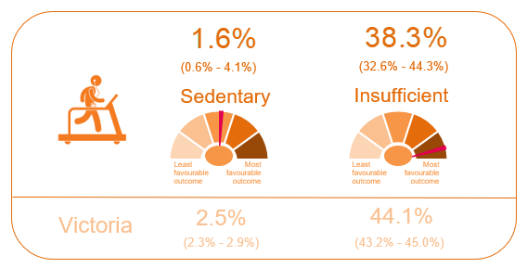

Council conducted a survey in September of nearly 170 Yarra Ranges residents, which highlighted a number of impacts experienced as a result of the pandemic. Reduced physical activity was a key issue for community members, and lack of access to people’s normal physical exercise opportunities were also affecting their stress levels.[15]

Physical activity was impacted by the pandemic for 56% of individual respondents and 51% of parents/carers; this was a major issue across the different age groups. As physical activity is a key source of social interaction, the loss of organised sport and loss or reduction of other means of exercise (e.g. gyms) have exacerbated people’s high levels of social isolation. Sports clubs, gyms, swimming pools and outdoor activities such as golf, were all unavailable during the survey period. Respondents also noted that they were experiencing higher stress levels due to not being able to do the exercise that they would normally do to relieve stress.[16]

#### What can we do?

Implementation guidance has been released to accompany the Victorian Public Health and Wellbeing Plan.[17] This identifies evidence-based strategies which can be used by local governments to increase active living, and the types of actions which can be used to support these strategies

**Summary of Australian Physical Activity & Sedentary Behaviour Guidelines[18]**

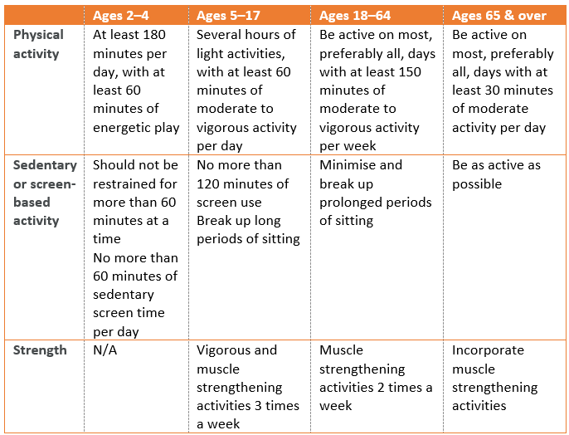

# PRIORITY 5: IMPROVING MENTAL WELLBEING & SOCIAL CONNECTIONS



Improving mental wellbeing is one of the ten priority areas in the Victorian Public Health and Wellbeing Plan 2019-2023. It is an indicator for the Plan’s desired outcomes that “Victorians have good mental health” and “Victorians are socially engaged and live in inclusive communities”. Social connection is intrinsic both to good mental health and to being socially engaged.

#### Why are we continuing to focus on mental health?

Mental health is crucial to good health and wellbeing, and is fundamental to Victoria’s social, cultural and economic life. Mental health conditions are one of the top five causes of disease and death in Australia. One in five Victorians will experience a mental health condition each year; 45% will experience this within their lifetime.

#### How does mental wellbeing help our communities?

Having good mental health supports people to live their lives to the fullest extent, cope with life stresses, work productively, and contribute to their communities.[19]

Mental health and physical health are inextricably linked – good mental health supports good physical health, and vice-versa. Compared to the general population, people with mental illnesses are more likely to develop physical illnesses such as cardiovascular disease, respiratory disease and cancer; and to have a reduced life expectancy.[20]

Mental health conditions overlap considerably with chronic diseases such as diabetes, cardiovascular disease, cancer, alcohol and substance misuse, and problem gambling. These various groups of conditions share numerous risk factors, are risk factors for each other, and frequently co-occur.[21]

#### Determinants affecting mental health

Some population groups are at higher risk of poormental health and mental illness due to unfavourable social, economic and environmental circumstances, including social isolation and loneliness.[22] Groups who are particularly at risk include persons living in remote areas, persons affected by socio-economic disadvantage, and Indigenous persons.[23] Service access also affects mental health. The main social determinants include social inclusion, and freedom from violence and discrimination.

Feeling connected to others, being able to cope with the typical life stressors, being able to contribute to the community, and being productive are all critical to mental health. Family and social connections can also affect how well people recover from mental illness. [24]

#### Mental health & social connection

#### during lockdown

The pandemic has harmed community health and wellbeing in a myriad of ways, and these impacts vary by geographic region and population group. The main social and mental health impacts include low levels of life satisfaction, lack of connection to other people, difficulties staying connected, and strained relationships within households. Climate change is also expected to see increased anxiety, and mental health is worse during heatwaves.

The pandemic has seen a 9.5% increase during lockdown in Victorians presenting to hospital for self-harm, with a 33% increase amongst young people[25]; a 23% increase in hospital presentations for mental illness; a 22% increase in calls to Lifeline in Victoria after the second Stage 3 lockdown began, with young people and women particularly at risk.[26] In general, women have been identified as more affected by a range of lockdown impacts, including job loss and homeschooling, so the ‘mental health gap’ between the genders can be expected to worsen.

A VicHealth survey of the impacts of the pandemic found that 46% of adults surveyed in Interface areas reported low-medium life satisfaction during coronavirus restrictions, compared to 20.5% during the previous survey. 24% of Interface residents did not feel connected with others, compared to 10% in February 2020.

#### Forecast ongoing mental health impacts

Forecasts for the next few years expect a large rise in residents with mental health disorders, particularly amongst 12-25 year olds.  The parts of Yarra Ranges forecast to have the most people affected are Kilsyth/Lilydale, Warburton-Yarra Junction, Healesville, Belgrave-Olinda, and Monbulk-Seville. The forecasts indicate that nearly 3,000 extra children and adults in Yarra Ranges will develop mental health issues by 2023 – 2% of Yarra Ranges’ population aged 4-84.

The factors which are expected to contribute to increased mental health issues include an increased number of people experiencing poor mental health as a result of physical distancing; those re-presenting to services in a heightened state of distress resulting from a discontinuation of treatment; or from those with severe mental ill-health who have been triggered by their experience of the pandemic.  Longer-term, educational disruption and disengagement, loss of employment, financial stress, housing stress and reduced wellbeing will have a significant impact on community mental health, and these factors increase the risk of mental illness and suicide. Young people are expected to be disproportionately impacted, and make up a large percentage of casual workers and persons working in retail and hospitality. This modelling assumes a 10% reduction in community connectedness, resulting from social dislocation unrelated to job loss (such as working from home, not participating in sports, reduced social gatherings), which could persist for at least a year. [27]

#### Mental health in Yarra Ranges

Even before the pandemic, many Yarra Ranges residents were experiencing mental health issues.

**Hospital admissions:**

* In 2018/19, children in Yarra Ranges (0-14 year olds) had a well above average hospital admission rate[28] for mental and behavioural disorders. Mental and behavioural disorders were the third-highest reason for admission to hospital for young people aged 15-24. Women had a 33% higher admission rate for mental and behavioural disorders than men.
* As a percentage of total admissions, young people aged 15-24 had the highest percentage of admissions for mental and behavioural disorders, at 8.6% of total hospital admissions amongst this age group (compared to 3.6% amongst the total for all age groups).
* In 2018/19, hospital admission rates for mental and behavioural disorders were highest in the Upper Yarra Valley (177.1 per 1,000 residents), Mount Dandenong-Olinda (21.8 per 1,000), Kilsyth (21 per 1,000) and Lilydale-Coldstream (20.9 per 1,000). The average rate for Yarra Ranges was 16.7 per 1,000, which is similar to the Victorian average.

**Mental health indicators:**

* 25% of adults had sought help for a mental health-related problem during the past 12 months, significantly higher than the 18% Victorian average and ranking Yarra Ranges second-highest in Melbourne (2017). This shows a substantial increase from the level of 16% in 2014. This issue is worse amongst females, at 29% of females compared to 23.5% of males.
* The level who had ever been diagnosed with anxiety or depression rose from 27% to 38% (compared to 27% across Victoria). This ranks Yarra Ranges highest on this indicator within metropolitan Melbourne.
* 15% of residents had high or very high levels of psychological distress (the same as the Victorian average).

The mental health of men and women in Yarra Ranges varies considerably on the available indicators. Overall, women were much more likely to have moderate levels of psychological distress, and were more likely to be diagnosed with anxiety or depression; their level of anxiety or depression was also much higher than the level for all Victorian women. Men in Yarra Ranges had an extremely high level of anxiety or depression compared to males across Victoria. They were more than twice as likely to have low or medium life satisfaction, or to have low or medium feelings of life being worthwhile:

* Women were much more likely than men to experience moderate levels of psychological distress, at 35.5% of women compared to 20% of men; the level is also much higher than the average level for Victorian women, which is 26%. The level with high or very high psychological distress was similar between males and females.
* Women were more likely to be diagnosed with anxiety or depression, at 41% compared to 36% of males, and to 34% of women Victoria-wide. Men are also above the Victorian average on this indicator, at 36% of males in Yarra Ranges compared to 21% for Victoria.
* Men in Yarra Ranges were also much more likely than women to have low or medium life satisfaction, at 29% compared to 15%; this is also higher than the level of 21% for all Victorian males.

The pandemic has seen a rise in mental health patients living in Yarra Ranges. Between the twelve months to May 2020 and the twelve months to June 2020, the number of active mental health patients in Yarra Ranges increased by 90%, to nearly 10,000 people.

In September 2020, Council conducted a survey of nearly 170 Yarra Ranges residents about the impacts of the pandemic and the resultant lockdown. It found that social isolation and mental health were by far the main areas of impact. The key issues for those surveyed were social isolation (nearly 70%) of respondents; and mental health of respondents (nearly 50%), their families (44%) and their children (35%). Relationship strain was also an issue for nearly 20% of respondents. Twenty-six percent of respondents had contacted mental health services for assistance.[29]

However, despite the mental health issues affecting parts of our community, Yarra Ranges also has very strong social connections which will support recovery work. Yarra Ranges residents were more likely to think that they could definitely get help from family when they needed it (87% compared to 82% for Victoria). Yarra Ranges residents were more likely to think that they could definitely get help from friends or relatives for care in an emergency, at 93% compared to 87.5% for Victoria. Residents were more likely to feel valued by society, at 52% compared to 48% across Victoria. They were also more likely to volunteer regularly or sometimes (39% compared to 36%).

#### What can we do?

Council has a role in responding to the factors forecast to contribute to worsening mental health:

* By supporting community connection in as many ways as possible, e.g. through community clubs and sport.
* By focusing on economic development, particularly to mitigate job losses, and to support work, education and re-training for young people.
* To advocate for increased access to essential services and infrastructure, particularly mental health services and affordable housing.

As social connection is one of the key determinants of mental health, Council policies and programs designed to promote a sense of belonging, increase awareness and acceptance of diversity, prevent violence, and build community resilience, can all support mental wellbeing.[30]

Healthy eating and being physically active also support mental wellbeing,[31] and Council is involved in a range of work which supports both of these.

Implementation guidance has been released to accompany the Victorian Public Health and Wellbeing Plan.[32] This identifies evidence-based actions which can be used by local governments to improve mental wellbeing.

# PRIORITY 6: REDUCING VIOLENCE AGAINST WOMEN & CHILDREN IN YARRA RANGES

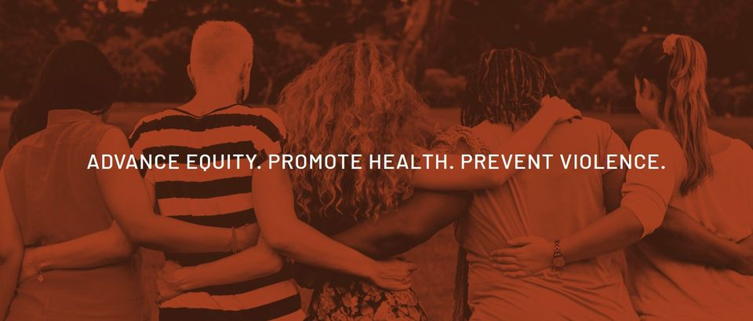

Reducing violence against women and children in Yarra Ranges is one of the priorities within Council’s 2021-2025 Health and Wellbeing Plan. Following the Royal Commission into Family Violence, Victoria’s Public Health and Wellbeing Act was amended to require councils to specify measures to prevent family violence and to respond to the needs of family violence victims, when preparing municipal public health and wellbeing plans. Councils are also required to align with their health and wellbeing planning with the priorities of the Victorian State Public Health and Wellbeing Plan - preventing all forms of violence is one of the priorities of this Plan, alongside improving sexual and reproductive health.

#### What is violence against women?

Violence against women includes family violence, but is also broader than this. Family violence consists of “coercive and abusive behaviours by a person towards a family member of that person that are designed to control, intimidate, humiliate, undermine and isolate, resulting in fear and insecurity”. These behaviours include coercive and abusive physical, sexual, emotional, financial and spiritual behaviours[33] - it does not necessarily include physical violence.

#### Why is this a priority?

All people have the right to live safely and free from all forms of violence. Violence is a significant but modifiable risk factor for ill-health amongst women, particularly those of child-bearing age.[34] In Victoria in 2017, 4.2% of men and 6.6% of women 5.4% of adults experienced family violence in the two years preceding the Victorian Population Health Survey. [35]

Family violence causes physical injury, psychological trauma and emotional suffering, which can affect victims and their families for the rest of their lives. In its most extreme form, it causes senseless deaths.[36] The personal impacts include pain, suffering and early death, with substantial physical and mental health impacts; loss of income and reduced financial security; loss of housing; loss of or limited access to employment; disconnection from family and friends; and property damage.[37]

Family violence can also affect child development. And if family violence is combined with other problems, such as drug and alcohol abuse, or mental health issues, children are placed at even greater risk of developing emotional, behavioural, health, social and educational problems.[38]

#### How reducing family violence help our communities?

Good mental health, physical health, and sexual and reproductive health, involves gender equality, respect, safety and freedom from discrimination, violence and stigma. Beyond the obvious health benefits, creating a society free from family violence, and undertaking the actions needed to get to this outcome, would lead to better socio-economic outcomes for women and young children; increased gender equity and with it better participation in social and economic life for all genders; increased feelings of safety; reduced drug and alcohol misuse; and reduced demand for family violence services and a range of other services. The benefits for our most vulnerable groups, including indigenous Australians, would be even greater.

#### Determinants affecting family violence

While anyone can experience family violence, some groups tend to be at increased risk. These include women who are indigenous; identify as having a disability; live in rural, regional or remote areas; are older; identify as LGBTIQ+; or are affected by socio-economic disadvantage.[39]

#### Family violence in Yarra Ranges in 2020

Family violence incidents (reported) went up by 4.7% across the Yarra Ranges population, in the 2020 calendar year (compared to 2019).  This includes the pre-pandemic March 2020 quarter, so it’s likely to be a slight understatement of the increase.  Females accounted for 76% of those affected by family violence.  Family violence incidents against persons aged 55 years or more in Yarra Ranges went up by 22% between 2019 and 2020, so there was much more of an increase in elder abuse than there was in family violence generally.[40]

Over the year to the end of December 2020, Yarra Ranges had a rate of reported incidents of 1,094 per 100,000 residents. Family violence appears to be much more prevalent in the outer east than in the inner east – Yarra Ranges, Knox and Maroondah all have rates of more than 1,000 per 100,000 residents, compared to rates ranging from 565 to 807 per 100,000 in the inner eastern local government areas.

Many people seeking assistance during COVID-19 were doing so for the first time (and majority of those seeking support were women). During Stage 3 and 4 restrictions in Melbourne, the level of first-time victims engaging with the Eastern Domestic Violence Service (EDVOS) doubled to 60%, from 30% before the pandemic. Cases showed increased frequency and severity of ongoing violence, particularly physical and sexual abuse, and coercive control. Referrals from general services rose by 20% between March and June; these services include community health, early childhood and counselling services. Many of these services had never contacted EDVOS previously, and were highly concerned for the safety of women and children.[41]

#### What can Council do?

At its core, family violence and violence against women is rooted in the inequality between women and men.**[42]**Council is committed to promoting gender equality in our workplace and community. Council is working towards an inclusive and diverse Yarra Ranges where women, men and gender diverse people have equitable access to resources, power and opportunities.

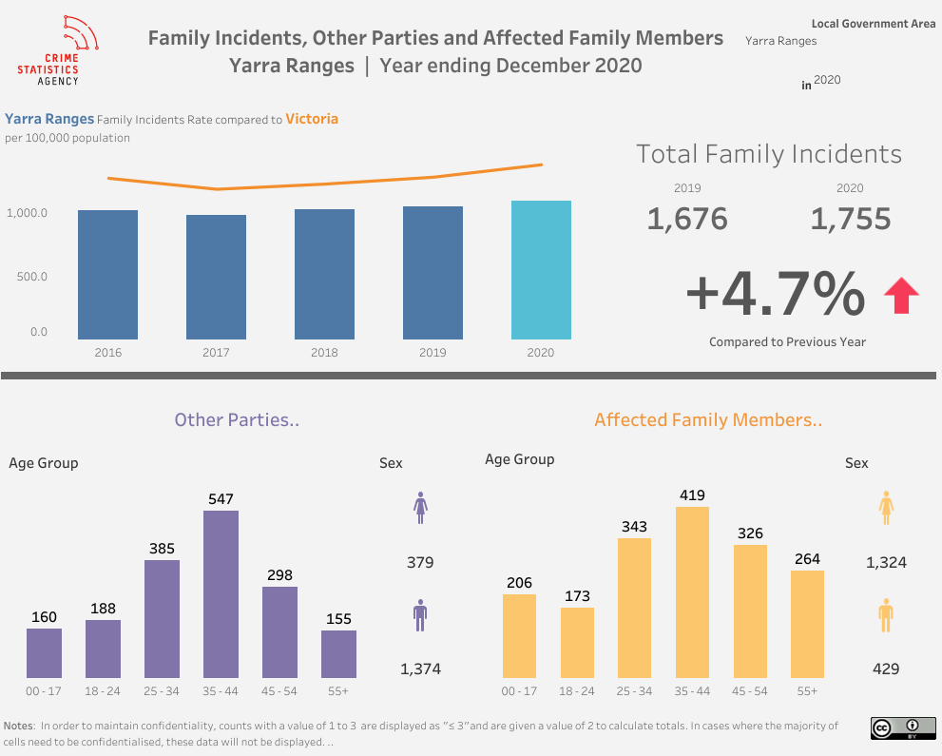

# PRIORITY 7: REDUCING HARMFUL ALCOHOL USE IN YARRA RANGES



Reducing harmful alcohol use is one of the priorities for Council’s 2021-2025 Health and Wellbeing Plan. A range of local data highlights high levels of alcohol consumption as a key health issue for Yarra Ranges residents. Also, Councils are required to align their health and wellbeing planning with the priorities of the Victorian State Public Health and Wellbeing Plan, and reducing harmful alcohol use is one part of the priorities of this Plan.

#### What is risky alcohol consumption?

For a healthy adult, risky alcohol consumption involves having more than 10 standard drinks a week or more than 4 standard drinks on any one day.[43] Drinking more than this substantially increases the risk of alcohol-related disease or injury. However, any level of consumption increases the risk of diseases such as cancer - the less you drink, the lower your risk of alcohol-related harm.

It is advised that those under 18 years of age, and women who are breast-feeding, pregnant or planning a pregnancy, do not consume any alcohol.[44]

#### Why are we continuing to focus on reducing harmful alcohol use?

Consuming alcohol at risky levels contributes to disease, injuries and violence. More than one-third of the burden of disease amongst Victorian residents is due to avoidable risk factors, including consuming alcohol at risky levels. Unlike other lifestyle risk factors, it affects not only the individual but also their families, friends and the wider community. Impacts include worse health and higher death rates due to health impacts such as cancer; higher crime rates (such as assaults and property damage); increased road accidents causing injury and death; impacts on mental health; and impacts on individuals’ capacity to live life to the full, including affects on workplace productivity, family functioning, etc. It also affects residents’ sense of safety, and general public amenity. Alcohol and substance misuse also overlap and share risk factors with mental health issues, problem gambling and physical health issues.[45]

Nationally, alcohol remains Australia’s most prevalent drug; a national survey found that more than one in three people drank at risky levels on single occasions (25% of Australians do this at least monthly).

Alcohol consumption contributes to more than 4,000 deaths per year nationally, and is a risk factors for 30 diseases and injuries - including eight types of cancer, chronic liver disease, and birth defects such as Fetal Alcohol Spectrum Disorder. Nearly 40,000 Victorians are hospitalised because of alcohol-related harm each year including those injured from alcohol-related road crashes, sexual assaults, street assaults and family violence.

#### Drug and alcohol consumption in Yarra Ranges

Alcohol is a continuing health problem in Yarra Ranges. Two-thirds of adults regularly drink at risky levels, ranking Yarra Ranges 7th in Victoria. The level of residents at risk of harm from occasional binge drinking is now at 50% of adults, and 10% binge drink regularly.

Yarra Ranges has an above average level of risky alcohol consumption. 67% of Yarra Ranges residents had an increased life-time risk of alcohol-related harm, compared to 59% across Victoria, ranking it 7th highest across Victorian local government areas. Nearly one-quarter (23%) of residents drank more than 2 standard drinks per day, on a weekly basis; and 10% of residents drank more than 4 drinks in one go, on a weekly basis. The level of residents at increased risk of alcohol harm from a single occasion of drinking (binge drinking) has risen from 45% to 50% over the past three years; the level with an increased lifetime risk rose from 62%.

Adults aged 25-39 in Yarra Ranges have a high hospital admission rate for alcohol, particularly males. Residents also have an above average rate of alcohol and drug service usage, particularly amongst males, 15-24 year olds and 25-39 year olds.

Yarra Ranges also has an above average level of: ambulance attendances related to alcohol, alcohol and drug treatment service usage, ambulance attendances related to pharmaceuticals, and serious road injuries during high alcohol use hours (amongst both males and females, and amongst 15-24 year olds).[46]

There are mixed data on the impacts of lockdown on alcohol consumption, with some research finding increased consumption and other research finding that it had stayed the same.

#### What can Council do?

Key areas of focus in Victoria for reducing risky alcohol use include preventing harm from alcohol via improving alcohol culture, supporting vulnerable groups and developing evidence-based alcohol control policies. [47]

The VicHealth Alcohol Strategy similarly identifies changing risky drinking cultures, and enabling environments to support low-risk drinking, as key strategies to reduce alcohol hamr.

VicHealth research has identified ways in which councils can prevent or minimise alcohol-related harm. [48] These include:

* Implementing strategic approaches that change alcohol cultures by changing social norms, attitudes and beliefs about alcohol consumption and intoxication
* building local partnerships that reduce alcohol-related harm.

The latest Toolkit also identifies influencing consumption of alcohol products in various settings and groups; increasing the effectiveness of alcohol harm prevention and minimisation strategies; and improving community safety.

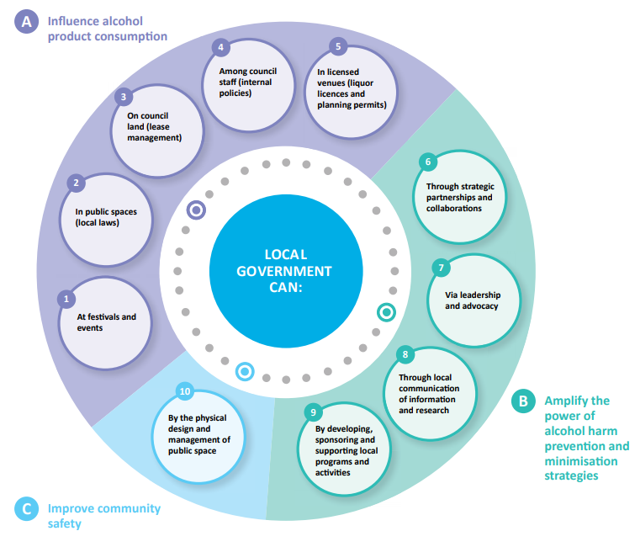

### **What are the revised Australian alcohol guidelines?**

These are the Australian guidelines to reduce health risks from drinking alcohol, as published by the National Health and Medical Research Council (2020).

**Guideline 1**: To reduce the risk of harm from alcohol-related disease or injury, healthy men and women should drink no more than 10 standard drinks a week and no more than 4 standard drinks on any one day.

The less you drink, the lower your risk of harm from alcohol.

Guideline 1 does not describe a “risk-free” level of drinking. As a general rule, the less alcohol a person chooses to drink, the lower their risk of alcohol-related harm. Drinking within the levels outlined in guideline 1 keeps the lifetime risk of dying from an alcohol-related disease or injury to below 1 in 100 for healthy men and women.

**Guideline 2**: To reduce the risk of injury and other harms to health, children and people under 18 years of age should not drink alcohol.

**Guideline 3**:

1. To prevent harm from alcohol to their unborn child, women who are pregnant or planning a pregnancy should not drink alcohol.
2. For women who are breastfeeding, not drinking alcohol is safest for their baby.

1. <https://www2.health.vic.gov.au/about/health-strategies/public-health-wellbeing-plan>
2. <https://www2.health.vic.gov.au/about/health-strategies/public-health-wellbeing-plan/tackling-climate-change>
3. <https://www.aihw.gov.au/reports/overweight-obesity/overweight-obesity-australian-children-adolescents/contents/summary>
4. The regional groupings are Inner Metropolitan, Middle Metropolitan, Outer Metropolitan and Interface.
5. <https://www.bettersafercare.vic.gov.au/sites/default/files/2019-09/190226-1_VAHI-food-insecurity-full%20report.pdf>
6. Department of Health and Human Services (2019). *Victorian public health and wellbeing plan 2019-2023.* Retrieved from: <https://www2.health.vic.gov.au/about/health-strategies/public-health-wellbeing-plan>
7. Department of Health and Human Services (2019). *Victorian public health and wellbeing plan 2019-2023.* Retrieved from: <https://www2.health.vic.gov.au/about/health-strategies/public-health-wellbeing-plan>
8. Department of Health and Human Services (2019). *Victorian public health and wellbeing plan 2019-2023.* Retrieved from: <https://www2.health.vic.gov.au/about/health-strategies/public-health-wellbeing-plan>
9. Department of Health and Human Services (2019). *Victorian public health and wellbeing plan 2019-2023.* Retrieved from: <https://www2.health.vic.gov.au/about/health-strategies/public-health-wellbeing-plan>
10. Department of Health and Human Services (2019). *Victorian public health and wellbeing plan 2019-2023.* Retrieved from: <https://www2.health.vic.gov.au/about/health-strategies/public-health-wellbeing-plan>
11. Department of Health and Human Services (2019). Increase active living. Retrieved from: <https://www2.health.vic.gov.au/about/health-strategies/public-health-wellbeing-plan/increasing-active-living>
12. VicHealth (2019). *Physical Activity Strategy 2019-2023.* Retrieved from: <https://www.vichealth.vic.gov.au/-/media/ResourceCentre/PublicationsandResources/Action-Agenda/Physical-Activity-Strategy-2019.pdf?la=en&hash=BFBFFBD4C8C778EFDECCF83395440772DE627FAE>
13. Victorian Health Promotion Foundation (2020). VicHealth Coronavirus Victorian Wellbeing Impact Study, Report for survey #1: How the first coronavirus lockdown impacted the health and wellbeing of Victorians. Retrieved from <https://doi.org/10.37309/2020.PO909>
14. Department of Health and Human Services (2019). Victorian Population Health Survey, 2017. Retrieved from: <https://www2.health.vic.gov.au/public-health/population-health-systems/health-status-of-victorians/survey-data-and-reports/victorian-population-health-survey/victorian-population-health-survey-2017>
15. Yarra Ranges Council (2020). Data analysis of results from *Be Kind survey of individuals in Yarra Ranges, September 2020*
16. Yarra Ranges Council (2020). Data analysis of results from *Be Kind survey of individuals in Yarra Ranges, September 2020*
17. <https://www2.health.vic.gov.au/about/health-strategies/public-health-wellbeing-plan>
18. Australian Institute of Health and Welfare (2020). *Insufficient physical activity.* Retrieved from: <https://www.aihw.gov.au/reports/risk-factors/insufficient-physical-activity/contents/insufficient-physical-activity>

    18 Department of Health and Human Services (2016). *Victorian public health and wellbeing outcomes framework.* Retrieved from: <https://www2.health.vic.gov.au/about/publications/policiesandguidelines/victorian-public-health-and-wellbeing-outcomes-framework>
19. <https://www.healthdirect.gov.au/good-mental-health>
20. <https://www.aihw.gov.au/reports/australias-health/physical-health-of-people-with-mental-illness>
21. Department of Health and Human Services (2019). *Victorian public health and wellbeing plan 2019-2023.* Retrieved from: <https://www2.health.vic.gov.au/about/health-strategies/public-health-wellbeing-plan>
22. Department of Health and Human Services (2019). *Victorian public health and wellbeing plan 2019-2023.* Retrieved from: <https://www2.health.vic.gov.au/about/health-strategies/public-health-wellbeing-plan>
23. Department of Health and Human Services (2019). *Victorian public health and wellbeing plan 2019-2023.* Retrieved from: <https://www2.health.vic.gov.au/about/health-strategies/public-health-wellbeing-plan>
24. Department of Health and Human Services (2019). *Victorian public health and wellbeing plan 2019-2023.* Retrieved from: <https://www2.health.vic.gov.au/about/health-strategies/public-health-wellbeing-plan>
25. The Age (2020). *More cash to boost Victorian mental health services as lockdown takes toll.* Retrieved from <https://www.theage.com.au/politics/federal/more-cash-to-boost-victorian-mental-health-services-as-lockdown-takes-toll-20200816-p55m93.html>
26. <https://insightplus.mja.com.au/2020/30/suicide-deaths-forecast-for-13-7-increase/?utm_source=InSight%2B&utm_campaign=34f6153416-EMAIL_CAMPAIGN_2020_07_31_05_27&utm_medium=email&utm_term=0_7346f35e23-34f6153416-43048133>
27. <https://insightplus.mja.com.au/2020/30/suicide-deaths-forecast-for-13-7-increase/?utm_source=InSight%2B&utm_campaign=34f6153416-EMAIL_CAMPAIGN_2020_07_31_05_27&utm_medium=email&utm_term=0_7346f35e23-34f6153416-43048133>
28. Source: Victorian Agency for Health Information (2020). Customised data request prepared for Yarra Ranges Council
29. Yarra Ranges Council (2020). Data analysis of results from *Be Kind survey of individuals in Yarra Ranges, September 2020*
30. Department of Health and Human Services (2019). Improving mental wellbeing. Retrieved from: <https://www2.health.vic.gov.au/about/health-strategies/public-health-wellbeing-plan/mental-health>
31. <https://headtohealth.gov.au/meaningful-life/physical-health>
32. <https://www2.health.vic.gov.au/about/health-strategies/public-health-wellbeing-plan>
33. <https://www.bettersafercare.vic.gov.au/reports-and-publications/vphs2017-family-violence-in-victoria>
34. Department of Health and Human Services (2019). *Victorian public health and wellbeing plan 2019-2023.* Retrieved from: <https://www2.health.vic.gov.au/about/health-strategies/public-health-wellbeing-plan>
35. <https://www.bettersafercare.vic.gov.au/sites/default/files/2020-11/Family-violence-in-Victoria%20-%20November%202020.pdf#page=76>
36. <https://www.vic.gov.au/cost-family-violence-victoria>
37. <https://www.vic.gov.au/cost-family-violence-victoria>
38. Department of Health and Human Services (2019). *Victorian public health and wellbeing plan 2019-2023.* Retrieved from: <https://www2.health.vic.gov.au/about/health-strategies/public-health-wellbeing-plan>
39. <https://www.bettersafercare.vic.gov.au/sites/default/files/2020-11/Family-violence-in-Victoria%20-%20November%202020.pdf#page=76>
40. <https://www.crimestatistics.vic.gov.au/crime-statistics/latest-crime-data-by-area>
41. EDVOS (2020). *Family violence data and trends between March & August 2020.*
42. Department of Health and Human Services (2019). *Victorian public health and wellbeing plan 2019-2023.* Retrieved from: <https://www2.health.vic.gov.au/about/health-strategies/public-health-wellbeing-plan>
43. <https://www.aihw.gov.au/reports/alcohol/measuring-risky-drinking-aus-alcohol-guidelines/contents/measuring-risky-drinking>
44. Department of Health (2021). *How much alcohol is safe to drink?* Retrieved from <https://www.health.gov.au/health-topics/alcohol/about-alcohol/how-much-alcohol-is-safe-to-drink>
45. Department of Health and Human Services (2019). *Victorian public health and wellbeing plan 2019-2023.* Retrieved from: <https://www2.health.vic.gov.au/about/health-strategies/public-health-wellbeing-plan>
46. Turning Point (2020). *AOD stats 2018/19 by LGA.* <http://aodstats.org.au/>
47. Department of Health and Human Services (2019). *Victorian public health and wellbeing plan 2019-2023.* Retrieved from: <https://www2.health.vic.gov.au/about/health-strategies/public-health-wellbeing-plan>
48. <https://cdn.community.adf.org.au/media/documents/ADF_VH_Art_of_Comm_Management3_Dec.pdf>