YARRA RANGES

COMMUNITY SURVEY 2021

HEALTH & WELLBEING

Summary of Responses
Council conducted a community health and wellbeing survey during mid-2021. A total of 281 online responses were made. Unless stated otherwise, the 2021 Yarra Ranges Community Health and Wellbeing Survey is the source for all data in this report.
Support for draft health and wellbeing priorities:
- Improve mental wellbeing and social connection (87% extremely or very important).
- Promote gender equality to prevent violence against women and children (86% extremely or very important).
- Respond to public health emergencies (85% extremely or very important).
- Increase active living (82% extremely or very important).
- Tackle climate change and its impact on health (75% extremely or very important).
- Reduce harmful alcohol and drug use (74%).
- Increase healthy eating (73%).

The survey sought to determine the extent of community support for the draft priorities of Council’s next Health and Wellbeing Plan. The survey also aimed to uncover how community members support their personal health, what they see their community can do and what they support Council having a role in.
Males and young people were under-represented in the survey sample.
80% of respondents were female and 19% were male (1% preferred not to say). Yarra Ranges has a 50:50 split of male to female residents.
Young people aged 18-34 were also under-represented, at 9% of respondents compared to 30% of the population; this also means that adults aged 35 years plus, were over-represented in the survey data.
Survey respondents welcomed the opportunity to participate in the survey, and often had not been aware of community opportunities to feed into Council planning; and they would like these opportunities to be more widely publicised.

Key health and wellbeing priorities
Survey respondents’ top health and wellbeing priorities are based on the issues with the highest percentage of respondents who thought a priority was extremely important or very important. The top priorities were to:
- improve mental wellbeing and social connection (87%)
- promote gender equality to prevent violence against women and children (86%)
- respond to public health emergencies (85%).
Focusing just on the priorities considered to be extremely important yields a slightly different list of the top priorities, with tackling climate change and its impact on health in the top three instead of public health emergencies.
Broadly speaking, responses showed more support for action on issues relating to general community health and wellbeing, and to socially supportive and protective environments for mental wellbeing, gender equality, climate change and public health emergencies. Comparatively less priority was given to healthy eating, active living and alcohol and drug use.
Whilst people placed more importance on some priorities, it is important to note that most community members saw all the priorities as extremely or very important.

Healthy eating had the lowest level of prioritisation, but still nearly 75% of respondents thought that this priority was extremely or very important.
In terms of Council’s role, people viewed all Council roles as important.

A strong theme across priority areas was community respondents wanting:
- more information about how to respond to issues
- information about what individuals and businesses can do
- more work on social connections and better communication within communities.

Rating the Priorities by importance and in our areas
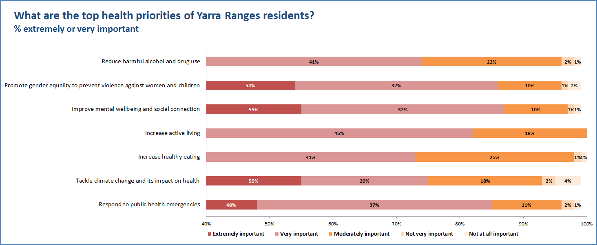
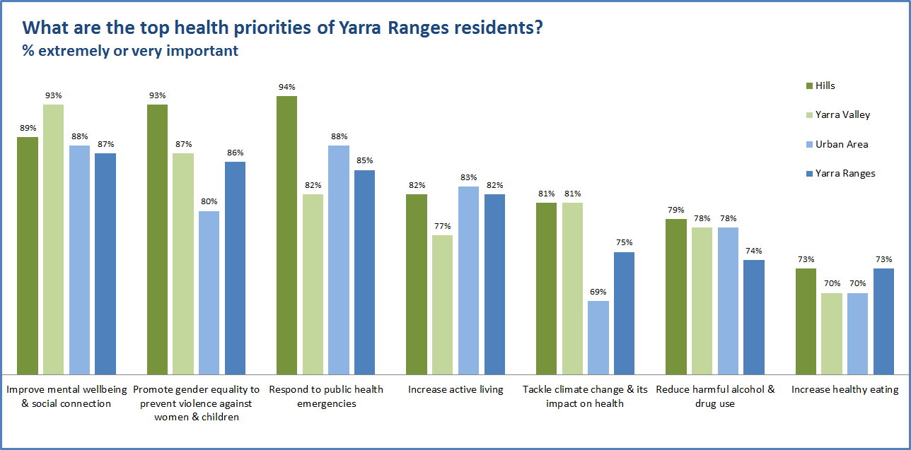

Top Priorities by Place
Top priorities for Hills residents:
- responding to public health emergencies (94% extremely or very important)
- promoting gender equality to prevent violence against women and children (93%)
- improving mental wellbeing and social connection (89%).
Climate change and preventing violence against women and children were higher respondents for Hills residents than for the rest of Yarra Ranges.
Top priorities for Yarra Valley residents were:
- improving mental wellbeing and social connection (93% extremely or very important)
- promoting gender equality to prevent violence against women and children (87%)
- responding to public health emergencies (94% extremely or very important).
Mental wellbeing was a much higher priority for Yarra Valley residents than for the rest of Yarra Ranges.
Top priorities for Urban Area residents were:
- improving mental wellbeing and social connection (88% extremely or very important)
- responding to public health emergencies (also 88% extremely or very important)
- increasing physical activity (83%).
Reducing harmful alcohol and drug use was a higher priority for Urban Area residents than for the rest of Yarra Ranges.

Top priorities by gender
There were differences in the top priorities of women (79% of respondents) and men (20% of respondents). Women were more likely to think that the following priorities were extremely or very important:
- Improve mental wellbeing and social connection (93% of women, 78% of men)
- Respond to public health emergencies (91% of women, 78% of men)
- Promote gender equality to prevent violence against women and children (89% of women, 80% of men)
- Tackle climate change and its impact on health (80% of women, 73% of men).

Top priorities by age
Looking within the age groups, the top priorities are:

Percentage for priorities rated extremely or very important within each age group
Priority areas | 18-24 | 25-34 | 35-44 | 45-54 | 55-64 | 65-74 | 75+ | Total
Respond to public health emergencies | 43% | 70% | 79% | 84% | 94% | 94% | 85% | 85%
Tackle climate change & its impact on health | 86% | 75% | 72% | 77% | 73% | 88% | 46% | 75%
Increase healthy eating | 57% | 60% | 68% | 75% | 76% | 86% | 46% | 73%
Increase active living | 71% | 85% | 80% | 75% | 84% | 85% | 85% | 82%
Improve mental wellbeing & social connection | 100% | 90% | 89% | 88% | 89% | 85% | 69% | 87%
Promote gender equality to prevent violence against women & children | 100% | 85% | 87% | 91% | 86% | 88% | 54% | 86%
Reduce harmful alcohol & drug use | 86% | 50% | 57% | 80% | 75% | 94% | 77% | 74%

There are differences at either end of the age range surveyed, that are interesting to note:
Top priorities 18-24 years:
- mental wellbeing (100% extremely or very important), promoting gender equity (100%), tackling climate change (86%) and reducing harmful alcohol and drug use (86%).
Top priorities 75 years or more:
- responding to public health emergencies and increasing active living (85%).

What community members told us about each priority

Health impacts of Emergencies
Strategies supported for minimising the impact of emergencies include following the advice of authorities, finding out where to get help if needed and having up-to-date insurance. Community connection was also important to residents.
Less than half had an emergency kit or an emergency management plan.
In terms of the role for communities, respondents would like simple ways for community members to be able to communicate in an emergency, and to have information about how to minimise the health impacts of emergencies. More training and information on preparation and response was also supported. The themes from people’s comments related to wanting more information and increasing community connections and communication within the community.
Throughout the survey, there were various comments about a preference for more hard-copy information delivered through letterboxes.
The community viewed all Council roles in minimising the impact of emergencies as being extremely or very important, particularly in terms of preparation, community support, information, and advocacy. Comments included:
“The Council has a crucial role in emergencies as they know so much about the local area in terms of access and safe routes and resources to assist with response. They have strong partnerships with business, health providers, clubs, community to bring together the correct groups to enact and coordinate responses.”
“Infrastructure [that allows emergency vehicles to be able to get through towns] in case of a bushfire or accident…. especially in the Upper Yarra region.”
The highest-ranked activities were:
- making sure that communities are better prepared for the next emergency
- better supporting communities to lead community recovery
- providing information about the impacts on health and wellbeing and how to protect against these impacts
- advocating to state and federal governments for more resources.
The comments have present relevance, including suggestions about the need for improved telecommunications infrastructure and emergency communication, and using strategies to minimise loss of power during emergencies. Having Council officers who could provide feedback on people’s emergency response plans was another suggestion.
People were asked about additional concerns relating to public health emergencies. The themes again included more information about what people and businesses could do, and for vulnerable residents; more emergency services and more resilient infrastructure; support for mental health issues relating to emergencies; and having community hubs and vaccination centres. A number mentioned that the impact of climate change on emergencies was their top priority.
“The Council has a crucial role in emergencies as they know so much about the local area in terms of access and safe routes and resources to assist with response. They have strong partnerships with business, health providers, clubs, community to bring together the correct groups to enact and coordinate responses.”
“Please reach out to All communities including people with a special needs, diverse culture & language groups.”

Climate change
Respondents’ main strategies to minimise the health impacts of climate change was to keep cool and hydrated on hot days (82%) and protect their homes from flood and fire (60%). In terms of the community role, support was more for climate change mitigation approaches such as minimising resource use, than for adaptation measures such as assisting those at risk. There was limited support for either Council or the community to have a role in providing spaces that allowed shelter from extreme weather. This is an area for further investigation regarding community awareness and support needs. It may be due to lack of awareness of the health impacts and of what responses are needed to minimise these impacts.
Apart from providing shelter, the community viewed most of the identified Council roles to minimise the health impacts of climate change as being extremely or very important. Particularly in terms of support for a local food system and projects to link food producers with consumers; there was also high importance attached to supplying drinking water in emergencies, understanding the health risks of climate change, and promoting ways to adapt. Thus, the community sees the need for this information, but responses suggest that they don’t yet have this type of knowledge. But they do see a major role for Council:
“I believe it is the most important issue of our time and the council has an opportunity to be a leader in this space.”
“It should be THE no 1. priority - if we fail in this, we will fail in everything else and certainly in the health and wellbeing of the community.”
“Shade trees in paved community spaces to help stop heat radiating off the paving.”
Nearly 60 people shared additional thoughts on the climate change priority. The themes of responses included focusing on renewable energy, supporting local food systems, increasing active transport and reducing car usage, protecting trees and open space, reducing resource use, supporting local initiatives, and providing education.

Healthy eating
People’s main approaches to eat healthily were cooking at home regularly (94%), buying fruit and vegetables regularly (92%), eating family meals together (70%) and eating whole foods (64%). Many were also trying to reduce their consumption of unhealthy foods, and to grow fruit and vegetables.
Increasing access to healthy food was the key community role in promoting healthy eating, in terms of affordable healthy food and support for food growing. Increasing access (cost and availability) to healthy food was also seen as the key Council role in promoting healthy eating. Survey respondents’ preferred supports from Council included support for local food growing (92%) and for the sale of affordable healthy food in low income areas (89%); and providing grants for healthy food projects (84%). They also wanted reduced promotion and marketing of unhealthy food in Council facilities (82%), which supports the findings of previous surveys on this issue. And in line with the responses on climate change mitigation, most respondents supported the development of a food plan which aligns with having a sustainable local food system.
“During and after last year 2020, fresh fruits & veggies are more expensive than meats and junk foods!”
“I see a lot of potential in partnering with key stakeholders to provide educational opportunities for community members to learn how to cook healthier meals.”

Physical activity
Enjoying the outdoors and improving health were people’s main motivations for exercising (84% and 82% respectively), followed by relaxation and stress reduction. The limits on outdoor exercise and sport were raised by community members during COVID as limiting their capacity to relieve stress, with the community being aware of the role of being active outside to improve mental wellbeing.
Many of the respondents were women, and respondents showed high support for supporting women, girls and gender diverse people to participate in sports and recreation activities (43%), and for more sports programs organised and led by women (31%). There was also high support for online classes and capacity to use social platforms to be active, something that is likely to have been fuelled by the pandemic. Compared to some of the other questions asked, the options for this issue had less support in terms of the community role. There was strong support for a range of Council roles.
There was a high level of support for Council’s role in promoting physical activity, particularly access to natural spaces; supporting inclusive participation (gender, ability, families); and making areas safer (e.g. lighting). Support seemed to be more for programs and having an inclusive approach than for providing addition physical facilities.
Several respondents were keen to see a wider definition of inclusion. For example, all ages, all fitness levels, all body shapes. Comments included:
“Support and increase participation in sports and recreation for older adults.”
“While physical activity is important, it's also important to include diversity and not focus on just one activity which caters mostly for a specific gender and age group.”
“I think this area has many options available for people to exercise. We are so lucky to have the rail trail.”
“Lighting [of] facilities is very important for women to feel safe when they exercise early morning or late at night.”

Mental wellbeing and social connection
People’s main methods of connecting with others in their community included shopping locally (80%), through friends and family (68%), and by attending local events and places (63%). Volunteering with local groups and organisations was important for 40% of respondents, and social media was important for 38%. The latter is likely to have increased substantially as a means of connection during lockdown.
The timing of activities appeared to be a barrier for people connecting. 60% said that more activities on evenings and weekends (as opposed to during the day on weekdays) would make it easier for people to connect. Providing different ways of offering volunteering opportunities would make it easier for 40%. People’s adaptation to online work and other activities may offer scope to increase access to volunteering, in that people may not need to physically attend. More than one-fifth of respondents wanted better internet access, and this has become crucial to social connections since the onset of the COVID-19 pandemic.
The determinants of health such as housing and employment are important to health and wellbeing across all key health issues facing the community, and the community seems aware of this. It sees a clear advocacy and support role for Council in terms of social connection and mental health, particularly in terms of:
- advocating for affordable and appropriate housing (89%);
- supporting local businesses to create employment (88%); and
- advocating for more mental health services (87%).
There was also a high level of support for promoting inclusion, providing information about mental health services, funding social activities, and supporting health promotion campaigns aimed at increasing use of services. Comments included:
“Affordable and long-term housing is very important for mental health.”
“Cheaper psychiatrists, as so many people can't afford them. More education on mental health in schools and in the community. Maybe a mental health first aid class run at the library.”
“Social connectedness is one of the main contributors to overcoming mental health concerns.”
“I believe council has a significant role to play in prevention initiatives around mental health. For example: early, middle and high school age literacy education increased. Continue to partner with key stakeholders to co-design YR specific interventions in a range of settings and cohorts across the municipality.”

Gender equity
Survey respondents’ main approaches to promoting gender equality and preventing violence against women include having respect and equality as the foundations of all of their relationships, valuing and listening to women’s voices and opinions, and supporting women’s choices in the home and community. They felt that the main thing that the community could do was to provide more specialist family violence services (63%), call out disrespectful behaviour by men and boys (63%), and promote opportunities for men and boys to participate in activities supporting respectful relationships (54%). Survey respondents viewed all Council gender equity roles as extremely or very important. The top two priorities were ensuring that public spaces are safe and inclusive for women and girls and being a model employer for gender equity; this was followed by inclusive and equitable approaches across programs and services, particularly in sport and recreation.
There were some comments highlighting people’s desire for the community to be equitable for all genders. These indicated a level of concern amongst some respondents that promoting gender equality was focused on females and ignoring the needs of males, or not treating them equally. This is an area to focus on in Council messaging, so that the community understands what is meant by Council’s work in the gender equality space.
As could be expected, the responses varied substantially by gender. Women were more likely to do the following:
- talking to family and friends about gender equality (66% of women, 49% of men);
- educating young men and boys about respect and equality (60% of women, 43% of men); and
- supporting men to share household tasks equally (67% of women, 60% of men).
Men were more likely to do the following:
- valuing and listening to women’s voices and opinions (86% of men, 69% of women); and
- supporting women’s choices in the home and community (80% of men, 70% of women).
Comments included:
“Keep calling out disrespectful behaviour and sexism.”
“Advocate for men to have flexible work environments so there is more time for men to be involved in family responsibilities. Supports for new Dads in the maternal child health services - engaging men in parental roles early in the child’s life.”
There were some comments in the survey about respect for men and boys and feeling this priority was discriminatory towards them. An example is…
“Please try to remember that gender equality means that men are also a gender. I have two boys who now feel that they are being treated as lesser human being, second class citizens, despite being kind and thoughtful people. … not all young men are potentially bad.”

Alcohol and other drugs use
Most survey respondents (68%) drank alcohol, whilst 31% did not drink alcohol and 1% preferred not to say. In terms of minimising the impacts of alcohol, most respondents did not drink alcohol daily (71%) and had some social gatherings where alcohol was not offered (52%).
211 respondents answered the question on illicit drug use. Only 2% of these respondents used illicit drugs (five people). Most of them did not use drugs daily and most did not feel that it had an impact on their health. The small number of illicit drug users who completed the survey makes detailed analysis of answers on this topic unreliable.
Respondents felt that the most important ways for the community to be involved were:
- to reduce the harms of alcohol, tobacco and other drugs were educating young people about the health risks (62%),
- not selling alcohol at children’s sporting events or school fund raisers (57%) and working to change attitudes about substance use (57%).
- provide non-alcoholic options at social events, function and clubs.
Support for Council roles in harm reduction:
- encouraging safe alcohol cultures in sporting clubs and Council-funded community organisations
- providing low/no alcohol options at Council events
- advocating to State Government for greater consideration of health impacts when issuing liquor licences
- supporting harm minimisation campaigns.
Comments included:
“…consider the number of outlets that sell alcohol. I live in _____ and there are 4 bottle shops within walking distance and multiple wine and spirit outlets.”

“the limited information there is around with what help looks like and information to parents about what supports they may get. I think the hardest thing is the guilt and shame that goes with asking for help ...”

