Appendix 2. Housing Change in Monbulk

Potential Re-Zoning of Three Areas In Monbulk from LDRZ to NRZ

- Description of Investigation Areas and the Monbulk Structure Plan

The Monbulk Structure Plan was adopted by Council on 28th November 2017 and provides a framework to guide the future growth and development of Monbulk. The structure plan contains recommendations that addresses environmental, economic, and social issues specific to the Monbulk area.
Action 2 in the Structure Plan is to:
Apply appropriate planning zones to housing change areas, once further investigation is complete. This applies to the proposed rezoning of three main areas, to the north of the activity centre along Mt Pleasant Road and to the south-east along Centre Road and either side of David Hill Road.
The Structure plan recommends re-zoning these areas as shown on Map 1 below from Low Density Residential Zone (LDRZ) to Neighbourhood Residential Zone (NRZ). These Investigation areas are currently zoned LDRZ and have a bushfire management overlay (BMO) and significant landscape overlay (SLO). applied.
The potential re-zoning of the investigation areas to enable further residential housing options will be further considered as part of implementing the Yarra Ranges Housing Strategy into the Planning Scheme.

- Criteria used to determine suitability of rezoning to NRZ

- Walkability (20 Minute Neighbourhood)

- The 20-minute neighbourhood is a policy of Plan Melbourne 2017 - 2050, the State Governments plan for Melbourne for the next 30 years. The policy promotes the accessibility objective of having local amenities within a 20-minute round trip or 800m walking, riding or public transport catchment from a resident’s home.
- The investigation areas are all within 600 metres walking distance to the activity centre located along Main Road.
- The Monbulk area is known for its undulating topography, and this could be seen as a challenge with regards to effectively meeting walkability objectives. This needs to be considered when assessing the accessibility and walkability of the investigation areas.
- Mt Pleasant Road and Moores Road that run parallel to the investigation areas show pedestrian infrastructure with a single sided sealed footpath. Although these roads are moderately steep, it appears to have appropriate infrastructure for increased pedestrian traffic.
- Centre Road located to the south of Monbulk’s activity centre is approximately 200m walking distance and is accessed by an undulating sealed road with no footpaths. While the lack of footpaths affects pedestrian accessibility, in this area, there are only two properties (2 and 4 Centre Road) that do not have direct access to sealed footpaths along adjoining roads at Emerald-Monbulk Road (to the west) and Moxhams Road (to the east) linking into the commercial centre. Given the short distance to these adjoining roads, and quiet township character of Centre Road, with relatively low vehicle movements, these properties are considered appropriate for application of the Neighbourhood Residential Zone despite the lack of a sealed footpath along Centre Road. The locations along Haigh Avenue and either side of David Hill Road to the east of the activity centre are undulating. These are sealed roads with sealed footpaths.
- The investigation areas proposed for re-zoning and future housing growth would meet the 20-minute neighbourhood and walkability objective, through providing further infill in locations that generally provide appropriate pedestrian infrastructure and are located within 600m (7.5-minute walk) of commercial land and local amenities.

- Bushfire Risk

  - The Bushfire Management Overlay (BMO) was applied to parts of Monbulk by the State Government after the adoption of the Structure Plan through Amendment GC13.
  - The investigation areas all had Bushfire Management Overlay – Schedule 1 (BMO1) applied as part of GC13.
- As a result of the application of the BMO, Council engaged a bushfire consultant to review the investigation areas and whether they were still appropriate for increased residential development from a bushfire perspective. An initial draft Monbulk Bushfire Study was prepared by Terramatrix in 2018 to examine bushfire impacts and analyse bushfire hazards in the Study Areas shown on Maps 2 and 3, that include the three investigation areas and other land inside the Urban Growth Boundary. The report was reviewed by the CFA and a report finalised in February 2019 to address matters raised relating to reliance on Fire Management Plans to address modified vegetation, how the proposed bushfire protection measures will be incorporated into the planning scheme and further information relating to the policies in Clause 13.02.
  - On the 18 April 2019 Terramatrix submitted their final report to Council with changes made to address the comments made by the CFA.
  - Terramatrix’s analysis is in accordance with Clause 13.02 (Bushfire) in the Yarra Ranges Planning Scheme, the BMO/AS 3959-2009 assessment methodologies as invoked by the Victorian planning and building system and, where appropriate, additional guidance provided in Planning Practice Note 64 Local planning for bushfire protection (DEWLP, 2015a), the Bushfire Management Overlay Technical Guide (DELWP, 2017) and Planning Advisory Note 68 Bushfire State Planning Policy Amendment VC140 (DEWLP, 2018).
  - The final report also includes the outcomes of fieldwork undertaken by Terramatrix with the CFA in 2019.
    - The broader landscape around the study area (shown on maps 2 and 3 below as a blue line) has potential for significant bushfire behaviour, dependent on fuel levels, weather and resultant fire activity.
    - The township could be threatened by a large established forest fire to the north, west or south-west.
  - The investigation areas are included in BMO-1 and have a Bushfire Attack Level (BAL) rating of 12.5 and require a defendable space extending for 30m or to the property boundary, whichever is the lesser distance, with a reduction in the separation requirement for tree canopies, from 5m to 2m (DELWP 2017).
  - BAL 12.5 is considered low risk under the BAL construction standards.
  - The Terramatrix bushfire report prepared for Council concludes that the fire risk in the study areas shown on Maps 2 and 3, inclusive of the three investigation areas, is manageable and low threat.
  - The purpose of the Monbulk Community Bushfire Fuel Management Plan is to contribute to the safety of people in the ‘safer centre’ of Monbulk, through fuel/vegetation management. This document acts as a guide for communities and fire management practitioners by providing practical information and a methodology to plan the management of bushfire fuels on public and private land around towns and settlements. It also provides a decision-making
framework for identifying different priority areas (such as Fuel Management Zones) for treatment and sets objectives and performance measures.
  - These investigation areas are located within the Asset Protection Zone (APZ) shown in the Terramatrix report at Maps 11 and 12.
  - The Asset Protection Zone is targeted to provide the greatest level of protection to most community assets. Bushfire fuel management will be intense, and the aim is to have very high fuel reduction across 90% of the area.
  - If areas of vegetation are managed in accordance with the prescriptions for fuel management as described in the Monbulk Community Bushfire Fuel Management Plan Information for Residents (MFMWG, 2019), then those areas are deemed to be low threat.
  - In conclusion the investigation areas proposed for modest housing change or town centre housing in the Structure Plan are in low-risk areas that with planned burn offs and vegetation maintenance are deemed appropriate for modest growth and infill.
  - Note that whilst this study includes a bushfire hazard site assessment, it has been undertaken at a strategic level, for settlement planning purposes. The results, including mapping of vegetation and potential BAL 12.5 areas, should not be relied upon for determining the applicable BAL or BMO measures for building or statutory planning compliance, in relation to any individual site or development application within the study area.

- Sewerage Capacity and Drainage

  - Monbulk has previously been constrained by limited sewerage provision, however after the implementation of the Yarra Valley Water - Community Sewerage Program, many areas across the Yarra Ranges municipality now have access to reticulated sewerage infrastructure.
  - The Monbulk sewerage system has been under construction and was completed in 2022. The new sewerage system with capacity to service approximately 1,000 properties in the Monbulk community, now provides an option for residents to connect to the sewerage system.
  - Council’s Drainage and Storm Water team has confirmed that the investigation areas are appropriate for modest growth with capacity for increased development subject to suitable drainage and storm water solutions.
  - The ability to provide suitable drainage and sewerage infrastructure provides an opportunity for modest housing redevelopment, ensuring greater housing diversity and choice in these areas.

- Recommendation

- Taking into consideration the above criteria, it is considered that a re-zoning of the investigation areas to Neighbourhood Residential Zone to accommodate modest residential infill to increase housing diversity is appropriate on the following strategic basis:

  - The investigation areas are within a 20-minute neighbourhood catchment and meet these policy objectives.
  - The investigation areas are in areas of low risk under the BMO and BAL construction ratings.
  - Drainage and sewerage capacity is available in these areas and will be able to accommodate the proposed modest future growth.

- Considerations

- Ongoing consultation and conversations with the CFA and internal Infrastructure and Storm Water Teams is recommended throughout the amendment process.
MAP 1 - PROPOSED NRZ RE-ZONING INVESTIGATION AREAS, MONBULK
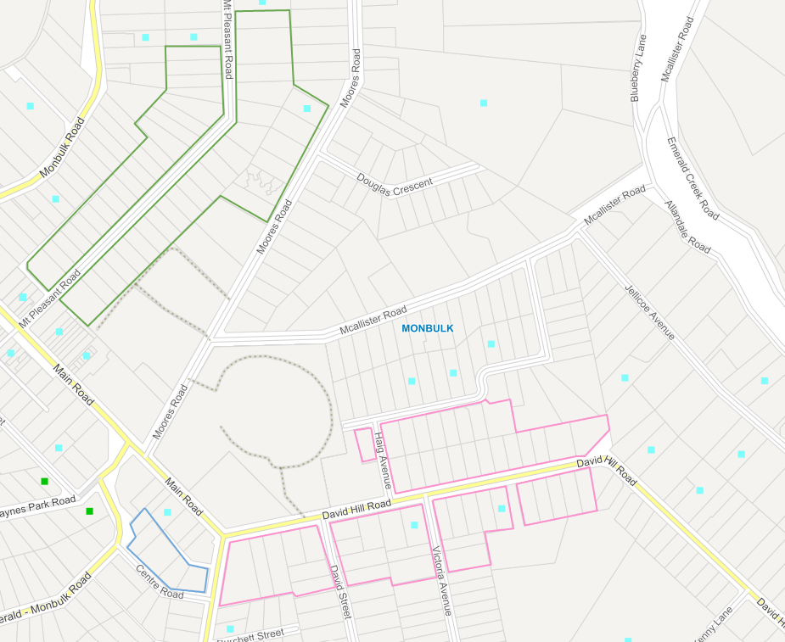
AREA 1
AREA 2
AREA 3

MAP 2 – TERRAMTRIX NORTHERN STUDY AREA, MONBULK

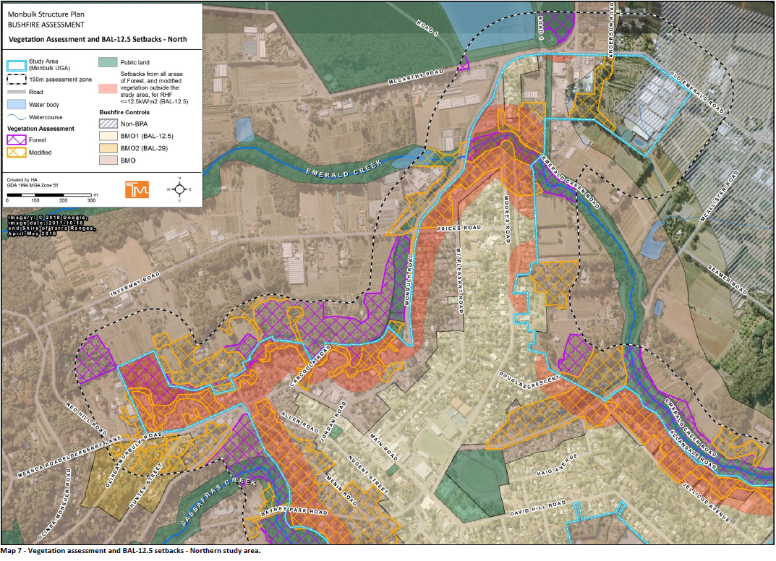

MAP 3 – TERRAMATRIX SOUTHERN STUDY AREA, MONBULK

