Yarra Ranges Council

Draft Community Waste
and Resource Recovery Plan

2022–2030
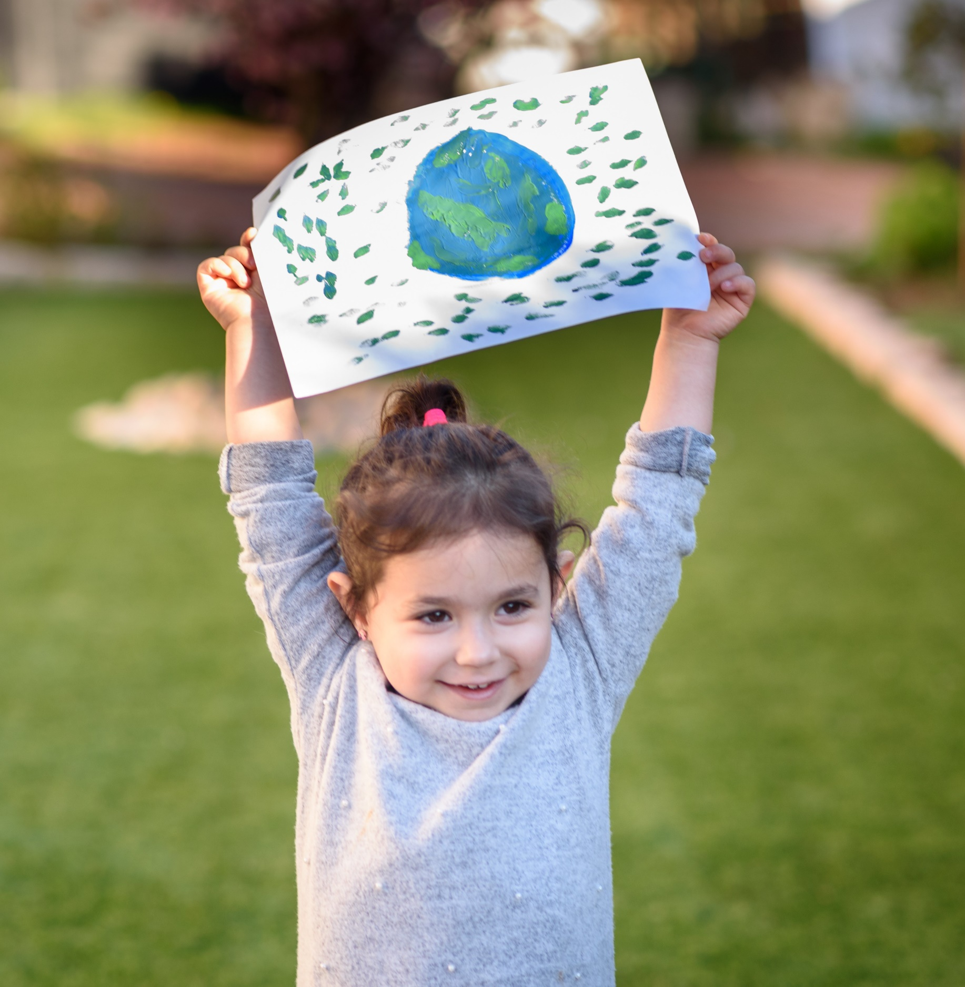

Acknowledgement of Country
We respectfully acknowledge the Traditional Owners, The Wurundjeri People as the Custodians of this land. We also pay respect to all Aboriginal community Elders, past and present, who have resided in the area and have been an integral part of the history of this region.
Council also acknowledges Indigenous ways of being, knowing and doing that led to sustainable societies thriving across Australia, for thousands of years.

Contents
1. Vision 6
2. Setting the scene – the need for change 6
Upcoming changes in Victoria’s waste management industry 7
Future challenges influencing waste management in Yarra Ranges 8
Emerging Trends in Waste Management 9
3. The Bigger Picture of Waste Management 11
Strategic and policy context 11
Yarra Ranges Community Profile 14
Community feedback 15
4. Current waste management services provided by Council 15
Kerbside bin collection services 15
2022 kerbside residential waste collection services 16
Household bin collection statistics 16
Hard Rubbish collections 17
Bundled Branches collections 18
Waste Transfer Stations 18
Other waste collections and services 19
Closed Landfill management 20
5. Our Guiding Principles for Change 20
Waste Hierarchy Principal 20
Circular economy principle 21
Working Together towards Zero Waste - we all have a role to play 22
6. Working Towards our Vision of Zero Waste to Landfill 24
Strategic Directions 24
Our Targets for Action 25
Future Changes to Residential Waste Collections 25
Other residential collections provided by Council 27
Council-supported Collections 28
Other Council waste collection services 28
7. Action Plan 28
8. Monitoring our performance 33
9. Glossary 33

Mayor’s message
People in Australia and in the Yarra Ranges are more aware of their waste than ever before.
When recycling was introduced in the 1990s, it was a pivotal change not just in the way we treated our products, but in the way we thought about what we used.
Separating out hard plastics, glass, paper products and metals gave us a chance to give materials a second life, to reduce what was made fresh and to lighten our impact on the world.
Thirty years on, we now know a lot more, and we can do a lot more. We’re more environmentally conscious, and we’re aware that our planet’s resilience is being stretched beyond its limits.
What we buy, and what we do with things we don’t want, has a tremendous impact on the environment. While there has been steps forward, in recycled packaging and reductions in plastic, we need to do more to make sure what we use can be re-used wherever possible.
This goes further than just making sure you put your items in the correct bin. It’s thinking about when something needs to be thrown away – if it can be repaired, re-purposed or find another home. It’s about finding places to recycle electronic items and batteries, soft plastics and appliances.
More than anything, it’s a change of thinking bigger than when recycling first came about.
It’s about knowing that when you get rid of rubbish, you’re not throwing it away. You’re sending it somewhere else – to be re-used, or to be buried in landfill, where items can potentially release harmful chemicals and take hundreds of years to start decomposing.
This Community Waste and Resource Recovery Plan has also been prompted by the State Government’s Recycling Victoria Policy – where every household in the state will move from rubbish and recycling to a four-stream system: food and garden organics, mixed recycling, glass, and rubbish (sent to landfill or alternative processing).
This plan has been informed by a Community Waste Survey, where thousands of people let us know how they’d like this new system to work for their household.
That feedback, along with expert advice, has shaped this plan.
When reading through this, and as we adjust to the new bin system, it’s vital that we remember that everything we buy and use has an impact, big or small, on the world around us. By being thoughtful about what we buy, how we use it and how we dispose of it, we can help preserve and improve our world for those who come after us.
We will need to work together, and this will be all of our responsibility. There will be challenges, but we’ll be here to support you at Council and we’ll manage this how we’ve managed the challenges of recent years – together.
Cr Jim Child, Mayor of Yarra Ranges

Executive summary
Each year, our modern lifestyles create increasing amounts of waste that pose a risk to human health and the environment. The need to reduce the amounts we create and dispose of it better is recognised by governments and the broader community.
In December 2020, the Victorian Government released its Recycling Victoria policy. This policy outlines some of the biggest changes to waste management since recycling was introduced to Victorian homes around 30 years ago.
The Yarra Ranges Community Waste and Resource Recovery Plan has been developed in response the Recycling Victoria policy, as well as growing concern in the local community about waste and recycling.
The plan presents a vision for the Yarra Ranges community to move toward zero waste sent to landfill, becoming a place where everyone plays their part – avoiding waste, reusing and rehoming items wherever possible, sorting recycling well, and minimising rubbish.
There are many challenges to improving how waste is managed. Population growth across eastern Melbourne and within Yarra Ranges will increase the overall amount of waste. The closure of our closest landfill site in coming years, the increased cost of transport to landfill located further away, increasing waste levy disposal fees and the environmental cost of continuing to dispose of rubbish into landfill means new solutions are necessary.
The desire to make better use of the items we no longer need is leading to the innovation of new technologies. Technologies such as advanced waste processing may allow energy to be made from rubbish rather than sending it to landfill. Recycled product is being used to make new products that could be used by council and local businesses. Council has an important role in keeping up with these new technologies and developments, ensuring they can be used in council activities and promoting these opportunities to local industry and businesses.
In response to the challenges and opportunities, changes are being made to how waste is collected in Victoria. These changes will reduce the amount of rubbish sent to landfill and make more material available for recycling.
Currently, council collects recycling (fortnightly), green waste (fortnightly) and rubbish (weekly) from households and a small number of businesses.
In accordance with the Victorian Government’s Recycling Victoria policy, Yarra Ranges Council will move to a four-stream waste collection over the next four years.
From October 2023, council will collect food and garden organics (weekly), mixed recycling (fortnightly), and rubbish (fortnightly).
In 2025/26, a specific collection for glass (only) will be introduced. From this point, glass will no longer be accepted in the mixed recycling bin.
A comprehensive education program will be provided to all residents and businesses using council collections, helping them use the new system correctly.
The plan proposes ambitious targets for council and the Yarra Ranges community, to minimise waste and significantly cut the amount sent to landfill. The actions outlined in the plan demonstrate the types of activities council will deliver in working toward these targets.
The achievement of this plan relies on council and the community working together to choose, use, sort and dispose of our items better, for the benefit of our community and our environment.

Vision
Our vision is for a Yarra Ranges community working together towards zero waste sent to landfill.
This plan envisions a future where our community is committed to produce less waste, and to maximise the life of the materials we use and the recovery of recyclable materials.
Our council operations, local business and industry, residents and visitors will work together to protect the environment, amenity and liveability of our townships, and create a strong, resilient and financially sound circular economy.

Setting the scene – the need for change
Waste management presents a complex and growing challenge. Our modern lifestyles are creating increasing amounts of waste, including problematic wastes such as plastics and electronic wastes that pose a contamination threat to the natural environment and community health.
Community attitudes are also changing significantly, with growing concern for the environmental costs of consumption and interest in minimising waste through reuse, repair and recycling.
These new expectations necessitate change in how we manage waste at all levels of government. New government policies are being developed, particularly at the state level, to directly address these concerns.
This plan details the context for change to how we manage waste in Yarra Ranges, in response to community concern and new waste regulations, and how these changes will occur over the coming decade. It outlines an action plan for council and the community to maximise resource use and minimise waste sent to landfill.
Delivery of actions will occur between 2022 – 2030, to align with council’s responsibilities under the Recycling Victoria Policy (2020 – 2030).

Upcoming changes in Victoria’s waste management industry
Waste management in Yarra Ranges is influenced by the actions, strategies and legislative requirements of different levels of government, and several of council’s own plans and policies.

Victorian Container Deposit Scheme
Container deposit schemes incentivise recycling through providing a refund when designated containers are returned to a specified place for reuse or recycling.
The first state-run container deposit scheme in Australia was introduced in 1977 in South Australia, where ten-cent deposit paid is on nominated containers, and a refund paid on return of the container. The scheme achieved a recovery rate of 80%.
In December 2020, the Victorian Government announced that a container deposit scheme would be established in the state by the end of 2023. The scheme is being introduced to encourage recycling of eligible drink containers, and to encourage the removal of these common types of litter from the environment.
This scheme will provide an opportunity to significantly reduce litter and enhance recycling in Yarra Ranges.

Recycling Victoria policy
In February 2020, the Victorian Government released its waste policy ‘Recycling Victoria: a new economy’.
This is a 10-year policy and action plan for waste and recycling in Victoria.
The policy aims to reform the kerbside waste and recycling system in Victoria, transforming how the Victorian economy uses materials, and focussing attention on reuse, repair and recycling of materials.
The policy outlines key reforms for household waste collections, to be delivered by councils to households across Victoria, including:
- The introduction of a four-stream waste collection service to all Victorian households by 2030, with bin lid colours meeting the Australian Standard:
  - Food & Garden Organics – lime green lid (food waste, green waste)
  - Mixed Recycling – yellow lid (paper, cardboard, plastics, metals)
  - Glass Recycling – purple lid (bottles, jars)
  - Rubbish – red lid (non-recyclable household waste)
- Targets to prioritise reduction in overall waste generation and waste sent to landfill
These reforms will be complimented by an extensive state-wide education campaign. Council is responsible for local implementation of these education campaigns.

Future challenges influencing waste management in Yarra Ranges

Population Growth
The population of Greater Melbourne – including Yarra Ranges – is expected to grow to 7.5 million people by 2046. At current rates, this will mean an extra half a million tonnes of rubbish will go to landfill each year.
The landfill site currently used by Yarra Ranges Council will close by approximately 2025. It is estimated that two new landfill sites would be required in metropolitan Melbourne to meet current and future needs – if rubbish continues to go to landfill at the same rate.
Landfills have obvious issues for local communities – odour, aesthetics and the need for ongoing management of leachate liquid and methane gas released by the decomposing rubbish. These have a clear and detrimental impact on the environment.
There are also costs to transfer rubbish to landfill sites, which increase for communities further away. These costs are reflected in the annual waste charge on council rates.
Several eastern Metropolitan councils are working together to explore alternatives to sending rubbish to landfill. Options include using advanced waste processing to turn rubbish into energy.
The move to a four-stream waste collection will dramatically reduce what gets sent to landfill by reducing contamination in recycling bins and allowing food and garden organic waste to be composted.
Council will continue investigating ways to promote and support reusable and sustainable options in the community to minimise waste sent to landfill.

Landfill and Waste Fees
Since 1992, Councils have been paying a landfill levy, based on the tonnes of rubbish collected from bins and hard waste that go into landfill.
This cost is passed on to households as part of their waste charge on rates notices. When rubbish is taken to a tip, a large part of the fee paid at the gate reflects the landfill levy. This fee has gone up significantly every year, which in turn makes waste fees higher.
In 2021, this charge was replaced with a waste levy, which it functions in the same way. The State Government can use money from this levy to fund sustainability and waste minimisation projects.
Waste levy fees can be kept lower in future years by minimising rubbish sent to landfill. However, this relies on less material going into rubbish bins.
The four-bin service will allow more material to be collected for recycling, reduce contamination of recyclables and help to keep the amount of waste going to landfill at a minimum.

Geographic constraints
The Yarra Ranges is one of the most unique local government areas in Victoria, with urban towns and regional areas, unmade roads and steep areas that can be difficult for trucks to access.
Due to these factors, rubbish, recycling and hard waste collections cost more, and require specialised trucks that can deal with the demands of the terrain.
Currently, rubbish is taken to the Hallam South Landfill, where it is buried. This landfill is expected to close in approximately 2025, and the next-nearest sites are much further away. Using landfill sites located further away would lead to an increase in landfill costs when the Hallam landfill closes.
Councils across the east of Melbourne are working together to find alternatives to landfill – both to keep costs down, and to reduce the amount of rubbish being buried.

Changing community needs
Community attitudes to waste and recycling have changed considerably in the past ten years.
There is a lot of variation in the amount of waste (recyclable and rubbish) generated by different households across Yarra Ranges.
Some households are trying to live a ‘low- waste’ lifestyle, requiring minimal collection services. Some households generate increasing amounts of waste for a variety of reasons, and experience difficulties in reducing their waste.
This variation is a challenge for the development of a generic waste collection service that meets the needs of a broad spectrum of the community.

Sustainability and climate change
There is increasing awareness in the community of environmental sustainability, and the actions that can be taken to live lighter on the earth.
Council supports several community groups delivering waste-related projects across the Yarra Ranges, including community workshops, clean-up days, composting, low-waste living and shifting away from plastic bag use. Council also provides waste collection support for community events.
Climate change is a significant threat to our environment and community. Decomposing organic waste sent to landfill continue to create methane gases after burial, and owners of closed landfill sites need to manage these emissions for many decades.
The introduction of a food and garden organics bin will allow this waste to be diverted from landfill for composting, using processes that significantly reduce methane emissions, and turning it into useful products for farms and gardens.

Emerging Trends in Waste Management

Advanced Waste Processing
Advanced waste processing (AWP) is a technique used successfully around the world to sort household rubbish materials and use residual waste to produce electricity and/or heat. It provides an alternative to burying waste in landfill, particularly in areas without suitable space for landfill construction.
AWP facilities are used in many large cities in the United Kingdom, Europe, Asia and North America, complying with strict safety and emission standards.
Advanced sorting and separation is part of the AWP process. Facilities can sort materials on arrival to retrieve recyclables from rubbish. Recyclable metals can also be retrieved using magnetic technology after incineration for energy production.
Data from Sustainability Victoria indicates that at least 10% of materials collected in rubbish bins in Victoria is recyclable paper, cardboard, plastics and glass.
Advanced sorting and separation technologies at an AWP facility could enable this material to be retrieved, a feature not available when sending rubbish directly to landfill.
A medium-sized AWP facility can process 300,000- 400,000 tonnes of waste per year, using a mix of anaerobic digestion, gasification and combustion technologies to create energy.
There is a small amount of ash and residual material left over after processing and incineration. Once leftover metals are retrieved from the residue, this material is tested for contamination. Uncontaminated material is sent to landfill, and any contaminated material is sent to an appropriate hazardous waste facility.
Advanced waste processing reduces the volume of waste sent to landfill by around 80%. This will significantly assist councils to reach waste reduction targets set in the Recycling Victoria policy.
There are currently no existing AWP facilities able to process the volume of waste being collected from households across eastern Melbourne.
Yarra Ranges Council is part of a group of councils planning to construct their own AWP facility by 2026. This new facility will assist a number of councils to avoid disposing to
landfill.
Further AWP facilities are planned for other areas of Australia, including Perth (WA), Woodlawn (NSW), Swanbank (QLD), Laverton North (VIC) and Morwell (VIC).
The Victorian Environment Protection Authority is supportive of AWP facilities being commissioned in Victoria. A study conducted for the EPA (Vic) concluded that there is little potential for health impacts or risk from exposure to airborne emissions from modern AWP facilities. Studies by Public Health England (the UK health protection agency) demonstrated that ‘particle levels caused by combustion (AWP) facilities are extremely low and could often not be distinguished from other background sources such as traffic’.

New and emerging markets for recycled product
One of the key commitments within the Recycling Victoria policy is to increase the use of products created with recycled content in Victoria. The Victorian Government has created a Recycled Markets Acceleration Package to encourage industry innovation, drive demand for products with recycled content, and develop industry standards for the use of recycled content in commercial, industrial and construction settings.
The Victorian Government has committed to increase the use of recycled content in their procurement of goods. Funding is also being provided to councils to work in partnership with industry in developing new uses and local industry markets for recycled content.

Product Stewardship Schemes
Product Stewardship Schemes place responsibility for product disposal and/or recycling with producers, importers and retailers of goods responsible rather than consumers – particularly for items that are difficult to dispose of or recycle.
Examples of existing product stewardship schemes include:
- Cartridges for Planet Ark – supported by Brother, Canon, Epson, HP, Konica Minolta and Kyocera;
- Mobile Muster – supported by phone handset and accessory manufacturers
- National Television and Computer Recycling Scheme – supported by the electrical goods industry
- Tyre Stewardship Australia – supported by a range of tyre importers, as well as automotive manufacturers Mercedes Benz, Porsche and Volkswagon.
The Federal Department of Agriculture, Water and Environment annually calls for submissions from industry, public and consumers recommending future stewardship schemes to be developed by industry with government support.
Councils can support product stewardship schemes by investigating options for local material collection points and promoting programs to local businesses and the community.

The Bigger Picture of Waste Management

Strategic and policy context
Waste management in Yarra Ranges is influenced by the actions, strategies and legislative requirements of different levels of government, and several of council’s own plans and policies.

Federal waste policy
The Federal Government’s ‘National Waste Policy: Less Waste, More Resources’ was released in 2018. The policy provides a framework for nation- wide waste and resource recovery. It outlines five key principles for transitioning to a circular economy, including:
- Waste avoidance
- Improved resource recovery
- Increased use of recycled materials and market development for these products
- Better management of materials to improve human and environmental health
- Improved information for innovation, investment and decision making.
The Federal Government currently regulates the export of all plastic, glass and tyre waste from Australia. From 2024, it will regulate the export of paper and cardboard, ensuring that waste cannot be sent overseas. These regulations impact how the waste collected from households can be processed and turned into new products.
The Federal Government also supports national product stewardship schemes to provide collections for difficult items such as electronics, packaging and vehicle tyres.

State waste policy – Recycling Victoria
State and territory governments are responsible for the regulation of waste management and resource recovery within their state.
In February 2020, the Victorian Government released its waste policy ‘Recycling Victoria: a new economy’. This is a 10-year policy and action plan for waste and recycling in Victoria, reforming kerbside collections to a state-wide four-stream system.
As well as outlining future kerbside collection reforms, the Recycling Victoria policy also outlines focus areas for broader change in how the Victorian community manages waste, including:
- Support for businesses to reduce waste and improve product stewardship
- Support for wide ranging efforts to repair and reuse products rather than send them to landfill
- Preventing plastic pollution and banning single-use plastics
- Introducing a container deposit scheme for Victoria by 2022-23
- Creating new markets for recycled materials
- Support for development of facilities to generate energy from rubbish incineration before sending waste to landfill
- Improving the safe management of hazardous materials

Regional context – Metropolitan Melbourne and Eastern Suburbs
Over the past decade, Yarra Ranges Council has been a member of the Metropolitan Waste and Resource Recovery Group, who work together to plan and deliver collaborative projects and contracts in waste management.
Regional Waste and Resource Recovery Groups across Victoria will soon merge with the waste business unit within the Department of Environment, Land, Water and Planning, to create the Recycling Victoria Authority. This authority will oversee the state-wide kerbside waste service reform and the implementation of the Recycling Victoria policy.
The development of collective regional waste collection and processing contracts will continue with the transition to a new authority. Regional partnerships for waste education projects will also continue.

Local Council – relevant strategies, policies, and plans
Waste services within Yarra Ranges Council influence, and are influenced by, several key council strategies and policies

Council Plan 2021–2025
The Yarra Ranges Council Plan aims to deliver a range of services that build inclusive and connected communities, with sustainable and balanced growth.

Strategic Objectives
The delivery of a new Community Waste Plan is a key action under the ‘Protected and Enhanced Natural Environment’ strategic objective of the Council Plan.
Connected and healthy communities | Vibrant economy, agriculture and tourism | Protected and enhanced natural environment | Quality infrastructure and liveable places | High performing organisation

Other relevant Council Strategies and Plans
Health and Wellbeing Plan 2021–2025 |  | Environment Strategy 2015–2025
 | Liveable Climate Plan | Community Waste Plan 2022–2030 | Recreation and Open Space Strategy
 | Waste Services Policy Tip Pass Policy

Yarra Ranges Environment Strategy 2015-2025
The Yarra Ranges Environment Strategy 2015-2025 has several strategic goals relevant to waste management, including
Goal 1 | Our iconic places and their natural character are actively protected | Examples of how we may achieve this goal include:  - Managing litter in our natural areas, parks, and streetscapes, and providing appropriate opportunities for disposal of waste in public areas.
Goal 4 | Our local economies are strengthened by environmentally sustainable activities | Examples of how we may achieve this goal include:  - Providing a commercial waste collection to small businesses that enables them to manage their waste in a sustainable manner.  - Where possible, supporting local industries to develop innovative solutions to local waste issues
Goal 5 | Our communities are resilient in the face of a changing climate and more extreme more events | Examples of how we may achieve this goal include:  - Providing green waste collection services that assist  property owners to reduce bushfire risk  - Providing sustainable waste management solutions in response to local emergencies  - Providing waste management services and education that will assist in reducing carbon emissions from waste disposal (e.g. composting food and organic waste rather than sending it to landfill).
Goal 6 | All who live and work in the Yarra Ranges see themselves as stewards of our environment | Examples of how we may achieve this goal include:  - Provide the community with waste-focussed education and resources to minimise waste  - Engage with the community and provide environmentally focused education, support, resources and events.  - Encourage environmentally sustainable choices for people’s homes, properties and businesses.

Yarra Ranges Community Profile
162,346  est. individuals currently residing in Yarra Ranges | 60,663  est. rateable properties  in Yarra Ranges for 2022 | 55+  townships in Yarra Ranges covering 2,500 square km
Neighbourhood character  of townships range from urban to forested hills and rural towns and localities | More than 70%  of the population is concentrated on smaller blocks in urban and township settings | Approx 90%  of dwellings are separate houses, 5.9% are medium density, and 0.2% are high density dwellings
185,902  projected population in 2041, with expected growth of 20% over next 20 years | 3,000  new homes expected at former Lilydale quarry, with most significant growth to occur in this township | Future growth  also projected in Chirnside Park, Kilsyth, Mooroolbark, Yarra Junction, Millgrove and Wesburn

Community feedback

The Yarra Ranges community is very passionate about waste.
In June 2021, Yarra Ranges Council conducted a Community Waste Survey to determine community views and expectations for local waste collections and waste management.
More than 7000 responses to the survey were received via the Shaping Yarra Ranges website and postal survey forms - well-exceeding expectations, and providing a statistically significant snapshot of community opinion.
Residents, landlords and local businesses detailed their satisfaction with the current waste services, preferences for future services complying with the Recycling Victoria policy, and suggestions for how waste education and engagement could be improved.
The findings of the survey have informed the service changes detailed in this plan, considered together with industry research into best practice waste management. A copy of the Community Waste Survey Summary Report is available on the council website.

Current waste management services provided by Council

Kerbside bin collection services
Yarra Ranges Council provides kerbside waste collection services to more than 60,000 households across the municipality.
Kerbside waste collections (e.g. rubbish, recycling) are also provided to small businesses, non-residential and non- rateable properties such as community centres, sporting clubs, community groups and churches. These services include either a twice-weekly collection of a 120- litre rubbish bin and fortnightly collection of a 240- litre recycling bin, or an equivalent service.
 | Frequency | Bin size | Options
Rubbish | Weekly | 120L | 80L for reduced annual fee
Recycling | Fortnightly | 240L | 120L available for elderly residents or those living in retirement villages
Green waste | Fortnightly | Optional; 120L or 240L | Green waste collection is available in urban areas, townships and the Dandenong Ranges.
Hard rubbish | Annual (residential properties) | Up to 3 cubic  metres, plus unlimited  metals | Collected in January – March
Bundled branches | Twice-yearly (residential properties) | Up to 3 cubic meters | Collected in November/ December and January – March

2022 kerbside residential waste collection services
 | Frequency | Bin size | Options
Rubbish | Weekly | 120L | 80L for reduced annual fee
Recycling | Fortnightly | 240L | 120L available for elderly residents or those living in retirement villages
Green waste | Fortnightly | Optional; 120L or 240L | Green waste collection is available in urban areas, townships and the Dandenong Ranges.
Hard rubbish | Annual (residential properties) | Up to 3 cubic  metres, plus unlimited  metals | Collected in January – March
Bundled branches | Twice-yearly (residential properties) | Up to 3 cubic meters | Collected in November/ December and January – March

Household bin collection statistics

The amount of waste collected in each of the three current kerbside bins is recorded by council’s Waste Management team for each financial year.

RECYCLABLES  280kg recyclables produced per household per year  Higher than average compared to state- wide and outer metro averages. | RUBBISH  504kg rubbish produced per household per year  Slightly higher than state-wide averages, but consistent with other outer metro averages. | GREEN WASTE  410kg green waste produced per household per year  Higher than state-wide and outer metro averages.

Recyclable resource recovery and contamination in household bins
The current rate of materials diverted from landfill from household bins in Yarra Ranges is 45% (not including contaminating items). This means that out of the total amount of waste from all streams collected from properties across Yarra Ranges, almost half of all waste is diverted away from landfill and collected within recycling and green waste bins.
Contamination of materials collected in recycling bins is an ongoing issue across the municipality. Contamination of recycling bins with materials that are not recyclable through council’s collection leads to materials that are of lesser quality of repurposing into new products. Contaminating items can cause damage to machinery that sorts materials collected for recycling. In extreme cases, high levels of contamination can cause an entire truck load of recyclables to be sent directly to landfill.
An audit of one truckload of recyclable materials collected from the kerbside in Yarra Ranges was conducted by VISY Industries (council’s recyclables receiver) in 2019.
This audit showed a contamination rate in recyclables of 10.5%.
In this audit, common contaminants included soft plastics (such as shopping bags and food packaging), textiles, bagged waste (including bagged recyclables that should have been disposed loose into the recycling bin) and shredded paper (not recyclable in kerbside bins).
This contamination rate is the same as the state-wide average during the 2018/19 financial year.
In the 2019/20 financial year, the state-wide average contamination rate increased to 13.3%.
Due to COVID restrictions, further recycling truck audits were unable to be conducted in 2020 and 2021 to provide a local comparison.
Ongoing education for residents about what is and is not acceptable in recycling bins is required to reduce contamination rates and improve the rate of materials diverted from landfill.

Hard Rubbish collections
Hard rubbish collections are provided once per year to each residential property in Yarra Ranges. These collections occur between January and March. The purpose of hard rubbish collections is to provide for the collection of materials that cannot be repurposed, donated, reused by others and can’t fit into kerbside rubbish bins.
Each property may dispose of up to 3 cubic metres of materials, including:
- Unwanted furniture that cannot be donated or reused by others
- Electronic waste – such as computers, televisions, monitors, all other battery and power-operated items and items with an electrical cord
- Mattresses
Each property may also dispose of unlimited household whitegoods and metals.
The level of material recycled from kerbside hard waste collections is low, with an average recovery rate of 24% per year

Bundled Branches collections
Bundled Branches collections are provided twice per year to each residential property. These collections occur in November- December (to assist with fire season preparations) and in conjunction with hard rubbish collections conducted between January and March.
The purpose of the bundled branches collections is to provide for the collection of materials that are too big to be placed into kerbside green waste bins.
Each property may dispose of up to 3 cubic metres of branches including branches up to 1.5m long and 200mm diameter, or single limbs of between 75mm and 200mm diameter and 1.5m long.
The bundled branches collection does not collect stumps, roots, timber pieces, bamboo, creepers and vines, palm trees or thorny plants. These plants should be cut up and disposed of into green waste bins or taken to a waste transfer station for disposal.
Over the last five years, an average of 405 tonnes of bundled branches has been collected each year from across the municipality. This material is composted to create products for gardeners and horticultural industries.

Public place litter bins
Approximately 940 litter bins are distributed in townships, parks, reserves and sporting clubs through the Yarra Ranges. These bins provide a disposal point for rubbish and recyclables in locations used by the community. Waste collected in litter bins is then sorted by council’s receiving contractor to capture recyclables.
Over the last five years, the amount of rubbish collected in these bins has averaged around 400 tonnes per year. In 2019/20 and 2020/21 these totals decreased by approximately 50 tonnes, likely due to reduced visitor numbers during coronavirus lockdowns.

Waste Transfer Stations
Waste transfer stations are central locations for the disposal of bulky recyclables and waste destined for landfill.
The items that can be taken to waste transfer stations for disposal often include bulk amounts of cardboard, green waste and hard rubbish, timber, bricks and concrete, glass, mattresses, and hazardous waste materials such as chemical containers, light globes, batteries, motor oil, electronic waste, paint and tyres.
Waste Transfer Stations in Yarra Ranges are operated by private waste management companies, and are located in:
- Lysterfield (operated by Cleanaway)
- Coldstream and Wesburn (operated by KTS Recycling)
- Montrose Transfer Station (operated by Grosvenor Lodge)
Some facilities also operate a ‘tip shop’ where reusable goods in reasonable condition can be purchased for a small fee. This includes both garden and construction materials, toys and household goods.

Other waste collections and services
Council supports the community with the management of other waste materials, either directly, through the delivery of activities, partnership with groups and industry, and through promotion of other service providers.
These services include:
- Promotion of drop off locations for household batteries
- Delivery of Detox Your Home events with Sustainability Victoria
- Waste collection services for local Clean Up Australia Day activities
- Waste management assistance to groups organising community events (delivered through council’s Community Grants program)
- Delivery of waste-focussed community events and educational workshops with community and industry partners
- Delivery of education, incentive and rebate projects and programs, such as educational webinars and council’s Home Composting Rebate Program
- Provision of special collections or tip passes for the disposal of materials, available to:
  - Charities disposing of unwanted and unsaleable goods, and materials collected from property clean up by charities
  - Emergency services disposing of materials from clean-outs or unsaleable donated goods
  - Friends Groups assisting with the collection and disposal of waste and weeds from council-owned bushland reserves
  - Residents applying for Weed Wipeout vouchers for assistance with removal of selected environmental weeds from private property.

Closed Landfill management
Yarra Ranges Council is responsible for the ongoing management of five former landfill sites. These include:
Coldstream closed landfill | active from 1977 to 2004
Healesville closed landfill | active from 1975 to 1997
Wesburn closed landfill | active from approx. 1970 to 1993
Lysterfield closed landfill | active from approx. 1968 to 1995
Mt Evelyn closed landfill | active from approx. 1960 to 1992

Once landfill sites are full, they are capped with a clay layer and grass or other low vegetation. This cap contains the materials and prevents infiltration of rainfall or surface water that may filter through the waste materials, picking up chemicals and other hazardous liquids, creating excess contaminated leachate.
Common issues with closed landfill sites that require careful management include the management of toxins and leachate from
hazardous materials within the landfill, and the management of methane emissions emitted from organic waste, such as food and garden waste breaking down within the landfill.
Each of the closed landfill sites in Yarra Ranges
is actively managed by council to minimise the risk to the environment and human health, in line with obligations under the State Environment Protection Act 2017.
Due to the ongoing decomposition of landfill materials in these sites, active management will be required for around 30 to 50 years after closure. Methane gases, leachate liquid and ground water are monitored over this time, until the sites are declared as no longer posing a risk by the Victorian Environmental Protection Authority.
The Coldstream and Healesville sites are managed in accordance with their Post Closure Management Plans and EPA Post Closure Pollution Abatement Notices.

Our Guiding Principles for Change

There are two key guiding principles for waste management that should be considered in the planning of all future waste services.

Waste Hierarchy Principal
The Waste Hierarchy Principle ranks waste disposal options from most preferable to least preferable. It is represented as an inverted triangle, representing the frequency of time that an option should be selected.
At the top of the hierarchy, waste avoidance should be considered most often, selecting items that will create minimal waste in the future. Reuse is the next option when considering how to deal with an item no longer wanted. Recycling is the next preferable option when reuse by yourself or another person is not possible.
Recovery of energy or other goods from waste items is the next option for items that cannot be dealt with by the higher ranked options.
Treatment and containment follow as next preferable, and this option is particularly relevant to hazardous waste items such as asbestos and radioactive waste.
Disposal in landfill is considered as the least preferable and last resort if no higher ranked option is possible.
The proposed changes to waste collection services in Yarra Ranges, together with waste education, should encourage the community to choose upper options from the waste hierarchy wherever possible.
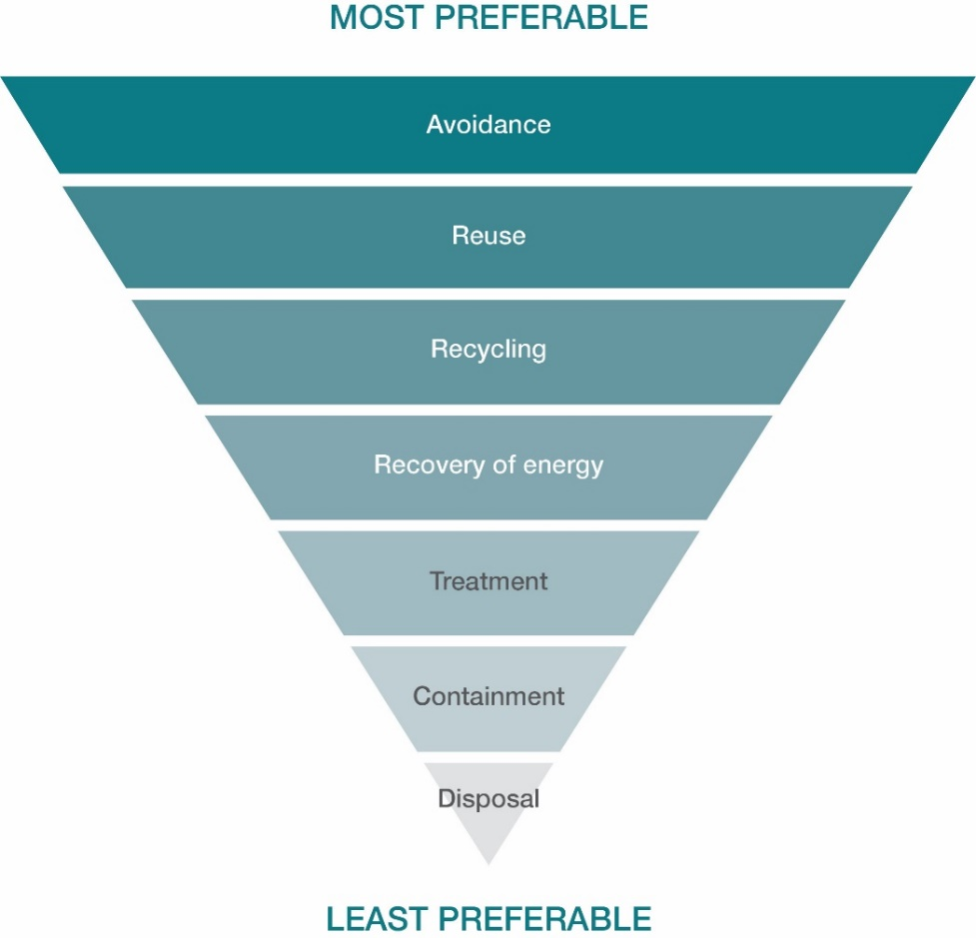

Circular economy principle
The Australian economy has traditionally always been linear in nature. This means that the steps in sourcing natural resources, manufacturing and using products, and creating waste has most often been a one-way system.
The concept of a circular economy has arisen from the realisation that our natural resources are finite, and their use to create products causes negative impacts on our environment.
A circular economy is an alternative model to the linear economy. It looks to find new uses for waste products through reuse, recycling, or recovery of resources for other purposes such as waste to energy. It encourages the management of waste using the waste hierarchy principle.
The proposed changes to waste collection services in Yarra Ranges, together with waste education, should encourage the community to
consider the circular economy and take responsibility for the waste they will create in their lifestyle and purchases.

Linear economy  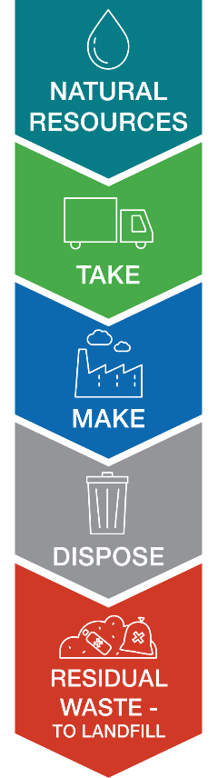 | Circular economy  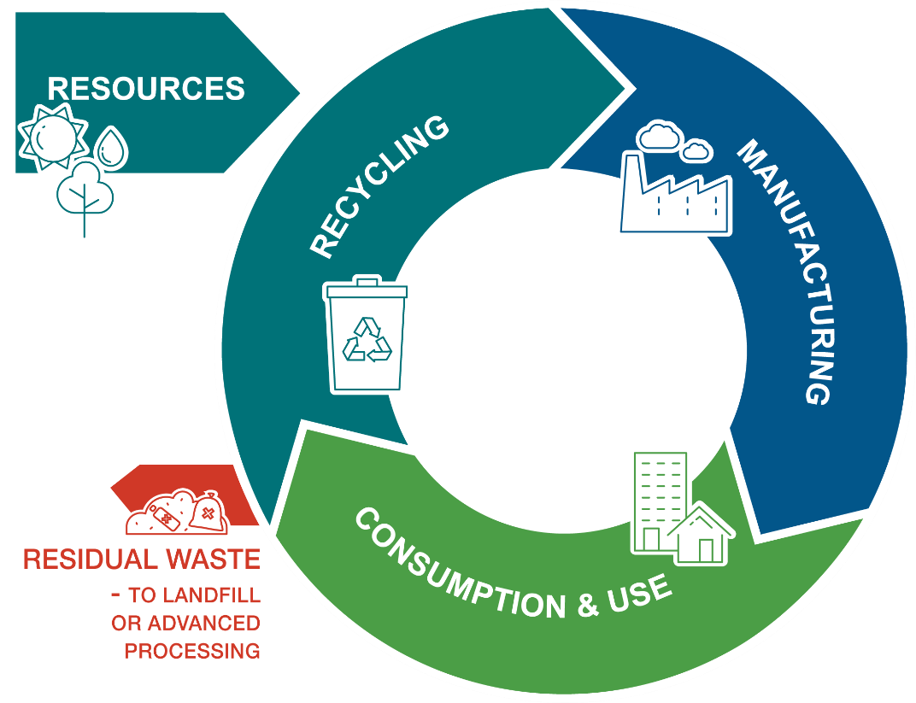

Working Together towards Zero Waste - we all have a role to play
We all create waste, and we all have a role to play to ensure that it is appropriately managed to conserve natural resources and minimise the amount we send to landfill.

Australian Government  Ensuring international obligations for waste management are met. Oversees national waste policy, administers product stewardship schemes |  | Victorian Government  Sets strategy policy direction, makes laws and regulates waste management across the State
Local Government  Delivers waste and recycling services to households and some businesses. Educates the community on how to use these services appropriately. |  | Waste and resource recovery industry  Collect, sort and manage waste for recycling and disposal.

Local industry  Makes decisions on how they use resources, design products or services and manage waste generated by their operations and products |  | Local households and businesses  Purchases products and make decisions about how they maintain, use and dispose of those products.
Community groups  May run projects to help their community minimise waste, such as educational workshops, tool sheds, repair cafes and clothing swaps. |  | Educational institutions  Help learners to understand their world, including the potential impacts of their decisions and how to make sustainable choices.

Based on example from Recycling Victoria policy.

Working Towards our Vision of Zero Waste to Landfill

Strategic Directions
Council will work to develop services and programs for waste management around four key themes.
Avoid & Reduce |  | Recover & Recycle
Council will encourage waste avoidance and reduction through education programs and supporting community programs for sharing, repurposing and repair of products and materials. |  | Council will encourage the recovery and recycling of materials through education programs and delivery of collection services focussed on maximising recovery of recyclables.
Engage & Empower |  | Lead by Example
Council will encourage and support community leadership of waste minimisation projects and involve a diverse range of participants in activities aimed to improve how we manage our waste. |  | Council will prioritise waste minimisation, procurement of recycled and recyclable goods, and the trial and use of recycled contents in its operations and delivery of projects and programs. We will become a leader in organisational sustainability, leading by example in the pursuit of a vision of zero waste sent to landfill.

Avoid & Reduce |  | Recover & Recycle
Council will encourage waste avoidance and reduction through education programs and supporting community programs for sharing, repurposing and repair of products and materials. |  | Council will encourage the recovery and recycling of materials through education programs and delivery of collection services focussed on maximising recovery of recyclables.
Engage & Empower |  | Lead by Example
Council will encourage and support community leadership of waste minimisation projects and involve a diverse range of participants in activities aimed to improve how we manage our waste. |  | Council will prioritise waste minimisation, procurement of recycled and recyclable goods, and the trial and use of recycled contents in its operations and delivery of projects and programs. We will become a leader in organisational sustainability, leading by example in the pursuit of a vision of zero waste sent to landfill.

Our Targets for Action
The Recycling Victoria policy sets three key targets to be achieved across the state by 2030.
The changes to waste collection services described in this plan will assist to achieve these targets.

Recycling Victoria Target

1. 15% reduction in total waste generation per capita between 2023 and 2030 |  | 2. Divert 80% of waste from landfill by 2030, with an interim target of 72% by 2025 |  | 3. Cut the volume of organic material going to landfill by 50% between 2022 and 2030, with an interim target of 20% by 2025
With increased community education programs, council believes that exceeding these targets is possible and desirable. Therefore, Yarra Ranges will aim to achieve the following waste reduction targets:
1. 20% reduction in total waste generation per capita by 2030. |  | 2. Divert 90% of waste from landfill by 2030, with an interim target of 75% by 2025. |  | 3. Cut the volume of organic material going to landfill by 60% by 2030, with an interim target of 25% by 2025.
Meeting these targets will depend on the level of behaviour change and correct use of the four- stream collection system achieved in the Yarra Ranges community in coming years.

Future Changes to Residential Waste Collections
Upcoming reform of the kerbside waste collections will significantly contribute to the reduction of waste sent to landfill, allowing the community to recover more materials for recycling (including composting).
Council proposes the following changes to waste and recycling collection services to begin from October 2023, with changeover complete in 2025/26 with the introduction of a separate glass collection service:
Mixed Recycling (continuing)
Frequency | Fortnightly
Bin size | 240L (120L available for elderly residents, those in retirement villages)
Put in this bin | - Plastic bottles, containers  - Steel cans; aluminium cans, trays and foil  - Cardboard, paper

Food & Garden Organics (starting October 2023)
Frequency | Weekly
Bin size | 240L or 120L
Put in this bin | - Fruit and vegetable scraps  - Citrus, onions, garlic  - Seafood, meat scraps, bones (raw and cooked)  - Leftovers  - Coffee grounds, tea leaves  - Plants, leaves, grass, twigs, branches

Rubbish (continuing, with lid changed to red from 2022/23)
Frequency | Fortnightly
Bin size | 80L or 120L
Put in this bin | - Non-recyclable plastics, polystyrene  - Plastic bags and soft plastic packaging  - UHT/Tetrapak, milk, juice cartons  - Broken glass, ceramics, non-electrical household items  - Bagged pet waste  - Disposable nappy and sanitary waste, wipes  - Bedding, clothing and textiles

Mixed Recycling (continuing)
Frequency | Fortnightly
Bin size | 240L (120L available for elderly residents, those in retirement villages)
Put in this bin | - Plastic bottles, containers  - Steel cans; aluminium cans, trays and foil  - Cardboard, paper

Glass Recycling (introduced 2025/26)
(Bin or centralised collection - yet to be finalised)
Frequency | Monthly
Bin size | 80L (if provided as a bin)
Put in this bin | - Wine bottles  - Other beverage bottles (soft drink, cordial, kombucha, beer)  - Jars – e.g., pasta, sauces, jam, salsa, marinade/dressing

Other residential collections provided by Council
Hard (bulky) Rubbish
Frequency | Annually January – March *
Bin size | 3 cubic metres per property plus unlimited metals
Put out for collection | - Unwanted furniture and items that cannot be repurposed, donated or reused by others and are too large to place into kerbside rubbish bins  - Whitegoods & metal (unlimited)  - Electronic waste – computers, TV’s, monitors, battery/power cord operated items  - Mattresses  - Glass, shower screens, mirrors (wrapped and marked ‘glass’)

Bundled Branches
Frequency | Twice per year - November/December and January - March during Hard (bulky) Rubbish collection
Bin size | 3 cubic metres per collection per property
Put out for collection | - Logs 75mm - 200mm wide, up to  - 1.5m long; straight and clean with side branches removed.  - Branches up to 75mm wide tied into bundles with non-plastic twine. Maximum of 20 bundles that are no longer than  - 1.5m and no more than 200mm wide.

Council-supported Collections
Council will continue to support special collections including Detox Your Home, Clean- Up Australia Day and special tip passes for charities, emergency services, community service groups and environmental weed control activities.
Council will continue and enhance its promotion of various special collections available in the community, such as electronic waste, soft plastics, textiles, batteries, polystyrene and chemical containers.

Other Council waste collection services
As part of the delivery of the Action Plan, council will conduct a review of the current commercial bin collection service, including services provided to community and sporting groups. This review will be conducted prior to the implementation of the new collection service in October 2023, and users notified of any changes to be made to collections.

Action Plan

The following table outlines the actions council will take towards achievement of the strategic objectives and targets of this plan.

Theme |  | Action | Potential Delivery Partners |  | Priority
 |  |  | Internal | External | 2023-  2024 | 2025-  2027 | 2028-  2030
Avoid &  Reduce | 1 | Promote the avoidance of, and alternatives to, single use plastics within waste education programs | Waste Management, Communications | Community Groups, Businesses | • | •
 | 2 | Investigate ways to support reuse, repair, share with sectors in the community through activities such as repair cafes and tool/toy/ equipment libraries | Waste Management, Sustainability | Community Groups | • | •
 | 3 | Provide advice and support for general community projects targeted at waste avoidance and minimisation | Waste Management, Community Partnerships & Wellbeing | Community Groups | • | • | •
 | 4 | Advocate for reuse shops to be established at all transfer stations across the municipality, to increase recovery of saleable second-hand goods | Waste Management | Transfer Stations | • | •
 | 5 | Support Yarra Ranges Food Connections and other local food groups and networks to include food waste avoidance in programs and activities | Waste Management, Community Partnerships & Wellbeing | Community Groups | • | • | •
Recover &  Recycle | 6 | Review and develop a plan for waste collection services to sporting clubs and community groups to ensure equitable provision of services | Waste Management, Recreation & Active Living | Sporting Clubs, Community Groups | •
 | 7 | Investigate options for larger bin sizes for residentially-rated, multi-unit developments to reduce kerbside and bin storage challenges | Waste Management, Planning Services | Developers, Property Managers | •
 | 8 | Investigate options for kerbside glass collection to ensure selection of the most appropriate option for the service to achieve maximum recovery | Waste Management | Recycling Victoria | • | •
 | 9 | Investigate appropriate options for park and street litter bins to meet requirements of collection reforms, with consideration of response measures to high levels of contamination in street litter recycling bins | Waste Management | Collection Contractor | • | •
Engage &  Empower | 10 | Develop and deliver a Waste and Resource Recovery Education Plan for residents and businesses using council’s waste services | Waste Management, Economic Development, Sustainability | Community Groups, Businesses | • | • | •
 | 11 | Deliver education programs in line with state-wide Recycling Victoria education campaigns | Waste Management, Communications | Sustainability Vic/ Recycling Victoria | • | • | •
 | 12 | Develop a change management plan for implementation of future waste services, including delivery of educational materials | Waste Management, Communications, Economic Development & Investment |  | •
 | 13 | Investigate options for promotion and incentivising use of waste minimisation items such as reusable nappies and sanitary items. | Waste Management, Sustainability | Partner Councils | •
 | 14 | Initiate and deliver quarterly online reporting of waste data to the  community – including recycling streams, waste sent to landfill | Waste Management, Strategy & Transformation | Waste audit consultant | • | • | •
 | 15 | Review current recycling bin provisions to school and early years services. Develop a policy for provision of new collections to schools in line with education programs | Waste Management, EASL - ResourceSmart Schools | Schools | • | •
 | 16 | Increase promotion of collections for hazardous and difficult to dispose items and increase participation of council-supported collections, based on 2022 levels. | Waste Management, Communications | Recycling Victoria, Transfer Stations | • | •
Lead by Example | 17 | Review litter and dumped rubbish enforcement procedures to ensure they align with regulatory expectations | Waste Management, Community Safety |  | •
 | 18 | Promote council’s Community Grants programs to attract and support waste minimisation projects in the community | Waste Management, Community Development & Wellbeing | Community Groups | • | •
 | 19 | Develop and implement a plan for measuring, monitoring, waste  minimisation and reducing waste sent to landfill from all council facilities | Waste Management, Property & Facilities Management, EcoLeaders |  | • | •
 | 20 | Review and amend council event policies and procedures to reflect changes to waste collection services, and strengthen requirements for waste minimisation in council-led and supported events | Waste Management, Cultural Facilities | Community Groups, Event Organisers | • | •
 | 21 | Work with council departments, contractors and designers in the creation of infrastructure and facilities that are designed for resource efficiency and include use of recyclable and recycled materials | Waste Management, Property & Facilities Management, Infrastructure Services, etc. | Contractors, Consultants, Recycling Victoria |  | • | •
 | 22 | Strengthen waste minimisation principles and actions in council procurement policies to utilise more recycled and recyclable product and ensure suppliers prioritise waste avoidance practices | Waste Management, Procurement Services | Recycling Victoria | • | • | •

Monitoring our performance

We will monitor our performance against this plan, its strategic objectives and targets on a regular basis.

Monitoring | Methods
Benchmarking council performance | Conduct regular truck audits across the collection streams to determine recovery and contamination rates
Monitoring | Truck audits – every two years  Quarterly collation of council collection data  Quarterly online recovery rate updates to the community via Council’s website
Reporting on achievement of this plan | Mid-term reporting in 2026  Final reporting of outcomes in 2030/31

Glossary
Advanced Waste Processing | a technique used to sort household rubbish materials, remove all misplaced recyclables and use residual waste to produce electricity and/or heat
Bundled Branches | a twice-yearly collection provided by council to collect branches and other specified plant material for composting, especially prior to bushfire season
Collection contractor | the company that picks up waste from properties on behalf of council
Container deposit scheme | a scheme that provides a small refund (~10 cents per container) on drink containers dropped off at specified locations and sends them for recycling
Contamination | undesirable items included with collected waste items, for example old clothing disposed in a recycling bin would be considered as contamination
Detox Your Home | a collection run by the Victorian Government, allowing residents to drop off chemicals for safe disposal
Electronic waste | unwanted items that are battery-operated or have a power cord
Four-stream  collection system | the new Victorian waste collection system that includes four bin/ collection types – Food & Garden Organics, Mixed Recycling, Glass Recycling and Rubbish
Hard plastics | recyclable plastic household containers that can hold or return to their shape when scrunched; especially food and beverage containers
Hard rubbish | an annual collection provided by council to collect specified unwanted  large, bulky items that cannot be placed into rubbish bins
Kerbside bin/  collection | waste bins and collections that are collected from the side of the road at the front of resident’s properties
Landfill | a location where rubbish is taken for disposal by burial in enclosed pits
Landfill Levy/  Waste Levy | a fee charged on each tonne of rubbish disposed into landfill
Materials  Recovery Facility | the facility where recyclables collected from kerbside bins are sorted into material types and bundled for recycling.
Methane gas/  emissions | a colourless and odourless gas that occurs in nature, produced by the break down of organic material such as the decay of plant matter in landfill, or the digestion of food by animals. Methane is a significant greenhouse gas contributing to climate change. The decomposition of organic matter in landfill is one of the top three contributors of global greenhouse emissions
Organic waste | waste of plant or animal origin that is biodegradable
Product stewardship scheme | a scheme run by producers that assists customers to return used items for correct disposal or recycling. For example, some television and computer companies provide recycling (product stewardship) schemes for used television and computer equipment
Residual waste | the waste left over after all recyclable (including compostable) materials have been taken away for recycling; also called rubbish
Resource recovery | the recovery of items (resources) for recycling, reuse or repair rather than sending it to landfill. This term considers items as having a value, rather than being ‘waste’ to be thrown away
Single-use plastics | plastic items that are normally used once – such as plastic straws, spoons, plates, take-away drink cups
Soft plastics | plastic packaging that does not hold its shape once emptied, and mostly remains as a ball when scrunched up rather than bouncing back into its original shape. Often in the form of bags that hold food items such as pasta, bread, lollies, potato chips
Waste avoidance | doing things in a way that avoids the creation of waste materials, whether recyclable or not
Waste charge | fees charged by council on rates notices to provide for the cost of waste collection and related information and services to homes and business
Waste education | information, programs and activities that provide guidance on how to manage different types of waste, maximise recycling and minimise the amount of material sent to landfill
Waste transfer station | a location where waste materials (recyclables and rubbish) are collected for sorting and transferred to a suitable location for recycling, processing or burial

