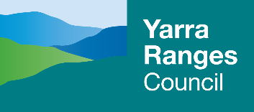
Draft Yarra Ranges Nature Plan 2022–2032
Protecting Our Biodiversity Assets
Table of Contents
Foreword 2
Mayors Message 2
Defining Nature 4
How is Our Nature Faring? 4
Why do we need this plan? 4
What will this plan deliver? 5
What makes Yarra Ranges special? 5
Legislative Context / Role of Local Government 6
Threats to our environment 7
Key Achievements 7
Vision 8
Guiding Principles 8
Themes 8
Targets 9
Monitoring & Review 9
Foundation Actions 9

Foreword
Biodiversity describes an intricate web, maintaining balance and supporting life. Understanding and knowing the natural world or Country, as a fully connected landscape, as every element of it in a symbiotic relationship. Our ancestors knew how the intimacy of the relationships between plant, animal, spirit and all things worked, it was their way of Knowing, their way of Being and informed all they did, their Doing.
Traditional Aboriginal culture and Lore achieved a natural equilibrium unmatched as a model of environmental sustainability when Aboriginal people meticulously cared for Country over thousands of generations. One key land management tool was the sophisticated use of fire. The application of fire in the landscape is based on a deep, intimate understanding of the oneness of the natural world that enables all things to survive and thrive.
Today, the health of all Victorians is intrinsically linked to Country; however, Country is sick, and our biodiversity is under threat like never before. It’s under deep stress as the loss of biodiversity after over two centuries of colonisation, continuing to exacerbate extinction of many local and iconic species.
Working in the traditional ways of Knowing, Being and Doing is essential if we are to halt the rampant decline of our biodiversity and the natural systems that we depend on to survive. Restoring the health of our landscapes is urgently needed, healing Country means a path to healthy people. It is this way of Knowing that guides the work of the Indigenous Development Team at Yarra Ranges.
The Yarra Ranges Nature Plan is a platform for our communities to reframe their connection to nature, to Country. The Plan presents a unique opportunity to integrate Indigenous Ways of Knowing, Being and Doing where we are custodians of the Earth as the mother of life with its beauty and its voice that can be seen and heard through the earth, wind and water, plants, and animals. It speaks of a time across eons when people and nature were one. Country is waiting for all to walk in harmony on this land, at one with all that exists.
Yarra Ranges Council Indigenous Development Team

Mayors Message
As Mayor of Yarra Ranges Council and custodian of a beautiful piece of the Upper Yarra, I am pleased to present the Draft Nature Plan; Protecting our Biodiversity Assets 2022-2032.
The natural environment of the Yarra Ranges is unique, highly valued by our community and is central to the character of the region. Our community has a strong connection to place, through Traditional Custodians, the Wurundjeri People, which continues through to this day. In all corners of our region, you’ll find passionate and dedicated groups, working tirelessly to care for, preserve and enhance our natural environment. Now, more than ever, we know that protecting our environment, the people, flora and fauna that call it home, is crucial for our society.
While we were developing our most recent Council Plan, community members raised the priority of protecting biodiversity – and the importance of having this priority outlined and committed to by Council. This plan outlines our plans, our goals, our actions and our commitment to do this. It shows what we’ll do in our space and how we’ll work with our community to create a healthy, resilient and connected natural landscape in the Yarra Ranges.
At Council, we recognise the important role we play in leading by example, with our own management of our natural environment both now and into the future. We’re keenly aware that decisions should always balance the needs of the environment with sustainable growth. Where we work in the environment, we want our decisions to be based on expert analysis, researched information and the view of delivering for our community and our environment. An example of this detailed work is our investment, to the tune of millions of dollars, into ecological and social assessments for the Warburton Mountain Bike Destination.
While we have direct responsibility for a small portion of our landscape, our role in sharing knowledge with others (such as other levels of Government) and supporting our community to do their part for biodiversity is equally important. In many ways, our community are leading the way on this – our committed environmental volunteers and community champions will be an integral part of this work.
The key themes of this plan have been identified through science and evidence. These themes in turn helped us develop our targets, and the actions we’ll take to meet them.
Much of our work focuses on mitigating threats - including habitat loss, pest animals and weed invasion, development pressure, stormwater impacts, bushfire and extreme weather events, many of which will increase in a changing climate.
A key step in achieving our vision is working hand-in-hand with our community to develop a Biolinks Plan for our municipality. This will mean that we can start re-connecting habitat through the landscape.
Expanding our popular Ribbons of Green and Gardens 4 Wildlife programs will provide our community with easy access to education, advice, support and encouragement to get involved.
Important monitoring and citizen science programs will continue to provide critical data for Council, so we can make evidence based decisions. Embedding Indigenous cultural practices into our bushland management program will foster a deeper connection to country and community.
We look forward to hearing from our community on the draft Nature Plan, and working with our community, our groups and volunteers to make our natural environment the best it can be for decades to come.

Defining Nature
Nature can be described as plants, animals, fungi, and bacteria along with the communities and ecosystems which they are part of and the ecological processes they sustain; which is often described as Biodiversity.
Biodiversity ‘bio’ meaning life and ‘diversity’ meaning variability. The variety of all living things, their genetic information and the ecosystems they form.
Nature has an intrinsic value and the natural world provides ecosystem services to the greater community, including humans. Some of these include; maintaining air quality, moderating climate, regulating freshwater, generating topsoil, recycling nutrients, controlling pests and diseases and pollinating crops important for our food security.

How is Our Nature Faring?
Victoria has seen a continuing legacy of biodiversity loss over almost two centuries. Today, between one quarter and one third of Victoria’s plants, birds, reptiles, amphibians and mammals, along with numerous invertebrates and ecological communities, are considered threatened with extinction.
Victoria is the most intensively settled and cleared state in Australia. This has enabled Victoria to become a powerhouse of agricultural production, with huge benefits to the state economy. However, this has also conversely created a legacy of loss, degradation and fragmentation of habitats. The introduction of exotic plants and animals has had significant consequences for Victoria’s native animal and plant species. (DELWP 2017).
Within Yarra Ranges, the challenges faced by our native plants and animals are numerous. Altered landscapes reduce movement of species, with impacts from road networks, agricultural land and fences, compounded by the limited tree canopy cover, loss of hollow-bearing trees, pest species, road-kill and food source competition. These threats are largely created by human settlement, and while some aspects appear condemned there is much opportunity for improvement through collective thinking and engaged partnership.

Why do we need this plan?
Council has a broad role to play in the management of the natural environment, along with supporting community to increase their environmental stewardship and building resilience against a changing climate. Significant investment currently occurs in natural resource management through weed control programs, incentive programs for private land, undertaking statutory functions as required by the planning scheme and education of, and partnership with community volunteers focussed on environmental protection.
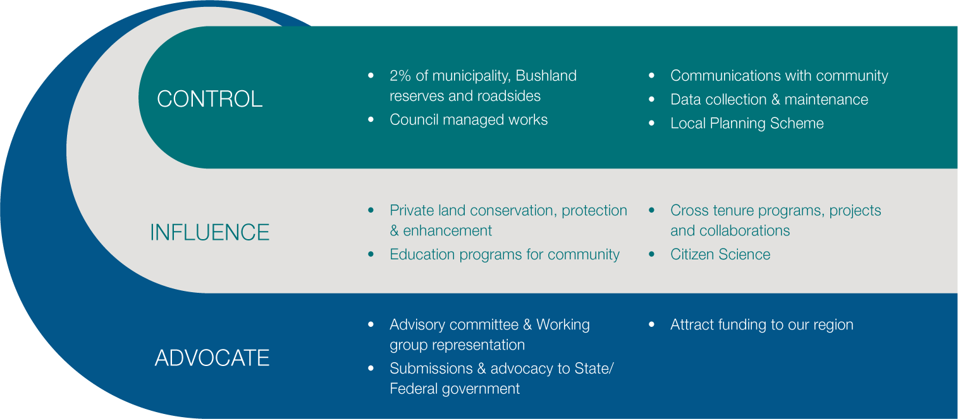

What will this plan deliver?
The Plan will define the activities, programs and projects of the highest priority for the next 10 years. It will set targets for council and allow for prioritisation of conservation action on council managed land. The Plan will improve our support to private landowners and increase environmental stewardship, identify areas to seek external funding, highlight key advocacy priorities for our municipality and ensure rigorous monitoring and adaptive management are embedded into our programs effectively.
This plan prioritises a suite of programs, activities and initiatives that will take us towards a future vision of a more connected landscape, with higher quality and more resilient habitat for native plants and animals. Council will support our community to care for nature in their own backyard and beyond, providing opportunities to engage with the natural environment and foster a deeper connection to the indigenous cultural heritage of Yarra Ranges.

What makes Yarra Ranges special?
Yarra Ranges Council is the largest municipality in Greater Melbourne by area, covering a total area of 244,700 ha
As managers of only 2% of the municipal area, council has a large role in advocacy and partnerships in biodiversity conservation. The areas under council management comprise 550ha of reserves and 403km of roadsides.
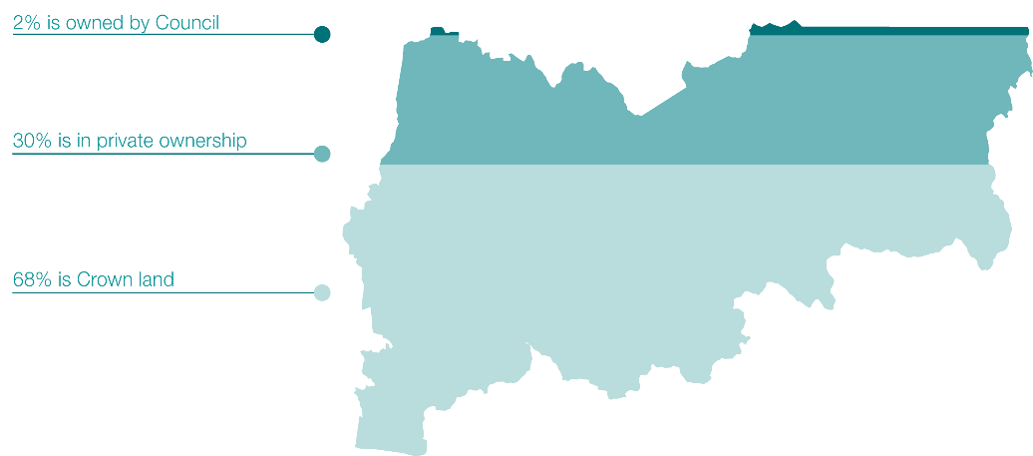
Yarra Ranges is part of the lands under the custodianship of the Wurundjeri people of the Kulin Nation and supports some of the most significant environmental areas in Victoria. These include the iconic Mountain Ash forests of the Dandenong Ranges and Central Victorian Highlands. Remnant native vegetation is home to iconic species such as the Powerful Owl, the Helmeted Honeyeater and Leadbeater’s Possum. Our municipality supports 188,000 hectares of native vegetation and is home to at least 1790 native flora and 968 native fauna species.
The upper half of the Yarra River and its tributaries support a diverse range of plants and animals including significant populations of platypus, frogs and fish. These waterways and key water reservoirs such as O’Shannassy, Upper Yarra, Maroondah and Silvan provide about 70% of Melbourne’s drinking water.
Yarra Ranges offers a beautiful setting for our residents, with scenic rural valleys and forested mountains. This scenery attracts tourists and provides a vital income for many local businesses.

Legislative Context / Role of Local Government
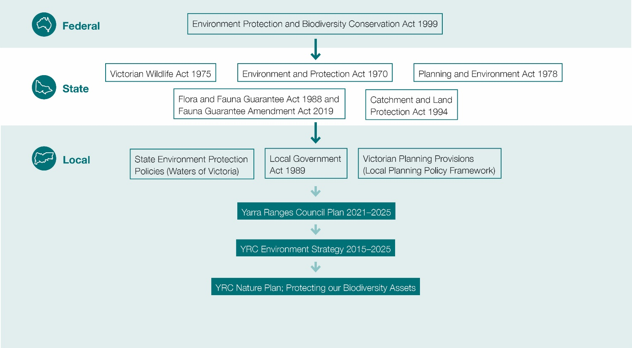

Threats to our environment
Broadly speaking the threats to our environment are created through human intervention. Impacts from climate change to land clearing and development, humans as a species apply direct and indirect pressure on nature often to the detriment of our natural environment.

Climate Change & Extreme Events - increased temperatures, frequency of severe weather events and altered rainfall patterns lead to localised species extinction and ecosystem collapse. Future predictions on climate change point to increasing intensity and frequency of wildfire, wind storm, flooding and extreme temperature events.
Habitat Loss & Fragmentation - housing development, agricultural activities and the construction of roads are altering landscapes through vegetation clearance and causing habitat fragmentation with biodiversity corralled into disparate pockets and the ability for migration between habitat fragments limited. Development in our forested areas can bring human safety and biodiversity into direct conflict. Under our changing climate these conflicts will exacerbate.
Invasive species, disease & pathogens - – a major threat to primary production, biodiversity, they can displace native species, contribute to land degradation and reduce food and habitat for wildlife. However, some non-indigenous weed species have very little environmental consequence. The impact from pest animals varies with deer the highest prominence in recent years. Pathogens can cause disease and dieback of susceptible plants, impacting agricultural and biodiversity outcomes alike.

Key Achievements
- Biodiversity conservation programs – “enhance, empower and educate”
- Ribbons of Green – 786,572 plants provided to 752 properties
- Gardens 4 Wildlife - 338 participants in 42 townships
- Environment Volunteer Support - 90 registered env vol groups, x workshops, x reserves
- Peri-urban Weed Management Partnership (PWMP) Initiative – x$, x land managed
- Birds 2 Butterfields – $450,000, X participants, ~600 deer culled, XXha treated for weeds
- Landcare networks partnerships – 12(?) groups across three networks (Northern Yarra, Yarra Ranges and Nangana)
- Annual rate rebate for conservation properties – $27,492 rate relief across 67 properties in 21/22
- Advocacy – deer, pest plants, threatened species, funding for managing biodiversity in YRC to all tiers of government
- Collaboration – multi-agency working groups including Yarra 4 Life, Helmeted Honeyeater Recovery Team/Working Group, Eastern Region Pest Animal Network, Deer Advisory Committee

Vision
“Yarra Ranges is a place of healthy, resilient and connected natural living landscapes thriving alongside us. Our community actively care for and feel a deep connection to nature.”

Guiding Principles
Our natural environment is valued intrinsically, and we foster a shared deep connection to nature.
We protect biodiversity assets through evidence-based decision making, enabling ecosystem resilience in a changing climate.
We collaborate across tenures and integrate traditional owner knowledge and cultural practices.

Themes
The four themes; Landscapes & Ecosystems, Land Use & Changing Climate, Pest Plants & Animals, People & Nature relate to key areas where council has the greatest impact and influence on biodiversity conservation. The aim is to preserve unique and indigenous ecosystems, remnant vegetation, and threatened species and communities. By protecting our natural environment and promoting a range of self-sustaining ecosystems, we enhance the quality and long-term sustainability of Yarra Ranges’ biodiversity. The role of community cannot be understated, engaging with and actively caring for nature is critical to the successful delivery of biodiversity conservation in Yarra Ranges
Landscapes & Ecosystems
Habitats and all biodiversity assets are holistically understood to enhance the resilience of native flora and fauna populations, enabling our ecosystems from land and water to flourish. Rare and threatened species and ecosystems are protected and restored across the landscape, ensuring thriving species and connected habitats.
Pest Plants & Animals
Native flora, fauna and their habitats are more resilient to threats of pest plants and animals. Collaboration and partnerships underpin successful landscape scale pest plant and animal programs across the municipality.
Land Use & Changing Climate
Engage statutory and strategic planning processes to enable best practice land management through integrated planning. Deeply engage with our townships and rural communities to build ecosystem resilience for a climate ready future.
People and Nature
Traditional owners are empowered to engage in cultural land management practices on Country within Yarra Ranges. Our community has access and a deep connection to nature; inspired to take action to actively care for the environment and create a legacy for our future generations.

Targets
- Yarra Ranges achieves an overall ‘net gain’ in native vegetation cover by 2032
- Triple restoration and revegetation works on private and council managed land per annum
- Increase the conservation value across our bushland reserve network over the next 10 years
- Enable at least 200 land stewards to improve the biodiversity on their land each year

Monitoring & Review
This plan will be assessed annually to review progress of the actions and contribution towards the targets and vision outlined.
A philosophy of continuous improvement and adaptive management is embedded in this strategy. Council is committed to promoting gender equality in all our work. As such, a gender impact assessment will be conducted on policies, programs and services, developed during implementation of this strategy. Accordingly, regular review of the actions associated with implementation the Nature Plan will be undertaken to ensure clarity, suitability and accountability with amendments made as required. Any substantial change to the targets adopted or priority actions outlined will be published publicly.

Foundation Actions
The Foundation Actions that support the delivery of the Nature Plan are categorised under each theme; Landscapes & Ecosystems, Land Use & Changing Climate, Pest Plants & Animals, and People & Nature.
The success of many of these actions relies on collaboration with land managers, agencies and importantly, our community to have meaningful outcomes.
Actions that support re-connecting habitat cannot be understated, a Biolinks Plan will seek to address this and is proposed to be delivered in collaboration with our community. Improved monitoring programs will contribute to creation and enhancement of these vital landscape links.
To protect our existing natural assets and restoration projects, a focus on partnership programs tackling pest plants and animals will also be a priority. Working to incorporate cultural burning and regenerative land management practices to support healthy landscapes and healthy country is also key.
Importantly support for our communities to protect their local environment, will be enabled through education and opportunities to learn and care for nature.
The following actions set council up for success in delivering on the outcomes of the Nature Plan.

Landscapes & Ecosystems
Target: Yarra Ranges achieves an overall ‘net gain’ of native vegetation cover by 2032

Vision | Action Description | Timeframe | Investment | Funding source
Habitats and all biodiversity assets are holistically understood to enhance the resilience of native flora and fauna populations, enabling our ecosystems from land and water to flourish. | 1.1 In partnership with community and agencies, develop a Biolinks Plan to identify important corridors for biodiversity protection and enhancement across the municipality | By 2024 | $100,000 | Seeking investment. Leverage opportunities (MW, DELWP)
 | 1.2 Develop a prioritisation matrix to identify biodiversity hotspots and focal areas across the municipality | Year 1 | $40,000 | $20,000 funded  $20,000 seeking investment
 | 1.3 Undertake vegetation surveys to measure change in native vegetation cover across Yarra Ranges to report on our target. | Year 1, 5 &  10 | $50,000  each survey ($150,000 total) | Seeking investment
 | 1.4 Establish an opt-in monitoring program of biodiversity assets on private land within Yarra Ranges, to better understand the ecological values and inform decision making for statutory and strategic planning | Year 1-10 | $50,000 per annum | Seeking investment
 | 1.5 Develop a research partnership programs with educational institutions focused on natural resource management and applied ecology to continuously improve evidence base for decision making | Years 3-10 | 0.4FTE Band 6 | Seeking investment
Rare and threatened species and ecosystems are protected and restored across the landscape, ensuring thriving species and connected habitats. | 1.6 Support restoration of waterway corridors, billabongs and floodplain habitat through the municipality through cross-promotion and facilitated engagement with landowners and action on council managed reserves | Years 1-10 | Not required | Within existing resources

Land Use & Changing Climate
Target: Triple restoration and revegetation works on private and council managed land per annum

Vision | Action Description | Timeframe | Investment | Funding source
Deeply engage with our townships and rural communities to build ecosystem  resilience for a climate ready future | 2.1 Increase support to community through the Ribbons of Green program, to deliver a revitalised incentive program and implement the Biolinks Plan. The program will include existing habitat protection, revegetation, pest plant & animal control and regenerative land management practices. | Year 3-10 | Anticipated range $250,000  - $500,000  per annum above existing program funding | Seeking investment, leverage opportunities.
 | 2.2 Work with traditional owners, local growers, peak bodies, and land managers to promote and support implementation of Resilient Land Management and regenerative agriculture practices, including firestick and carbon drawdown. | Year 3-10 | 1FTE Band 6 + $50K  operational | Seeking investment
 | 2.3 Implement sustainable bushfire reduction works which achieve net biodiversity benefit in collaboration with relevant agencies. Incorporate cultural burning practices to support biodiversity improvements. | Year 2-3 | 1FTE Band 6 (2  year fixed term  role) | Seeking investment, to support existing Firestick Officer role.
Engage statutory and strategic planning processes to enable best practice land management through integrated planning | 2.4 Foster strong collaboration with other land managers, conservation organisations, Landcare, and community groups through representation on multi-agency collaborative committees | Years 1-10 | Not required | Within existing resources

Pest Plants & Animals
Target: Increase the conservation value across our bushland reserve network over the next 10 years

Vision | Action Description | Timeframe | Investment | Funding source
Collaboration and partnerships underpin successful landscape scale pest plant and animal programs across the municipality | 3.1 Implement catchment-scale, targeted, cross-tenure pest plant & animal control programs at identified locations, working with community and other land managers to achieve broad biodiversity benefit. | Years 2-10 | Leverage existing Bushland budget with external funding circa $500,000  - $2Million total | External funding sought (DELWP, MW, Federal)
 | 3.2 Collaborate with land managers to address the prevalence of feral deer across Yarra Ranges, through partnerships, funding programs and education of residents to achieve an overall reduction in the impact of deer | Years 1-10 | $50,000  per annum operational funding sought, plus external funding | Seeking Investment (operational). External funding sought (DELWP, MW, Federal)
Native flora, fauna and their habitats are more resilient to threats  of pest plants and animals. | 3.3 Utilise prioritisation matrix, Biolinks Plan and updated levels of service to develop Bushland Reserve Management Plans for high priority reserves, with emphasis on invasive species that drive ecological change. | By 2025 | $60,000 – 80,000 | Seeking investment

People & Nature
Target: Enable at least 200 land stewards to improve the biodiversity on their land each year

Vision | Action Description | Timeframe | Investment | Funding source
Traditional owners are empowered to  engage in cultural land management practices on Country within Yarra Ranges | 4.1 Support the development of areas suitable for the application of contemporary concepts of Indigenous Ways of Knowing, Being & Doing such as cultural burning. Enhance opportunities for Council and community connection through delivery of cultural awareness program. | Year 2-3 | Not required | Within existing resources
 | 4.2 Enhance opportunities for cultural awareness and integration of indigenous land management practices into Bushland management through employment of Indigenous Ranger | Year 1-10 | 1.0FTE Band 6 | Year 1 funded, ongoing funding required
Our community has access and a deep connection to nature; inspired to take action to actively care for the environment and  create a legacy for our future generations | 4.3 Enhance biodiversity in urban townships through increase in street tree cover and habitat planting, along with expanding community support through Gardens 4 Wildlife | Years 1-10 | 0.6FTE (Band5)  + $30K  operating budget per annum | Role partially funded, remainder unfunded. Street tree planting program partially funded.
 | 4.4 Support council network of environment volunteers, including Friends of groups, Landcare network and others to undertake direct action and community led knowledge sharing of environmental values of Yarra Ranges | Years 1-10 | Not required | Within existing resources
 | 4.5 Provide a suite of environmental education programs, events, and opportunities to engage the community in environmental topics. A renewed focus on providing opportunities for equitable access and diversity of offerings to reach more of our community. | Years 1-10 | 0.5FTE Band 6 | Seeking investment

