Yarra Ranges Council
Draft for Community Consultation
August 2022

Towards a regenerative Yarra Ranges
  - Economic Development Strategy 2022-2032
Local strengths
Global recognition
Regenerating the Yarra Ranges
Contents
Message from the Mayor 5
Glossary 6
Regenerating the Yarra Ranges economy 8
What is regenerative economy? 8
Regenerative principles underpinning the Strategy 8
Executive Summary 9
A new direction for economic development is required 9
Vision 10
Our future direction 10
Impact of this strategy 11
Introduction 13
A bright future for all – our inclusive approach. 13
An evidence-based approach 13
Our strategic alignment 14
Council’s Strategic Framework 15
How our regenerative economic principles provide further alignment 16
Alignment with the Sustainable Development Goals (SDGs) 17
Broader strategic context 17
A community centred approach 19
How we engaged 19
What matters to our community 19
Who we spoke to and what we heard 20
Yarra Ranges snapshot 22
Gross Regional Product 22
Regional Exports 22
Local Businesses 22
Local Jobs 23
Tourism 23
Unequal outcomes Socio-economic status 23
Trends influencing our economic future 24
Trend - Migration away from cities 24
Trend - Lifestyle changes due to the global pandemic 24
Trend - Post-COVID shakeup of the global economy 24
Trend - Demographic shifts and workforce changes 24
Trend - Sustainability, the circular economy, climate change and community-led economic development 25
Trend - Technological innovations 25
Our unique proposition 27
Size and scale 27
Access to markets 27
Lifestyle 27
Skilled workforce 27
Appetite for future growth 28
Globally recognised food, wine and tourism assets 28
Our future direction 29
Our vision 29
How our economic transition will unfold 29
Key factors in our journey 30
Our strategy 31
Our vision 31
Goals and targets 31
Priority areas 31
Opportunity industry sectors 31
Regenerative principles underpinning the Strategy 31
The development of our framework 32
The opportunity industry sectors 32
Our action plan 34
The priority areas and our key actions 34
Understanding Council’s role and proposed timeframes 34
Identity, Leadership and Collaboration 35
Trade, Commerce and Workforce Capability 37
Investment Attraction 38
Innovation and Entrepreneurship 40
A Collaborative approach 41
Implementation, monitoring and review 43
Implementation 43
Monitoring and measurement 43
Evaluation and Review 43

Acknowledgment of Country
We respectfully acknowledge the Traditional Owners, The Wurundjeri People as the Custodians of this land. We also pay respect to all Aboriginal community Elders, past and present, who have resided in the area and have been an integral part of the history of this region. Council also acknowledges Indigenous ways of being, knowing and doing that led to sustainable and health‑giving societies thriving across Australia, for thousands of years.

Message from the Mayor
The Yarra Ranges is one of the most visited and most iconic tourist regions in Victoria – and Australia.
We have an incredibly varied local economy. The Yarra Ranges boasts wineries, orchards, restaurants and cafes – it has a strong retail presence, a vibrant farming community and an ever-growing manufacturing sector.
We’re proud to say that more than 13,000 businesses call the Yarra Ranges home, with more than 41,000 people employed locally.
Recent events have impacted our business community, increasing pressures across a range of industries.
Our workforce has changed dramatically since the COVID pandemic, our community is ageing and new technology disrupting, improving and transforming every part of society. Climate change will impact our businesses with more extreme weather events become more common.
This means we need to support our businesses to become more resilient. We will continue to with our partners and industry to build up the workforce capability to support our businesses with skills shortages. We will continue our ongoing advocacy for reforms to facilitate accommodation for our workers – ie seasonal worker accommodation.
By 2032, we’re aiming for our economy grow to $9.1 billion, supporting more than 57,000 local jobs. But that won’t happen by chance, and we in Council have to take a leading role in making this happen.
This is where our Economic Development Strategy comes in.
This strategy sets a clear vision for how we’ll regenerate the Yarra Ranges, make the most of opportunities and help our business communities become more resilient, thriving in the face of change.
It outlines how the spirit of entrepreneurship will be at the heart of how we work with and support our local businesses and how we can support the social wellbeing of our 55 townships and protect our natural environment, all the while driving economic prosperity.
This strategy will be our guide as Council – it will inform our decisions, our conversations and our thinking about business and about the economy.
This document has been shaped by a great depth of local expertise, and I look forward to working with our community to make these goals a reality.
Councillor Jim Child,
Mayor of Yarra Ranges

Glossary
Adaptive re-use
The process of taking an existing item or structure and updating or adapting it for a new use or purpose.
Circular economy
A systems solution framework that reduces material use, redesigns materials to be less resource intensive, and recaptures “waste” as a resource to manufacture new materials and products.
In practice, it implies reducing waste to a minimize by sharing, leasing, reusing, repairing, refurbishing and recycling existing materials and products as long as possible.
Community led economic development
A community-driven process where communities identify and initiate their own solutions to economic, social and environmental issues to build healthy, economically viable communities.
Economic development
Programs, policies or activities that seek to improve the economic well-being and quality of life for a community through innovation, job creation and business support.
Future proof
Anticipating the future and developing methods or process that minimise the effects of shocks and stresses of future events.
Opportunity industry
An opportunity industry sector is a dynamic grouping of industries that are responsive to the economic climate and provide focus and direction for the implementation of actions. They are included based on their concentration of high value-add industries, their ability to be catalysts for the growth of other industries, and that create a net-positive impact on the environment and across our local community.
Public Benevolent Institution (PBI)
A type of charitable institution whose main purpose is to relieve poverty or distress.
Public Benevolent Institutions are recognised by the Australian Charities and Not-for-profits Commission (ACNC) and Australian Tax Office as a subtype of charity.
Regenerative economy
Moving away from extractive business models and thinking towards potential for positive contributions for nature and society. An economy concerned less with growth for growth’s sake, and more with building a sustainable economy which purposefully meets the needs of both people and the environment.
Regenerative travel
A sustainable way of travelling with goals for visitors to have a positive impact on their holiday destination, leaving it in a better condition than how they found it. Moving beyond “not damaging” the environment and towards actively revitalising and regenerating it, resulting in a positive impact on local communities and economies.
Scalability
The capacity for something to be changed in response to changing resources.
Skills revolution
Technology will continue to impact the world of business and have a huge impact on jobs. Training and future proofing the workforce is the best strategy for fortifying growth and diversifying into new markets.

Regenerating the Yarra Ranges economy
During the development of this Strategy, a clear sense of local pride was evident throughout community consultation. From that, a strong collective aspiration emerged, for the desire for sustainable, purpose-driven economic growth, balancing environment, social wellbeing and economic needs.
In response, this Strategy is underpinned by the philosophy of regenerative economics, a ground-breaking economic direction, emerging with increased relevance in the face of the urgent global climate position and the long term impacts of the Covid-19 pandemic. Regenerative economic principles are increasingly being used around the world by forward-thinking cities and regions to build healthy, thriving and sustainable economies, with dynamic balances that purposefully sustain both people and planet.

What is regenerative economy?
According to the World Economic Forum a regenerative economy “reconsiders ideas and ideals informing economic policy by looking beyond net-zero emissions to a net-positive impact on the planet. We can create the conditions for life to flourish resiliently and renew infinitely”.
Stokel-Walker, Chris. World Economic Forum 2022. What is Regenerative Capitalism and Why is it Important? Published 24 Jan 2022

Regenerative principles underpinning the Strategy
To drive and support the transition into a regenerative Yarra Ranges economy, the Strategy encompasses specific initiatives and defines the following set of principles along with a commitment to ensuring they underpin all key economic decisions:
- Leaving the planet in better shape than the status quo; looking beyond net-zero emissions to a net-positive impact on the planet and on our community
- Respecting and reflecting community values
- Supporting local efforts that enable the environment, communities, businesses, and culture to thrive
- Drawing on the knowledge of Indigenous Australians and their connection to Country
- Embracing systemic change aligned with principles of a circular economy

Executive Summary
Yarra Ranges has a bold, new direction for economic growth, building on the legacy established by our past and current business leaders and local communities.
Respecting this legacy and seizing the opportunity to regenerate Yarra Ranges under the current economic conditions, will future proof the local economy with jobs, innovation and the capacity to access emerging markets, building community led economic development and resilience.
We have a clear vision for balanced growth, an appetite for capitalising on new opportunities, and a Council with a renewed focus on economic development, industry engagement and business responsiveness.
Our transition to a regenerative economy will see us emerge as a thriving community and economy in the face of global pandemics, threats from climate change, and global economic disruption.
The Yarra Ranges Economic Development Strategy 2022-32 sets us on an ambitious growth trajectory to become a $9.1 billion economy in 2032 that supports over 57,000 local jobs.
The economic conditions that enabled us to flourish in the past are changing. The distribution and costs associated with the supply of goods and services – globally and nationally – have substantially altered. A steady supply of young workers to fill jobs is no longer guaranteed, especially with an aging population. New technologies will offer unforeseen market opportunities. Some of the markets we once relied upon are no longer viable. Emerging markets once out of our reach are now accessible. The global state of climate change requires urgent and unified action.
Guided by our regenerative principles, the key actions over the initial 18 months will drive positive economic outcomes in:
- partnerships and collaborations
- accessing a diverse, responsive workforce
- actively supporting business
- attracting and facilitating appropriate investment

A new direction for economic development is required
There is risk of a plateaued economic growth if the challenges identified in the current economic climate are not addressed and opportunities strengthened. This may negatively affect community health and wellbeing due to lack of access to local goods and services, and employment opportunities, lack of innovation in industries and low investment.
Although many uncertainties lie ahead, there are actions we can take to create a strong economic foundation for the future of our community, and establish our place in the new global economy.
A wide range of variables influence economic development with many of these beyond the direct control or influence of Council. The Strategy provides clarification of Councils role in economic development and a well-established partnership approach with stakeholders in government, the non-government sector, education and industry to deliver local economic outcomes.
To ensure we maintain a strong economic base for improving liveability of our local communities and townships, we need to:
- Protect and regenerate our biggest assets: environment, community, cultural heritage, and character
- Leverage our local strengths, especially our world-class industry innovations, from wine production through to advanced manufacturing
- Future-proof and support opportunities for local industries that align with our commitment to regenerative economics
- Increase our competitiveness – nationally and globally – with regards to investment attraction and business efficiency and responsiveness
- Develop an adaptive local workforce to support more local jobs for residents
- Continue to grow a diverse and resilient business environment responsive to emerging trends (climate change, circular economy, and workforce challenges).

Vision
In 2032 Yarra Ranges will have a balanced economy that supports growth, our environment and our communities.

Our future direction
Local Strengths, Global Recognition Regenerating the Yarra Ranges Economy
We will play to our local strengths, expanding the capacity and offerings of our value-add industries. Innovation, technology, and a spirit of entrepreneurship will be central to our local and global competitiveness.
With a collectively inspired, new direction in regenerative economic development, we will work collaboratively to attain national and global recognition as a region that is focused on purpose-driven economic growth. A region that balances environment, social wellbeing and economic prosperity for the benefit of current and future residents and businesses.

A strong strategic direction
The Yarra Ranges Economic Development Strategy 2022-32 (The Strategy), sets a clear path to achieving our overall goals of balanced economic growth, more local jobs for our residents and improved quality of life for all in our region.
Through detailed economic research and community consultation, we identified four priority areas, each with a suite of actions. The Strategy identifies five opportunity industry sectors that are included based on their concentration of high value-add industries, their ability to be catalysts for the growth of other industries, such as construction and social enterprises and that create a net- positive impact on the environment and across our local community.
Furthermore, the Strategy draws from regenerative economic development theory and sets guiding principles that will be evident across all key decision-making processes – from investment attraction to prioritisation of projects, balancing environment, social wellbeing and economic prosperity for the benefit of current and future residents and businesses.
Relying on a collaborative effort from industry, Council, government (State and Federal) and the broader community, this framework will drive the implementation and success of the Strategy.
The Strategy was developed in partnership with Alphacrane Intercultural Specialists and Lucid Economics and through strong engagement with our community – local people and organisations who live, work or operate in Yarra Ranges, our Councillors and stakeholders including government agencies and, education institutions.

Priority areas
- Identity, Leadership and Collaboration
- Investment Attraction
- Trade, Commerce and Workforce Capability
- Innovation and Entrepreneurship

Opportunity industry sectors
- Food, Wine and Tourism
- Health and Wellness
- Agribusiness
- Advanced Manufacturing
- Knowledge, Innovation Entrepreneurship

Impact of this strategy
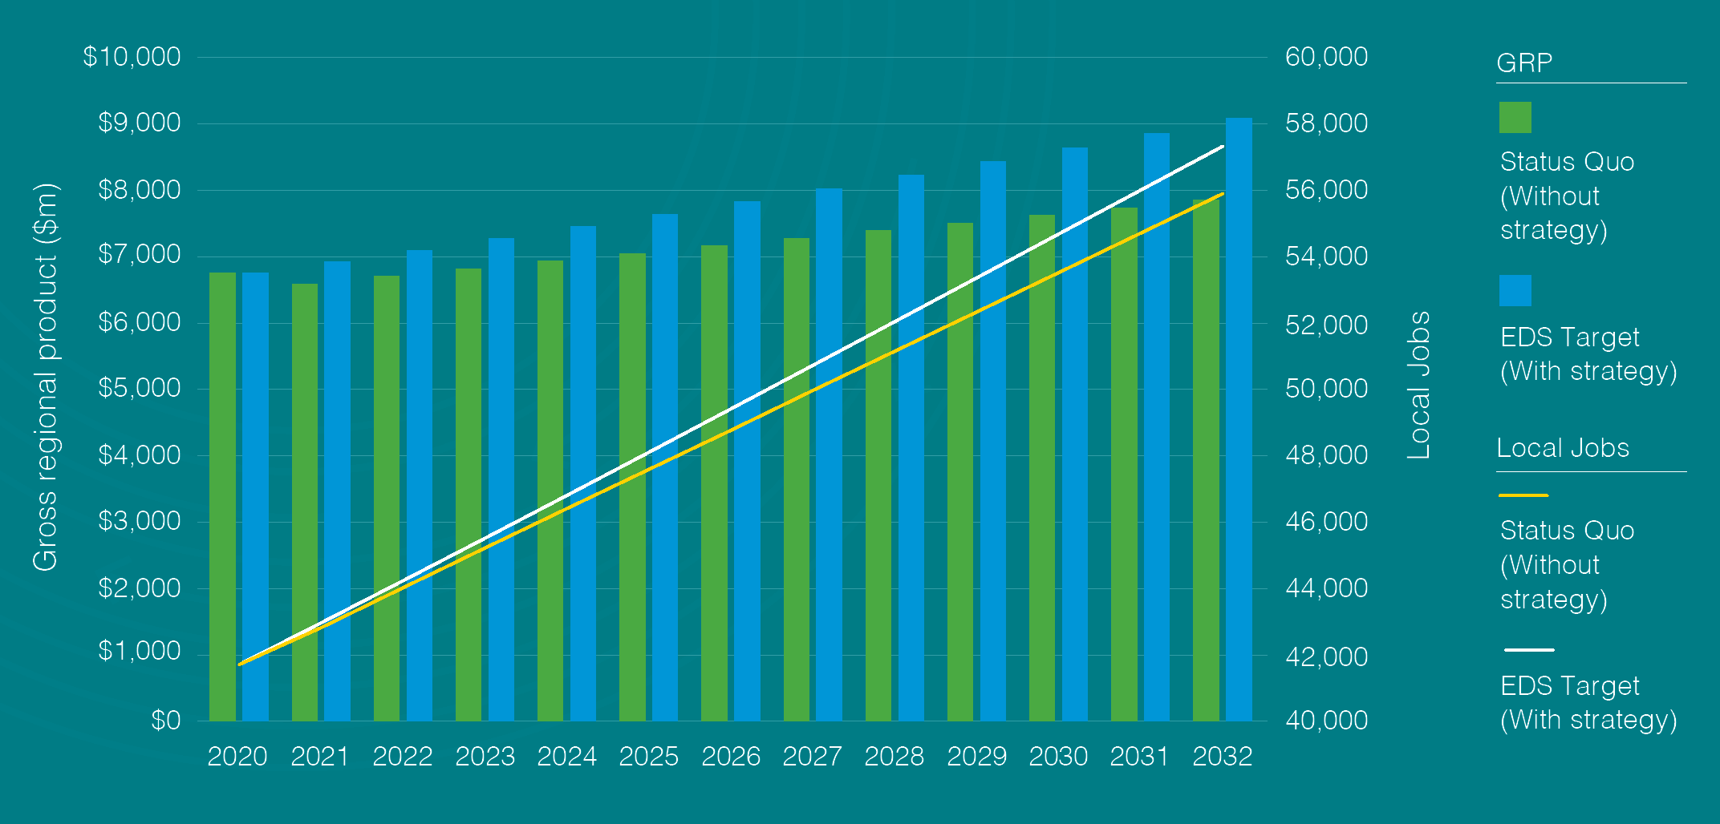
Year | Status Quo  (GRP, $m) | EDS Target  (GRP, $m) | Status Quo (Employment, No.) | EDS Target (Employment, No.)
2020 | $6,754 | $6,754 | 41,700 | 41,700
2021 | $6,593 | $6,923 | 42,813 | 42,958
2022 | $6,707 | $7,096 | 44,017 | 44,229
2023 | $6,822 | $7,273 | 45,216 | 45,510
2024 | $6,936 | $7,455 | 46,405 | 46,801
2025 | $7,051 | $7,642 | 47,585 | 48,101
2026 | $7,165 | $7,833 | 48,763 | 49,408
2027 | $7,280 | $8,028 | 49,964 | 50,721
2028 | $7,394 | $8,229 | 51,147 | 52,039
2029 | $7,509 | $8,435 | 52,331 | 53,359
2030 | $7,623 | $8,646 | 53,517 | 54,681
2031 | $7,738 | $8,862 | 54,706 | 56,003
2032 | $7,852 | $9,083 | 55,894 | 57,323
Data and projections source: Lucid Economics 2022

Goals
- Balanced economic growth
- More employment opportunities
- Improved community sentiment

Targets
- 9.1 billion economy
- 57,323 (GPR) local jobs
- 50% of local jobs filled by local people (up from 40%)
- 70% satisfaction with Council’s economic, social and environmental management and leadership

Impact of this strategy
- 15.5% higher than the current projection of $7.9 billion, adding $1.2 billion to the local economy
- 2.6% higher than the current projection of 55,894 jobs, generating 1,430 additional jobs in the local economy for local residents and to support an aging community
- A satisfaction baseline will be established as a priority action of this Strategy

Introduction
Yarra Ranges is embarking on a bold, new direction that maximises our local strengths and elevates our presence within the global economy.
With a strong focus on regeneration, Yarra Ranges is well positioned to attract new investment, business, population growth, and local employment. Although the strategy has a 10-year lifespan, we have set the foundations to future-proof our economy for generations to come.
The Strategy delivers:
- A contemporary approach to economic development steeped in regenerative principles, focussed on future-proofing the economy beyond the global pandemic.
- Globally competitive ideas that differentiate the Yarra Ranges from other local government areas.
- A strong vision, grounded in the aspirations of the local community.

A bright future for all – our inclusive approach.
The Strategy recognises that a healthy economy is the basis for improving quality of life for all residents. This includes:
- People of all ages
- Residents from all socio-economic backgrounds
- Indigenous Australians
- People with a disability
- Multicultural communities
- People who identify as gay, lesbian, bi-sexual, transgender, queer or intersex (LGBTIQ+).
We will demonstrate our commitment to promoting gender equality in all our work. To enhance the economic participation of people of all genders, as per the Gender Equality Act 2020, Yarra Ranges Council will conduct gender impact assessments on all policies, programs and services, developed as part of this strategy.
This strategy builds on the existing work of Council and other organisations aimed at supporting an inclusive and connected approach towards access and engagement in work and education for all members of our community.

An evidence-based approach
This Strategy and action plan provides the economic development direction for the Yarra Ranges region over the next decade and follows review of the earlier Yarra Ranges Economic Development Strategy 2012-2022. The development of the new framework has been informed by detailed economic analysis and background research, risk assessments and extensive community consultations.
There are key alignments and considerations of relevant local, state and federal strategies and plans.
This Strategy should be read in conjunction with Yarra Ranges Economic Development Strategy Background Report and Community and Stakeholder Engagement Findings Report which provides the evidence and rationale for the key actions and priorities outlined in the plan.

Our strategic alignment
Yarra Ranges Community Vision 2036:
“Whether you live here or visit, you will see how much we care for Country, how inclusive and connected our communities are, and how balanced growth makes this the best place in the world.”
Yarra Ranges Council is proud of its integrated planning framework, which ensures Council’s plans, strategies and resources are closely aligned and increase the connection between what the community values, their priorities and Council’s planning processes.
This Strategy aligns with Yarra Ranges Community Vision, Council Plan objectives and directly delivers on the Vibrant Economy, Agriculture and Tourism goal.

Council’s Strategic Framework
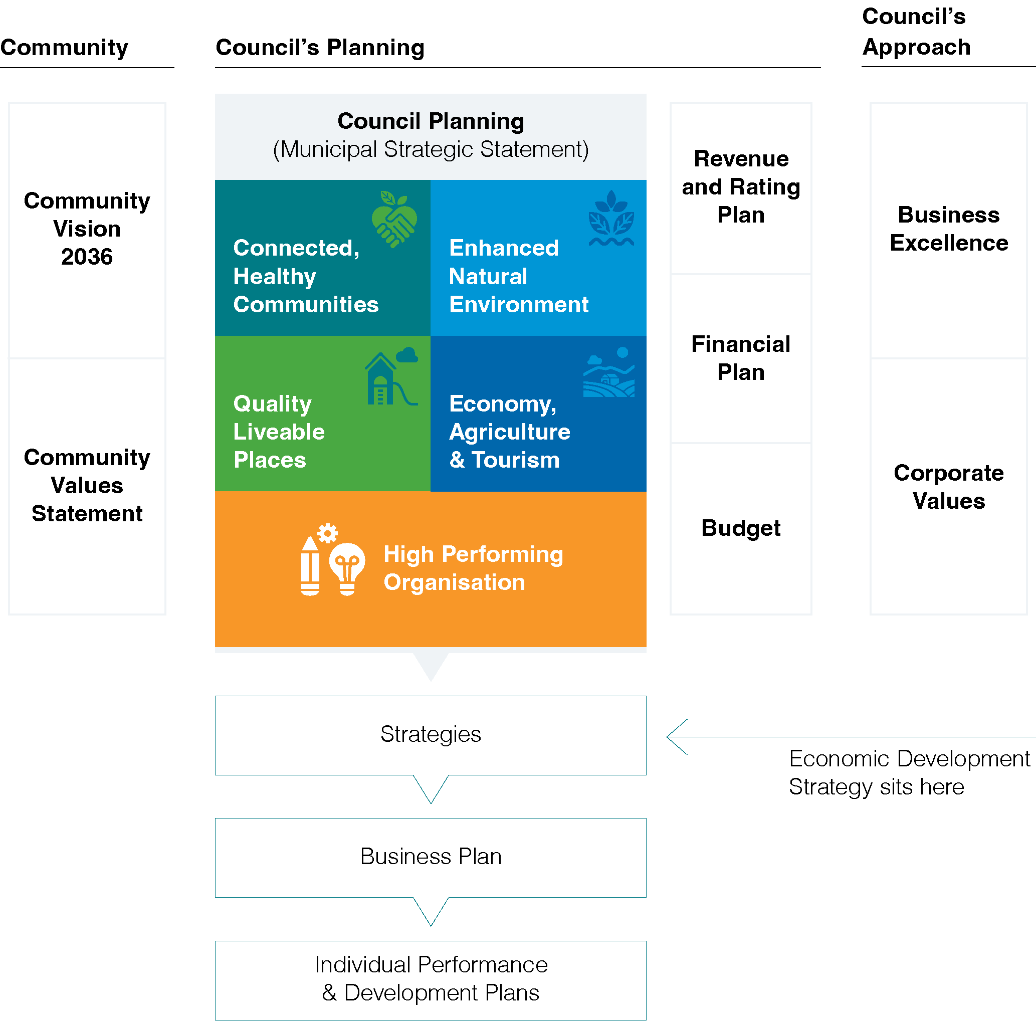
The framework guides the Council in:
- recognising Community through their Community Vision 2036 and Community Values Statement
- planning through their Municipal Strategic Statement which underpins Connected Healthy Communities, Enhanced Nature Environment, Quality Liveable Places, Economy Agriculture & Tourism, High Performing Organisation), Revenue and Rating Plan, Financial Plan, Budget), Strategies (including the Economic Development Strategy), Business Plan and Individual Performance & Development Plans
- their approach to achieve Business Excellence and Corporate Values

How our regenerative economic principles provide further alignment
Council Plan 2021-2025
“The municipality’s natural beauty, stunning landscapes and reputation for exceptional local produce is enhanced, and have a significant influence on decisions made regarding sustainable growth and development in the region”
“balanced economic development has enhanced the region’s reputation and improved quality of life for all”
Further strengthening links between Councils Key Strategic Objectives, this strategy enables delivery of outcomes that support our collective future-focussed goals. This strategy underpins Connected and Healthy Communities so that communities are resilient and connected, drives a Protected and Enhanced Natural Environment through its principles of ensuring the environment is considered in all decisions relative to economic development and ensures Quality Infrastructure and Liveable Places through its approach to investment opportunity.

Connected and healthy communities
Communities are safe, resilient, healthy, inclusive and socially well connected.
Quality services are accessible to everyone.

Protected and enhanced natural environment
A healthier environment for future generations.

Vibrant economy, agriculture and tourism
Our tourism, agriculture, health, manufacturing and other industries are leading and dynamic. Strong investment and attraction underpins sustainable economic growth and job creation.

Quality infrastructure and liveable places
Quality facilities an infrastructure meets current and future needs. Places are well planned hubs of activity that foster wellbeing, creativity and innovation.

High Performing Organisation
An innovative, responsive organisation that listens and delivers quality, value for money services to our community.

Alignment with the Sustainable Development Goals (SDGs)
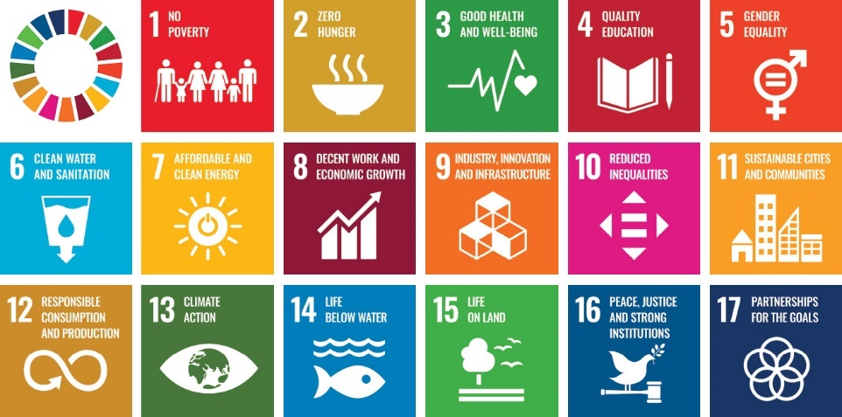
- No Poverty
- Zero Hunger
- Good Health and Well-being
- Quality Education
- Gender Equality
- Clean Water and Sanitation
- Affordable and Clean Energy
- Decent Work and Economic Growth
- Industry, Innovation and Infrastructure
- Reduced Inequalities
- Sustainable Cities and Communities
- Responsible Consumption and Production
- Climate Action
- Life Below Water
- Life On Land
- Peace, Justice and Strong Institutions
- Partnerships for the Goals
The World Economic Forum aligns regenerative growth with the United Nations (UN) SDG 11: Sustainable Cities and Communities. SDGs are the UNs framework for making real progress towards a more sustainable future by the year 2030.
For more information on SDGs head to the United Nations Sustainable Development website

Broader strategic context
Many aspects of facilitating better conditions for our community and economic development in Yarra Ranges is dependent on the work of the Victorian and Federal governments. Through relevant alignment and advocacy, this Strategy aims to leverage the legislative frameworks and financial resources within which local authorities operate.
Recent changes to the Australian Government may result in adaptations to previous economic plans focused on “more jobs and a strong economy” as climate change and the economic conditions continue to emerge as key challenges.
The Victorian Government 2021-2025 Strategic Plan is “focused on Victoria’s economic recovery and growth, ensuring it benefits all Victorians — by creating more jobs for more people, building thriving places and regions, and supporting inclusive communities. Priority industries and sectors that will drive Victoria’s economic growth and jobs”. This could be subject to change with a state election set for late 2022.
The Climate Change Act 2017 recognises that Victoria’s climate is changing and requires certain decision-makers to have regard to climate change and to consider its potential impacts and contributions to greenhouse gas emissions. The commitment by the Federal (bipartisan support) and State Governments in reaching zero net emissions by 2050 will require businesses to adapt and change practices to reach these targets. Included in the supporting action plan is initiatives to assist businesses transition into a low or zero carbon economy.

A community centred approach

How we engaged
To ensure the Strategy captured the vision, attitudes, and aspirations of the community we undertook extensive community, industry and business consultation and engagement including:
- More than 100 business leaders, stakeholders, and community representatives providing input and insights during our Community and Stakeholder Engagement Workshops.
Equating to approximately 1,268 participant hours of engagement.
- Two surveys were conducted on Councils Shaping Yarra Ranges platform, receiving over 780 unique visitors to the page and 98 contributions.
- Consults with relevant and varied Industry and Business groups (including the inaugural meeting of the Business Leaders Roundtable), various advisory committees and close engagement with Council’s elected representatives.

What matters to our community
Through our balanced and cross-sectional engagement, several shared aspirations emerged:

Driving economic growth
- Through attracting value-add industries, jobs and investment with a strong desire for purpose-driven growth rather than “growth for the sake of growth.”
- Along with an expectation that to achieve overall economic success for the region, Council needs take a leadership role in the economic development of the Yarra Ranges.

Capitalising on our strengths
- Our sense of identity and pride, our products and brands and quality innovation.
- A strong belief that Yarra Ranges has the potential to attract “appropriate levels of investment”, through a professional and collaborative approach to investment attraction.
- Strong aspirations around maintaining and enhancing the unique environment, character and lifestyle of the Yarra Ranges whilst also leveraging these and our proximity to Melbourne in coordinated and purposeful attraction activities.

Addressing our weaknesses
- With more a differentiated identity, more responsive Council, better collaboration among business networks, building successful partnerships to deliver initiatives and improved workforce capability.

Leveraging opportunities
- Including future societal and technological trends, investment, innovation and start-ups and entrepreneurs attraction.

Managing challenges
- Such as regulatory controls that impact business expansion, intensification, or adaptive re-use.

Who we spoke to and what we heard
Who we spoke to:
- Service Providers
- Tourism
- Innovation
- Education & Skills
- Resident
- Retail
- Small Business
- Sustainability
- Business & Trader Groups
- Robotics
- Investment
- Health and Wellbeing
- Manufacturing
- Accommodation
- Agriculture
- Indigenous
- Community
- Hospitality
- Government
- Community Organisation
- Industry Organisations
What we heard:
“We are recognised internationally for our quality and innovation in food and wine production, so it makes sense to develop Centres of Excellence and promote our region to the world.”
“We believe that Council should be the lead driver for economic development so that local businesses – from small-medium enterprises to large corporations – can grow.”
“We want greater flexibility in land zoning to address the shortage of sites for future development and economic growth. There’s a huge potential for more hotel accommodation, hospitality, aged care, and retirement villages.”
“We need more diverse housing in our townships to support a thriving workforce”
“We should make Yarra Ranges known for careers, not just jobs.”
“Our tourism potential is huge. The supply of visitor accommodation needs to be expanded. We need to target the right visitors who value our environment and local culture, and who will spend locally.”
“We have to maintain this unique character and lifestyle within our special patch of the world.”
“Commitment drives investment. We need to demonstrate our commitment towards being investment- friendly.”
“Many of our local brands are known internationally, but there’s more we can do to increase our presence on the world stage.”
“Currently, entrepreneurs from the cities have no idea what an attractive place we are for startups. We’re still close to a capital city and well connected internationally, but we also offer a lifestyle like no other, at a fraction of the cost.”
“We have great local produce. Let’s showcase this through expositions, attracting people and industry into our region from far and wide.”
“Agribusiness is the backbone of our economy. We should celebrate our innovations and value-add services in this area.”
“We have so many strengths to share with the world. We just need package these into a strong identity to gain greater recognition.
“Innovation is our strength and can be seen across so many of our industry sectors.”
“Yarra Ranges has enormous potential as a diverse economy.”

Yarra Ranges snapshot
- 2,500 km² land area
- 55 suburbs and townships
- 156,068 people
  - 49.5% Female
  - 50.5% Male
156,068 people and 55 suburbs and townships spread over a diverse 2,500 km of beautiful and unique land, ranging from the densely populated urban areas, agriculturally rich valley and vibrant hills communities.

Gross Regional Product
$6.7 billion gross regional product.
Top value-add industries:
- 14% Construction
- 10% Manufacturing
- 9.5% Education and Training
- 8% Health Care and Social Assistance
- 8% Agriculture, Forestry and Fishing
- 7% Retail Trade

Regional Exports
$3.7 billion regional exports.
- 53% Manufacturing
- 12.3% Agriculture, forestry and Fishing
- 11.5% Construction
- 3.2% Accommodation & Food Services
- 3.1% Education and Training

Local Businesses
There are 13,447 local businesses with:
- 98% being small business
- 61% self-employed
- 37% having 1-19 employees
The top 5 business sectors are
- 31% Construction
- 12% Professional, Scientific & Technical Services
- 8% Rental, Hiring & Real-estate
- 6% Retail Trade
- 5% Other Services

Local Jobs
There are 41,700 local jobs. The top 5 employing industries:
- 13% Retail Trade
- 12% Construction
- 10% Education
- 10% Health Care and Social Assistance
- 9% Manufacturing
73,577 of our residents are employed however an estimated 60% leave the Yarra Ranges every day for work.

Tourism
Tourism plays a significant role in contributing towards improving the vibrancy, liveability and prosperity of the region. Bustling local retail precincts, gourmet food and beverage destinations, a rich cultural scene and unrivalled natural beauty create unique Yarra Ranges experience and offer further opportunities to grow the visitor economy.
Tourism visitation was rising strongly before Covid-19 and in the year ending March 2020, the region had 3.7 million visitors. Made up predominantly by day trippers 85%.

Unequal outcomes Socio-economic status
Compared with the national average, Yarra Ranges is above average in terms of socio-economic status. However there are large differences in the socio‑economic profile in the region with pockets of affluency as well higher socio-economic disadvantage. This highlights our diverse, mix of communities and reinforces the need for regenerative economic development that creates socio‑economic benefit for everyone, not just for a few.
Data source: Remplan 2021
Population data source: ABS 2021 Census Socio-economic data source: ABS 2018
Socio-economic Index for Areas (SEIFA), ranks areas in Australia according to relative socio-economic advantage and disadvantage. Yarra Ranges Council score is 1040.

Trends influencing our economic future

Trend - Migration away from cities
Melbourne has experienced the single largest net loss of population out of any part of Australia as a result of COVID-19.

Implications for Yarra Ranges
- Potential reduction in the number of day-trip visitors to the Yarra Ranges.
- Decrease in the overall consumer market, potentially impacting other sectors in our region such as construction and retail trade.
- Opportunity to pro-actively target these Melbourne residents, businesses and entrepreneurs into the Yarra Ranges.

Trend - Lifestyle changes due to the global pandemic
Globally, people are re-evaluating their lifestyles and prioritising health and wellness. Coupled with the ability to now work remotely, there are major changes in regional migration, how and where we work, and how we spend our leisure time.

Implications for Yarra Ranges
- Opportunity to leverage the high quality of life offered by living and working in the Yarra Ranges as a competitive advantage for attracting new residents that strengthen the local workforce, businesses and entrepreneurs.

Trend - Post-COVID shakeup of the global economy
Changes in the supply, demand and distribution of goods and services.

Implications for Yarra Ranges
- Opportunities to increase connectivity and influence within local, national and global markets across all opportunity industries.

Trend - Demographic shifts and workforce changes
Aging population in the western world.
Increase of remote working, outsourcing, offshoring.
Skills revolution and associated need for expertise in emerging technologies e.g. AI (Artificial Intelligence) and robotics.

Implications for Yarra Ranges
- Population – Yarra Ranges has a historically slow growth in this area and faces an aging population. Residents aged over 65 years are expected to increase from 15.0% of the total population in 2016 to 21.2% by 2041.
- Opportunity to attract new businesses (including those providing services to and aging community), workers, professionals and entrepreneurs in to strengthen the local workforce.

Trend - Sustainability, the circular economy, climate change and community-led economic development
Growing interest in regenerative communities, regenerative industries, and regenerative travel.
Moving beyond sustainability, trends are highlighting the importance of businesses being good community citizens.
Equally, community wealth building through community-led economic development is gaining momentum. This type of economic development creates opportunities and benefits are distributed to all in our communities.

Implications for Yarra Ranges
- Opportunity to take a national leadership position as regenerative economy.
- Opportunity to support and develop the desire for community-led economic development initiatives, linking in with ongoing work addressing:
  - Major weather event impacts and resilience building
  - The Powelltown, Yarra Junction and Warburton townships transition away from native timber harvesting on Crown land, by 2030.
- Opportunity to build the capabilities and awareness of local Social Enterprises and Not for Profit sectors. These businesses play a valuable role in the economic, environmental and social well-being of the community, offering many benefits that will contribute to a more socially and economically inclusive Yarra Ranges.

Trend - Technological innovations
Perceptions of sprawling, pollutive industrial factories are quite far removed from the reality of the future, where industrial uses such as biotech facilities and data centres require less land and consume fewer resources. And, it is not just industrial uses that are evolving. For example, in the food and retail sectors, there a likely increased demand for drone technology for deliveries. Worldwide, there are major supply issues for getting supplies into stores, and products to customers.

Implications for Yarra Ranges
- Already most industries operating within our region are applying technological innovations and advanced manufacturing practices. This trend is expected to grow and broaden across other industries.
- From a planning perspective, the challenge is to ensure that regulations keep abreast of these trends and enable technological innovations across all industries to flourish.
- Opportunity to showcase our region’s innovations nationally and globally.

Our unique proposition

Size and scale
- A healthy economy ($6.7 billion) with strong historical growth (average 3.4% per year during the last five years), and a steady growth projection by 2032.
- One of Victoria’s largest and most diverse local government areas.
- Potential for scalability by taking advantage of our proximity to Melbourne and the current migration away from Australia’s capital cities.

Access to markets
- Convenient road and rail access to Melbourne’s CBD, airports, sea ports, and the rest of Victoria.
- Localised and well-connected supply chains and business ecosystems that are innovative, adaptive and technologically advanced (Industry 4.0) for example Bayswater Business Precinct.

Lifestyle
- An enviable lifestyle, spectacular natural and rural scenery, a long-established commitment to environmental custodianship and regeneration, a strong sense of community, and a rich Indigenous and non-Indigenous cultural heritage.

Skilled workforce
- Access to one of Australia’s largest workforces (over 2 million within Greater Melbourne).
- More local jobs are being provided to local residents. The proportion of local residents working locally will grow from 40% to 50% by 2032.
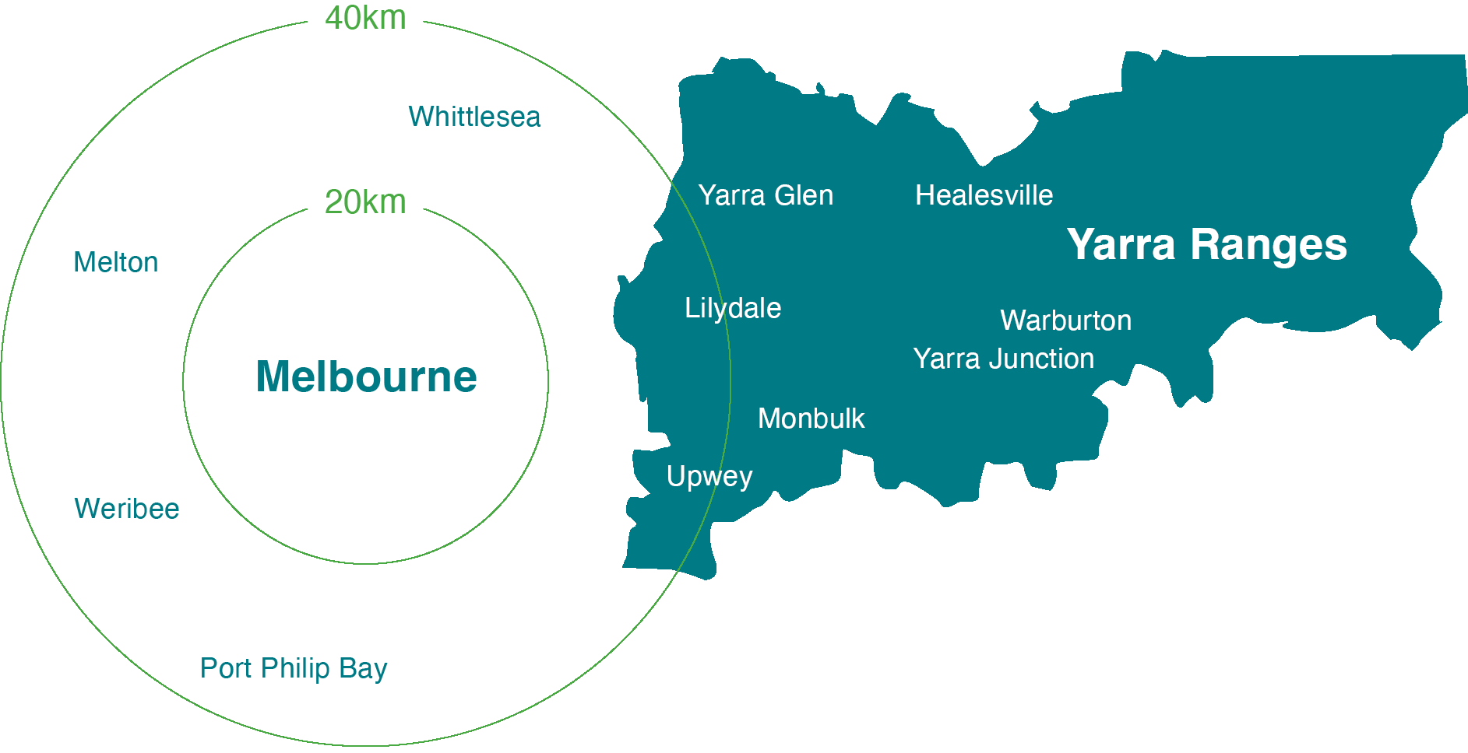

Appetite for future growth
- A bold new direction that prioritises economic growth based on our principles of regeneration.
- Commitment by Council and the local business community to supporting business expansion, future-proofing our workforce and expanding our markets.
- Implementation of measures to increase land supply and building spaces for investors to establish and grow businesses, with more opportunities within the existing Urban Growth Boundary e.g. Kinley, Chirnside Park, Mooroolbark, Bayswater Business Precinct.
- Strong focus on the growth of five opportunity industry sectors: Agribusiness, Food, Wine and Tourism; Health and Wellness; Advanced Manufacturing; Knowledge Innovation and Entrepreneurship.

Globally recognised food, wine and tourism assets
- Victoria’s most internationally recognised wine region.
- One of the epicurean capitals of Australia, supplying fresh produce to Melbourne and premium food products globally.
- Strong growth potential for attracting domestic and international visitors.

Our future direction

Our vision
In 2032 Yarra Ranges will have a balanced economy that supports growth, our environment and our communities
- Local Strengths
- Global recognition
- Regenerating the Yarra Ranges economy

How our economic transition will unfold
- We will play to our local strengths, expanding the capacity and offerings of our value-add industries. Regenerative innovation, technology, and a spirit of entrepreneurship will be central to our global competitiveness.
Examples of how we will get there
  - Expand value-add industries, such as developing complementary products, services and attractions.
  - Showcase our enviable lifestyle and proximity to Melbourne as competitive advantages for destination marketing, business, investment and workforce attraction.
  - Increase the value of local exports by leveraging the existing national and global recognition of well-known local brands.
- Through our transition into a regenerative economy, we will work collaboratively to attain national and global recognition as a region that is focused on purpose- driven economic growth. A region that balances environment, social wellbeing and economic prosperity for the benefit of current and future residents and businesses.
Our commitment to regenerative principles will be evident in all key decision-making processes – from investment attraction to prioritisation of projects.
Examples of how we will get there
  - Export our world-class industry innovation in areas such as food and wine production, agribusiness and advanced manufacturing.
  - Establish local Experiences of Excellence that showcase our local innovation, generate more visitor expenditure from inbound business travel and open new export opportunities.
  - Develop an iconic Yarra Ranges brand that will differentiate the Yarra Ranges nationally and globally.
  - Register a place-based provenance trademark to increase value and awareness of Yarra Ranges’ local produce, manufacturing and tourism offerings.
  - Expand our visitor source markets beyond Melbourne, to include more High Value Travellers from interstate and international regions.

Key factors in our journey

Protection and regeneration of our biggest assets: environment, community, cultural heritage and character.
This includes:
- The green wedge, rural land uses and spectacular vistas.
- Sense of community.
- Indigenous and non-indigenous cultural heritage.
- Our distinctly “Yarra Ranges” green character.
- Special character and identity of individual towns.

Navigating a decade of unprecedented change, emerging as an Australian economic leader for similar regions in the future.
The qualities we will grow to achieve this are:
- Agility in handling unforeseen opportunities and threats as they arise.
- Responsiveness to change.
- Determination to influence change for a better outcome, and increasing our sphere of influence.

Increasing our competitiveness with regards to investment attraction and business responsiveness.
- Investors, businesses, and entrepreneurs will recognise Yarra Ranges as a favourable place to set up and operate.
- Enhancing the established transport networks through improved coverage and service delivery

Evolving an inclusive, localised, innovative and resilient economy.
- Acknowledging the intrinsic connection between our local businesses and communities, how they enrich each other and help us grow.
- Accountability and alignment with current and future Council Plan initiatives, actions and measures of success.

Our strategy

Our vision
In 2032 Yarra Ranges will have a balanced economy that supports growth, our environment and our communities.
- Local Strengths
- Global recognition
- Regenerating the Yarra Ranges economy

Goals and targets
- $9.1 billion economy - Purposeful growth and development
- 57,323 local jobs - 50% of local jobs filled by local residents
- 70% satisfaction with Council’s economic, social and environmental management leadership Improved community sentiment

Priority areas
- Identity, Leadership and Collaboration
- Investment Attraction
- Trade, Commerce and Workforce Capability
- Innovation and Entrepreneurship

Opportunity industry sectors
- Food, Wine and Tourism
- Health and Wellness
- Agribusiness
- Advanced Manufacturing
- Knowledge, Innovation Entrepreneurship

Regenerative principles underpinning the Strategy
The principles underpin the Strategy and represent our commitment to their application when implementing the action plan and key economic decisions.
- Leaving the planet in better shape than the status quo; looking beyond net-zero emissions to a net-positive impact on the planet and on our community
- Respecting and reflecting community values
- Supporting local efforts that enable the environment, communities, businesses, and culture to thrive
- Drawing on the knowledge of Indigenous Australians and their connection to Country
- Embracing systemic change aligned with principles of a circular economy

The development of our framework
Our Strategy for the next decade has four priority areas each with a suite of actions, then further identifies five opportunity industry sectors.
This strategic framework is closely interrelated, and a consolidation of the collective aspirations received throughout the community engagement process during the development of this Strategy, see below.
Collectively they provide the direction and design on how we will achieve our vision, goals and targets.
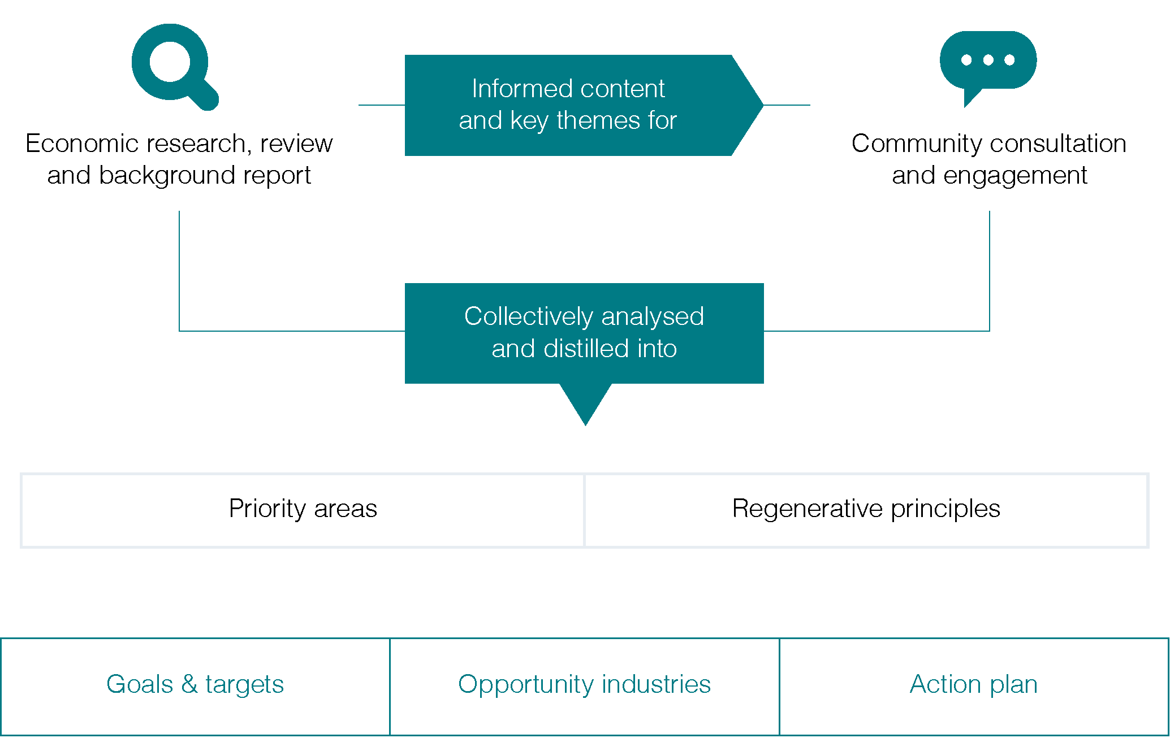

The opportunity industry sectors
- Food, Wine and Tourism
- Advanced Manufacturing
- Health and Wellness
- Knowledge, Innovation Entrepreneurship
- Agribusiness
These opportunity industries allow us to focus our strategic direction and the implementation of actions towards industries that:
- Increase economic contribution to meet our ambitious stretch targets for Gross Regional Product (GRP)
- Be catalysts for the growth of other industries, such as construction (which is currently the number one high value-add industry) and social enterprises and community-led economic development
- Future-proof our local economy through their capacity to innovate and evolve
- Improve the natural environment, creating a net-positive impact on the planet and across our local community
- Boost employment and entrepreneurship opportunities for local businesses
- Service the needs of both current and future residents – for example, by growing our aged care and health care sectors
- Open up new export opportunities to further elevate the Yarra Ranges brand nationally and globally
The ongoing review mechanisms that are in place within the Strategy, allow a dynamic and adaptive response to new opportunity industries that may arise.

Our action plan

The priority areas and our key actions
- Identity, Leadership and Collaboration
- Trade, Commerce and Workforce Capability
- Investment Attraction
- Innovation and Entrepreneurship
These actions are a consolidation of the collective aspirations received throughout the community engagement process during the development of this strategy. The vision, goals and targets will only be achieved through key partnerships, collaborations and the collective effort of our businesses, industries, Council, government (State and Federal) and the broader community. The implementation of the recommended actions will be delivered through existing resources, grants funding, and other funding subject to future budget bids, business cases and advocacy efforts.

Understanding Council’s role and proposed timeframes
Council’s Role | What Council may do?
Provider  To implement projects, programs and campaigns for use by businesses and community for a prosperous and diverse economy. | Initiate campaigns, incentives and business or educational support programs.
Facilitator  To establish partnerships and collaborate with stakeholders, to create economic participation opportunities. | Partner with key stakeholders and provide contributions (knowledge and expertise, funding, network opportunities) to roll out programs.
Advocate  To support economic and region investment through promotion and influencing decision- making, rather than direct involvement. | Educate key stakeholders including higher levels of government to address provision gaps, and influence government and decision making.

Time frames | Time in Years
Short term | 1 year
Medium term | 2-3 years
Long term | 3-5 years
Ongoing | n/a

Identity, Leadership and Collaboration
Taking a unified and collaborative approach that demonstrates leadership in economic development, industry engagement and business responsiveness. Establishing a strong identity that raises national and global brand awareness.
Action | Intent and success factors | Timeframe | Council role
1.1 Prepare a Brand Identity Strategy that develops an iconic umbrella brand for Yarra Ranges and a brand promise that will clarify, leverage, elevate and support the regions environment, social and economic values. | Nationally and globally raising brand awareness through  a strong and differentiated Yarra Ranges identity, showcasing the unique, diverse and balanced economy. | Medium | Provider and Facilitator
1.2 Register a place-based provenance trademark, backed by a Yarra Ranges Provenance Plan (guide to region-based authenticity and quality).  Cross reference 1.1 Prepare Brand Identity Strategy. | Raise brand awareness of Yarra Ranges’ commerce and trade offerings – domestically and internationally – beyond our established reputation as a premium wine region. | Long | Provider and Facilitator
1.3 Ensure industry engagement and business responsiveness are incorporated across Council operation through:  - Developing regional networks of business groups, trader groups, and industry organisations.  - Foster partnerships, alliances, and collaborations across council, government, industry, education institutions, community organisations, and the broader community. | Reinforce Council’s commitment to economic development, industry engagement and business responsiveness.  Resilient, connected and collaborative networks of businesses, investors, community, and government achieving positive economic outcomes. | Short and ongoing | Provider and Facilitator
1.4 Increase capacity and awareness of Council’s business concierge services including:  - Updating approval processes to improve efficiency of business permit provisions and providing prioritisation of catalytic projects for economic growth.  - Providing business development or planning workshops for businesses to improve changes of success when making submissions to Council. | A single-point-of-contact, responsive and effective customer service experience with streamlined processes, and clarity of information. Providing expert advice and assistance, reducing time, stress, and cost for businesses and investors.  Resilient, connected and collaborative networks of businesses, investors achieving positive economic outcomes. | Short and ongoing | Provider
1.5 Deliver programs and develop resources to build local business capacity and capability in applying principles of regeneration. | Actively support businesses regardless of size and industry sector, in the transition to sustainability, zero carbon and circular economy models. | Short and ongoing | Provider, Facilitator
1.6 Establish an Economic Leadership Taskforce comprised of industry and chaired by the Council CEO, that will advise Council on delivering positive and lasting economic outcomes to the opportunities and challenges facing the Yarra Ranges economy. | Strengthen Council- Industry engagement and collaboration.  Ensure that the Strategy remains relevant and aligned with Industry needs.  Additional accountability and transparency on the implementation of the Strategy. | Short and ongoing | Provider. Facilitator, Advocator
1.7 Develop a series of community pulse engagement activities (ensuring accessibility and connection to a broad range of community), that routinely monitor community matters and sentiment. | Increased participation and improved economic outcomes by and for the Yarra Ranges Community. | Short and ongoing | Provider

Trade, Commerce and Workforce Capability
Future-proofing our workforce to be productive, sustainable, inclusive and responds to industry and community. Supporting and managing opportunities around business expansion, national and global markets, land use intensification, and adaptive re-use.
Action | Intent and success factors | Timeframe | Council role
2.1 Review Council’s planning scheme through a regenerative economic lens to facilitate appropriate business expansion, land use intensification, and adaptive re-use. | Strengthen local planning policy and advocate for contemporary change to State Planning Policy to enable and support business expansion, land use intensification and adaptive re-use. | Medium | Provider, Advocator
2.2 Ensure an integrated tourism approach aligned to the Brand Identity Strategy and the Destination Management Plan. | Coordinated strategic plans that take a balanced approach to leverage and support tourism and visitor economy opportunities, that care for and respects our residents, creates low-impact visitor experiences, protects our natural environment, celebrates our cultural diversity and shares our social values. | Medium and ongoing | Advocator, Facilitator
2.3 Prepare a Workforce Infrastructure and Development Plan addressing existing and emerging issues regarding access as well as attraction and retention of a local workforce to meet current and future industry and community requirements. Workforce infrastructure includes transport, housing stock (seasonal and permanent) and digital connectivity. | Access to a quality local workforce that is productive, sustainable, inclusive and that supports and is responsive to industry and community current and future needs. | Medium | Provider, Facilitator, Advocator
2.4 Promote and foster Yarra Ranges Career Expos to increase awareness, particularly among young people, of available career development opportunities within the Yarra Ranges. | Access to a quality local workforce that is productive, sustainable, inclusive and that supports and is responsive to industry and community current and future needs.  Protect and grow our younger workforce and pro-actively address perceptions of limited local choices when it comes to jobs and career pathways. | Short and ongoing | Facilitator
2.5 Investigate and resolve barriers to facilitate the establishment of a night-time economy for Yarra Ranges that encourages attraction and retention of younger workers. | Protect and grow our younger workforce and pro-actively address perceptions of limited local choices when it comes to lifestyle.  Complement and support visitor economy, improve liveability for locals and maximise economic returns. | Medium to Long | Provider, Facilitator, Advocator
2.6 In partnership with the Victorian Government support the communities of Powelltown, Yarra Junction and Warburton transition away from native timber harvesting on Crown Land. | Development of a Local Development Strategy leading to creation of new jobs in sustainable industries resulting in long-term economic and social benefits for each community. | Short and ongoing | Provider, Facilitator, Advocator

Investment Attraction
Presenting a coordinated, professional, proactive, and competitive approach to investment and business attraction.
Action | Intent and success factors | Timeframe | Council role
3.1 Prepare an Investment Attraction Plan and associated prospectus. | A clear understanding of the right types of investment for our region and tools and resources required to present a coordinated, professional, proactive, and competitive approach to investment and business attraction. | Short | Provider
3.2 Audit and collate a dynamic list of potential sites for regenerative development. | Strengthen Yarra Ranges’ capacity to accommodate business expansion, intensification, and adaptive re-use.  Activation of underused sites. | Medium | Provider
3.3 Prioritise infrastructure that increases the economic contribution of our identified opportunity industry sectors.  Infrastructure priorities include:  - Traffic and movement of people.  - Roads, freight and produce movement.  - Digital connectivity.  - Ongoing transformation of the Bayswater Business Precinct (BBP) as a hub for innovation and excellence in advanced and specialist manufacturing. | Improved liveability for residents and maximised economic returns from tourism, agribusiness, business parks and other facilities / attractions by ensuring there is sufficient supporting infrastructure. | Medium | Advocator, Facilitator
3.4 Demonstrate Council’s commitment to facilitating investment in opportunity industry sectors through a targeted communication campaign showcasing Council’s organisational and policy reforms.  Campaign elements to showcase outcomes from Actions 1.3,1.7, 2.1 and 3.1. | Increased awareness and confidence in Council’s commitment to helping resolve barriers and facilitate investment in the region. | Short and ongoing | Provider
3.5 Investigate the viability of establishing a place based Public Benevolent Institution (PBI) for the Yarra Ranges to encourage philanthropic funding for local projects. | Enable local philanthropists to fund local initiatives that create wealth and prosperity for the benefit of all residents across the broader community. | Medium | Provider, Facilitator

Innovation and Entrepreneurship
Growing the innovation capacity of local industry by creating a locally based, globally connected networks. Showcasing and exporting industry knowledge for innovation.
Action | Intent and success factors | Timeframe | Council role
4.1 Develop Innovation and Entrepreneurship Growth and Recognition Programs for local businesses, leaders, start- ups, entrepreneurs and social enterprises that will:  - mentor and enhance the capacity and capabilities of emerging and existing local businesses.  - facilitate dynamic local and global networks of collaboration between education and industry.  - showcase and promote local Innovation and Entrepreneurship excellence at a national and global level. | Dynamic, connected and collaborative networks of businesses, industry, education and government harnessing creativity and innovation to address rising social, environmental and economic challenges.  Develop our domestic and international reputation as a region supportive of start-ups, entrepreneurs and social enterprises.  Opportunity to export industry knowledge for innovation and expand domestic and international trade. | Short and ongoing | Facilitator, Advocator
4.2 Develop an integrated model of innovation hubs, precincts, and co-working spaces. | Dynamic, connected, and collaborative networks of community, businesses, industry, education and government harnessing creativity and innovation to address rising social, environmental, and economic challenges to improve outcomes. | Short to Medium | Advocator, Facilitator
4.3 Establish Centres of Excellence to showcase local industry, innovation and entrepreneurship globally including:  - Location-based multi-use facilities that accommodate experiential activities, seminars, training and innovation.  - Virtual Centres of Excellence bringing capabilities, knowledge and expertise together from across geographical boundaries, connecting into national and global networks. | Opportunity to export industry knowledge for innovation and expand domestic and international trade.  Multiple centres of excellence within the Yarra Ranges fostering a culture of national and international recognition, development and continued innovation.  Increased opportunities to export industry knowledge for innovation and expand domestic and international trade. | Medium to Long | Advocator, Facilitator

A Collaborative approach
At the core of this Strategy is collaboration – from its preparation through to implementation over the coming decade. The vision and goals will only be achieved through the collective effort of our industries, Council, government (State and Federal) and the broader community.

Yarra Ranges Council
- Overall leadership and coordination role for the Strategy’s progress and implementation.
- Lead advocacy role for actions not directly under Council’s influence or control.
- Lead agency for all industry advancement and investment attraction initiatives.

Australian Government including, Australian Trade and Investment Commission
- Provide support to local businesses looking to export their products, and will engage with businesses seeking to invest in Australia.

Industry, business, Trader Groups and Chambers of commerce
- Provide support and coordination amongst local industry networks.

Eastern Region Group of Councils
- Work collaboratively on issues of common significance, importance and priority.
- Activities will include advocacy, integrated planning, shared services, and joint procurement to benefit communities of the Eastern Metropolitan Region.

Invest Victoria
- Work across industries to identify business and job creation opportunities that foster longer term economic prosperity.

Regional Development Australia, Melbourne
- Work with business leaders and industry experts to accelerate the economic development of Melbourne’s inner and outer suburbs, including the Yarra Ranges.
- Advocate for projects, programs and services that create jobs, support business and deliver economic growth.

Education institutions, TAFEs, Registered Training Organisations and schools
- Support economic growth by producing tomorrow’s workers and entrepreneurs equipped with the right skills to service industry.
- Deliver innovations and technological advances that will benefit local businesses.
- Collaborate with industry and Council to address workforce issues.

Victorian Government
- Deliver programs provided locally to support and enhance local business opportunities and a skilled workforce.
- Assist in addressing legislative burdens that prevent timely decisions for investors.

Yarra Ranges Tourism
- Create a strong brand identity for the Yarra Ranges.
- Identify the “ideal visitor” for the Yarra Ranges.
- Activate tourism-related initiatives on the national and global stage.

Who are our customers?
Our customers will be invited to provide ongoing input and feedback to ensure the Strategy remains relevant and responsive to customer needs.
- Any person or organisation who is a direct beneficiary of this Strategy – including key delivery partners and the communities within which they live.
- Existing local communities and community organisations.
- Existing local businesses and business organisations of all sizes and operating environments, including for-profit entities, not-for-profit organisations and social enterprises.
- Future investors (from within and outside the Yarra Ranges), particularly from the five opportunity industry sectors.
- Existing and future residents from both within and outside the Yarra Ranges.

Implementation, monitoring and review

Implementation
This Strategy encompasses the collective aspirations of the community for the economic prosperity of our current and future generations.
Therefore, implementation will require the collective effort of local businesses across all industries, Council, government (State and Federal) and the broader community.
Council is committed to taking a leadership and coordination role of the overall strategy. This is to ensure implementation, monitoring, evaluation and review is progressed in a timely and efficient manner.

Monitoring and measurement
The Strategy will be monitored bi-annually by Council, with advice and input from the Economic Leadership Taskforce comprising industry stakeholders and chaired by the CEO.
The annual monitoring process will track progress against the goals and targets and against other proxy indicators of success where quantitative or qualitative data is available.

Evaluation and Review
Mid-term evaluations of the Economic Development Strategy will be undertaken by Council at the end of Years four and eight. This will determine:
- The extent to which the Strategy has contributed towards achieving the identified goals.
- The degree of improvement in our four priority initiative areas.
- The level of success achieved in implementing the action plan and any future modifications to reflect the situation.
- The effectiveness of Council’s internal and external coordinating mechanisms in relation to implementation of the Economic Development Strategy.
Following each evaluation, a review of the Strategy will be undertaken to ensure relevance and responsiveness to Council plans, community vision, industry needs and shifts in the local and global economic environment.
Yarra Ranges Council
PO Box 105
Lilydale VIC 3140
1300 368 333
mail@yarraranges.vic.gov.au
Yarra Ranges website

sdgs.un.org/goals
http://www.yarraranges.vic.gov.au

