Asset Management Policy

Version: | 1.0
Approved by Council: | <Date>
Responsible Officer: | Executive Officer Strategic Asset Management
Department: | Assets & Capital Programming
Contact Officer: | Graeme Fletcher

We respectfully acknowledge the Traditional Owners, the Wurundjeri People, as the Custodians of this land. We also pay respect to all Aboriginal community Elders, past and present, who have resided in the area and have been an integral part of the history of this region.

Table of Contents
1. Table of Contents 2
Revision history 2
1. What is the purpose of this policy? 3
2. Scope 3
2.1 Supporting materials 3
3. What is Asset Management? 4
4. Strategic and Legislative Context 5
4.1 Relationship with the Community Vision and Council Plan. 5
4.2 Asset Management System 6
4.3 Legislative Context 8
5. Guiding Principles 9
6. How the principles are applied 10
7. Engagement 12
8. Roles and Responsibilities 12
9. Monitoring and Review 14
9.1 Monitoring and evaluation process 14
9.2 Review cycle 14
10. Definitions 14

Revision history
Version | Date | Summary of revisions
2009 - 1.0 | 2009 | Asset Management Policy (Original)
2012 - 1.0 | August 2012 | Last policy update endorsed by Council. The policy was updated to include key roles, and stronger links to corporate priorities, coordination and continual improvement strategies of the organisation
2017 -1.0 | November 2017 | Minor amendments and edits to reflect current corporate structures and add clarity. Adapted to current Council policy format.  Policy tabled and adopted at Council.  Approval, effective and review dates updated to reflect adoption.
2022 – 1.0 |  | Revision and updates based on audits and community engagement

What is the purpose of this policy?
Council has a stewardship role for approximately $1.5 billion of infrastructure and property assets.
This policy defines the guiding principles, practices and responsibilities which Council consistently applies in managing these assets.
It ensures that asset related decisions align with community expectations and service needs in a sustainable manner and acts to moderate the risk of poorly managed assets.

Scope
This policy provides a framework for the procedures, processes, systems and asset information required to manage Council’s existing and future physical assets.
The adherence to this policy is the shared responsibility of all employees, Councillors, contractors and external consultants acting on behalf of Council.
It applies to the management of all Council’s physical assets including property, infrastructure, plant and equipment.

Supporting materials
There is a range of supporting materials which are referred to within this policy for use when interpreting and applying this policy . These include:
- Council Plan, 2021-2025, Council’s key planning document for the four-year Council term, https://www.yarraranges.vic.gov.au/Council/Corporate-documents/Policies-strategies/Council-Plan-and-Budget
- Financial Plan, 2021/22-2030/31, Council’s key financial planning document, https://www.yarraranges.vic.gov.au/Council/Corporate-documents/Policies-strategies/Council-Plan-and-Budget
- Strategic Asset Management Plan, 2019/20-2023/24, Key strategic plan to ensure continuous improvement in asset management, https://www.yarraranges.vic.gov.au/Council/Corporate-documents/Policies-strategies/Strategic-Asset-Management-Plan
- Community Engagement Policy, 2021, Sets the direction and requirements for meaningful, authentic and responsive engagement across the organisation, https://www.yarraranges.vic.gov.au/Council/Corporate-documents/Policies-strategies/Community-Engagement-Policy-2021

What is asset management?
Council manages a large network of assets including buildings, roads, bridges, footpaths, stormwater drainage, swimming pools, parks and recreation facilities.
These assets play an important role in supporting the delivery of Council services which are essential to a thriving community’s quality of life. Some of these services are also shared with State Government departments, for example nearly a quarter of all roads in the Yarra Ranges are the responsibility of the Department of Transport to manage and maintain.
There is a need to build more infrastructure to support the ongoing population and economic growth of the Yarra Ranges. At the same time the existing assets are continuing to age and require adequate levels of maintenance and replacement to ensure that services are available into the future.
It’s important to balance the costs of these activities with the ability for our community to pay, while also recognising the risks that will result from any under-funding.
Council is now presented with significant challenges including the impact of climate change, rising construction prices, increases in community expectations, ageing infrastructure that may not meet future service needs.
Sound asset management practices ensure that these assets continue to support the delivery of services in a sustainable, effective and cost-efficient manner, for current and future generations.
Thereby optimising the value assets provide to the community and minimising costs across the entire lifecycle of assets shown in Figure 1.

Figure 1 - Asset lifecycle phases

Strategic and legislative context

Relationship with the Community Vision and Council Plan.
Stewardship of its assets is a core function of Council. The crucial requirements for a sustainable organisation includes long term asset and financial management.
Sound strategic asset management is fundamental to ensuring assets support Council’s services in a sustainable manner over the long term. As such, it is vital that asset management decisions align with the following Key Strategic Objectives as detailed in the Council Plan.

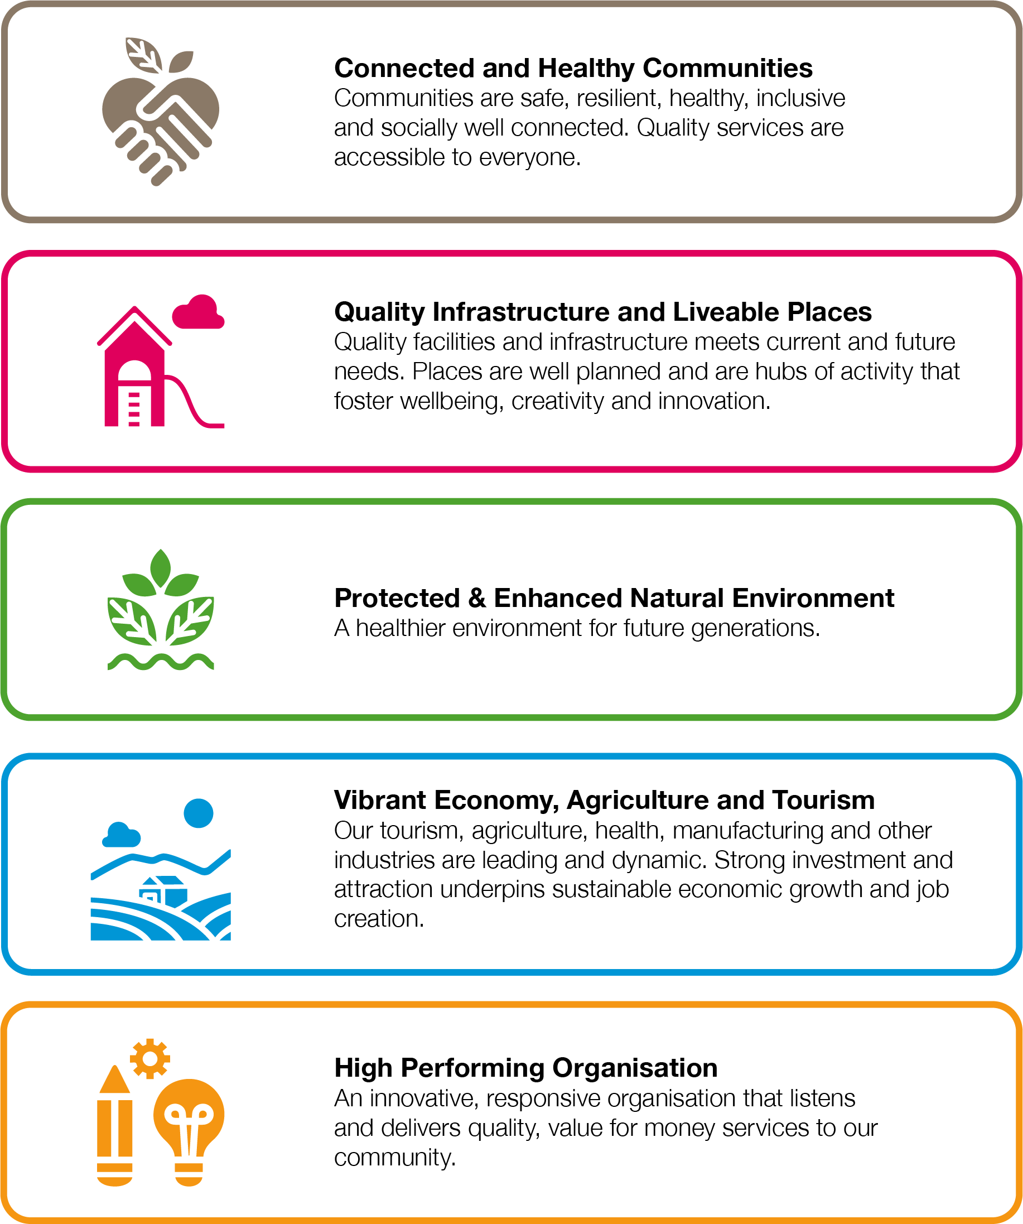
Figure 2 - Council's key strategic objectives

Asset Management System
In 2014 a family of global standards for asset management was published under ISO 55000. These standards guide Council in developing an overall management system for the effective management of its assets.
The asset management system is a set of tools, including policies, plans, business processes and information systems, which integrate to ensure that the asset management activities will be delivered in alignment with Council’s objectives.
This policy is the overarching document in Council’s Asset Management System, as shown in Figure 3.
Community Vision & Council Plan
Strategic Asset Management Plan (SAMP)
Asset Management Policy
Asset Management Plans (AMP)
Implementation of AMPs
Asset Portfolio
Performance evaluation and improvements
Asset Management Improvement plans
Asset Information Management System & relevant support elements
Asset Plan
Financial Plan
Asset Management System
Integrated Strategic Planning and Reporting Framework
Figure 3 - Asset Management System
Strategic Asset Management Plan
The Strategic Asset Management Plan (SAMP) underpins and supports the Asset Management policy by detailing the current state of Council assets and the ongoing resources required to manage those assets for a period of at least ten years. It outlines the actions required to improve asset management capability and performance in accordance with the principles detailed in this Policy.
Asset Management Plans
The Asset Management Plans (AMP) are based on an assessment of each major asset portfolio and detail the activities, forecasted expenditure and risks associated with providing the assets to a defined level of service. This information is summarised in the SAMP and Council’s Financial Plan.
Asset Management Improvement Plans
Council’s SAMP and AMPs include improvement plans with actions to ensure the continuous improvement of how assets are managed.
Asset Plan
An element of Council’s Integrated Strategic Planning and Reporting Framework as required by the Local Government Act 2020. It summarises Council’s asset inventory, value, performance and future funding requirements.

Legislative context
Local Government Act
The Local Government Act 2020 (the Act) sets out the role, purpose, responsibilities and powers of local governments, including the provision of significant long life infrastructure.
The Act requires an integrated strategic reporting framework that includes:
- Community Vision
- Council Plan as Council’s principle strategic document, which includes Council’s long term strategic objectives. The Council Plan is further supported by a long-term Financial Plan and asset management plans to help ensure sustainable service delivery.
- Financial Plan
- Asset Plan

Road Management Act
The Road Management Act 2004 requires Council to prepare a Road Management Plan which specifies an affordable level of service. Strategic asset management helps determine the affordability of various service levels and the successful implementation of the Road Management Plan is supported by sound tactical asset management planning and operations.

Guiding principles
Sound asset management is necessary to enable the Council to meet its responsibilities by:
- Planning to provide services to current and future generations within the community
- Encouraging and supporting the economic, environmental, social and cultural development of the municipality
- Providing quality community infrastructure as an integral factor in providing liveable places that support community connection
- Developing assets that are responsive to the changing environment in which we live.

Decisions on how we invest resources in the assets that support our services are guided by the following principles:
Evidence-based: asset management planning and decisions are based upon the best available information, research, knowledge and experience.
Sustainability: assets are managed in a way that supports the financial, environmental, social and cultural sustainability of the council, assets and the services provided to the community.
Appropriate Quality: assets are fit for purpose and support the present and future service needs of the community in an efficient and effective manner.
Strategic Alignment: investment in assets aligns with the community vision and strategic objectives as defined in the Council Plan
Fairness: assets are managed in a way that supports equity and inclusiveness of assets across the municipality by considering impacts on people equally and impartially, without favouritism or discrimination.
Health and Wellbeing: impacts on health and wellbeing are considered, and where appropriate, assets support or improve people’s health and wellbeing
Safety and resilience: risks associated with providing services from assets are identified and managed, including the capacity to cope with emergency events such as storms and bushfire.
Continuous Improvement: Council continues to look for opportunities to improve the way it manages its assets

How the principles are applied
Council will apply the guiding principles to asset management and asset related decisions in the following ways.
Evidence based
- Informed decision making will be based on best available evidence
- Asset planning will incorporate population projections and demand forecasts for Council services
- Asset data is recorded in a central Asset Information Management System (AIMS)
- Rigorous rules and processes are implemented to ensure sound data governance and data quality management
- The reliability of asset data will be regularly reviewed, and any necessary improvements identified and documented
- Council will maintain a regular schedule of performance assessments relating to asset condition, functionality and utilisation for all major asset portfolios
Sustainability
- The impact on environmental, financial, social and cultural sustainability will be considered when evaluating asset projects and processes
- Asset planning and service levels are developed in consideration of available resources identified in Council’s 10-year Financial Plan
- Funding of lifecycle costs for any additional or upgraded assets will be incorporated into budgets
Appropriate Quality
- Assets are planned and managed in a structured and co-ordinated way to be functional, efficient and sustainable for current and future generations.
- A consistent framework for determining and documenting service levels is implemented across all asset portfolios
- Asset management decisions are based on evaluating costs, risk and performance throughout all phases of their lifecycle - planning, design, creation/acquisition, operation/maintenance, renewal and disposal.
Community vision
- Asset management objectives align and are consistent with the community vision and key strategic objectives noted in the Council Plan
- The views of the Community are considered in determining appropriate levels of services for assets through engagement activities that are consistent with Councils Engagement Policy
Fairness
- Asset provision will consider fairness in population distribution and geographic location
- Assets will be managed in consideration of intergenerational equity - Asset investment will consider the levels of service and provision for future generations compared to current generations
- Asset provision supports assets and services that are accessible, gender equitable and inclusive, catering for all ages, genders and abilities.

Health and Wellbeing
- Council plans for, and manages, infrastructure that supports active living, mental wellbeing and social connection
- Council optimises the utilisation of public spaces and facilities to meet service demands and support community connections.
Safety and resilience
- Critical assets are identified and managed to maximise their availability, including times of emergency response and recovery
- Asset related risks are identified and managed
- Asset planning takes into account the predicted impacts of climate change
- Assets are managed in accordance with all relevant legislative, regulatory and legal requirements
Continuous improvement:
- Development and continuous improvement of the Asset Management System consisting of policies, plans, practices, processes, and information systems that guide and support asset management activities and objectives.
- The implementation and performance of the Asset Management System will be overseen by an internal steering committee that has cross organisational representation
- Adequate resources are provided to ensure Council realises its asset management objectives
- Asset Management Plans for each major asset portfolio are documented in a consistent format, integrate with Council’s Strategic Asset Management Plan and are reviewed on a regular basis

Engagement
Community engagement enables Council to understand the needs, aspirations, concerns and ideas of the community while providing the opportunity to be involved in planning and decision-making. Council will demonstrate transparent decision making by way of clear, honest communication and engaging the community in accordance with the Council’s Community Engagement Policy.
Measures of asset performance against adopted levels of service will be regularly monitored, evaluated and reported throughout the organisation and to the community.

Roles and responsibilities
The key to successful and sustainable asset management in Local Government is the strength and clarity of core roles within the organisation.
Councillors
In its role of asset stewardship the Council embraces asset management by:
- Adopting suitable principles that guide asset management at Council (This document)
- Approving a long-term Financial Plan that provides appropriate resources for asset management activities.
- Endorsing the definition of levels of service for all business areas that will best balance community aspirations and financial sustainability.

Chief Executive Officer(CEO)
The CEO acts as principal advocate for asset management in the Council by ensuring:
- a long-term strategic asset management focus within Council is developed
- community involvement in asset development and management is promoted
- Council’s performance in managing its assets and promotion of continual improvement in place across the organisation is monitored and reviewed
- cross organisational awareness and responsibilities for asset management are developed
- asset management, service planning and financial planning within Council is integrated
- Accurate and reliable asset information is utilised for decision making.
- Legislative obligations and regulations are met.

Director Environment & Infrastructure
As Council’s sponsor for asset management, the Director Environment and Infrastructure:
- takes primary responsibility to monitor, promote and align resources to strategic asset management improvements
- allocates resources to manage functions associated with strategic asset management for the organisation
- implements strategic improvement processes and the development of cross organisational responsibilities
- builds commitment to best appropriate practice in asset management
- ensures that the appropriate training programs and supporting tools are made available to both Council and Council officers.

Asset Management Steering Committee (AMSC)
The AMSC is a cross-functional group of Council officers responsible for the oversight of major decisions and direction of Strategic Asset Management practice within Council. Their role is to:
- Monitor and review the implementation of Council’s Asset Management System
- Monitor and evaluate the progress of improvement actions set out in Council’s SAMP and AMPs

Managers and Executive Officers (Asset Managers)
The role of senior staff and asset managers in relation to assets is to:
- Acknowledge and take responsibility for their role in asset management
- Maintain skilled and experienced staff and provide training when needed
- Develop strategies and plans for all asset categories
- Implement asset management improvement plans
- Ensure timely and accurate management and reporting of asset inventory
- Monitor and report on asset management performance
- Ensure that all assets have an appropriate asset owner
- Create, renew, upgrade and dispose of assets to serve both current and future community needs.
The Strategic Asset Management Unit plays a lead role in supporting and facilitating the discharge of these roles and responsibilities.
Community Asset Committees
The community may have a shared role in management of a range of assets through delegated responsibilities to Community Asset Committees under Section 65 of the Local Government Act. Council does not currently have in place any Community Asset Committees.

Monitoring and review

Monitoring and evaluation process
The Asset Management Steering Committee is responsible for overseeing the continued implementation, monitoring and review of this policy.
Accountability and transparency of the ongoing work of this steering committee will occur through periodic reports to Council’s Executive Leadership Team.

Review cycle
This policy is reviewed every 4 years by 31 October in the year following a Council election.

Definitions
Asset Management: The systematic and coordinated activities and practices through which Council optimally manages its physical assets and their associated performance, risks and expenditure over their lifecycle for the purpose of achieving its Council Plan.
Asset Management Plan (AMP): A tactical plan developed for the management of a class of assets that combines multi-disciplinary management techniques (including technical and financial) over the lifecycle of an asset in the most cost-effective manner, to provide a specific level of service. A significant output of the plan is the long-term financial strategy required to manage the assets.
Community Vision: describes Council’s aspirations for the future of the municipality - how we would like Council to be in 15 years.
Council: Yarra Ranges Council organisation
Council Plan: Council’s key planning document for the four-year electoral term. It describes the Council’s vision, organisational objectives, the main activities to be completed and how these activities are going to be resourced. Importantly, it also explains how performance will be measured and reported through the Annual Report and other performance reports.
Financial Plan: The Financial Plan is the key financial planning document of Council which is governed by a series of financial strategies and accompanying performance indicators that Council considers and adopts. It establishes the financial framework upon which sound financial decisions are made.
Level of Service: An attribute of service (e.g. quantity, quality, availability, frequency or accessibility) against which service performance can be targeted and measured.
Lifecycle: The cycle of activities that an asset goes through during its life, including planning, design, construction/acquisition, operation, maintenance, renewal, upgrades and/or disposal.
Strategic Asset Management Plan (SAMP): A high level strategic plan that documents the relationship between the organisational objectives and the asset management objectives, defines the framework required to achieve the asset management objectives and details the long-term resource requirements for managing Council assets

