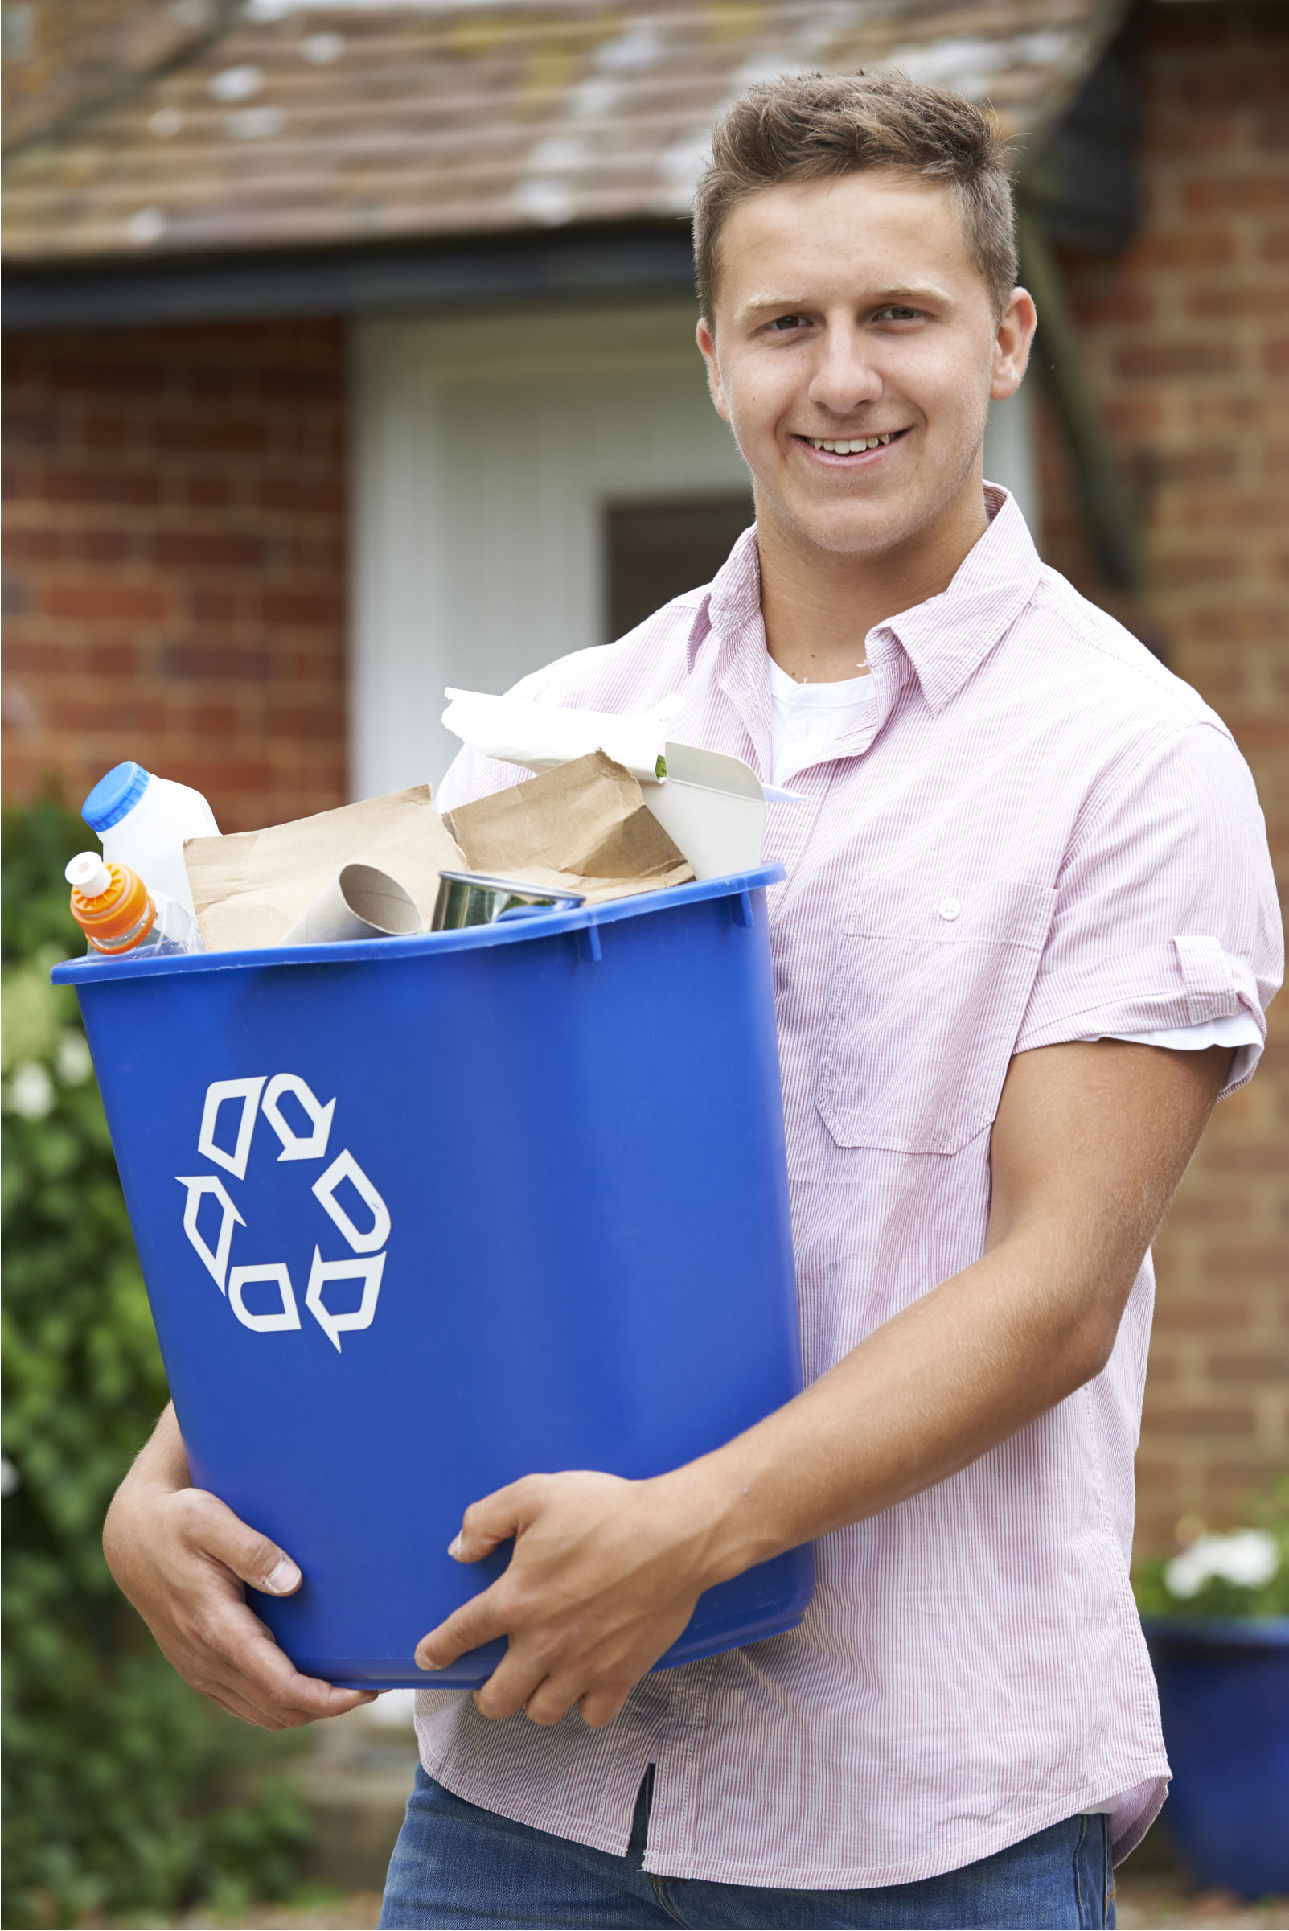
COMMUNITY
WASTE
SURVEY 2021
Results Summary

ABOUT THE SURVEY
The Victorian Government recently released its Recycling Victoria policy, setting targets for waste reduction in Victoria over the next ten years. These targets include several services that Council must provide to residents, including:
- a food and garden waste service for all households (rather than putting food scraps into the rubbish bin)
- a glass service for all households, separate to the existing recycling bin
- changing all bin lids to meet standardised state-wide bin lid colours

From 6 May to 6 June, we invited residents, landlords and businesses in Yarra Ranges to respond to a survey about future waste collection services provided by Yarra Ranges Council.
The survey was promoted by email and mailout to every ratepayer, in community newsletters, Community Links and local libraries, and on social media.
The survey could be completed online via the Shaping Yarra Ranges website. Printed surveys were also available from Council’s Customer Service Centres, and libraries across Yarra Ranges for return in a reply-paid envelope.
The response to the survey
In total, we received 7057 surveys, made up of:
- 6899 responses to our residential surveys
  - 6509 online surveys
  - 390 postal surveys
- 74 landlord surveys
- 84 business surveys
- Responses were received from people living in more than 50 different townships and localities across Yarra Ranges.
This is one of the largest responses received to community consultation undertaken by Council. More than 11% of Yarra Ranges households responded to the survey.

WHAT YOU TOLD US

Food and Garden Organics (FOGO)
We asked about:
- Your preferences for food and garden organics collections
- Your main comments about the introduction of the service
- Frequency of service

You told us:
- 60% of respondents said they would like to maintain a weekly rubbish collection, with a fortnightly FOGO collection
- 65% of webinar viewers said they would like a weekly FOGO and fortnightly rubbish collection. This was after learning about how a FOGO bin & waste bin would be used
- Some enthusiastic composters felt they would not use a FOGO bin and would prefer an opt-in FOGO collection
- Respondents were concerned about the risk of odour and hygiene
- A weekly FOGO bin could assist residents in high bushfire prone areas to manage fuel loads and reduce the need for burning off
- Increased community education is essential to help people understand how to use a FOGO bin correctly
- Some people told us of their positive experience using FOGO collections in other areas.
“I use (a FOGO bin) at my primary residence in (another municipality), and was more impressed with it than I expected.”

“My sister lives in (another) Council. They've been doing it for a few years now and it's great.”

“I lived in (a regional NSW Council) where a similar program was introduced years ago. They supplied a kitchen tidy and free compostable bags so that organic waste could be just dropped in to the bin. (Rubbish) Bins were collected fortnightly. Initially there was uproar and people said that bins would smell, but all of that settled down very quickly. It was disappointing to move back to my home area and move backwards as far as waste was concerned.”

What we will do from here:
The Recycling Victoria policy dictates that Council must provide all residents with a FOGO service.
In planning the new collection services, Council will consider feedback from this survey along with the findings of waste industry research on best practice for FOGO collections.
Proposed arrangements for this collection will be presented in our Draft Community Waste Plan, to be released in early 2022.
Any change in service or introduction of a FOGO collection would most likely occur in late 2023 when our current waste contracts expire.

Recycling
We asked about:
- Your level of satisfaction with the current recycling collection
- The things most important to you when thinking about recycling
- Your suggestions to improve recycling in Yarra Ranges
- The items that you find difficult to recycle

You told us:
- 86% of respondents to the survey were satisfied with the current recycling collection
- You want recycling to be as easy as possible, and to be able to recycle more items in your recycling bin.
- Recycling education is very important to you. You would like to know more about what can and can’t be placed into your recycling bins, and what happens to the items after they are collected from the kerbside.
- Soft plastics are currently recycled only through collections at local supermarkets (in collaboration with Recycle). Many suggested to make soft plastics recycling easier by allowing these items to be placed into our recycling bins.

What we will do from here:
The Victorian Government is establishing a standard list of items that can and can’t be recycled as part of the statewide approach to reducing waste. Each Council will have to offer collections based on the standard acceptable items lists.
This list of items is currently being negotiated between the Victorian Government, Councils and recycling companies. Your responses to the Community Waste Survey will inform our input into these discussions.
As we make changes to our waste services, we will share information well in advance of changes taking place. We will use email, post, social media, print advertising and educational workshops to ensure our community is well-informed.

Glass Recycling
We asked about:
- Your preferences for a separate glass collection for recycling (bin collected from home vs. drop off service at designated locations)
- Your comments about the introduction of a separate collection for glass

You told us:
- 90% of survey respondents would prefer glass collection in a bin collected from home, rather than to drop off glass at a central location
- The cost of an additional glass-only service (leading to an increase in rates) was a concern to many
- The space for an additional bin, both in your yard and at the kerbside on bin night, was a concern

What we will do from here:
The Recycling Victoria policy dictates that Councils must provide a separate glass service to each Victorian household.
When planning this collection, we will consider your preference for a glass bin collection from home, and how this can be provided at lowest cost to residents.
All waste collection services are charged at a cost recovery rate only, meaning that users are only charged what it costs to deliver the service to our community.
We will also look at how we can time collections so that we don’t have all bins out at the same time.
Residents will be notified well in advance of the commencement of a new service.

Hard Waste Collections
We asked about:
- Your preference between a scheduled hard waste collection service or on-call hard waste collection service
- Your preferred timing for a scheduled hard waste service, if provided
- What is important to you when considering hard waste collections

You told us:
- 75% of respondents to the survey would prefer the scheduled hard waste collection to remain, and occur during January to March (the current arrangements).
- key comments regarding hard waste collections were: the convenience of hard waste collections
  - reducing the amount of material from hard waste collections going to landfill
  - increasing recovery of usable goods from hard waste collections.

What we will do from here:
In planning the new collection services, Council will consider feedback from this survey along with the findings of waste industry research. We will consider how to maximise the recovery of reusable and recyclable materials from this collection.
We will include issues around the reuse and minimisation of hard waste items when planning our waste education materials and activities.
We will investigate ways that we can support the community to minimise hard waste, such as repair cafes (i.e. community workshops where people can receive assistance to repair broken items rather than dispose of them).

Other waste related topics
We asked about:
- The litter issues that you observed in your area
- The types of items that you find difficult to recycle
- How you would like to receive information on waste topics
- The types of activities that would help you to minimise your waste

You told us:
- The top five items that are most difficult to dispose of correctly are polystyrene, household batteries, electronics, clothing and printer cartridges
- More than 50% of all respondents would like to apply for a compost rebate from council, but many were unaware that these were available
- Around 20% of respondents were interested in assistance to purchase reusable items such as sanitary and continence items and reusable nappies through a rebate scheme
- Most respondents would be interested to attend special drop off days for difficult to recycle materials
- Repair workshops for broken items and workshops on how to compost and reduce food waste were also of interest
- Litter was not a significant issue for 65% of respondents to the survey, and was mostly observed in township areas and on roadsides

What we will do from here:
We will tell you more about existing recycling services that are less well known, such as household battery recycling, and Detox Your Home events for unwanted household chemicals.
We will investigate opportunities to offer other recycling options within Yarra Ranges.
We will promote our Home Composting Rebate Program more widely to ensure more residents are aware of its availability, and how to apply.
We will investigate opportunities to promote and support the use of reusable items, through projects run by Council, or with partners in the community.
We will organise or support activities in our community that help to minimise waste, such as educational workshops and repair cafes.

OUR NEXT STEPS
Our Waste Management team is now developing a draft Community Waste Plan.
The plan will outline how we will deliver new waste services that align with our obligations under the Recycling Victoria strategy. Feedback from the Community Waste Survey will be used in planning our new waste collection services and community education activities.
We will aim to have the draft plan available in early 2022.

